Meldencio  Czarlemagne  Corrales  Software Engineer and Architect,  DevOps Engineer,  Database Manager and Administrator,  IT & IS Manager | 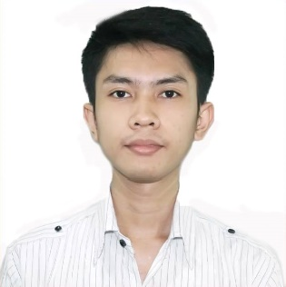  🏠 St. Peter, New Era, Quezon City, Philippines, 1121  📞 (+63) 967 205 6160  📧 mczvc.biomew@gmail.com 📧 mczvc@proton.me  🌐 https://mczvc-biomew.github.io/mczvc  🌐 https://mczvc-biomew.github.io/k9gb  🌐 https://g.dev/mczvc
ABOUT ME |  | EDUCATION
Results-driven software developer with extensive experience in both systems and business domain programming languages (C, C++, C#, Java) and (Python, JavaScript, Ruby, Typescript), leveraging expertise and proficiency in wide variety of frameworks for these languages, for example: Python (Strawberry, Graphene, flask, Django, Pandas, Numpy), Java Spring, Ruby-on-Rails, JavaScript (NextJS, ReactJS, VueJS, NuxtJS), C++ (Boost, Qt5, and OpenGL graphics library), delivering high-quality and innovative solutions across multiple platforms.  Strong foundation and solid grasp in algorithms, data-structures, and mathematics, with proficiency in TDD and safety assurance, ensuring code quality and functionality of tested software, in compliance to specifications and use cases of software; applied to, and worked for Distributed, High-performance, and Scientific Computing.  I am experienced in technical and team leadership: As a seasoned technical leader, I excel and bring expertise in software design, leveraging in deployment automation to improve and optimize the CI/CD pipelines; commend testing frameworks to the team; and playing the role of designing and operating mission critical services in a cloud-based architecture — I effectively guide cross-functional teams and drive project and business to success — delivering high-quality and efficient, scalable software solutions.  Polyglot to familiarize programming in 15+ languages, which includes: Bash, Perl, Powershell, Ruby, Clojure, Haskell, Julia, Go, Kotlin, Swift, Lua, Rust, Zig, Assembly, SQL, Typescript.  As a software architect and database manager, I am proficient in designing API, software architecture, and cloud-based services, providing solutions in building effective, efficient, and robust software. |  | August 2014 – October 2016  Bachelor of Science in Computer Science  New Era University  College of Computer Studies  New Era, Quezon City  Programming Languages  C, C++, C#, Clojure,  Carbon, Go, Java, Kotlin,  Python, Lua, Haskell, Julia,  HTML5 / XML, CSS3, PHP,  JavaScript, Typescript, Rust,  Ruby, OCaml, Swift, Zig,  Assembly, Bash, Powershell,  SQL, Solidity, Vyper  Frameworks, Libraries  Django, Strawberry-Django, Graphene, Flask, FastAPI, Vue.js, React.js, Angular.js, Next.js, Nuxt.js, Webpack, Vite, Express.js, Fastify.js, Nest.js, OpenAPI, GraphQL, Redis, Apollo, Mongoose, Jest, Cypress, Node.js, Deno, Bun, Electron, React Native, Bootstrap, TailwindCSS, UnoCSS, Bulma, Boost, Qt5, Kafka, Spring, Ruby-on-Rails  Tools & Technologies  Docker, Kubernetes, Oracle,  PostgreSQL, MySQL,  MariaDB, SQLite3,  MongoDB, GraphQL,  Compass, Postman,  Selenium, Nginx, Git,  Apache, Jira, Eclipse, Pycharm, CMake, CLion,  IntelliJ, VS Code, Linux,  Ansible, Chef, Terraform,  IBM Control Desk, Vivantio,  Firebase, Elasticsearch,  Logstash, Kibana, Salesforce,  SAP, Heroku, AWS  Methodologies  Pragmatism, ArchOps, Waterfall, SRE: Site Reliability Engineering, DevOps (CI/CD, dynamic testing, Infrastructure as Code, CCA: Continuous Configuration Automation), TPS: Transaction Processing System (Kaizen, Continuous Improvement, OLTP: Online Transaction Processing), Agile (Scrum, Lean, XP, Crystal), Twelve-Factor App (SaaS, PaaS), DevSecOps (DAST, PSS ISE, Security by Design, Security Automation), DataOps  

Mastered and practiced clean code principles and Design Patterns for 10+ years; pragmatic, and highly accomplished practitioner of agile methodology such as Scrum, Lean, XP, and crystal.

As a full-stack developer and DevOps engineer with 6+ years of experience, I possess a unique blend of technical expertise, leadership skills, and passion for delivering high-quality software solutions.

WORK EXPERIENCE

(Dec. 2019 – Present)

Senior Software Engineer and Architect, Full-stack Developer,
DevOps Engineer – R&D, Database Administrator

DADS University, Bayanihan College, Network Careers |

Quezon City

Built several micro-services and API endpoints — for the consumers and producers operating in the open-source,

MOOC, value-based Careers platform, to implement automated management solutions — implementing REST protocol specifications and leveraging scalability by integrating GraphQL procedures.

Developed automation tools for document generation.

Created full-stack web applications for the university’s virtual learning environment.

(May 2019 – Nov. 2019)

CEO & Founder, Software Engineer and Architect

Picosoft, Egg. Co. Creations | Quezon City

Developed the Easy Graphics, Easy Game, and Easy Animation library using Java and OpenGL.

Released two Android games using the library.

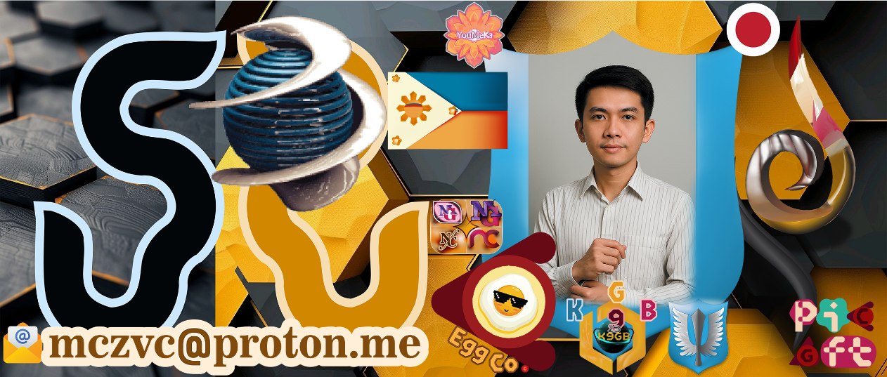 |  |  | 

