**Project Proposal**

Course Title : SOFTWARE ENGINEERING LAB

Course Code : 452 IT

Course Teacher : **Nusrat Jahan Oishi**

Head

Department of IT

**Group Member**

NAME ID

Md. Abu Sayed 142010400015

Md. Toukir Haque Khan 142010200003

**Project Name : Two player Matching Games**

Platform : Java

Client Name : Mr. Khan

**Project Requirement :**

1. There will be 16 button in the board.
2. There are two players. First player name “A” Second player name “B”.
3. Sound system all button.
4. A restart button.
5. A exit button.
6. Score individual player.

There are sixteen button in the board . Player “A” matching three button same time so “A” player is win.Player “B” matching three button same time so “B” is win.

Player “A” matching three cross button than player “A” is win

Example:

A

A

A

A A A

So “A” is win.

Player “B” matching three cross button than player “A” is win

Example:

B

B

B

B B B

So “B” is win.

First player win than score add player “A” . Score count 1,2,3,4,5,…………………...

Second player win than score add player “B”. Score count 1,2,3,4,5,…………………..

Click the restart button than games again play time.

Click the exit button than game is exit.

**Used Model**

Model : Waterfall Model

**Model Specification:**  There is no editing in the features of the Application.

**Why used this model in my Application :**

I used this model because The client gives me all the specifications. So That There is no need to change the key features indeed.

But as an games desktop base application it needs to maintain the total project for perfection.

The games play desktop.

**Demo Project :**

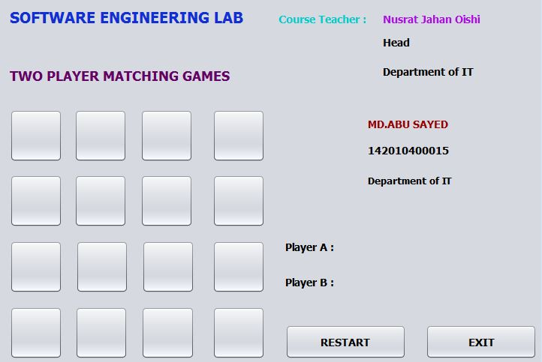

UML Diagram

Player A Player B

**Class Diagram :**

**Score**

+Increment(): void

**Player A**

-score: int

take-turn(): void

**Player B**

-score: int

take-turn(): void

**Player**

-name : char

+take-turn() : void

**Board**

-game:2player-matching

+Board-display(): void

+button() : void

**Two-player-matching**

+board : char

+player : String

+play-game():void

**Time Table :**

|  |  |  |  |
| --- | --- | --- | --- |
| **Sn** | **Design & Code** | **Date** | **Day** |
| **1** | Gui design |  | 7 day |
| **2** | Board code |  | 10 day |
| **3** | Button sound code |  | 7 day |
| **4** | Wining code |  | 15 day |
| **5** | Score code |  | 7 day |