1. Executive Summary
- Objective: To develop an interactive Power BI dashboard providing key insights into bike sales performance, customer demographics, and product trends, supported by robust data preparation and modeling.
- Key Findings :
  - Sales are heavily dominated by 'Bikes' (96% of total revenue), with 'Road Bikes' and 'Mountain Bikes' being the top-performing subcategories.
  - There is a clear seasonal sales trend, peaking in late spring/early summer across all years, with 2014 showing strong year-over-year growth.
  - The majority of customers are concentrated in [United State and Australia] and fall within the [35-49] age group, suggesting targeted marketing opportunities.
- Recommendation:
  - Focus marketing efforts on the dominant 'Bikes' category during peak seasonality (April-July) and explore strategies to boost sales in underperforming categories like 'Clothing'.

2. Introduction
- Project Context: This project analyzes sales data for a hypothetical bike retailer to understand historical performance, identify key growth drivers, and inform strategic decisions.
- Problem Statement: The business lacks a centralized, interactive view of its sales data, making it difficult to track KPIs, identify product performance, and understand its customer base.
- Solution Overview: A robust data pipeline involving Python for initial cleansing, MySQL for structured storage, and Power BI for dynamic visualization.

3. Data Source and Acquisition
- Source: Simulated bike sales datasets provided as CSV files.
- Initial State: Multiple CSV files for sales facts, product details, customer information, each requiring integration.
- Data Volume: Approx. 50,000 sales transactions across 3 main table.
4. Data Preparation and Transformation
4.1. Data Loading and Initial Assessment (Jupyter/Python)
- Tools Used: Python (Pandas, NumPy).
- Process:
  - Loading CSV files into Pandas DataFrames.
  - Initial df.info(), df.describe(), df.head() to understand structure, data types, and potential issues.
  - Identification of missing values, duplicates, and inconsistent formats.

4.2. Data Cleaning and Transformation (Jupyter/Python)
Tools Used: Python (Pandas).
The initial raw datasets (e.g., bikesales_db_fact_sale.csv, bikesales_db_dim_product.csv, bikesales_db_dim_customer.csv, dim_date.csv) required several cleaning and transformation steps to ensure data quality, consistency, and suitability for relational database loading and Power BI analysis.
- Date Parsing:
  - The sls_order_dt column in the bikesales_db_fact_sale table was initially loaded as an object (string) data type. To enable chronological analysis and the creation of a robust date dimension, this column was explicitly converted to a datetime object using pd.to_datetime(). This ensured proper date hierarchy creation and time-intelligence functions in Power BI.
  - Example: fact_sale['sls_order_dt'] = pd.to_datetime(fact_sale['sls_order_dt'])
- Missing Values Handling:
  - Missing values were primarily observed in geographical columns (e.g., cst_country) and sometimes in product attributes (MAINTENANCE).
  - For categorical columns like cst_country where a direct imputation was not feasible or meaningful, null values were explicitly filled with a placeholder string like 'Unknown' or 'N/A'. This approach allows Power BI to display these unclassified records and prevent errors during data loading or relationship creation, without distorting numerical aggregates.
  - Example: dim_customer['cst_country'].fillna('Unknown', inplace=True)
  - For numerical columns, if any nulls were present, the strategy would depend on the column (e.g., sales_amount nulls would be investigated, quantity nulls might imply 0 or require imputation based on context). In this project, significant numerical nulls were not widely present.

- Data Type Conversion:
  - Crucial numerical columns were checked and converted to appropriate numeric types to enable aggregation and calculations.
  - sales_amount (revenue) and sls_quantity (quantity sold) in the bikesales_db_fact_sale table were ensured to be numeric (e.g., float or int) to facilitate correct summation and averaging.
  - Example: fact_sale['sls_sales'] = pd.to_numeric(fact_sale['sls_sales'], errors='coerce') (using errors='coerce' to turn unparseable values into NaN for later handling).
  - cst_id, prd_key, sls_order_num were ensured to be appropriate integer types for key relationships.
- Standardization:
  - Text standardization was performed on categorical columns to ensure consistency and prevent issues with grouping in Power BI.
  - cst_country: Values in the country column were checked for variations (e.g., 'USA' vs. 'United States') and unified to a standard format to ensure accurate mapping in geographical visuals.
  - cst_gndr: Values like 'M' and 'F' were standardized to 'Male' and 'Female' (if not already done) for clearer display in Power BI visuals.
  - MAINTENANCE: Boolean-like values (e.g., '1', '0' or 'True', 'False') were converted to consistent 'Yes'/'No' strings for user-friendly display.
  - Example (for Gender): dim_customer['cst_gndr'] = dim_customer['cst_gndr'].replace({'M': 'Male', 'F': 'Female'})

- 4.3. Data Storage and Schema Design (MySQL)
- Purpose: To establish a structured, relational database that acts as a robust, query-optimized source for Power BI, ensuring data integrity and analytical flexibility.
- Schema Design (Star Schema Methodology):
- The database was designed following a star schema methodology, which is ideal for analytical reporting. This involves a central fact table (fact_sales) containing measurable events, linked to several dimension tables (e.g., dim_product, dim_customer, dim_date) that describe the "who, what, where, when" of those events. This design optimizes for performance when querying large datasets and simplifies complex analytical queries.
- Table Descriptions and Relationships:
- fact_sales (Fact Table - Central):
- Purpose: Stores individual sales transactions, including measurable metrics like sls_sales (revenue) and sls_quantity (quantity sold).
- Foreign Keys: Contains foreign keys that link to the primary keys of the dimension tables, enabling easy joining and slicing of sales data by various attributes.
- dim_customer_id (FK dim_customer.cst_key)
- dim_product_id (FK dim_product.prd_key)
- dim_product (Dimension Table):
- Purpose: Provides descriptive attributes about each product, such as prd_nm (product name), CAT (category), SUBCAT (subcategory), and MAINTENANCE status.
- Surrogate Key: A surrogate key, prd_key, was introduced as the primary key for this table. This is an auto-incrementing integer identifier, distinct from any original source system product ID (prd_id).
- Benefit of Surrogate Key: It ensures data integrity, simplifies joins, is resistant to changes in the source system's natural keys, and is typically more efficient for database indexing and Power BI relationship management than complex multi-column keys or string-based natural keys.
- dim_customer (Dimension Table):
- Purpose: Stores descriptive attributes about each customer, including cst_gndr (gender), cst_marital_status (marital status), cst_country (country), and BDATE (birth date).
- Surrogate Key: A surrogate key, cst_key, was introduced as the primary key for this table. This is an auto-incrementing integer identifier, distinct from any original source system customer ID (cst_id).
- Benefit of Surrogate Key: Similar to prd_key, it provides a stable, simple, and efficient primary key for relationships, insulating the data model from potential changes or complex primary key structures in the source customer data.
- dim_date (Dimension Table):
- Purpose: Provides a comprehensive set of date-related attributes (Year, Month, Day, Month Name, etc.) to support time-intelligence analysis.
- Primary Key: A unique date_key (typically an integer like YYYYMMDD) serves as its primary key.

Data Loading: The cleaned and transformed data from the Python/Pandas environment was loaded into these MySQL tables using Load data infile Method.
Example SQL Queries :
CREATE DATABASE bikeSales_db;
USE bikeSales_db;
-- creating dim_customer table
CREATE TABLE dim_customer(
cst_id INT,
cst_number VARCHAR(50),
cst_firstname VARCHAR(50),
cst_lastname VARCHAR(50),
cst_marital_status VARCHAR(50),
cst_create_date DATE,
cst_country VARCHAR(50),
cst_birthdate DATE,
cst_gender VARCHAR(50),
cst_key INT PRIMARY KEY
);
-- loading data in dim_customer
LOAD DATA LOCAL INFILE "C:\\Users\\sharf\\OneDrive\\Desktop\\bike_sales_csv\\clean_dim_customer.xls"
INTO TABLE dim_customer
FIELDS TERMINATED BY ','
ENCLOSED BY '"'
LINES TERMINATED BY '\r\n'
IGNORE 1 ROWS;

5. Data Modeling and Analysis (Power BI)
5.1. Data Connection:
- Power BI Desktop connected directly to the hosted MySQL database using the built-in MySQL database connector. Data was loaded in Import mode, optimizing performance for dashboard interaction by caching the data within the Power BI file.
5.2. Data Model Design and Relationships:
- The star schema established in MySQL was faithfully recreated and enhanced within the Power BI data model view. This structured approach facilitates intuitive navigation of the data for reporting.
- Relationships between Tables: One-to-many relationships were defined, ensuring correct data propagation and filtering across the model:
- 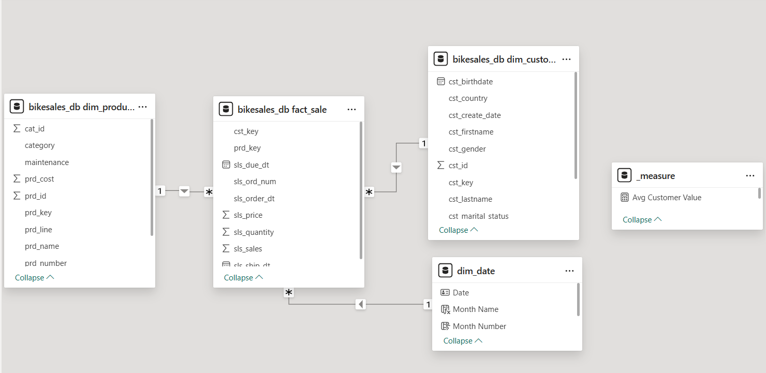
- Surrogate Keys in Power BI: The surrogate keys (cst_key, prd_key) created in MySQL served as the backbone for establishing these active relationships in Power BI. This provided stable, efficient, and unambiguous join conditions, crucial for a robust analytical model.
- dim_date Table Enhancement: The dim_date table was generated using Power BI's CALENDARAUTO() function, which dynamically creates a date table based on all dates present in the model. Custom columns like Month Name (using FORMAT([Date], "mmmm")) and Year (using YEAR([Date])) were then added to dim_date. A critical step involved sorting the Month Name column by a Month Number column (e.g., MONTH([Date])) to ensure chronological order in visuals.
- Customer Age & Age Group:
  - A calculated column Customer Age was created in dim_customer using DAX: Customer Age = INT(DIVIDE(DATEDIFF('dim_customer'[BDATE], TODAY(), DAY), 365.25)).
  - This numeric Customer Age column was then used to create Age Group bins (e.g., 10-year intervals) directly within Power BI's modeling capabilities. The Age Group column was subsequently sorted by the Customer Age column to maintain chronological order in charts.
5.3. DAX Measures:
- The key DAX measures:
  - Total Sales = SUM(fact_sales[sls_sales])
  - Total Quantity = SUM(fact_sales[sls_quantity])
  - Total Customers = DISTINCTCOUNT(dim_customer[cst_id])
  - Total Orders = DISTINCTCOUNT(fact_sales[sls_ord_num])
  - Avg Order Value = DIVIDE([Total Sales], [Total Orders])
  - Avg Customer Value = DIVIDE([Total Sales], [Total Customers])
  - Sales YTD = TOTALYTD([Total Sales], 'dim_date'[Date]) (if created)

6. Dashboard Development and Visualization (Power BI)
- Dashboard Structure
- The dashboard employs a multi-page, structured design to guide the user through the data narrative logically, moving from high-level summaries to detailed performance and demographic breakdowns.
- Page Name | - Purpose
- Global Sales Overview | - Acts as the Executive Summary. Provides the overall health of the business via key performance indicators (KPIs), high-level trends, and market dominance (category, top products). Designed for 30-second understanding.
- Product Performance | - Focuses on what the business sells. Enables deep-dive analysis into category hierarchies, profitability, maintenance impact, and granular subcategory comparisons.
- Customer Demographic | - Focuses on who the customers are. Provides essential insights into customer segmentation by age, gender, marital status, and geographical distribution.

Navigation:
A custom, persistent navigation pane was implemented on the left side of every report page. This was achieved by using simple Button visuals that were placed in a consistent layout and configured with the Page Navigation Action. This method provides a clean, user-friendly, and professional interface, allowing users to move between the core sections of the report with a single click.
Visual Design (Theme):
- Theme: A Dark Mode theme was selected for a modern, high-contrast, and professional appearance, reducing eye strain and making data points visually pop.
- Background: A rich, deep red/purple background color was used as the canvas to provide a strong, unified base.
- Accent Colors: A complementary palette was used for data:
  - Vibrant Blue/Cyan: Used for KPI cards and primary lines/bars (e.g., Total Sales, overall trend lines) to signify primary financial metrics and growth.
  - Electric Green: Specifically used to represent the dominant "Bikes" category in donut and column charts, immediately reinforcing the most important segment.
  - White Text: Used consistently for all chart titles, axis labels, and data labels to ensure maximum readability against the dark background.
  - Rounded Edges: Applied to KPI cards and slicers for a modern, softer design aesthetic.
KPI Cards:
KPI (Key Performance Indicator) cards are placed prominently at the top of the Global Sales Overview page. They provide immediate, high-level insight into the state of the business using core measures such as Total Sales, Total Orders, Total Customers, and Average Customer Value. They are formatted with large fonts and a contrasting blue background to serve as the initial point of focus for the user.
Chart Types and Justification
Specific chart types were chosen to best communicate the underlying data story:
Visual Type | Metric | Rationale
Line Chart | Total Sales by Year & Month | Ideal for trend analysis and seasonality. Using separate lines for each year allows for quick year-over-year comparison, confirming seasonal peaks (e.g., Summer) and identifying growth or decline trends.
Donut Chart | Sales by Category | Used to effectively show proportional distribution. The clear dominance of the "Bikes" slice tells an instant story about market focus.
Bar/Column Chart | Top 5 Products, Sales by Age Group | Excellent for comparison and ranking. The horizontal bar chart is specifically used for long category names (like Subcategories and Products) to avoid label rotation and improve readability.
Map | Total Customers by Country | Provides a geographic distribution overview. Bubble size is used to quickly illustrate where the customer base is most concentrated.
Matrix | Revenue Breakdown (Category, Maintenance, Product) | Used for hierarchical drill-down. This enables the user to move from a high-level Category view down through Maintenance status to the individual Product Name in a single, organized table, providing detailed, structured performance data.

\
6.1. Executive Summary Page:
- Visuals:
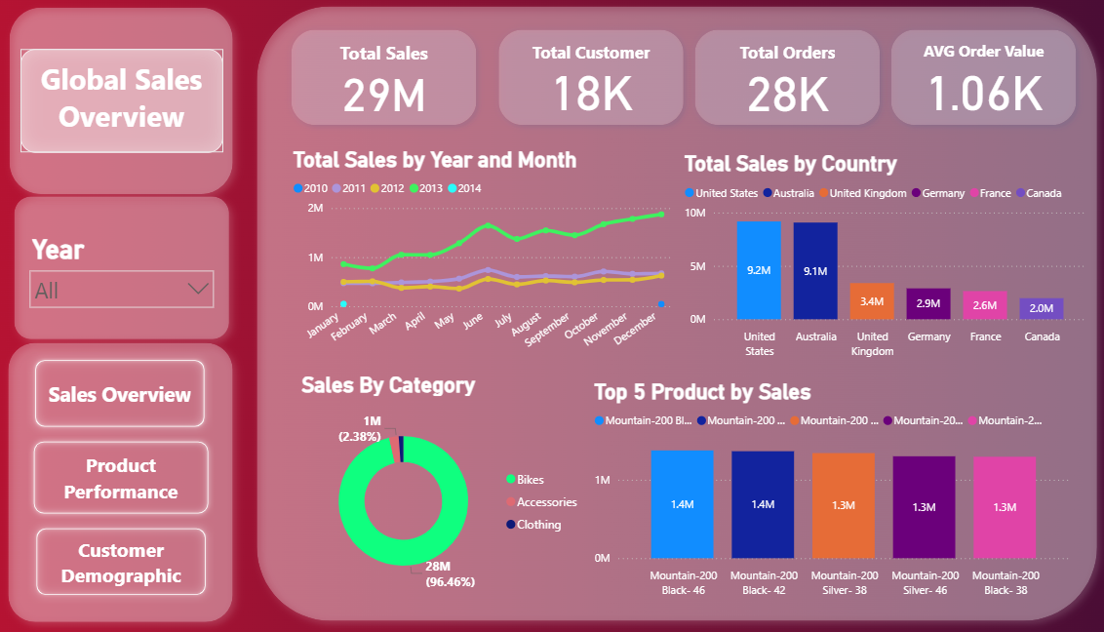
6.2. Product Performance Page:
- Visuals:
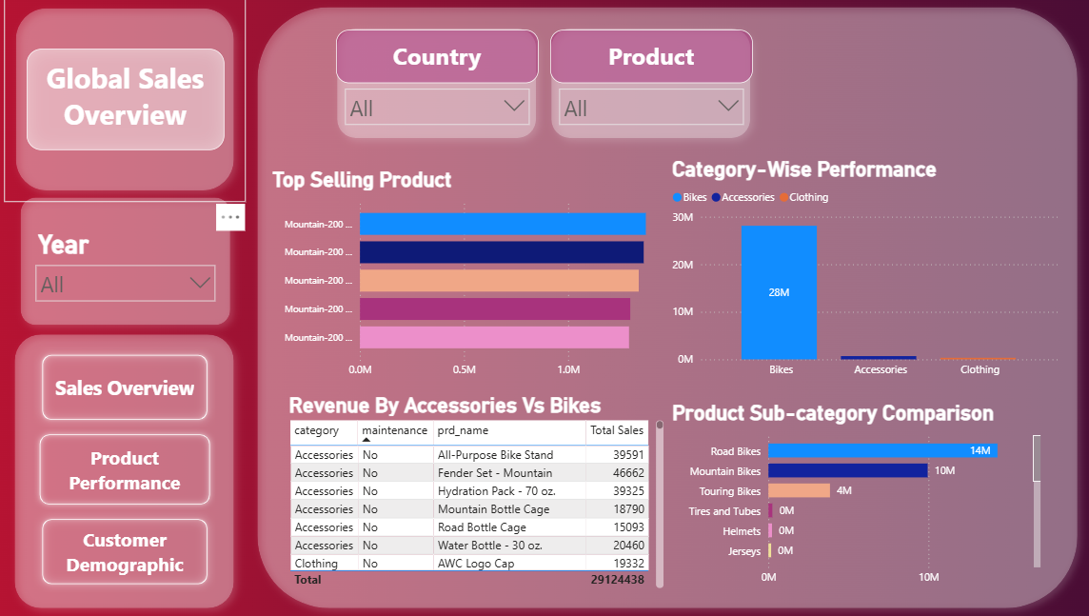

6.3. Customer Demographic Page:
- Visuals:
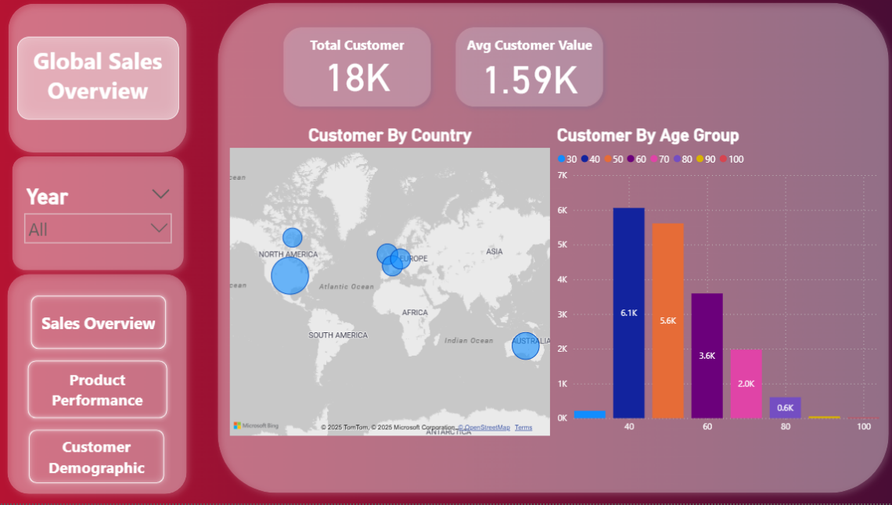

7. Key Insights and Business Recommendations
The interactive Power BI dashboard provides critical visibility into sales performance, customer demographics, and product trends, leading to the following key insights and actionable recommendations:
Detailed Insights:
- Seasonal Sales Patterns & Historical Anomalies: The "Total Sales by Year and Month" line chart clearly demonstrates a consistent seasonal pattern, with sales generally peaking during the spring and summer months (April-August) across all years. However, notable dips in early 2011 and early 2013, particularly in comparison to 2010 and 2014, warrant further investigation into potential external factors, marketing campaign effectiveness, or supply chain issues during those specific periods.
- Dominance of the Bikes Category: The "Sales by Category" donut chart unequivocally highlights that the 'Bikes' category accounts for an overwhelming 96.46% of total sales revenue. Further analysis on the "Product Sub-category Comparison" chart reveals that 'Road Bikes' and 'Mountain Bikes' are the primary drivers within this dominant category, making them the most critical components of the product portfolio.
- Geographic Customer Concentration vs. Sales: While the "Customer Count by Country" map shows a broad global customer base, the "Total Sales by Country" bar chart on the Global Sales Overview page pinpoints the United States, Australia, and Germany as the leading revenue contributors. This indicates that while customers exist globally, sales are heavily concentrated in a few key markets.
- Core Customer Demographic: The "Customer Count by Age Group" chart identifies the 30-49 age range as the largest customer segment, providing a clear target for marketing efforts.
- Data Quality Flag: Unclassified Sales: The persistent presence of an 'N/A' category in "Total Sales by Country" and potentially in product-level breakdowns indicates underlying data quality issues. This suggests that a portion of sales transactions or customer records lack complete classification.
Business Recommendations:
- Optimize for Peak Seasonality & Investigate Anomalies: Capitalize on the strong seasonal peaks by strategically launching marketing campaigns and ensuring optimal inventory levels for 'Bikes' between April and August. Concurrently, conduct a retrospective analysis into the sales drops in early 2011 and 2013 to understand root causes and prevent recurrence.
- Strategic Investment in Core Bike Categories: Given the overwhelming success of 'Bikes,' allocate additional R&D and marketing spend towards the development and promotion of new bike models, particularly in the high-performing 'Road Bikes' and 'Mountain Bikes' subcategories. This represents a low-risk strategy to drive continued growth.
- Targeted Marketing by Demographic: Implement targeted marketing campaigns specifically designed for the 30-49 age group, tailoring product messaging and channels to resonate with this largest customer segment. Explore cross-selling opportunities with accessories relevant to this demographic.
- Data Quality Improvement for Classification: Address the 'N/A' data quality issue by reviewing data collection processes or implementing data enrichment strategies. Properly classifying these transactions will provide a more accurate and complete picture of sales origins and product performance.
- Expand Market Penetration: Focus efforts on deepening market presence and increasing sales conversion in countries that show a high number of customers but relatively lower total sales. This suggests existing interest that can be capitalized upon with localized marketing or improved distribution.
- Diversify Product Strategy (Long-Term): While 'Bikes' dominate, develop a long-term strategy to assess and potentially revitalize underperforming categories like 'Clothing' and 'Accessories'. This could involve market research, product innovation, or revised pricing strategies to diversify revenue streams, reducing over-reliance on a single product category.

8. Conclusion
This project successfully delivered a robust, end-to-end data analytics solution for bike sales performance, culminating in a highly interactive and insightful Power BI dashboard. By meticulously processing raw data through Python (Pandas) for cleaning and transformation, structuring it efficiently within a MySQL relational database, and finally visualizing key metrics and trends in Power BI, a powerful analytical tool has been established.
The developed dashboard provides immense value to the business by:
- Centralizing Critical Information: Consolidating disparate sales, product, and customer data into a single, accessible platform.
- Driving Data-Driven Decisions: Offering immediate insights into sales trends, product performance (category, subcategory, top products), and customer demographics (age, gender, location).
- Enhancing Strategic Planning: Equipping stakeholders with the ability to identify dominant product lines, understand customer segments, detect seasonal patterns, and pinpoint areas for growth or concern.
- Promoting Self-Service Analytics: Enabling users to dynamically explore data through intuitive navigation and interactive filters, fostering deeper understanding without requiring technical assistance.
Looking ahead, the foundation laid by this project opens avenues for several valuable enhancements. Future iterations could include:
- Integrating Cost Data: To enable comprehensive profitability analysis across products, categories, and customer segments.
- Developing Predictive Forecasting Models: Leveraging historical sales data to forecast future demand and optimize inventory management.
- Expanding Data Scope: Incorporating inventory, supply chain, or marketing campaign data to provide a holistic view of the business operation.
- Implementing Advanced Analytics: Exploring customer lifetime value (CLTV) or market basket analysis to uncover further sales opportunities.
This dashboard stands as a testament to the power of integrating diverse data tools to transform raw data into actionable business intelligence, providing a clear roadmap for strategic growth and operational excellence.

