CrewAI-based Reel Generation Agent using HeyGen + Submagic + Media Gallery.
https://www.figma.com/board/McVGyf7ql612KDqH3P0DwG/AI-Reel-Agent-Architecture?node-id=0-1&p=f&t=10UdgEPlys5T0khN-0

User Input → Media Analyzer → Decision Engine → Strategy Agent
→ Script Agent → Avatar Selector → Pipeline Execution (HeyGen/Submagic)
→ Quality Check → Final Output

→ QC Agent → Final Render → Delivery
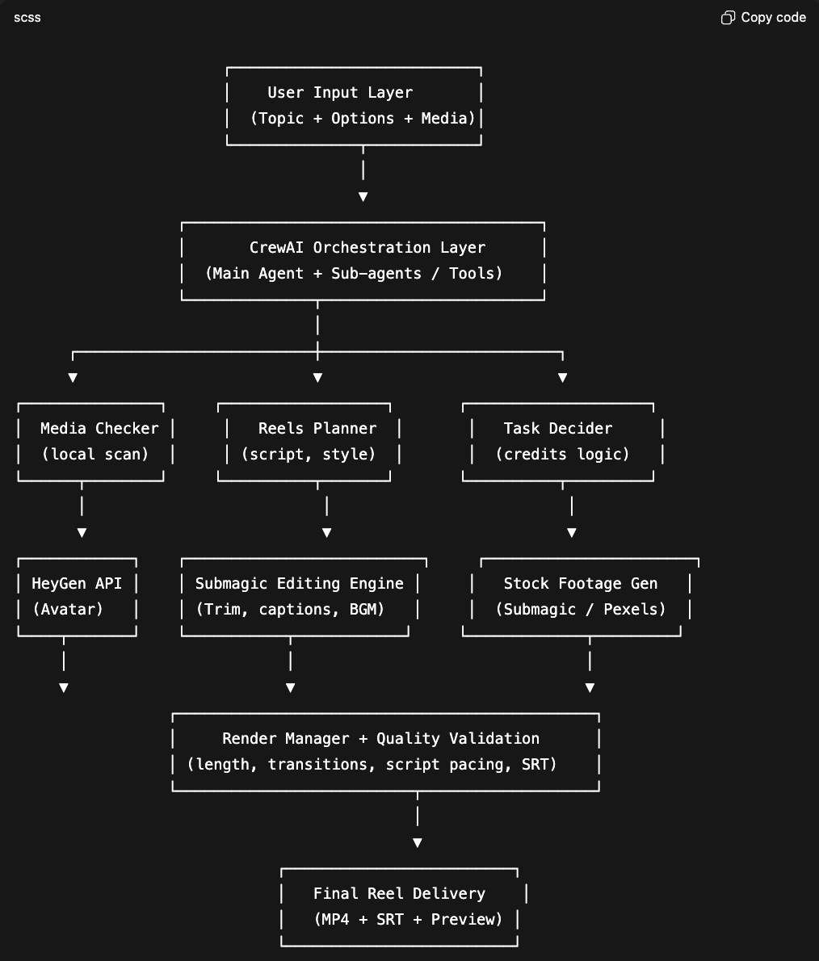

✅🔥 1. INPUT LAYER (Updated)

User provides:

Topic

Mode (single / bulk)

Credits available

Local media folder path

Avatar choice (optional upfront)
If the user doesn’t select → system must offer 7–8 avatars to choose from.

🔥 2. AVATAR SELECTION LOGIC (NEW)

You will store a structured list like:

[

{ "id": "avatar_1", "name": "Sarah AI", "style": "professional" },

{ "id": "avatar_2", "name": "Marcus AI", "style": "casual" },

{ "id": "avatar_3", "name": "Priya AI", "style": "friendly" },

{ "id": "avatar_4", "name": "Jake AI", "style": "energetic" },

{ "id": "avatar_5", "name": "Hiro AI", "style": "calm" },

{ "id": "avatar_6", "name": "Sophia AI", "style": "luxury" },

{ "id": "avatar_7", "name": "Karan AI", "style": "corporate" }

]

Handling Selection

Case 1: User selects avatar upfront

→ pass avatar ID → HeyGen pipeline continues.

Case 2: User doesn’t select

CrewAI Avatar Selector Agent will:

Read topic + script style

Recommend 2–3 avatars from the list

Ask the user to choose before processing

🔥 3. DECISION ENGINE (Updated)

✔ If local folder has 3+ videos

Offer:

Edited Reels (5 credits)

Avatar Reels (30 credits)

✔ If local folder has < 3 videos

Offer:

Avatar Reels (30 credits)

Stock Footage Reels (5 credits)

✔ Bulk Mode

Automatically:

50% avatar (heygen)

50% edited/stock (submagic)

Important:
Bulk mode must allow different avatars per reel
BUT also allow user to lock to 1 avatar for all.

🔥 4. CREW AI AGENT SETUP (Updated)

You will now have 5 core agents:

A. Media Analyzer Agent

No change:

Counts videos

Extracts metadata

B. Strategy Agent

No change:

Plans reel style

Defines tone

C. Script Generation Agent

No change:

Writes 15–40 sec script

D. Avatar Selector Agent (NEW)

Role:
Help user select the best avatar from 7–8 available.

Tasks:

Read script style + topic

Recommend top avatars

Show avatar preview (name + personality)

Wait for user's selection

Pass avatar ID to HeyGen pipeline

E. Pipeline Execution Agent

Runs 3 different pipelines:

1. HeyGen Avatar Generation

Input:

script

avatar_id ← SELECTED by user

voice

style

emotion

Output:

avatar_raw.mp4

2. Submagic Edited Reel (local videos)

Adds cuts, zooms, subtitles, emojis

3. Submagic Stock Reels

If <3 videos

Fetches stock

Auto-edits

🔥 5. QUALITY CHECK (QC Agent)

Checks:

Pacing

Duration

Subtitles alignment

No broken frames

Avatar lip-sync quality (HeyGen)

Re-renders if fail.

🔥 6. FINAL OUTPUT

Package:

final.mp4

subtitles.srt

thumbnail.jpg

summary.json

In bulk:

folder per reel

✅ UPDATED PHASE PLAN (with avatar selection)

PHASE 1 (Day 1–2): Base Logic + Credit Rules

Implement video count logic

Implement offering logic

Implement avatar list

PHASE 2 (Day 3–4): CrewAI Core Agents

Create agents:

Media Analyzer

Strategy Agent

Script Agent

Decision Engine

PHASE 3 (Day 5–6): Avatar Selector Agent

Show list of 7–8 avatars

Bring up personality descriptions

Save selected ID

Pass it to HeyGen pipeline

PHASE 4 (Day 7–10): API Integrations

HeyGen avatar generation

Submagic edited reels

Submagic stock reels

Progress polling

PHASE 5 (Day 11–12): Bulk Mode

50% avatar

50% edited/stock

Choose avatars dynamically or fixed

PHASE 6 (Day 13–14): QC + Final Packaging

Build QC agent

Standardize outputs

Add summary metadata

🎯 Final Result

You now have a system that:

Checks local videos

Chooses best pipeline

Lets user choose from 7–8 avatars

Generates high-quality reels

Supports bulk processing

Mixes avatar + edited reels

Ensures final quality

