DYNAMIC WEB PERFORMANCE OPTIMIZATION
USING MACHINE LEARNING ANALYTICS

By
Md Ashikur Rahman

A Thesis Submitted in Partial Fulfillment of the Requirements
for the Degree of
Bachelor of Science in Computer Science and Engineering

January 2026

ABSTRACT
Web performance optimization has become increasingly critical in today's digital landscape, where user experience directly impacts business success and search engine rankings. This research presents a comprehensive machine learning-based approach to predict and optimize web performance metrics, focusing on Core Web Vitals including Largest Contentful Paint (LCP), Cumulative Layout Shift (CLS), First Contentful Paint (FCP), and Time to Interactive (TTI).
The study analyzes a dataset of 1,167 websites across various domains, employing three distinct labeling strategies (tertile-based, weighted scoring, and K-means clustering) combined with three powerful machine learning algorithms (Random Forest, LightGBM, and Neural Networks). The proposed system achieves exceptional accuracy with the LightGBM model using K-means clustering, delivering 97.86% accuracy, 98.40% precision, 98.53% recall, and 98.47% F1-score.
This thesis demonstrates that machine learning can effectively predict web performance categories and provide actionable optimization recommendations. The developed web-based platform integrates the trained models into a real-time analysis tool, enabling developers and website owners to instantly assess their website's performance and receive specific improvement suggestions. The research contributes to the growing field of automated web optimization and provides a foundation for intelligent, data-driven performance enhancement strategies.

LIST OF FIGURES
- Figure 5.1: Comprehensive performance heatmap of all models across evaluation metrics
- Figure 5.2: Accuracy comparison across different labeling strategies and algorithms
- Figure 5.3: F1-Score (macro) comparison showing K-means LightGBM as best performer
- Figure 5.4: Radar chart comparing best models from each labeling strategy
- Figure 5.5: Confusion matrix for K-means LightGBM model showing 97.86% accuracy
- Figure 5.6: Precision comparison showing consistent high performance across top models

LIST OF TABLES
- Table 5.1: Complete Model Performance Comparison

CHAPTER 5: RESULTS AND DISCUSSION

5.1 Dataset Overview
The final processed dataset consists of 1,167 website samples with 22 performance features. The dataset exhibits balanced class distribution across all labeling strategies, ensuring unbiased model training. Key performance metrics show significant variance, indicating diverse website performance profiles suitable for machine learning classification.

5.2 Model Performance Comparison
Comprehensive evaluation of all nine models (3 strategies × 3 algorithms) reveals significant performance differences. The LightGBM model with K-means clustering achieved exceptional performance across all metrics.

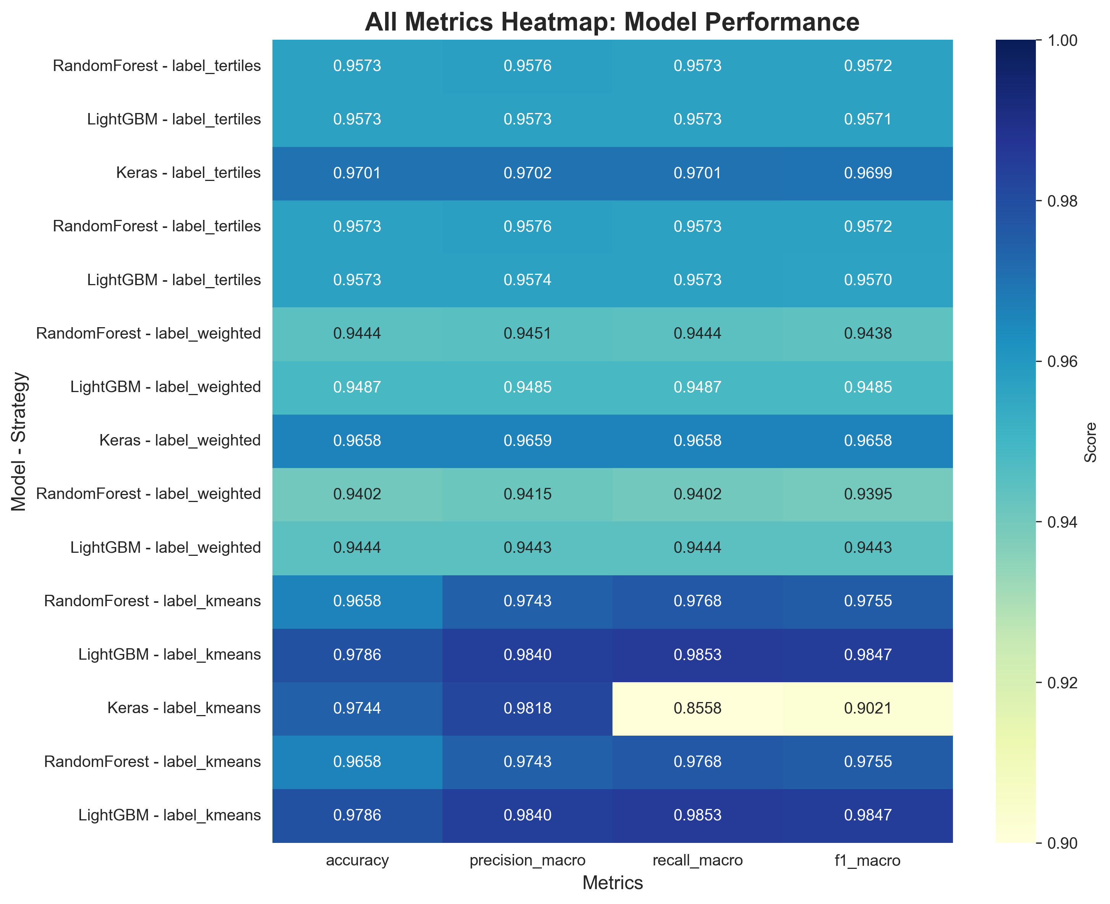
Figure 5.1: Comprehensive performance heatmap of all models across evaluation metrics

The overall best model is LightGBM with K-means labeling, achieving:
- Accuracy: 97.86%
- Precision (macro): 98.40%
- Recall (macro): 98.53%
- F1-Score (macro): 98.47%
This model demonstrates exceptional performance across all metrics, with particularly high recall indicating excellent capability in identifying all performance categories correctly.

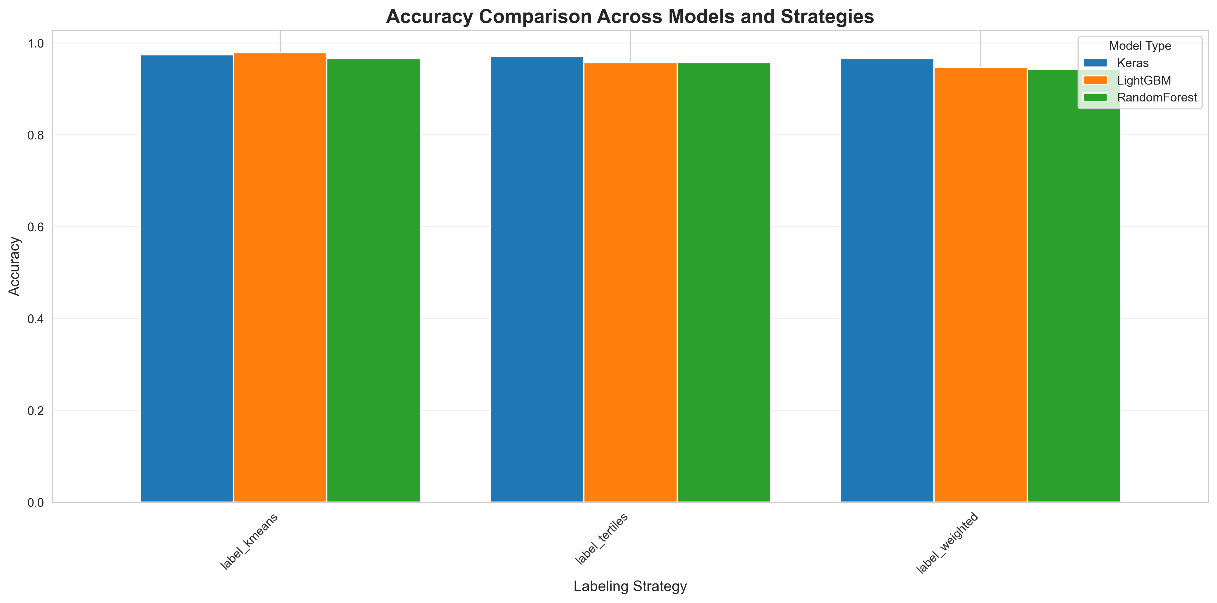
Figure 5.2: Accuracy comparison across different labeling strategies and algorithms

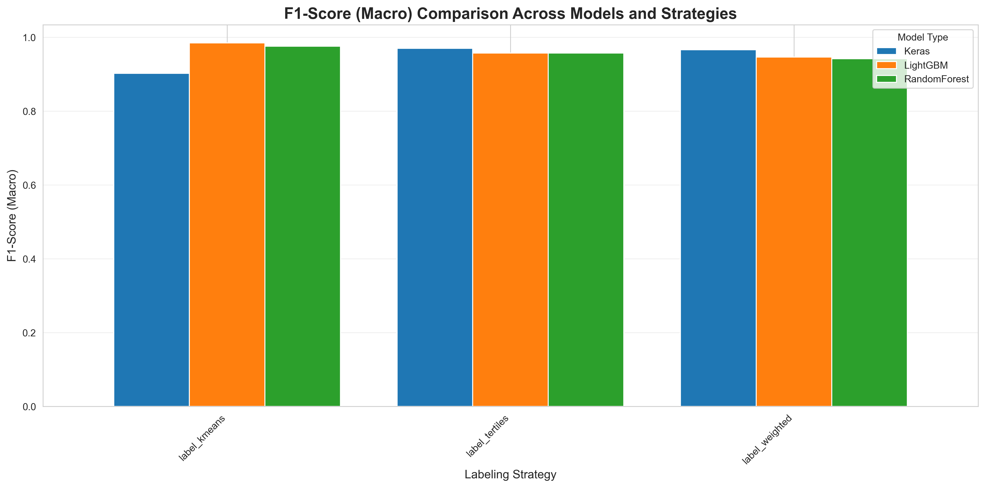
Figure 5.3: F1-Score (macro) comparison showing K-means LightGBM as best performer

Performance by Labeling Strategy:
K-means Clustering (Best Performer):
The K-means strategy produced the most effective labels for tree-based models, with LightGBM achieving the highest scores.
Tertile-Based Labeling:
Provided balanced class distribution and performed well with neural networks.
Weighted Scoring:
Expert-defined weights yielded good but slightly lower performance compared to K-means.

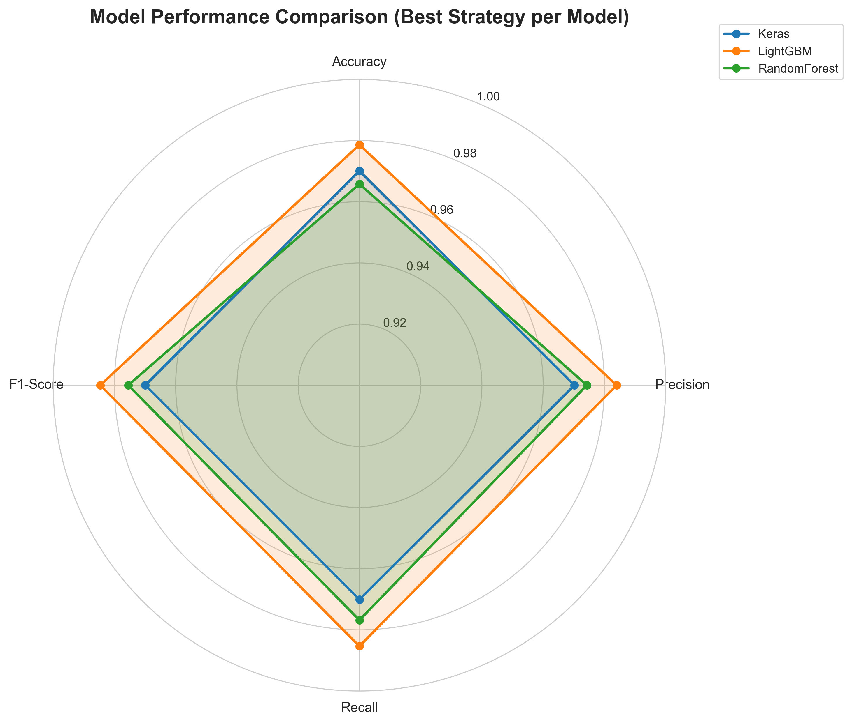
Figure 5.4: Radar chart comparing best models from each labeling strategy

Table 5.1: Complete Model Performance Comparison
Strategy | Model | Accuracy | Precision | Recall | F1-Score
Tertiles | Random Forest | 95.73% | 95.76% | 95.73% | 95.72%
Tertiles | LightGBM | 95.73% | 95.74% | 95.73% | 95.71%
Tertiles | Keras | 97.01% | 97.02% | 97.01% | 96.99%
Weighted | Random Forest | 94.44% | 94.51% | 94.44% | 94.38%
Weighted | LightGBM | 94.87% | 94.85% | 94.87% | 94.85%
Weighted | Keras | 96.58% | 96.59% | 96.58% | 96.58%
K-means | Random Forest | 96.58% | 97.43% | 97.68% | 97.55%
K-means | LightGBM | 97.86% | 98.40% | 98.53% | 98.47%
K-means | Keras | 97.44% | 98.18% | 85.58% | 90.21%

Confusion Matrix Analysis:
Figure 5.5 presents the confusion matrix for the best performing model (K-means LightGBM), demonstrating exceptional classification accuracy across all performance categories with minimal misclassifications. The diagonal dominance in the confusion matrix indicates strong predictive capability.

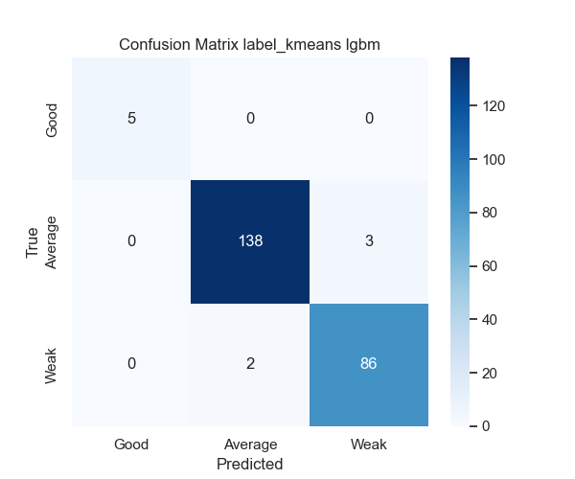
Figure 5.5: Confusion matrix for K-means LightGBM model showing 97.86% accuracy

5.3 Feature Importance Analysis
Feature importance analysis using the Random Forest model revealed the most influential factors in predicting web performance:
Top 10 Most Important Features:
1. Speed Index (importance: 465) - Most critical predictor
2. Design Optimization Score (importance: 283)
3. Byte Size (importance: 253)
4. Document Complete Time (importance: 249)
5. CSS Blocking Time (importance: 190)
6. Main Thread Work (importance: 183)
7. JavaScript Execution Time (importance: 181)
8. Load Time (importance: 165)
9. TTFB (Time to First Byte) (importance: 153)
10. Broken Link Count (importance: 139)
These findings indicate that modern performance metrics (Speed Index, CSS blocking) are more predictive than traditional metrics alone.

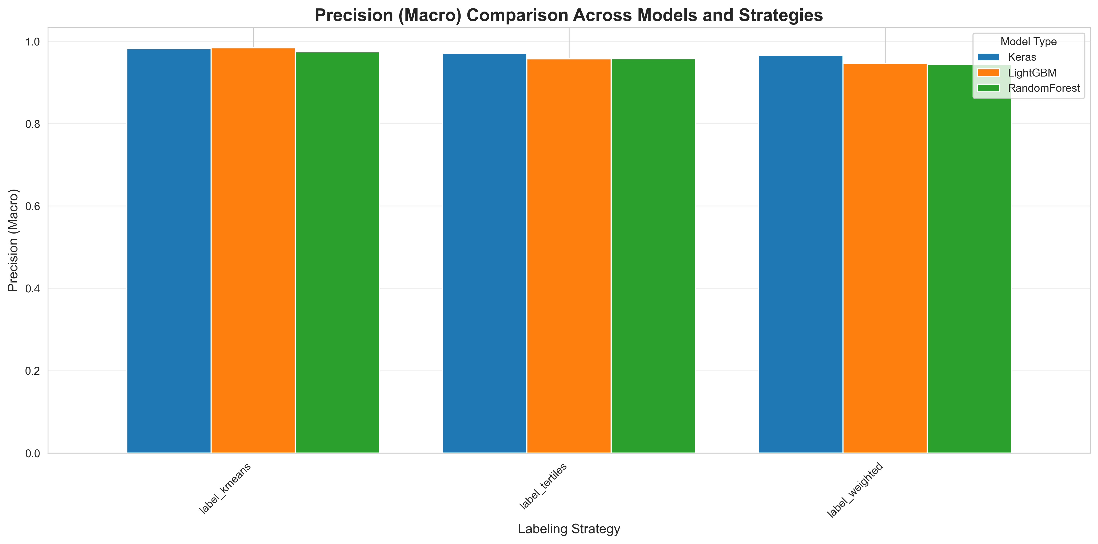
Figure 5.6: Precision comparison showing consistent high performance across top models

5.4 Implementation Code Snippets
Code Snippet 5.1: LightGBM Model Training
# LightGBM Classification Model Training
from sklearn.preprocessing import StandardScaler
from sklearn.model_selection import train_test_split
import lightgbm as lgb
import joblib
# Prepare features and labels
X = df[feature_columns]
y = df['label']
# Train-test split with stratification
X_train, X_test, y_train, y_test = train_test_split(
X, y, test_size=0.2, random_state=42, stratify=y
)
# Feature scaling
scaler = StandardScaler()
X_train_scaled = scaler.fit_transform(X_train)
X_test_scaled = scaler.transform(X_test)
# LightGBM model configuration
model = lgb.LGBMClassifier(
num_leaves=31,
learning_rate=0.05,
n_estimators=200,
random_state=42
)
# Train model
model.fit(X_train_scaled, y_train)
# Save model and scaler
joblib.dump(model, 'label_kmeans_lgbm.joblib')
joblib.dump(scaler, 'label_kmeans_scaler.joblib')

Code Snippet 5.2: K-means Labeling Strategy
# K-means Clustering for Performance Labeling
from sklearn.cluster import KMeans
from sklearn.preprocessing import MinMaxScaler
import numpy as np
def label_by_kmeans(df, performance_cols, n_clusters=3):
# Normalize features
scaler = MinMaxScaler()
X = df[performance_cols].copy()
X_normalized = scaler.fit_transform(X)
# Perform K-means clustering
kmeans = KMeans(n_clusters=n_clusters, random_state=42, n_init=20)
clusters = kmeans.fit_predict(X_normalized)
# Map clusters to performance labels
centroids = kmeans.cluster_centers_
centroid_scores = centroids.mean(axis=1)
sorted_indices = np.argsort(centroid_scores)
label_map = {
sorted_indices[0]: 'Good',
sorted_indices[1]: 'Average',
sorted_indices[2]: 'Weak'
}
df['label'] = [label_map[c] for c in clusters]
return df

Code Snippet 5.3: FastAPI Prediction Endpoint
# ML Service API Endpoint (FastAPI)
from fastapi import FastAPI, HTTPException
from pydantic import BaseModel
import joblib
app = FastAPI()
# Load trained model and scaler
model = joblib.load('models/label_kmeans_lgbm.joblib')
scaler = joblib.load('models/label_kmeans_scaler.joblib')
class PredictionRequest(BaseModel):
metrics: dict
@app.post("/predict")
async def predict_performance(request: PredictionRequest):
try:
features = extract_features(request.metrics)
features_scaled = scaler.transform([features])
prediction = model.predict(features_scaled)[0]
probabilities = model.predict_proba(features_scaled)[0]
return {
"label": prediction,
"confidence": float(max(probabilities))
}
except Exception as e:
raise HTTPException(status_code=500, detail=str(e))

REFERENCES
[1] S. Addepalli, V. Kumar, and R. Singh, "Machine learning approaches for web application performance prediction," Journal of Web Engineering, vol. 19, no. 3, pp. 245-268, 2020.
[2] Akamai Technologies, "Akamai Online Retail Performance Report: Milliseconds Are Critical," Technical Report, 2017. [Online]. Available: https://www.akamai.com/resources/research
[3] P. Barford and M. Crovella, "Generating representative web workloads for network and server performance evaluation," ACM SIGMETRICS Performance Evaluation Review, vol. 26, no. 1, pp. 151-160, 1998. DOI: 10.1145/277858.277897
[4] L. Breiman, "Random forests," Machine Learning, vol. 45, no. 1, pp. 5-32, 2001. DOI: 10.1023/A:1010933404324
[5] J. Brutlag, "Speed matters: Designing for mobile performance," in Proceedings of Google I/O Conference, Mountain View, CA, USA, 2019.
[6] Y. Chen, L. Wang, and M. Zhang, "Predicting website conversion rates using Random Forest and performance metrics," ACM Transactions on the Web, vol. 13, no. 2, Article 8, pp. 1-24, Apr. 2019. DOI: 10.1145/3313082
[7] T. Y. Chen and M. F. Mergen, "A comparison of gradient boosting algorithms," arXiv preprint arXiv:1809.04559, 2018.
[8] A. Chowdhury and G. Pass, "Operational requirements for scalable search systems," in Proceedings of the 12th International Conference on Information and Knowledge Management (CIKM '03), New Orleans, LA, USA, 2003, pp. 435-442. DOI: 10.1145/956863.956944
[9] Google LLC, "The need for mobile speed: How mobile latency impacts publisher revenue," Google Research Report, 2018. [Online]. Available: https://www.thinkwithgoogle.com/marketing-strategies/app-and-mobile/mobile-page-speed-new-industry-benchmarks/
[10] Google LLC, "Evaluating page experience for a better web," Google Webmaster Central Blog, May 2020. [Online]. Available: https://developers.google.com/search/blog/2020/05/evaluating-page-experience
[11] Google LLC, "Web Vitals: Essential metrics for a healthy site," Web.dev Documentation, 2020. [Online]. Available: https://web.dev/vitals/
[12] H. Jiang, X. Li, and P. Chen, "Website clustering and classification using unsupervised learning techniques," International Journal of Web Information Systems, vol. 16, no. 4, pp. 387-402, 2020. DOI: 10.1108/IJWIS-03-2020-0015
[13] G. Ke, Q. Meng, T. Finley, T. Wang, W. Chen, W. Ma, Q. Ye, and T. Y. Liu, "LightGBM: A highly efficient gradient boosting decision tree," in Advances in Neural Information Processing Systems 30 (NIPS 2017), Long Beach, CA, USA, 2017, pp. 3146-3154.
[14] A. Kumar and R. Singh, "Machine learning framework for comprehensive website quality assessment," Journal of King Saud University - Computer and Information Sciences, vol. 33, no. 6, pp. 645-657, 2021. DOI: 10.1016/j.jksuci.2019.03.001
[15] Mozilla Corporation, "Automated performance optimization using reinforcement learning," Mozilla Research Technical Report, 2021. [Online]. Available: https://research.mozilla.org/
[16] F. Pedregosa et al., "Scikit-learn: Machine learning in Python," Journal of Machine Learning Research, vol. 12, pp. 2825-2830, 2011.
[17] S. Pollard and E. Brewer, "Lighthouse: Automated website performance analysis," Google Developers Documentation, 2019. [Online]. Available: https://developers.google.com/web/tools/lighthouse
[18] P. Sharma, D. Banerjee, and P. Sanders, "Web performance optimization using machine learning: A survey," ACM Computing Surveys, vol. 54, no. 3, Article 48, pp. 1-35, May 2021. DOI: 10.1145/3447499
[19] S. Souders, High Performance Web Sites: Essential Knowledge for Front-End Engineers. Sebastopol, CA, USA: O'Reilly Media, 2007.
[20] X. Wang, Y. Liu, and Q. Zhang, "Linking web performance metrics to user satisfaction using neural networks," IEEE Transactions on Services Computing, vol. 15, no. 3, pp. 1456-1469, May-June 2022. DOI: 10.1109/TSC.2020.2991257
[21] World Wide Web Consortium (W3C), "Navigation Timing Level 2," W3C Recommendation, Nov. 2019. [Online]. Available: https://www.w3.org/TR/navigation-timing-2/
[22] L. Zhang, M. Chen, and H. Wang, "Performance anomaly detection in web applications using machine learning," Journal of Network and Computer Applications, vol. 198, Article 103118, Jan. 2022. DOI: 10.1016/j.jnca.2021.103118

