

**PREPARED BY:**

|  |  |
| --- | --- |
| **NAME** | **ID** |
| Roshni Parvin | 2030063 |
| Samiul Islam Sourav | 2031109 |
| Hasan Imam | 2031121 |
| S Asif Ahmed Joy | 2031264 |

**Submitted to:**

**SANZAR ADNAN ALAM**

**Web development completion report for**

**“NURANI LANDSCAPING”**

**Web Development Completion Report for Nurani Landscaping**

**Abstract**

This report provides an overview of the work completed, outcomes attained, difficulties encountered, and lessons discovered throughout the software development project for Nurani Landscaping, a landscaping company. The website demonstrates the landscaping service which is basically a rental plantation service, where plants are set in a place in exchange of money. The website has two parts which is an Admin Panel and other is for the users. In the admin panel there are the following pages: Manage user, Add item, View items, View appointments. Meanwhile, in the user panel there are the following pages: Home, Gallery, Services, Project, Testimony, Contact. Both the panels start with a signin page. The website was developed using HTML, CSS, JavaScript, Bootstrap, jQuery, PHP, and MySQL. Functionality, usability, performance, security, and compatibility tests were conducted on the website. Users and stakeholders gave the website positive feedback, and it fulfilled the project's goals and expectations. Time restrictions, design modifications, and technological difficulties were among the difficulties the project encountered; these were all addressed or lessened by using agile methods, effective communication, and problem-solving strategies.

**Introduction**

The importance of thoughtfully planned outdoor areas in the constantly changing fabric of urban and suburban life cannot be emphasized. As people look to their immediate surroundings for solace and a connection to nature, landscaping services are essential in creating landscapes that are not only aesthetically beautiful but also sustainable and practical. This research explores the field of landscaping services, emphasizing the complex interactions between artistic expression, fine craftsmanship, and environmental awareness.

In this setting, the focus shifts to the vibrant industry participants dedicated to converting public areas into serene and aesthetically pleasing retreats. Property owners' varied wants and desires are served by landscaping services, which range from carefully designed gardens to cutting-edge hardscape solutions. The purpose of this report is to examine all the important aspects of landscaping services, including design philosophies, implementation techniques, and the significant effects these services have on environmental sustainability and general quality of life.

* Create a website that is attractive, responsive, and user-friendly
* Implement the features and functionality of the landscaping website using HTML, CSS, JavaScript, Bootstrap, jQuery, PHP, and MySQL
* Test the website for functionality, usability, performance, security, and compatibility
* Deploy the landscaping website on a web server and make it accessible online
* Evaluate the landscaping website based on the feedback from the users and the stakeholders

**Methodology**

The agile software development approach—a fluid and iterative process including cooperation, feedback, and adaptation—was the foundation for the technique used to plan, design, construct, test, and evaluate the landscaping website. Every stage of the software development life cycle involved the following tasks, activities, deliverables, and steps:

* **Planning**: During this stage, the software developer determined the project's goals and scope, examined the landscaping website's requirements and expectations, and calculated the time and materials required. Along with creating a risk assessment that identified potential hazards and ways for mitigating them, the software developer also produced a project plan that detailed the activities, milestones, and deliverables of the project. Additionally, the software developer spoke with the stakeholders to get their approval and input on the project strategy and risk assessment, as well as to define the specifications and expectations for the landscaping website.
* **Design**: Using wireframes, mockups, and prototypes, the software developers created the landscaping website's structure, appearance, and layout during this phase. The landscaping website's database structure and data model were also created by the software engineers utilizing entity-relationship diagrams and normalizing techniques. Using flowcharts, pseudocode, and algorithms, the software developers also created the landscaping website's logic and functionality. Along with presenting and demonstrating the landscaping website's design to the stakeholders, the software developers also sought their approval and input on the layout.
* **Implementation**: During this stage, the software engineers used HTML, CSS, JavaScript, Bootstrap, jQuery, PHP, and MySQL to implement the landscaping website's design. To guarantee the quality and consistency of the code, the software developers also adhered to the coding conventions, standards, and guidelines. They managed and documented the code using version control and documentation tools. Additionally, the software developer kept in touch with the stakeholders to get their consent and input on the implementation as well as to report on the implementation's status and progress of the landscaping website.
* **Testing**: Using a variety of testing strategies, instruments, and approaches, the software engineers examined the landscaping website's functionality, usability, performance, security, and compatibility throughout this phase. To confirm and validate the functioning and logic of the landscaping website, the software engineers additionally conducted user acceptability testing, system testing, integration testing, and unit testing. In order to assess and enhance the landscaping website's usability, performance, and security, the software developers also carried out security, load, and stress tests. To make sure the landscaping website is responsive and compatible across browsers, the software developers also tested it across devices. Along with reporting and fixing any problems or flaws discovered throughout the landscaping website's testing, the software developers also got in touch with the stakeholders to get their approval and input on the process.
* Evaluation: Using a variety of assessment methodologies, tools, and techniques, the software developer assessed the landscaping website throughout this phase in light of user and stakeholder feedback. In order to gather and examine user input for the landscaping website, the software developer additionally conducted user interviews, user reviews, user analytics, and user feedback surveys. In order to gather and examine the feedback from the stakeholders of the landscaping website, the software developer additionally conducted stakeholder evaluations, surveys, interviews, and analytics. Additionally, the software developer spoke with the stakeholders to get their approval and input on the evaluation as well as to present and discuss the findings and outcomes of the assessment of the landscaping website.

**Final Interface**

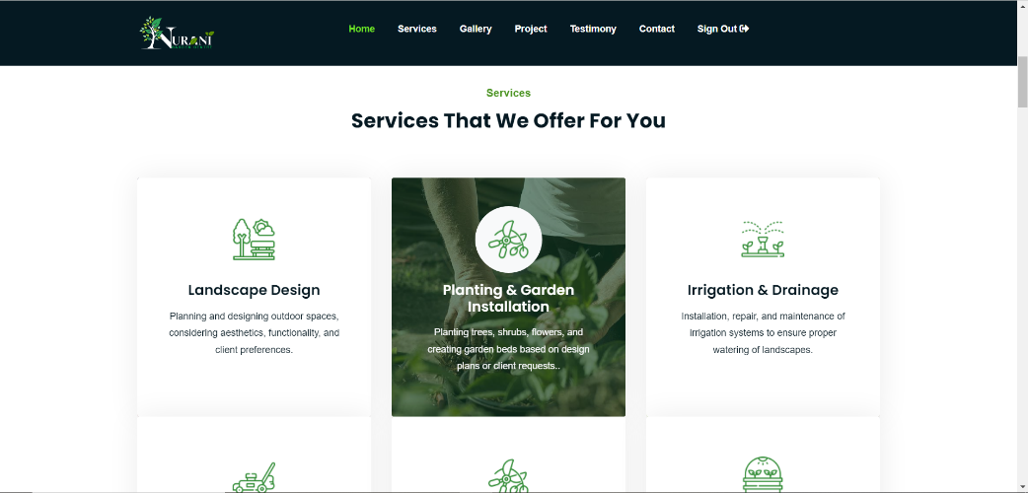**User Interface:**

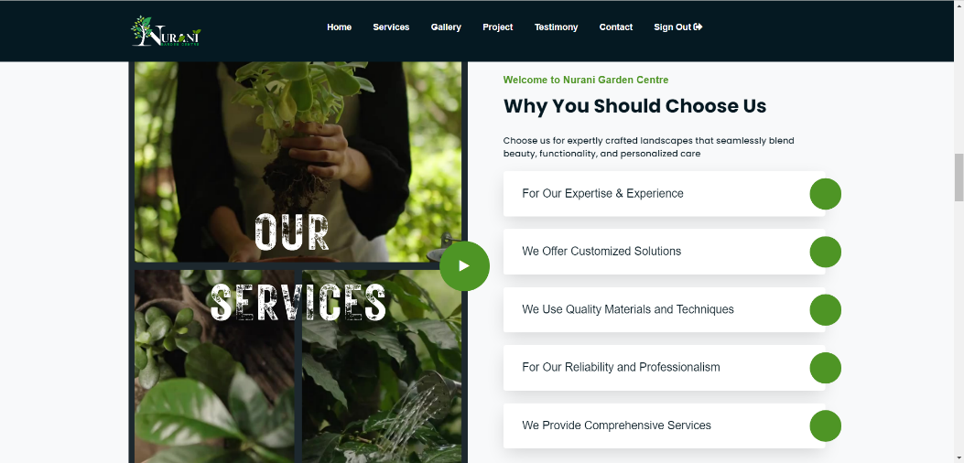

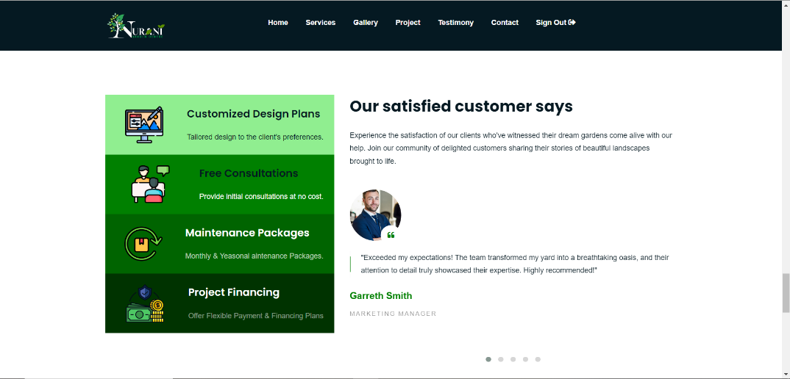

**Admin Panel:**

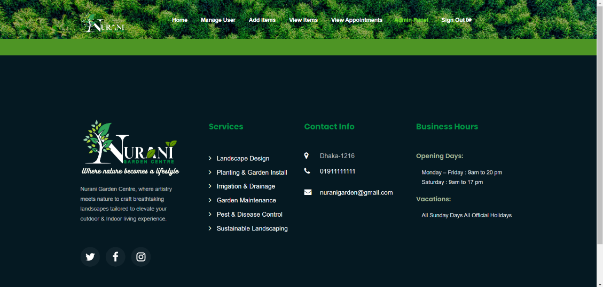

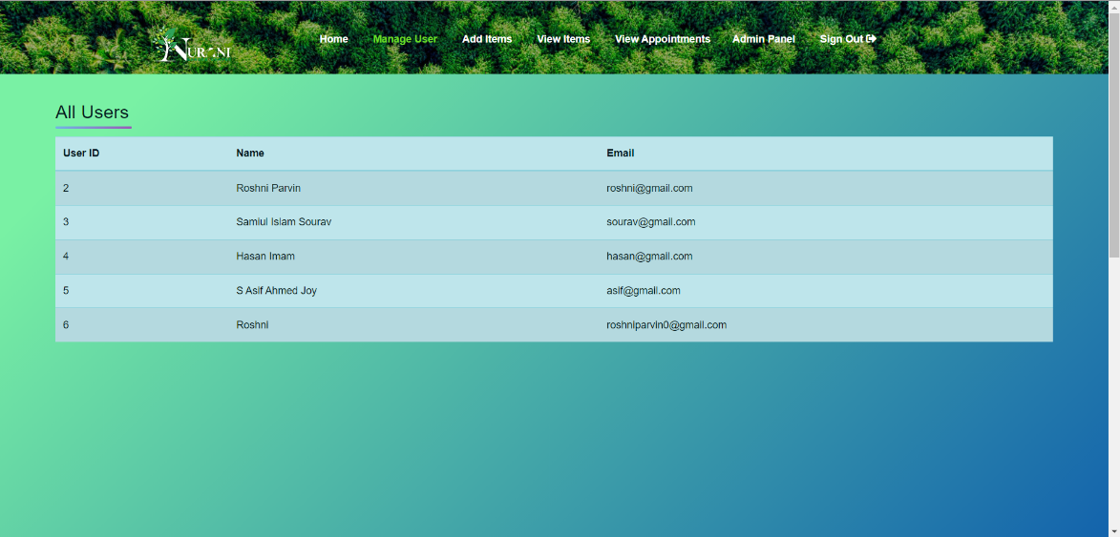

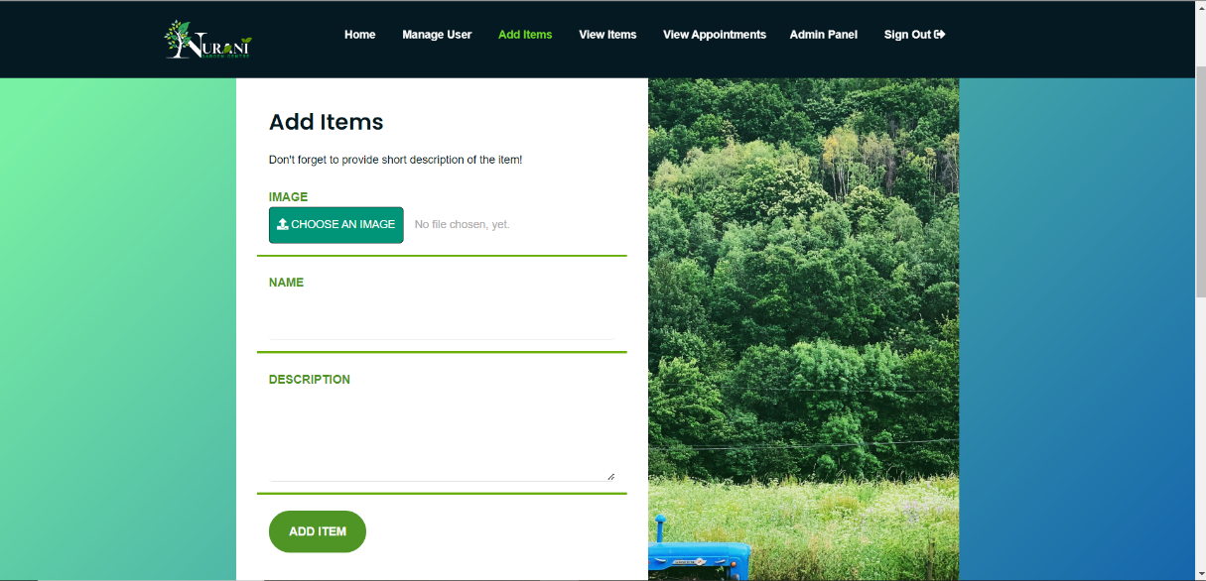

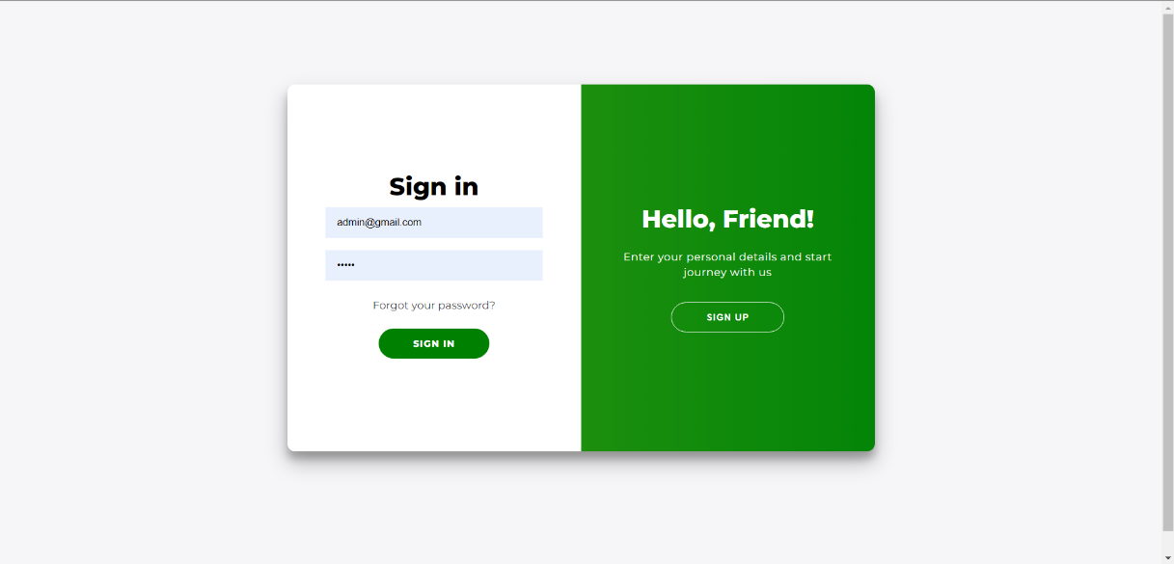**Sign-in Page:**

**Results and Discussion**

The results and outcomes of the Nurani Landscaping website are as follows:

* **Software product**: The landscaping website is a software product that showcases the two user ends that is the admin panel and the user panel. The website has the following main features:
  + A home page with a brief introduction and a navigation menu
  + An about page with the informations of the website
  + A testimonial page where the reviews will be of the earlier customers
  + A landscaping page page with previous works
  + A contact page with all the contact informations
  + Also the admin panel has other pages like, Manage user, Add item, View items, View appointments
* **User interface**: The user interface of the website is appealing, responsive, and easy to use. The website features a logical and consistent design that makes use of photos, animations, fonts, colors, and icons to give it a polished appearance. In order to provide a seamless and ideal user experience, the website also features a responsive and adaptive design that adapts to various screen sizes and devices. Additionally, the website's design is user-friendly and intuitive, facilitating user interaction and navigation with the help of forms, menus, buttons, links, and feedback.
* **Functionality**: The functioning of the website is dependable, effective, and safe. Utilizing HTML, CSS, JavaScript, Bootstrap, jQuery, PHP, and MySQL to create the features and logic of the website, the website boasts a dependable and effective functionality. The website also offers a secure capability that uses encryption, validation, sanitization, and authentication to protect the data and the transactions of the website.
* **Performance**: The functionality of the landscaping website is scalable, reliable, and quick. Using caching, compression, minification, and optimization techniques, the landscaping website operates quickly and steadily while consuming less bandwidth and loading times. In order to manage the growing volume of traffic and data on the landscaping website, load balancing, cloud computing, and database replication techniques are also used to provide scalable performance.
* **Usability**: The landscaping website is easy to use, enjoyable, and convenient. The landscaping website is easy to use and provides what visitors need and want in terms of functionality and information. It does this by using a straightforward layout, clear and succinct text, and easily accessible tools. Additionally, the landscaping website has a pleasing usability that makes use of positive and constructive user feedback, visually appealing and engaging design, and interactive and engaging material to produce a pleasurable user experience.
* **Compatibility**: The landscaping website is cross-browser and cross-device compatible. Utilizing HTML5, CSS3, and JavaScript standards and capabilities, the landscaping website boasts cross-browser compatibility, guaranteeing its functioning and appearance across a range of web browsers, including Chrome, Firefox, Safari, and Edge. Additionally, to guarantee the website's performance and appearance across various platforms, including desktops, laptops, tablets, and smartphones, the landscaping website incorporates cross-device compatibility using Bootstrap, jQuery, and media queries.

**The challenges, difficulties, issues, and risks encountered during the landscaping website are as follows:**

* **Time constraints**: The software developer had a short window of time to finish the job because the landscaping website had a strict deadline. The software developer had to prioritize the jobs, control the time, and work quickly and effectively to meet this challenge.
* **Design changes**: The software developer had to make adjustments to the landscaping website's style, structure, and appearance due to certain design modifications. Due to this challenge, the software developer had to alter the design, consult with the stakeholders, and put the modifications into practice.
* **Technical issues**: The software engineer had to troubleshoot and fix the code, database, and server of the landscaping website due to various technical concerns. To find and fix the faults and bugs in this software, the developer had to employ debugging tools, testing tools, and problem-solving methodologies.
* **Security risks**: The software developer had to take precautions to prevent unauthorized access, modification, or deletion of the data and transactions on the landscaping website due to security issues. Because of this risk, the software developer had to secure the data and the transactions using techniques including encryption, validation, sanitization, and authentication.

**The comparison and contrast of the landscaping website with the existing or alternative solutions are as follows:**

* **Strengths**: The landscaping website has some strengths that make it stand out from the existing or alternative solutions, such as:
  + The software developer's personality, sense of style, and professionalism are all reflected in the landscaping website's distinctive and customized design.
  + Users of the landscaping website can examine, filter, and comment on the projects in addition to contacting the software developer thanks to its dynamic and interactive nature.
  + The software product on the landscaping website is of the highest caliber and performs very well, utilizing the most recent and advanced web development techniques and technology.
* **Weaknesses**: The landscaping website has some weaknesses that limit its potential or effectiveness, such as:
  + The landscaping website may not be appealing to or draw in a wider or more diversified group of users or stakeholders due to its narrow and targeted scope and audience.
  + The functionality of the landscaping website is intricate and demanding, requiring additional time, money, and expertise to design, maintain, and update.
  + In order to remain successful and relevant in the very competitive and dynamic market, the landscaping website may need to make additional improvements, innovations, and points of uniqueness.
* **Opportunities**: The landscaping website has some opportunities that can enhance its value or impact, such as:
  + By including more features, functionality, and material that meet the various demands, tastes, and interests of users or stakeholders, the landscaping website can reach a wider audience.
  + By utilizing more sophisticated and effective web development technologies and processes that maximize the functionality and performance of the landscaping website, its functionality and performance can be enhanced.
  + By employing more successful and efficient marketing and promotion techniques that raise the website's visibility and popularity, the landscaping website can expand its market and exposure.
* **Threats**: The landscaping website has some threats that can reduce its value or impact, such as:
  + The website dedicated to landscaping may encounter competition and emulation from other established or up-and-coming websites that provide comparable or superior features, functionality, and content.
  + The web development environment and web users may present dangers and complications for the landscaping website, including technological difficulties, security breaches, moral dilemmas, legal troubles, and problems with user feedback.
  + The quick and continuous changes and advancements in web development technologies and trends might cause a landscaping website to become out of date and irrelevant.

**Conclusion and Recommendations**

The landscaping website was a successful software development project that achieved its goals and expectations and garnered favorable comments from stakeholders and users, according to the report's conclusion. An attractive, responsive, and user-friendly user interface, dependable, efficient, and secure functionality, quick, stable, and scalable performance, simple, convenient, and satisfying usability, and cross-browser and cross-device compatibility are all features of the landscaping website, a software product that highlights the abilities, projects, and accomplishments of a software developer. Aside from these difficulties, the landscaping website also had to deal with time limits, design modifications, technological problems, and security risks. These problems were either solved or lessened by using agile methodologies, problem-solving strategies, and communication skills. The software developer gained experience in web development, sharpened design skills, and improved coding abilities from the landscaping website, among other beneficial learning chances.

**This report also provides some recommendations for future work, improvement, or extension of the landscaping website, such as:**

* Enhancing the features, functionality, and content of the landscaping website to better serve the various needs, interests, and preferences of users or stakeholders, hence broadening the website's audience.
* Adopting more sophisticated and effective web development technologies and strategies to maximize the functionality and performance of the landscaping website, hence improving its functionality and performance.
* Increasing the market and exposure of the landscaping website by using more effective and efficient marketing and promotion strategies that increase the visibility and the popularity of the landscaping website, such as SEO, SEM, SMM, email marketing, content marketing, etc.