PROJECT DOCUMENTATION
RestaurantHub
Multi-Tenant Restaurant Management SaaS Platform

Version 1.0
Prepared: July 2026

Table of Contents

1 Executive Summary
RestaurantHub is a complete restaurant operating system that helps restaurants manage their daily operations — orders, employees, inventory, customers, payments, analytics, and business growth — from a single, centralized platform.
This document consolidates the product vision, business and functional requirements, system architecture, and delivery plan into one reference for the engineering, product, and business teams building the platform.

Vision
Give every restaurant — from a single café to a multi-branch chain — one connected system to run sales, kitchen operations, inventory, staff, and finance, replacing paper and disconnected point tools with real-time, data-driven operations.

Target Users
- Independent and small restaurants
- Medium-sized restaurants with multiple staff roles
- Restaurant chains with several branches
- Cafes and quick-service food businesses

2 Problem Statement & Solution

The Problem
Many restaurants still manage operations manually — using paper, spreadsheets, and disconnected systems — which creates recurring, compounding issues:
- Order management issues and miscommunication between front-of-house and kitchen
- Inventory wastage from a lack of real-time stock visibility
- Poor customer tracking and no loyalty insight
- Lack of analytics to guide business decisions
- Employee management difficulties across shifts and roles
- No centralized system tying operations together

The Solution
RestaurantHub provides one centralized platform where restaurants can manage sales, orders, kitchen operations, inventory, customers, employees, finance, and analytics — all from a single dashboard, in real time.

Technology Stack
Layer | Technology
Frontend | Next.js, Tailwind CSS, Apollo Client, Zustand
Backend | NestJS, GraphQL, Prisma ORM
Database | PostgreSQL
Infrastructure | Docker, Redis, Cloud Storage

3 Product Requirements

Product Goal
Build a scalable restaurant management SaaS platform that digitalizes end-to-end restaurant operations.

Main Objectives
- Digitalize restaurant operations end to end
- Reduce manual, paper-based work
- Provide real-time business insights
- Improve customer experience
- Support multiple restaurants on one platform

Success Metrics
The platform should reliably support:
- Multiple restaurants operating independently on shared infrastructure
- Thousands of concurrent orders
- Multiple employees per restaurant, across roles
- Real-time updates across kitchen, front-of-house, and dashboards
- Secure, auditable transactions

4 Business Requirements

Business Model
RestaurantHub operates as a SaaS platform. Restaurants subscribe to a plan that matches their size and needs:
Plan | Positioning
Free | Entry point for single-location restaurants trying the platform
Basic | Core order, menu, and inventory management for small restaurants
Professional | Full analytics, multi-branch, and staff management
Enterprise | Custom contracts, dedicated support, and advanced integrations

Revenue Sources
- Monthly subscription fees
- Premium feature add-ons
- Optional integrations and add-ons
- Enterprise contracts

5 Functional Requirements

Authentication
- Register
- Login / Logout
- Reset password
- Verify email
- Refresh token

Restaurant Management
- Create restaurant
- Update restaurant information
- Add branches
- Manage settings

Menu Management
- Create categories
- Add menu items
- Upload item images
- Manage availability

Order Management
- Dine-in orders
- Takeaway orders
- Delivery orders
- Order tracking

Inventory
- Add ingredients
- Track stock levels
- Manage suppliers
- View inventory reports

Analytics
- Revenue reports
- Sales charts
- Customer analytics

6 Non-Functional Requirements
Category | Requirements
Performance | Fast API response times, database query optimization, caching layer
Security | JWT authentication, password hashing, role-based access control
Scalability | Support for multiple restaurants, large datasets, and high traffic
Availability | Target of 99.9% uptime
Maintainability | Clean Architecture, modular design, thorough documentation

7 User Roles & Permissions
Role | Responsibilities
Super Admin | All restaurants, subscriptions, and system-wide settings
Restaurant Owner | Restaurant profile, employees, reports, and finance
Manager | Orders, menu, and staff for their restaurant/branch
Cashier | Point of sale and payments
Waiter | Customer orders at the table
Kitchen Staff | Food preparation and order status
Delivery Rider | Delivery fulfillment and status updates
Customer | Browse menu, place orders, leave reviews

8 Feature Roadmap
Delivery is organized into five sequential phases, each building on the platform capabilities established before it.
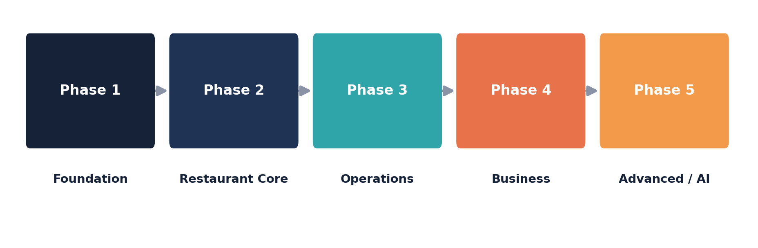
Phase | Focus | Key Deliverables
Phase 1 | Foundation | Project setup, authentication, core database schema
Phase 2 | Restaurant Core | Restaurant, branch, and employee management
Phase 3 | Operations | Menu, order, and kitchen workflows
Phase 4 | Business | Inventory, customer management, and reporting
Phase 5 | Advanced | AI features, notifications, subscription billing

9 System Architecture
RestaurantHub follows a layered architecture: a Next.js client communicates through Apollo Client to a GraphQL API served by NestJS, backed by PostgreSQL via Prisma ORM. Supporting services handle caching, file storage, notifications, and payments.
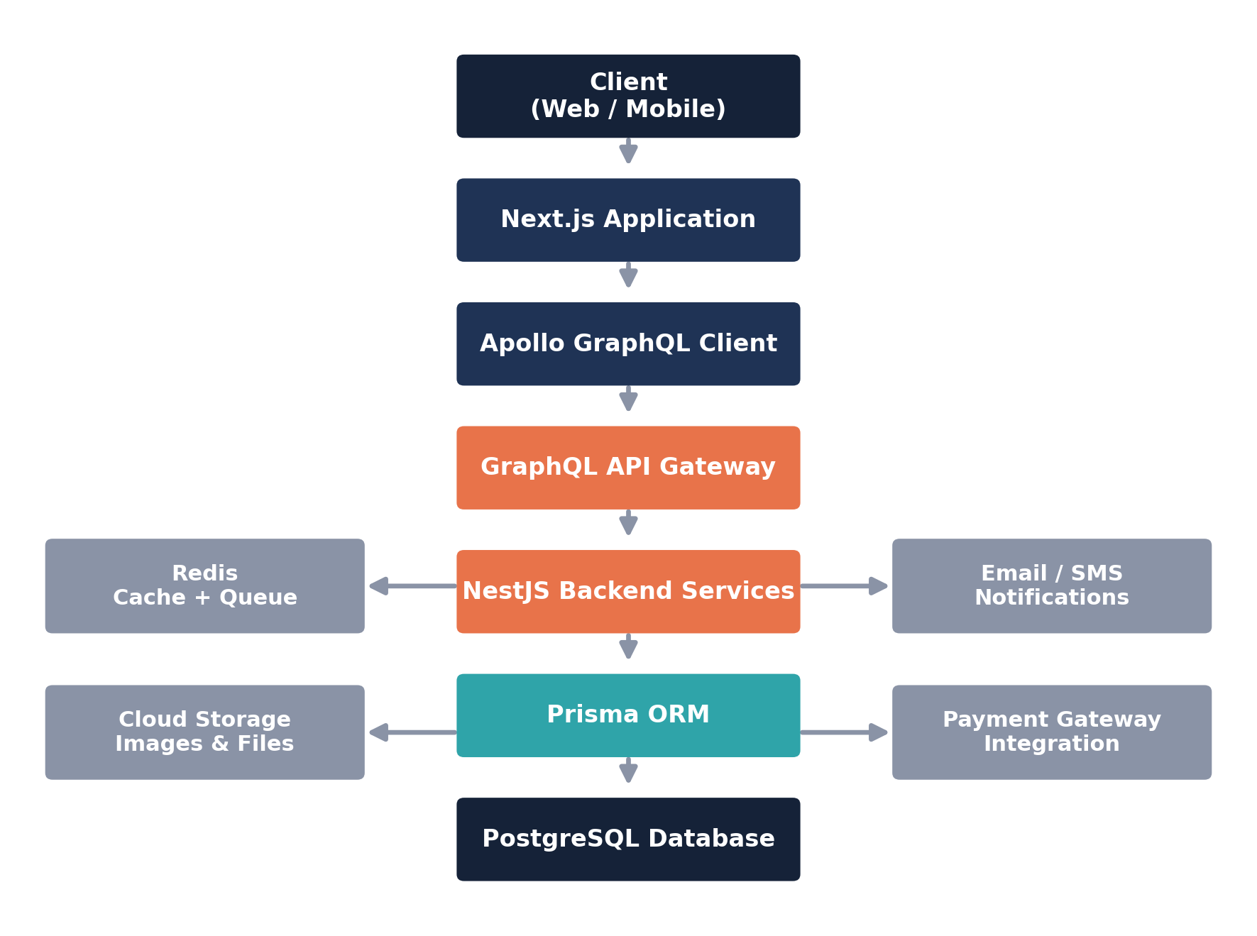

10 Frontend Architecture
Framework: Next.js App Router.

Project Structure
- app — routes and pages
- components — shared UI components
- features — feature-based modules
- graphql — queries, mutations, and subscriptions
- hooks — reusable React hooks
- store — Zustand state management
- utils — shared utilities
- styles — Tailwind and global styles

Guiding Principles
- Component-based architecture
- Reusable, composable components
- Feature-based folder structure

11 Backend Architecture
Framework: NestJS, following a clean, layered request flow:
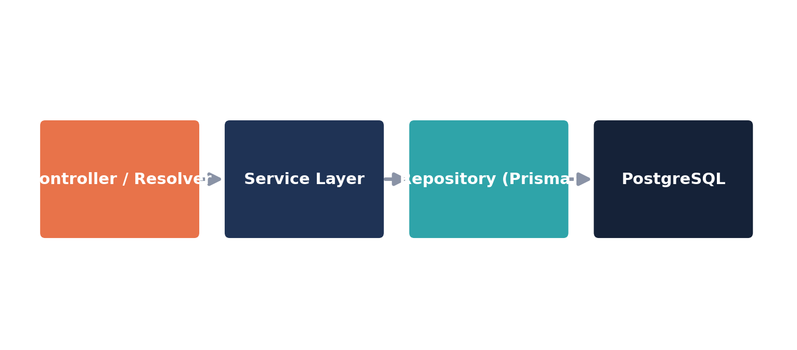

Core Modules
- auth
- users
- restaurant
- menu
- order
- inventory
- payment
- notification

12 Database Design
Database: PostgreSQL, accessed through Prisma ORM.

Core Entities
Entity | Purpose
User | Platform account used to authenticate across roles
Restaurant | A tenant on the platform
Branch | A physical location belonging to a restaurant
Employee | Staff member assigned to a restaurant or branch
Role / Permission | Access control definitions
Customer | End diner or delivery customer
MenuCategory / MenuItem | Menu structure and items
Order / OrderItem | Customer orders and line items
Payment | Transaction records
Inventory / Supplier / Purchase | Stock and procurement tracking
Notification | System and customer notifications

13 API Design
API type: GraphQL, exposing Queries, Mutations, and Subscriptions.
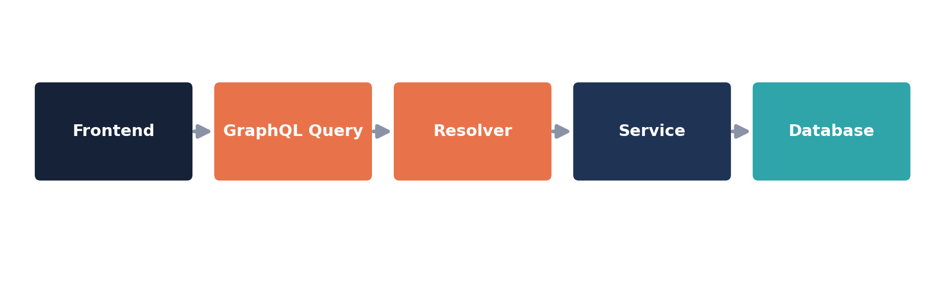

Example Schema Sketch
- Query — restaurants { id name }
- Mutation — createRestaurant(input: CreateRestaurantInput!)
- Subscription — orderCreated(restaurantId: ID!)

14 Authentication & Security

Authentication
JSON Web Tokens (JWT), using a short-lived access token paired with a refresh token.

Security Measures
- Password hashing (bcrypt/argon2)
- Input validation on every endpoint
- Route guards per role and permission
- Rate limiting on sensitive endpoints
- Audit logs for critical actions

15 Multi-Tenancy Design
RestaurantHub supports multiple restaurants on shared infrastructure. Every record is scoped to a tenant through a restaurantId column, keeping data fully isolated between restaurants.
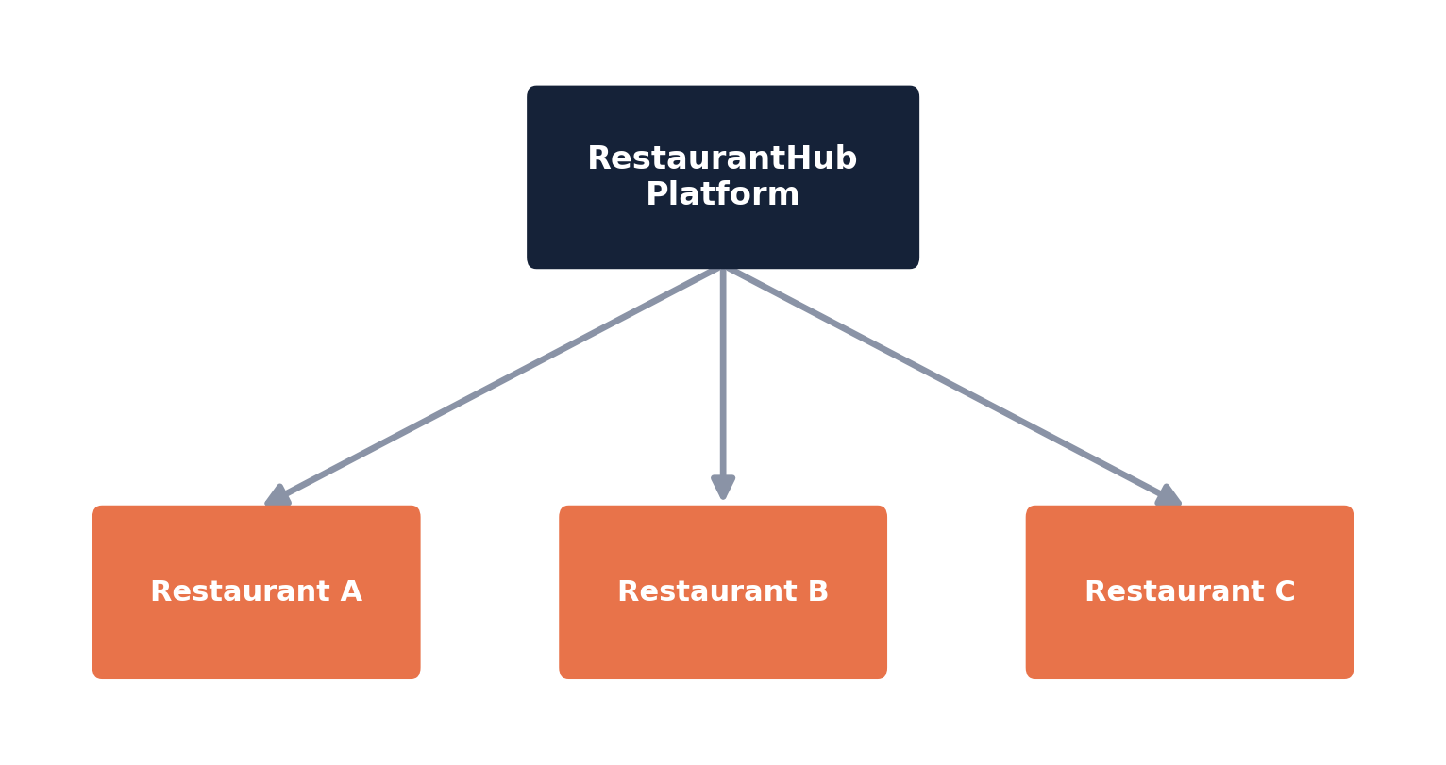

Example: Order Entity
- id
- restaurantId
- customerId
- amount

16 UI / UX Guidelines

Design Principles
- Clean, uncluttered dashboard
- Fully responsive across devices
- Mobile-friendly by default
- Dark mode support

Core Components
- Sidebar
- Navbar
- Data tables
- Forms
- Charts
- Modals

17 Development Guidelines
- Clean Code practices
- SOLID principles
- DRY — Don't Repeat Yourself
- Meaningful, descriptive naming
- Proper, consistent error handling
- Mandatory code review before merge

18 Git Workflow

Branch Strategy
- main — production-ready code
- develop — integration branch
- feature/auth, feature/orders, feature/menu — feature branches

Commit Convention
- feat: add authentication module
- fix: resolve order bug
- docs: update architecture

19 Testing Strategy
Layer | Testing Approach
Backend | Unit testing, integration testing, API testing
Frontend | Component testing, user-flow testing
Tooling | Jest, Playwright

20 Deployment & DevOps
Component | Platform
Frontend | Vercel
Backend | Docker
Database | PostgreSQL
Server | AWS / DigitalOcean
CI/CD | GitHub Actions

21 Future Improvements
- AI Assistant for staff and customers
- Native mobile application
- Advanced analytics and forecasting
- Menu and upsell recommendation system
- Voice ordering
- Accounting software integration
- Delivery route optimization

22 Development Log Template
Field | Entry
Date
Completed
Problems
Solutions
Next Steps

