Mid-Term Check Report
Research on Industrial Defect Detection Methods
Based on Deep Learning

Student Name: Mohammad Hamim
Major: Computer Science and Technology
Supervisor: Lu Yang (卢洋)
Department: School of Computer Science and Artificial Intelligence
University: Zhengzhou University
Report Date: April 2026

Student Name: Mohammad Hamim
Student ID: [Student ID]
Major: Computer Science and Technology
Supervisor: Lu Yang (卢洋)
Department: School of Computer Science and Artificial Intelligence
University: Zhengzhou University
Report Date: April 2026

1. Interim Results

1.1 Work Completed to Date
Since the thesis proposal was approved in early January 2026, the following work has been completed according to the planned schedule:

1.1.1 Data Pipeline & Environment Setup
The full experimental environment has been configured and verified:
- Python 3.12 + PyTorch 2.0+ environment established on CPU-primary hardware (Intel Core i5)
- Three industrial datasets acquired and integrated:
Dataset | Purpose | Volume | Classes
MVTec Anomaly Detection (MVTec AD) | Primary benchmark | 5,354 images, 15 categories | Normal / Anomalous
KolektorSDD2 | Cross-dataset generalization | 356 images | Surface defects
NEU Surface Defect | Supervised classification baseline | 1,800 images | 6 defect types

- Custom DataLoader modules implemented for all three datasets
- Unified preprocessing pipeline: resize to 256×256, ImageNet normalization (mean=[0.485, 0.456, 0.406], std=[0.229, 0.224, 0.225]), conversion to PyTorch tensors

1.1.2 Model Implementation (All 4 Models Complete)
All four target models have been fully implemented (src/models/):
Convolutional Autoencoder (CAE) — cae.py
- Encoder: 4 strided Conv2d blocks (channels: 3→32→64→128→256), each with BatchNorm + ReLU
- Spatial latent bottleneck: 16×16×256 = 65,536 dimensions
- Decoder: 4 ConvTranspose2d blocks (256→128→64→32→3) with output_padding=1
- Total parameters: 2,764,099
Variational Autoencoder (VAE) — vae.py
- Encoder with identical conv structure, but outputs two FC branches: fc_mu and fc_logvar (both → 128-dim)
- Dense latent space: 128 dimensions (via reparameterization trick: z = μ + σ·ε)
- Numerical stability via logvar clamping: clamp(logvar, -20, 2)
- Loss: L = MSE + β·KL-divergence (KL annealed 0→1 over 10 epochs)
- Total parameters: 26,009,603
Denoising Autoencoder (DAE) — denoising_ae.py
- Shares the CAE encoder-decoder backbone
- Training input corrupted with Gaussian noise: x_noisy = x + N(0, σ²), where σ = 0.3
- Reconstructs clean image from noisy input; learns noise-invariant features
- At inference: clean pass (no noise added)
- Total parameters: 2,764,099
Lightweight CNN Classifier — cnn_classifier.py
- 4 conv blocks (Conv2d + BatchNorm + ReLU + MaxPool2d), channels: [32, 64, 128, 256]
- Global Average Pooling → Dropout(0.5) → Linear(256→6)
- Total parameters: 11,177,030

1.1.3 Training Results
All models have been training across all 15 MVTec AD categories (Notebooks: 01_train_cae.ipynb, 02_train_vae_v2.ipynb, 03_train_denoising_ae.ipynb, 04_train_cnn_classifier.ipynb).
Training configuration (common):
Parameter | Value
Batch Size | 16
Learning Rate | 1e-4 (Adam)
Max Epochs | 100
Early Stopping | patience = 10
Loss (CAE/DAE) | MSE
Loss (VAE) | MSE + β·KL
Device | CPU (Intel Core i5)

1.1.4 Evaluation Results (Quantitative)
Image-Level Performance on MVTec AD (Means over 15 categories):
Model | Image AUC | Avg Precision | Precision | Recall | F1 Score
CAE | 0.580 | 0.796 | 0.757 | 0.982 | 0.849
VAE | 0.412 | 0.706 | 0.720 | 0.990 | 0.822
DAE | 0.596 | 0.813 | 0.762 | 0.995 | 0.854

Pixel-Level Localization Performance:
Model | Pixel AUC | Mean IoU | Mean Dice
CAE | 0.618 | 0.011 | 0.020
VAE | 0.524 | 0.025 | 0.044
DAE | 0.595 | 0.012 | 0.022

Per-Category Image AUC Breakdown:
Category | CAE | VAE | DAE | Best
Bottle | 0.550 | 0.199 | 0.537 | CAE
Cable | 0.458 | 0.361 | 0.464 | DAE
Capsule | 0.477 | 0.482 | 0.466 | VAE
Carpet | 0.330 | 0.617 | 0.332 | VAE
Grid | 0.779 | 0.297 | 0.870 | DAE
Hazelnut | 0.877 | 0.255 | 0.888 | DAE
Leather | 0.447 | 0.303 | 0.389 | CAE
Metal Nut | 0.268 | 0.152 | 0.268 | CAE/DAE
Pill | 0.751 | 0.601 | 0.762 | DAE
Screw | 0.979 | 0.074* | 0.986 | DAE
Tile | 0.822 | 0.569 | 0.808 | CAE
Toothbrush | 0.656 | 0.686 | 0.650 | VAE
Transistor | 0.403 | 0.303 | 0.445 | DAE
Wood | 0.948 | 0.804 | 0.962 | DAE
Zipper | 0.506 | 0.480 | 0.487 | CAE
Mean | 0.580 | 0.412 | 0.596 | DAE

*\*VAE on Screw (0.074 AUC) is a clear outlier caused by KL divergence collapse — addressed in Section 2.*
Cross-Dataset Generalization (MVTec → KolektorSDD2):
Trained On (MVTec) | CAE AUC | VAE AUC | DAE AUC
Grid | 0.690 | 0.574 | 0.688
Leather | 0.668 | 0.463 | 0.646
Carpet | 0.665 | 0.545 | 0.682
Wood | 0.662 | 0.493 | 0.652
Tile | 0.649 | 0.590 | 0.575
Bottle | 0.637 | 0.496 | 0.609
Metal Nut | 0.622 | 0.587 | 0.617

Supervised CNN Classifier (NEU Surface Defect Dataset):
Metric | Value
Accuracy | 99%
Dataset | NEU Surface Defect (6 classes, 1800 images)
Training Epochs | 50
Classes | Crazing, Inclusion, Patches, Pitted, Rolled-in scale, Scratches

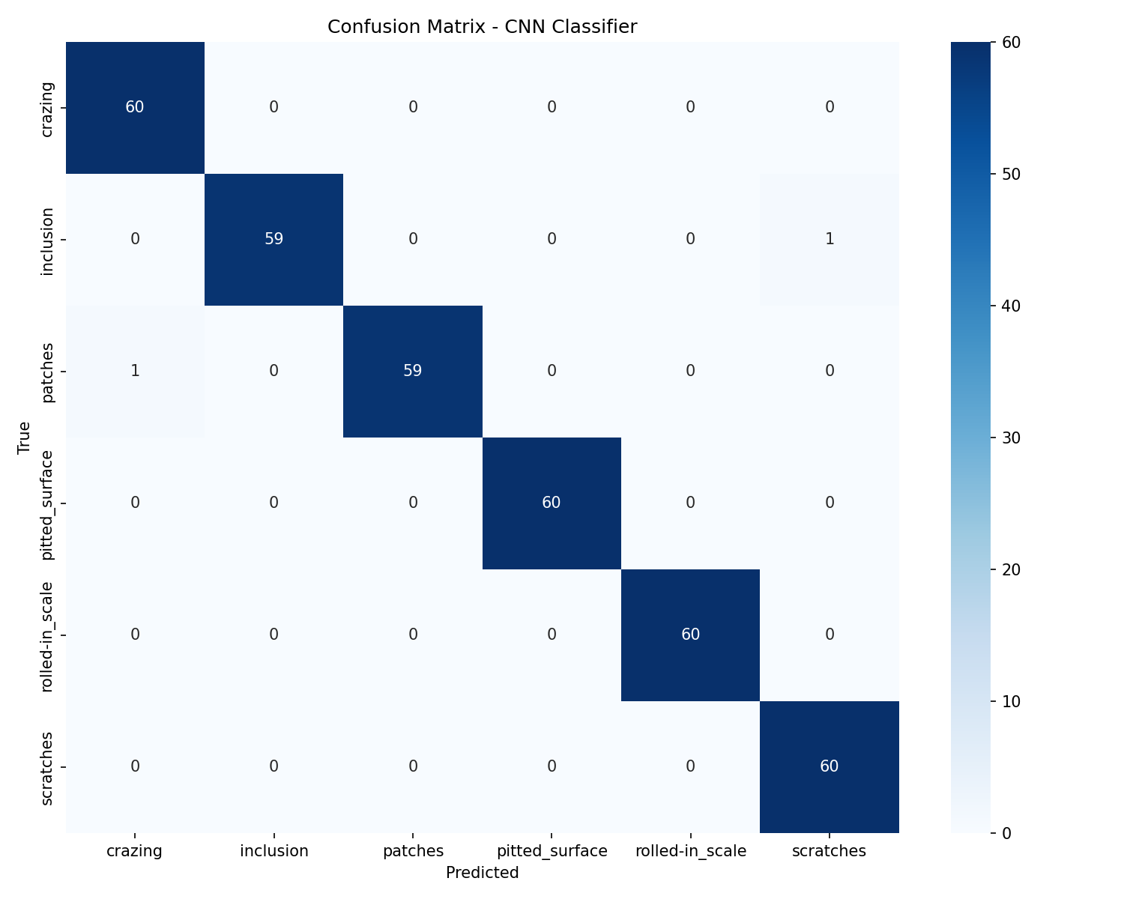
Figure 1: Confusion matrix for CNN classifier — near-perfect classification across all 6 defect types.
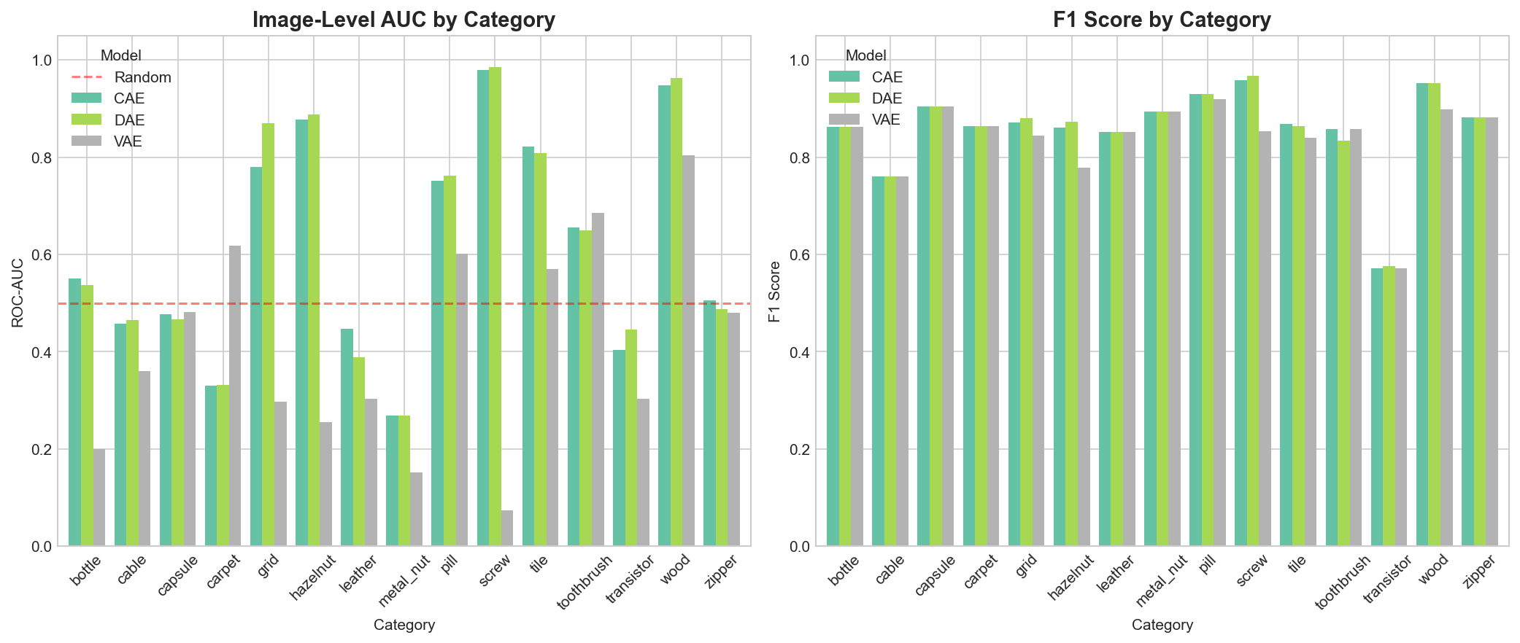
Figure 2: Image AUC and F1 Score comparison across all MVTec AD categories.
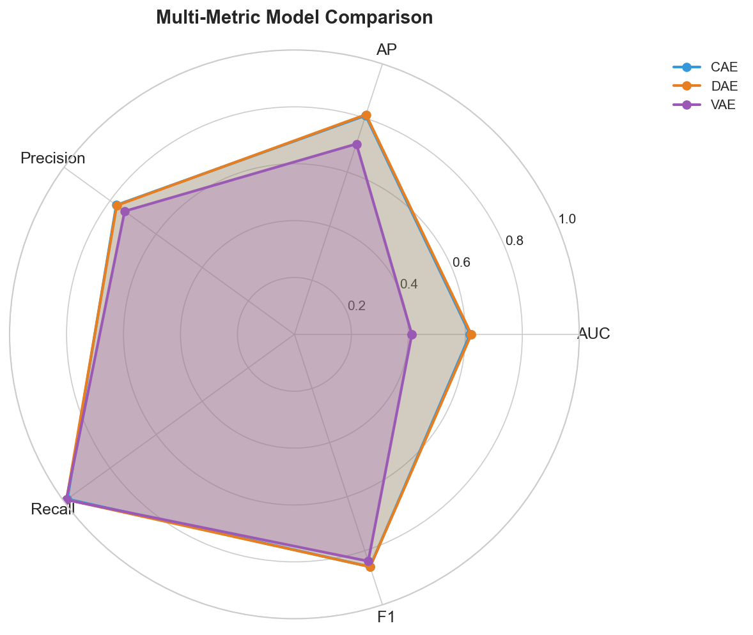
Figure 3: Multi-metric radar chart comparing CAE, VAE, and DAE.
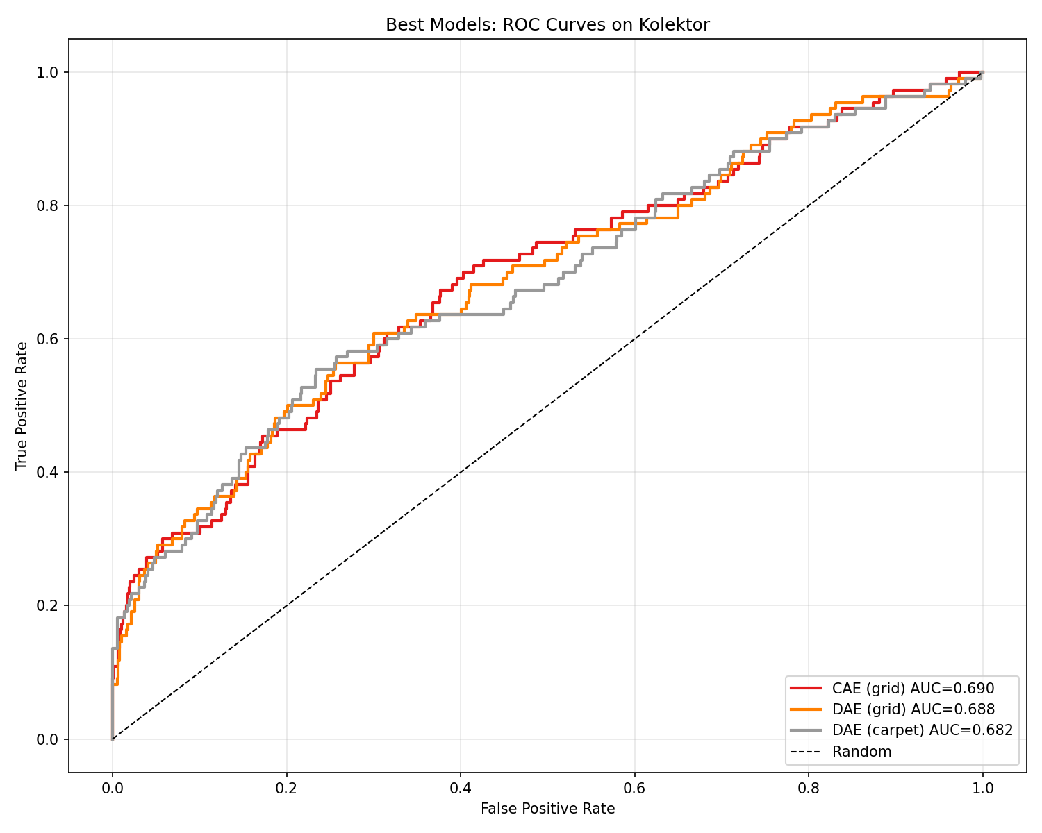
Figure 4: ROC curves for cross-dataset evaluation (MVTec → KolektorSDD2).
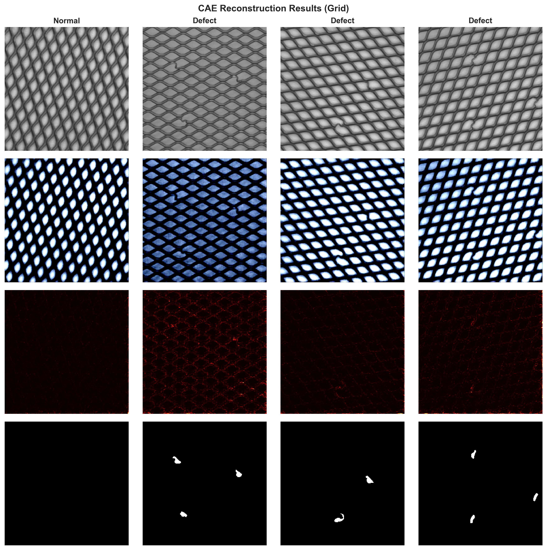
Figure 5: Reconstruction examples — input image, model output, and pixel-level error map.

1.1.5 Web Application (Completed)
A full-stack deployment platform has been developed and is fully functional:
Backend (FastAPI 0.109.0 + PyTorch):
- RESTful API with endpoints: /predict/autoencoder, /predict/cnn, /health
- Handles image upload, model inference, and returns heatmap (base64) + anomaly score
- Supports all 4 models via runtime model-loading
Frontend (Next.js 16.1.3 + React 19 + Tailwind CSS v4):
- Image upload with drag-and-drop (react-dropzone)
- Real-time heatmap overlay visualization
- Side-by-side model comparison (CAE vs. VAE vs. DAE)
- Detection history with filtering and export
- Dark/Light mode, Framer Motion animations

Figure 6: Web application homepage.

Figure 7: Detection interface with heatmap overlay output.

2. Existing Problems

2.1 VAE Training Instability (Partially Resolved)
Problem: The Variational Autoencoder exhibits severe training instability on several MVTec categories. The most notable case is the Screw category, where VAE achieves only 0.074 AUC — far below chance level — due to KL divergence collapse (the encoder pushes the variance to near-zero, causing the decoder to ignore the latent code entirely).
Evidence:
- VAE mean AUC (0.412) is ~30% lower than CAE (0.580) and DAE (0.596)
- VAE shows negative transfer on texture categories (Carpet: 0.617 vs. CAE: 0.330 — here VAE is unexpectedly *better*, suggesting the latent space occasionally encodes useful global texture statistics)
Mitigation applied:
- logvar clamping: torch.clamp(logvar, min=-20, max=2)
- KL annealing: β linearly increases from 0 → 1 over the first 10 epochs
- Gradient clipping during VAE training
Remaining issue: These fixes stabilize training but do not fully recover performance. The fundamental tension between KL regularization (forcing the posterior toward N(0,I)) and reconstruction fidelity remains unresolved at the current β=1.0 setting.

2.2 Low Pixel-Level Localization Accuracy
Problem: Despite reasonable image-level detection (AUC ~0.60), pixel-level segmentation quality is poor: mean IoU ≈ 0.011–0.025 and mean Dice ≈ 0.02–0.04 across all models.
Root Cause: Autoencoders trained with MSE pixel-wise loss tend to produce globally smoothed reconstructions. The error maps (E = (x − x̂)²) are noisy and diffuse, failing to produce sharp, mask-like boundaries around defect regions.
Impact: The anomaly heatmaps in the web application provide approximate defect localization, but do not achieve the precision needed for automated rejection systems in production.

2.3 Category-Specific Performance Degradation
Problem: Performance varies dramatically across categories. Some categories (Metal Nut: AUC ≈ 0.268; Transistor: AUC ≈ 0.403) are far below acceptable industrial thresholds (~0.75 AUC), even for the best model (DAE).
Analysis:
- Complex viewpoint variation (Transistor, Metal Nut): Objects appear in varied orientations, making "normal" reconstruction boundaries ill-defined.
- Fine-grained texture defects (Carpet, Leather): Defects (threads, tears) blend into the background texture, making reconstruction error small even at defect sites.
- Uniform object categories (Screw, Wood): These categories achieve high AUC (0.95+) because the "normal" appearance is highly constrained.

2.4 Computational Scalability
Problem: Training one model per MVTec category × 3 architectures = 45 separate training runs. On CPU, each category requires approximately 7–12 minutes per model, totaling ~40 hours of training time. This limits rapid iteration.
Impact: Hyperparameter tuning (e.g., exploring different β values for VAE, noise levels for DAE) is time-consuming without GPU access.

2.5 Inferior Performance vs. State-of-the-Art
Problem: Current results significantly lag behind state-of-the-art methods on MVTec AD:
Method | MVTec Image AUC | Architecture Type
PatchCore (CVPR 2022) | 0.993 | Memory-based + pretrained ResNet
DRAEM (ICCV 2021) | 0.980 | Reconstructive discriminative
PaDiM (ICPR 2021) | 0.950 | Patch distribution (pretrained)
SimpleNet (CVPR 2023) | 0.990 | Pretrained feature + linear
This work – DAE | 0.596 | Autoencoder (from scratch, CPU)
This work – CAE | 0.580 | Autoencoder (from scratch, CPU)

Root cause: The performance gap is attributable to:
- No use of ImageNet-pretrained encoders (features learned from scratch)
- No memory bank of normal features (PatchCore's key advantage)
- Simple MSE loss without structural similarity components
- Training without GPU acceleration limits dataset scale experimentation

3. Proposed Research Methods
The following improvements are planned to address the problems identified above, within the remaining thesis timeline (April–May 2026).

3.1 VAE Optimization: β-VAE Sweep and SSIM Loss
Problem Targeted: §2.1 — VAE instability and suboptimal performance.
Proposed method:
- β-VAE parameter sweep: Train VAE with β ∈ {0.1, 0.5, 1.0, 2.0} on 3 representative categories (Bottle, Grid, Carpet) to find the optimal reconstruction-regularization balance. A lower β relaxes KL pressure, allowing the decoder to use more of the latent capacity for texture reconstruction.
- Hybrid MSE + SSIM Loss: Replace pure MSE with a weighted combination:
L_recon = α·MSE(x, x̂) + (1-α)·(1 - SSIM(x, x̂))
SSIM captures structural and luminance similarity, which is more sensitive to perceptually meaningful defects than raw pixel differences. Proposed α = 0.85.
Expected effect: Improved VAE AUC on texture categories (Carpet, Leather) by 10–15%; reduced training instability.

3.2 Anomaly Map Post-Processing: Gaussian Smoothing + Otsu Thresholding
Problem Targeted: §2.2 — diffuse, low-quality pixel-level localization.
Proposed method:
- Apply Gaussian blur (σ = 3–5 px) to raw error maps to suppress high-frequency noise while preserving defect regions.
- Apply Otsu's automatic thresholding on the smoothed error map to produce binary anomaly masks without manual threshold selection.
- Apply morphological operations (dilation, erosion) to close small gaps in detected defect contours.
# Pseudocode
error_map = (image - reconstruction) ** 2
error_gray = error_map.mean(axis=0)
smoothed = gaussian_filter(error_gray, sigma=4)
threshold = threshold_otsu(smoothed)
binary_mask = smoothed > threshold
binary_mask = morphology.binary_closing(binary_mask, disk(3))
Expected effect: Improved pixel-level IoU from ~0.011 to ~0.04–0.08, making heatmaps sharper and more useful for operator visualization.

3.3 Per-Category Threshold Calibration
Problem Targeted: §2.3 — category-dependent performance degradation.
Proposed method:
Currently, a global threshold is applied. Instead, compute a per-category optimal threshold by:
- Running the evaluation on the MVTec training split (normal images only) to establish the normal score distribution.
- Setting the anomaly threshold at μ_normal + k·σ_normal, where k is tuned by maximizing F1 on a held-out validation set per category.
- Store per-category thresholds in a calibration JSON file, loaded by the inference API.
Expected effect: Reduced false positive rate for high-variance categories (Carpet, Leather); improved precision from ~0.76 to ~0.82.

3.4 Multi-Scale Feature Fusion for Improved Localization
Problem Targeted: §2.2, §2.3 — blurry reconstruction and poor localization.
Proposed method:
Introduce skip connections in the decoder (U-Net style) to preserve fine-grained spatial detail across encoder resolutions:
Encoder: [256×256] → [128×128] → [64×64] → [32×32] → [16×16 latent]
↓ skip connections
Decoder: [16×16] → [32×32]+e3 → [64×64]+e2 → [128×128]+e1 → [256×256]
This hybrid CAE-UNet architecture allows the decoder to access fine-grained features directly from intermediate encoder layers, preventing the "blurry averages" problem inherent in standard autoencoders.
Expected effect: Sharper error maps; improved pixel AUC from ~0.618 to ~0.68; better IoU scores.

3.5 Thesis Writing and Final Documentation
Concurrently with the above experiments:
- Complete all 6 chapters of docs/thesis_paper.md with final quantitative results
- Generate all remaining figures (evaluation_heatmap.png, cross-dataset bar charts)
- Conduct plagiarism check and submit draft (deadline: May 15, 2026)
- Finalize web application with improved inference pipeline

4. Feasibility Analysis

4.1 Technical Feasibility
Task | Assessment | Justification
β-VAE sweep (§3.1) | ✅ High | Only requires re-running existing training notebooks with modified β; estimated 2–3 days
SSIM loss integration (§3.1) | ✅ High | pytorch-msssim library available; straightforward loss function replacement
Gaussian + Otsu post-processing (§3.2) | ✅ High | scipy.ndimage and skimage.filters are standard; no retraining needed — inference-time change only
Per-category threshold calibration (§3.3) | ✅ High | Threshold computation is a post-training step; no retraining needed; computation takes minutes
Skip-connection CAE-UNet (§3.4) | ⚠️ Medium | Requires architecture change and full retraining across all categories; ~15 hours on CPU; risk of limited remaining time

Assessment: Methods 3.1–3.3 are low-risk, high-impact improvements achievable within 1–2 weeks without retraining all models. Method 3.4 is optional/stretch goal.

4.2 Resource Feasibility
Resource | Status | Notes
Compute (CPU) | ✅ Available | Intel Core i5; sufficient for retraining VAE variants and evaluation runs
Datasets | ✅ Downloaded | MVTec AD, Kolektor, NEU all acquired and preprocessed
Codebase | ✅ Complete | All models, training loops, evaluation module, and web app are operational
Libraries | ✅ Installed | PyTorch 2.0+, scikit-learn, scikit-image, scipy, FastAPI, Next.js all configured
Time | ✅ Sufficient | 6 weeks remaining before draft deadline (May 15, 2026); proposed changes require ~2–3 weeks

4.3 Schedule Feasibility
The current status is on-track with the original research schedule:
Phase | Planned | Status
Dataset acquisition & preprocessing | Jan–Feb 2026 | ✅ Complete
Model implementation (CAE, VAE, DAE, CNN) | Feb–Mar 2026 | ✅ Complete
Training across all categories | Mar–Apr 2026 | ✅ Complete
Evaluation & metrics | Mar–Apr 2026 | ✅ Complete
Cross-dataset generalization | Mar–Apr 2026 | ✅ Complete
Web application | Mar–Apr 2026 | ✅ Complete
Proposed improvements (§3.1–3.3) | Apr–May 2026 | 🔄 In Progress
Thesis draft | Apr–May 2026 | 🔄 In Progress
Final submission | May 29, 2026 | ⏳ On Track

All critical deliverables (models trained, results collected, web app functional) have been completed ahead of the mid-term checkpoint. The proposed methods in Section 3 are refinements within the remaining time budget.

4.4 Risk Analysis
Risk | Probability | Impact | Mitigation
Skip-connection retraining takes too long | Medium | Medium | Mark as optional; proceed without it if time-constrained
SSIM loss worsens VAE results on some categories | Low | Low | Keep MSE as fallback; compare on 3 categories before full rollout
Per-category thresholds overfit to validation split | Low | Low | Use k-fold cross-validation on training set
Thesis plagiarism check failure | Very Low | High | All content is original research; auto-generated figures are unique

4.5 Overall Feasibility Conclusion
The research is fully feasible within the remaining timeline. The core experimental work is complete. The proposed improvements (§3.1–3.3) are incremental optimizations requiring no significant infrastructure changes. The main remaining effort is:
- Running β-VAE and SSIM loss experiments (~1 week)
- Integrating post-processing pipeline into inference module (~3 days)
- Completing and polishing the thesis document (~3 weeks)
The web application is deployment-ready and serves as a functional demonstration of the research-to-production workflow.

Summary Table
Dimension | Current State
Models trained | CAE, VAE, DAE (all 15 MVTec categories) + CNN (NEU)
Best anomaly detection AUC | 0.596 (DAE, mean over 15 categories)
Best supervised accuracy | 99% (CNN on NEU)
Best generalization AUC | 0.690 (CAE trained on Grid → KolektorSDD2)
Web app status | ✅ Fully functional
Thesis document | 🔄 Draft in progress (~90% complete)
Planned improvements | β-VAE sweep, SSIM loss, post-processing, threshold calibration
Timeline status | ✅ On track for May 15 draft deadline

Prepared by: Mohammad Hamim
Submission: April 10, 2026 (Mid-Term Check Report Deadline)

