Customer Shopping Behavior
Data Analytics Portfolio Project — Report

1. Project Overview
This project analyzes a customer shopping behavior dataset to uncover patterns in purchasing habits, demographics, and subscription status. It was built as a portfolio piece to demonstrate an end-to-end analytics workflow: from raw data cleaning in Python, through storage in SQL Server, to an interactive Power BI dashboard for exploration and presentation.

Goal
Build a complete, presentable analytics pipeline — clean and structure raw shopping data, move it into a relational database, and surface key customer and sales insights through an interactive dashboard suitable for a GitHub portfolio.

Tech Stack
- Python (pandas, Jupyter Notebook) — data cleaning and transformation
- SQL Server (SSMS) — relational storage and querying
- SQLAlchemy + pyodbc — Python-to-SQL Server connectivity
- Power BI Desktop — interactive dashboard and visualization

2. Data Preparation (Python / Jupyter)
The raw dataset (customer_shopping_behavior.csv) was loaded and cleaned in a Jupyter Notebook before being pushed to SQL Server. Key steps:

Cleaning & Standardization
- Loaded the CSV with pandas and reviewed structure via df.info(), df.describe(), and null counts
- Filled missing Review Rating values using the median rating within each product Category (rather than a single global median)
- Standardized column names to lowercase with underscores (e.g. "Purchase Amount (USD)" → purchase_amount)

Feature Engineering
- Created an age_group column (young_adult, adult, middle-aged, senior) by splitting customer age into quartiles with pd.qcut
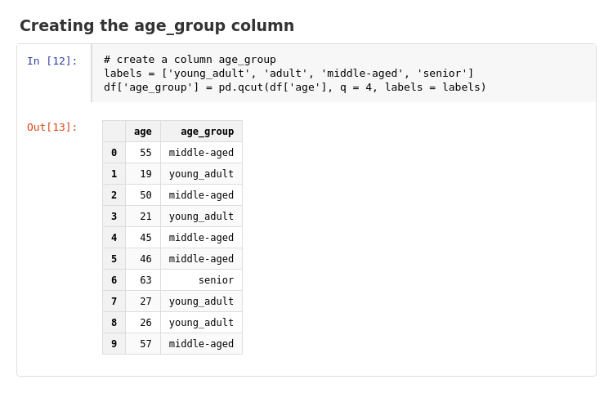
Figure 2 — Notebook cell creating the age_group column
- Converted the categorical frequency_of_purchases field (e.g. "Weekly", "Quarterly") into a numeric purchase_frequency_days field via an explicit mapping, enabling numeric analysis of purchase cadence
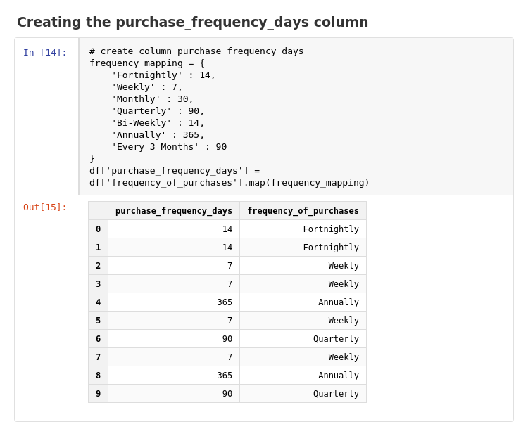
Figure 3 — Notebook cell creating the purchase_frequency_days column
- Identified that discount_applied and promo_code_used were fully redundant (identical values in every row) and dropped promo_code_used to avoid duplication
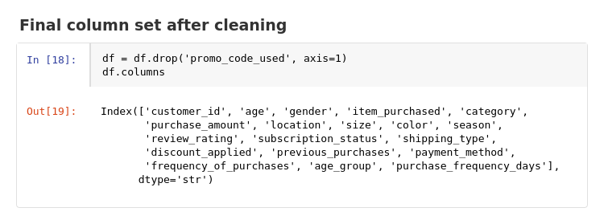
Figure 4 — Final column set after cleaning and feature engineering

Loading into SQL Server
Connected the notebook to a local SQL Server instance using SQLAlchemy and pyodbc with Windows Authentication, then wrote the cleaned dataframe to a table:
DRIVER={ODBC Driver 17 for SQL Server}; SERVER=YOUR_SERVER_NAME\\SQLEXPRESS;
DATABASE=customer_behavior; Trusted_Connection=yes;
df.to_sql("customer_shopping_behavior", engine, if_exists="replace", index=False)
From here, the recommended workflow was to write and refine further queries directly in SSMS (saved as .sql files for the GitHub repo), then pull results back into Jupyter with pd.read_sql() for any additional Python-side visualization.

3. Power BI Dashboard
The cleaned data was connected to Power BI to build a single-page "Customer Behavior Dashboard" combining KPI summaries, category and demographic breakdowns, and interactive filtering.
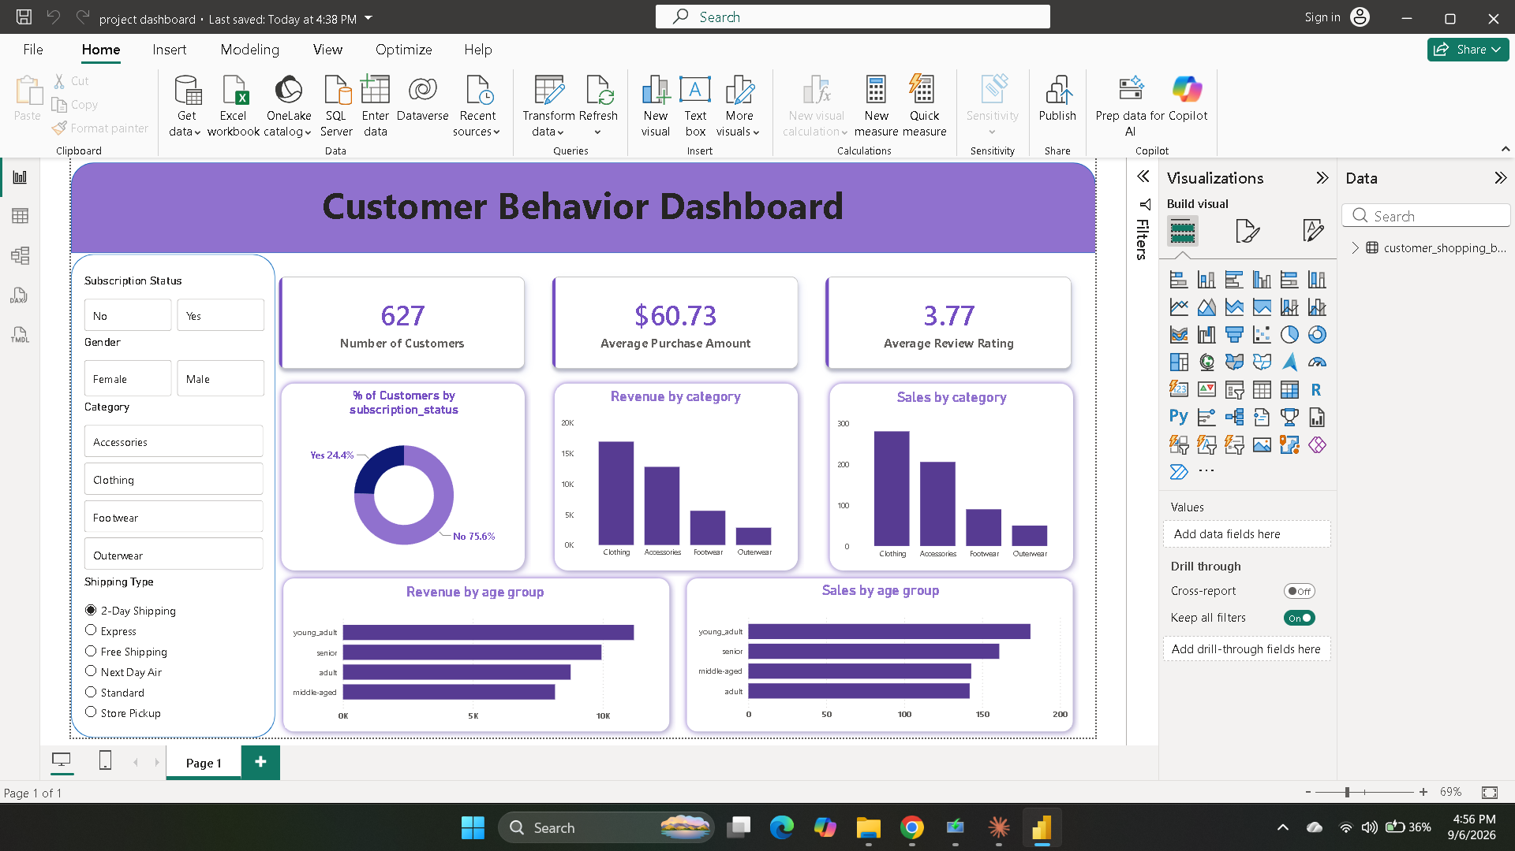
Figure 5 — Customer Behavior Dashboard (Power BI Desktop)

Key Metrics (KPI Cards)
627  Number of Customers | $60.73  Average Purchase Amount | 3.77  Average Review Rating

Report Visuals
- Donut chart — % of Customers by Subscription Status (24.4% subscribed, 75.6% not)
- Clustered column chart — Revenue by Category
- Clustered column chart — Sales (count) by Category
- Clustered bar chart — Revenue by Age Group
- Clustered bar chart — Sales (count) by Age Group

Interactivity
- Slicers for Subscription Status, Gender, and Category
- A list slicer for Shipping Type (2-Day, Express, Free, Next Day Air, Standard, Store Pickup)
- All visuals cross-filter together, letting a viewer drill into any customer segment

4. Key Observations
- Clothing and Accessories generate noticeably more revenue and sales volume than Footwear and Outerwear, suggesting these categories drive most of the business.
- Only about a quarter of customers (24.4%) are on an active subscription, leaving a large majority as one-off or non-subscribed shoppers — a potential retention opportunity.
- Revenue and sales are fairly evenly distributed across age groups (young_adult, adult, middle-aged, senior), with no single group dominating purchasing.
- Average review rating (3.77 / 5) sits in a moderate range, which could be worth segmenting further by category to spot problem areas.

5. SQL Analysis
With the cleaned data loaded into SQL Server, a set of SQL queries was written and refined in SSMS (customer_shopping_behavior_analysis.sql) to demonstrate a broad range of SQL techniques against the customer_shopping_behavior table.

Exploration
- Row counts and a quick preview of the table
- Purchase counts broken down by category

Revenue & Spending
- Total and average purchase amount by category
- Revenue and customer counts by age group
- Revenue by gender and subscription status

Customer Loyalty
- Average days between purchases by category
- Top 10 most loyal customers by number of previous purchases

Window Functions
- RANK() to rank customers by spend within their own category
- A running total of revenue using SUM() OVER()
- PERCENT_RANK() to find each customer’s spend percentile
- LAG() to compare each customer’s spend to the previous customer’s

CTEs & Subqueries
- A CTE isolating customers who spend above the overall average
- A CTE summarizing revenue and rating by category, filtered to above-average categories
- A correlated subquery finding customers rated below their category’s average rating

Discounts, Shipping & Payment
- Impact of discounts on average purchase amount
- Shipping type popularity and average spend
- Payment method breakdown by order count and total revenue

