Transcriptomic Reprogramming and Regulatory Architecture of the Systemic Immune Response in COVID-19

Abstract
Background: The clinical trajectory of COVID-19 is dictated by the complex interplay between viral replication and the host immune response. Peripheral Blood Mononuclear Cells (PBMCs) serve as a critical window into systemic immunity, yet the precise transcriptional alterations and upstream regulatory mechanisms driving the adaptive response remain an area of intense investigation.
Methods: We performed a comprehensive RNA-sequencing analysis of 20 PBMC samples (10 COVID-19 patients vs. 10 healthy controls) from dataset GSE152418. The raw sequencing data were processed using a reproducible systems biology pipeline comprising adapter trimming, splice-aware alignment (HISAT2), and gene quantification. Differential expressions were assessed using DESeq2. Functional interpretation included pathway enrichment (KEGG/GO) and the construction of a Gene-miRNA regulatory network using experimentally validated interactions from miRTarBase v9.0.
Results: We identified a profound transcriptional divergence characterized by the massive upregulation of cell-cycle progression genes (MKI67, TOP2A, CCNA2) and immunoglobulin variable regions (IGHV), indicative of plasmablast expansion. Functional enrichment highlighted the remodeling of Extracellular Matrix (ECM) interactions and "synaptic-like" immune signaling. Furthermore, network analysis revealed a dense post-transcriptional regulatory landscape where hub genes (TWIST1, TERT, SPC25) are modulated by key miRNAs.
Conclusion: The COVID-19 systemic immune response is defined by a "proliferative burst" and structural remodeling, heavily fine-tuned by a complex miRNA-gene regulatory network. These findings suggest that circulating immune compartments undergoes rapid clonal expansion subject to tight post-transcriptional control.

1. Introduction
Severe Acute Respiratory Syndrome Coronavirus 2 (SARS-CoV-2) precipitates a spectrum of clinical phenotypes, ranging from asymptomatic carriage to fatal respiratory distress. While the alveolar epithelium is the primary site of infection, the outcome is largely determined by the systemic immune response. PBMCs comprising T cells, B cells, Natural Killer (NK) cells, and monocytes orchestrate this defense.
Transcriptomic profiling via RNA-sequencing (RNA-seq) allows for the unbiased quantification of gene expression changes. However, gene expression is not a linear process; it is heavily influenced by post-transcriptional regulation, particularly by microRNAs (miRNAs) small non-coding RNAs that silence mRNA targets. Understanding not just which genes are expressed, but how they are regulated, is crucial for unraveling the stability and drivers of the immune phenotype.
In this study, we applied a standardized systems biology pipeline to dataset GSE152418. Our objective was to characterize the differential gene expression landscape between COVID-19 patients and healthy controls and to map these changes to upstream miRNA regulatory networks, distinguishing the molecular features of the active antiviral response.

2. Materials and Methods
2.1 Data Acquisition and Quality Control
Raw sequencing data were obtained from the Gene Expression Omnibus (GEO) under accession GSE152418 (N=20; 10 COVID-19, 10 Healthy). Raw FASTQ files were processed using fastp to trim adapter sequences and filter low-quality reads (Phred score < Q20).
2.2 Alignment and Filtering
Cleaned reads were aligned to the human reference genome (GRCh38) using HISAT2 (v2.2.1). Post-alignment processing was conducted using SAMtools and Picard Tools.
- Deduplication: Picard MarkDuplicates was employed to identify and flag PCR duplicates.
- Filtering: Reads mapping to the mitochondrial genome (MT) and ribosomal RNA (rRNA) intervals were computationally removed to ensure accurate quantification of the nuclear transcriptome.
2.3 Quantification and Differential Expression
Gene-level counts were generated using featureCounts, targeting the Homo_sapiens.GRCh38.110.gtf annotation. Statistical analysis was performed in R using DESeq2. Significance was defined as $P_{adj}<0.05$ and $∣{log⁡}_{2}(FoldChange)∣>1$

2.4 Functional Enrichment and Network Analysis
- PPI Networks: Protein-Protein Interaction networks were constructed using the STRING database.
- Pathway Enrichment: Gene Ontology (GO) Biological Process and KEGG pathway enrichment analyses were performed on significant Differentially Expressed Genes (DEGs).
2.5 Gene-miRNA Regulatory Network Construction
To investigate upstream regulatory mechanisms, we constructed a Gene-miRNA interaction network. Significant DEGs were mapped to experimentally validated miRNA targets using miRTarBase v9.0, a comprehensive database of experimentally verified miRNA-target interactions (MTIs). Network topology was analyzed to identify "hub" genes (targets regulated by multiple miRNAs) and key regulatory miRNAs.
3. Results
3.1 Sequencing Metrics and Data Integrity
The bioinformatics pipeline yielded robust data quality. Following the removal of PCR duplicates (mean duplication rate ~38%) and contaminants, we retained an average of 8.03 million clean, unique nuclear reads per sample. Principal Component Analysis (PCA) confirmed that biological variance exceeded technical noise.
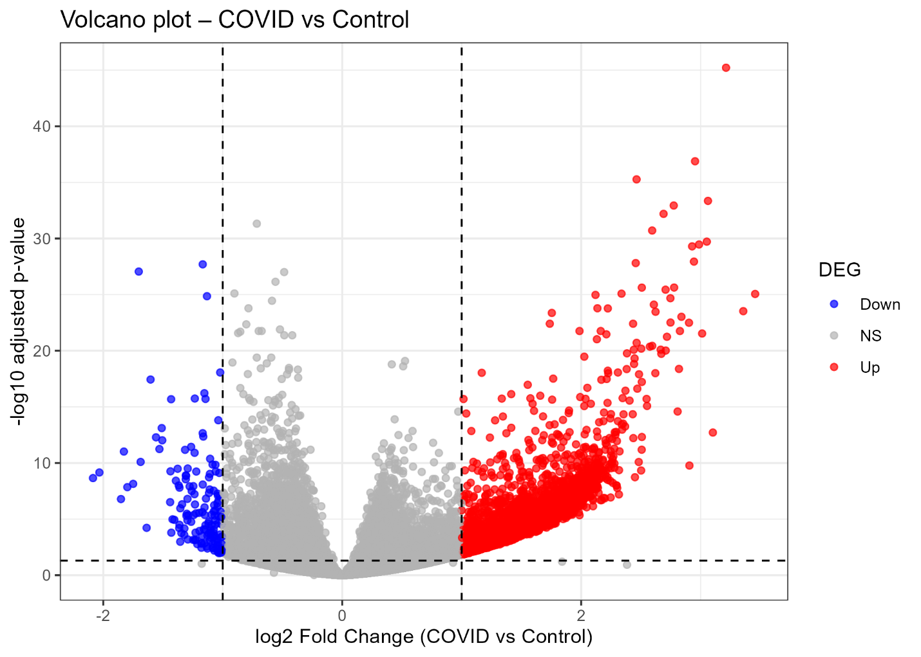
Figure 1: Volcano plot displaying the distribution of differentially expressed genes (DEGs) between COVID-19 patients and healthy controls. The x-axis represents the ${log⁡}_{2}$ Fold Change, and the y-axis represents statistical significance ($-{log⁡}_{10}$ adjusted p-value). Red points indicate significantly upregulated genes ( $P_{adj}<0.05,{log⁡}_{2}FC>1$), while blue points indicate downregulated genes. Grey points represent non-significant genes.
3.2 The Transcriptional Landscape of Infection
Differential Expression (Volcano Plot): Analysis identified a dramatic skew toward upregulation in COVID-19 samples (Figure 1).
- Cell Cycle Markers: The most significantly upregulated genes were canonical markers of mitosis, including MKI67 (Ki-67), TOP2A (Topoisomerase II $α$), and CCNA2.
- Immunoglobulins: A distinct cluster of immunoglobulin genes (IGHV1-24, IGLV9-49) was highly upregulated, providing transcriptomic evidence of B-cell activation.
Hierarchical Clustering: Unsupervised clustering (Figure 2) revealed a cohesive "proliferative block" (MELK, CDK1, RRM2) universally upregulated in COVID-19 samples.

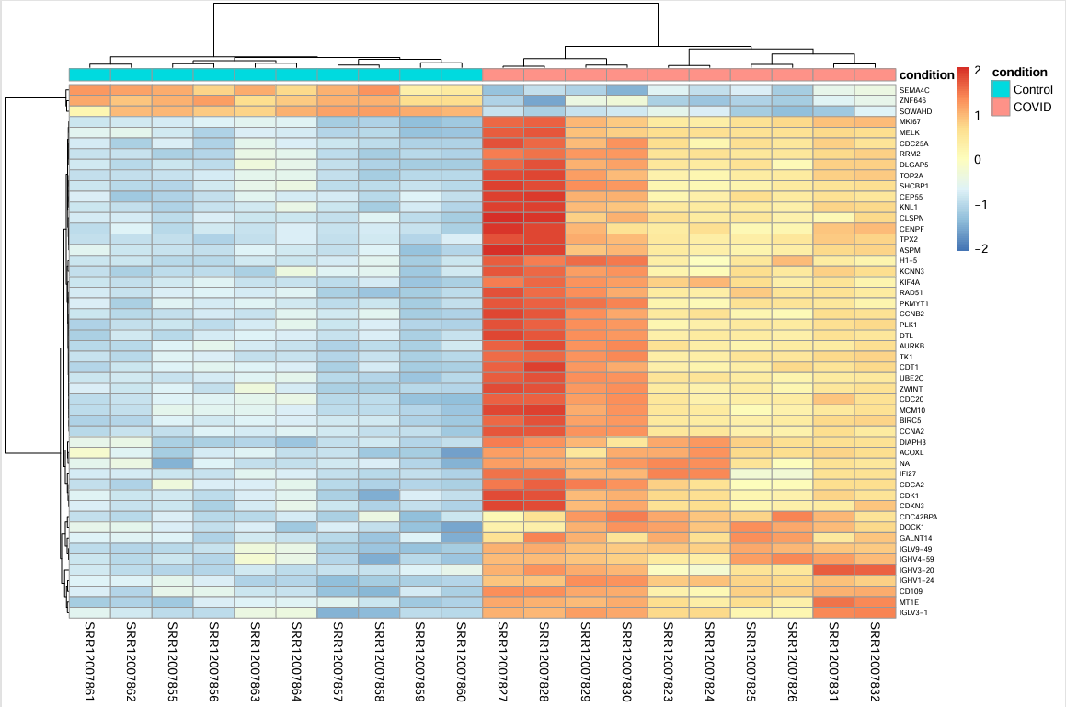
Figure 2. Hierarchical clustering of the top 50 differentially expressed genes. Heatmap illustrates the expression profiles of the top 50 DEGs (ranked by adjusted p-value) across all 20 samples. Gene expression values are Variance Stabilizing Transformed (VST) and scaled by row (z-score); red indicates high relative expression, and blue indicates low relative expression. Columns are annotated by clinical condition (Pink: COVID-19, Cyan: Control). The dendrogram at the top confirms perfect unsupervised segregation of the two cohorts, while the row dendrogram reveals a cohesive block of upregulated proliferative genes in the COVID-19 group.
3.3 Functional Pathway Enrichment (KEGG & GO)
- Synaptic Signaling (GO): Unexpectedly, the top enriched terms were related to "Synaptic signaling" (FDR $1.0e^{-17}$) and "Neuroactive ligand-receptor interaction." In PBMCs, this reflects the molecular machinery of the Immunological Synapse (e.g., adhesion molecules, ion channels).
- ECM-Receptor Interaction (KEGG): This was the most significant KEGG pathway (FDR $1.8e^{-08}$), indicating modulation of the interface between immune cells and the extracellular matrix, a prerequisite for extravasation.

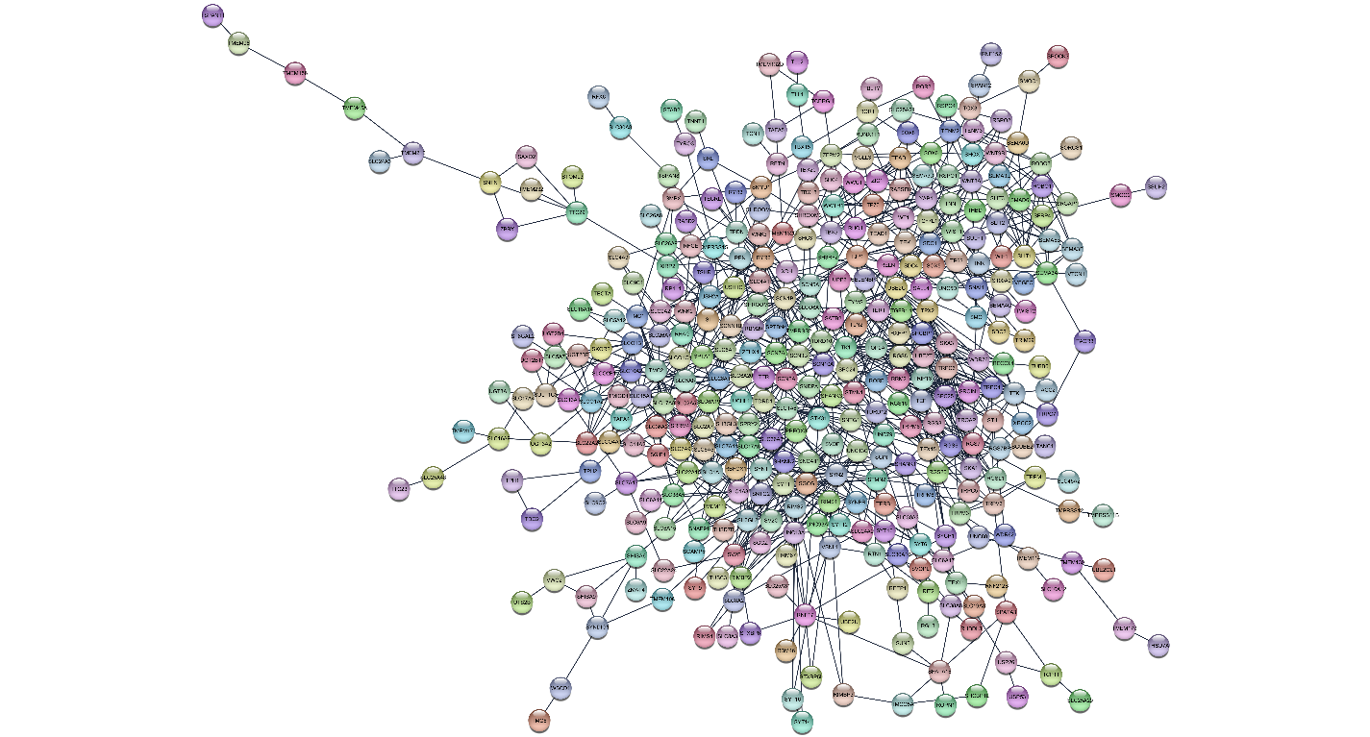
Figure 3. Protein-Protein Interaction (PPI) network of upregulated DEGs. Network analysis was constructed using the STRING database based on significantly upregulated genes in COVID-19 PBMCs. Nodes represent proteins, and edges represent known physical or functional interactions with a high confidence score ($>0.7$). The network topology reveals a dense, highly interconnected "hairball" structure, indicating a coordinated functional module driven by central hubs associated with cell cycle regulation (CDK1, CCNB1) and cell division (AURKB).

Figure 4. KEGG pathway enrichment analysis.
Dot plot summarizing the top enriched Kyoto Encyclopedia of Genes and Genomes (KEGG) pathways for the significant DEGs. The x-axis represents the enrichment signal strength. Dot size correlates with the number of DEGs mapped to the pathway ("Gene count"), and color intensity represents the False Discovery Rate (FDR). The analysis highlights "ECM-receptor interaction" and "Calcium signaling pathway" as the most significantly enriched biological programs.
Figure 4. KEGG pathway enrichment analysis.
Dot plot summarizing the top enriched Kyoto Encyclopedia of Genes and Genomes (KEGG) pathways for the significant DEGs. The x-axis represents the enrichment signal strength. Dot size correlates with the number of DEGs mapped to the pathway ("Gene count"), and color intensity represents the False Discovery Rate (FDR). The analysis highlights "ECM-receptor interaction" and "Calcium signaling pathway" as the most significantly enriched biological programs.
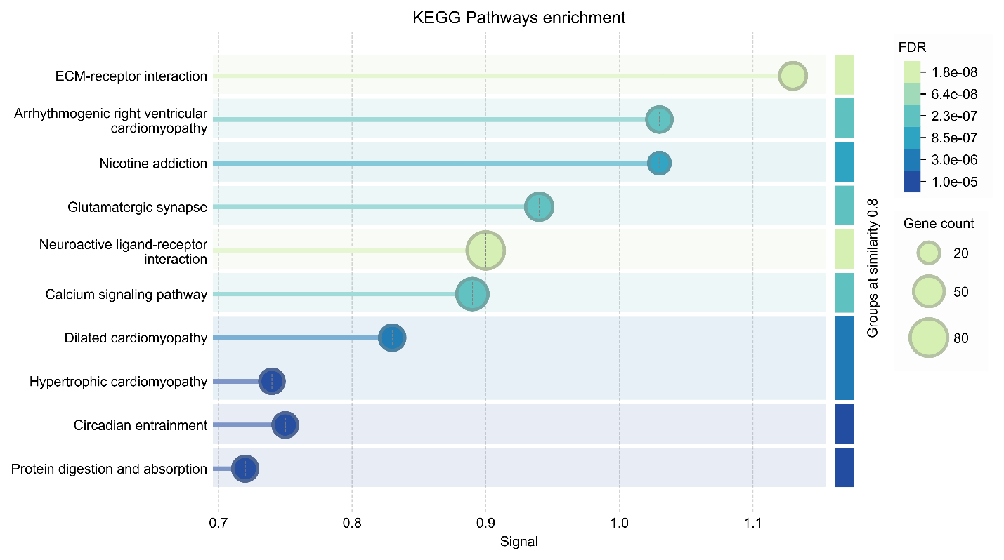
Figure 4. KEGG pathway enrichment analysis. Dot plot summarizing the top enriched Kyoto Encyclopedia of Genes and Genomes (KEGG) pathways for significant DEGs. The x-axis represents the enrichment of signal strength. Dot size correlates with the number of DEGs mapped to the pathway ("Gene count"), and color intensity represents the False Discovery Rate (FDR). The analysis highlights "ECM-receptor interaction" and "Calcium signaling pathway" as the most significantly enriched biological programs.

3.4 Gene-miRNA Regulatory Network
Using miRTarBase v9.0, we mapped the significant DEGs to their regulating miRNAs (Figure 6). The resulting network reveals a complex, multi-layered regulatory architecture:
- Hub Genes: We identified several DEGs acting as central hubs, heavily targeted by multiple miRNAs. These include TWIST1 (a transcription factor involved in differentiation), TERT (Telomerase Reverse Transcriptase), SPC25 (Kinetochore component), and SLC family transporters.
- Regulatory miRNAs: The network highlights key regulatory nodes, such as hsa-miR-335-5p, which appear to modulate multiple targets within the network. The density of interactions suggests that the high expression of these genes is under tight post-transcriptional surveillance.

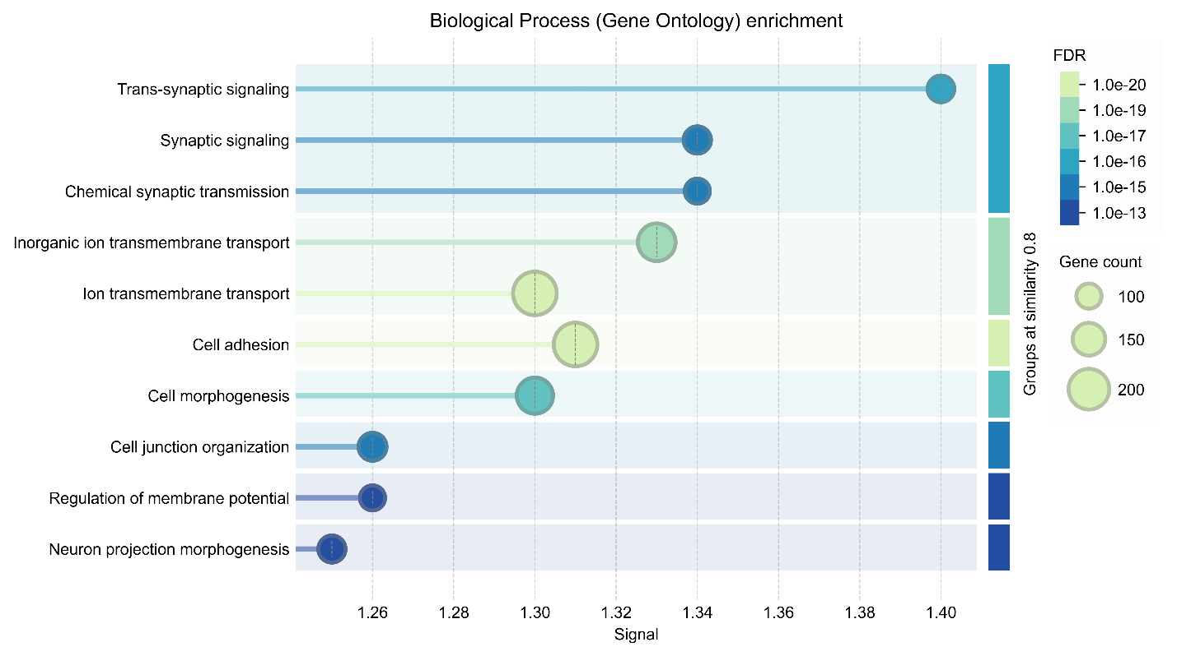
Figure 5. Gene Ontology (GO) Biological Process enrichment. Functional enrichment analysis of GO Biological Processes. The dot plot visualizes the most significant functional categories associated with the DEGs. The results reveal an unexpected but significant enrichment of "Synaptic signaling" and "Trans-synaptic signaling," reflecting the molecular machinery of the immunological synapse and intercellular communication required for lymphocyte activation and adhesion.
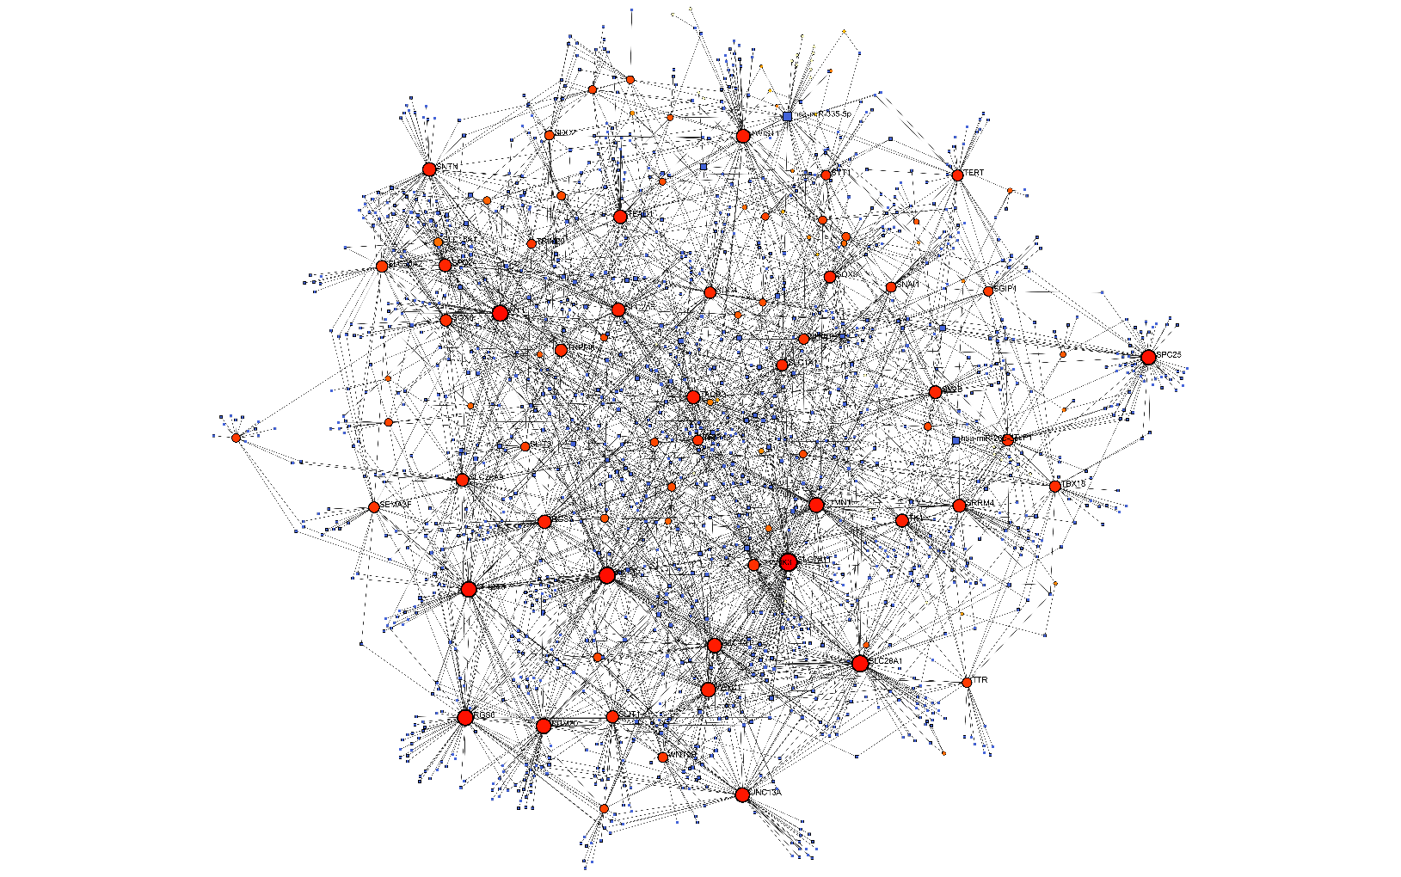
Figure 6. Gene-miRNA regulatory interaction network. A bipartite regulatory network constructed using experimentally validated interactions from miRTarBase v9.0. Red circular nodes represent significantly upregulated target genes (mRNA), and blue square nodes represent regulatory microRNAs (miRNAs). Edges denote validated miRNA-target interactions. The network topology highlights key hub genes (e.g., TWIST1, TERT, SPC25) that are targeted by multiple miRNAs (e.g., hsa-miR-335-5p), suggesting that the observed proliferative burst is subject to complex post-transcription regulation.

4. Discussion
This systems biology assessment reveals that the PBMC response to COVID-19 is defined by a coordinated program of rapid clonal expansion, structural remodeling, and complex post-transcriptional regulation.
4.1 The Proliferative Burst and Plasmablast Expansion
The strongest signal is the upregulation of cell cycle machinery (MKI67, TOP2A, SPC25) and immunoglobulin genes (IGHV). This signature confirms the mobilization of plasmablasts—antibody-secreting cells that flood the blood during acute infection. The host prioritizes the quantity of adaptive effectors, necessitating the activation of DNA replication pathways.
4.2 The "Immunological Synapse" and Migration
The enrichment of "Synaptic signaling" and "ECM-receptor interaction" highlights the functional endpoint of this activation. Activated lymphocytes utilize synaptic-like architecture (ion channels, adhesion molecules) to communicate with Antigen-Presenting Cells. Furthermore, the remodeling of ECM receptors indicates that these cells are priming themselves to adhere to the endothelium and extravasate into infected tissues, such as the lung parenchyma.
4.3 Post-Transcriptional Regulatory Control
The integration of miRTarBase v9.0 data (Figure 6) adds a critical layer of biological context. The identification of TERT and SPC25 as major hubs in the miRNA network suggests that the proliferative burst described above is not unchecked; it is subject to rigorous post-transcriptional regulation.
- SPC25 & TERT: As essential components of the kinetochore and telomere maintenance, respectively, their regulation by miRNAs ensures that the rapid cell division does not lead to genomic instability.
- TWIST1: Known for its role in Epithelial-Mesenchymal Transition (EMT), the regulation of TWIST1 by miRNAs in PBMCs likely influences cellular plasticity and the differentiation state of lymphocytes as they transition from circulating cells to tissue-resident effectors.
Conclusion
In summary, our analysis of GSE152418 elucidates a robust transcriptomic signature of COVID-19 infection. The immune response is characterized by a shift from quiescence to a highly proliferative state, fine-tuned by a complex miRNA-gene regulatory network. These results demonstrate that the systemic response to SARS-CoV-2 involves not just the upregulation of effector genes, but the intricate coordination of upstream regulatory checkpoints.

References
- Huang, H. Y., et al. (2022). miRTarBase update 2022: an informative resource for experimentally validated miRNA-target interactions. Nucleic Acids Research, 50(D1), D222-D230.
- Kim, D., et al. (2019). Graph-based genome alignment and genotyping with HISAT2. Nature Biotechnology.
- Liao, Y., et al. (2014). featureCounts: an efficient general purpose program for assigning sequence reads. Bioinformatics.
- Love, M. I., et al. (2014). Moderated estimation of fold change and dispersion for RNA-seq data with DESeq2. Genome Biology.
- Szklarczyk, D., et al. (2019). STRING v11: protein-protein association networks. Nucleic Acids Research.

