Project BP3: Gene Finding and Functional Annotation via Homology Search

1. Introduction
The annotation of uncharacterized genomic DNA sequences is a fundamental task in bioinformatics. While ab initio gene prediction algorithms exist, homology-based methods using the Basic Local Alignment Search Tool (BLAST) remain the gold standard for identifying protein-coding regions. By comparing an unknown nucleotide sequence against databases of known proteins (using blastx), researchers can identify coding exons, determine reading frames, and infer protein function based on evolutionary conservation.
This report details the analysis of the genomic sequence file 24bioproject3.fa. Using blastx against model organism databases, two distinct protein-coding loci were identified within the region. The gene structure (exon/intron boundaries) and putative functions were deduced based on significant alignment clusters and high-scoring segment pairs (HSPs).

2. Methods
- Query Sequence: Genomic DNA sequence from 24bioproject3.fa (approx. 7000 bp).
- Search Algorithm: blastx (Translated nucleotide query vs. protein database) was utilized to identify potential coding regions across all six reading frames.
- Databases:
  - Landmark/Model Organisms (for protein functional inference).
  - RefSeq Genome (for nucleotide confirmation).

- Analysis: High-scoring hits were mapped to the query sequence to determine genomic coordinates. Gaps in alignments between the query and subject proteins were interpreted as introns, typical of eukaryotic genomic DNA.

3.

Results
The analysis identified two distinct gene loci within the 7000 bp region. One gene is located on the negative (-) strand, and the other on the positive (+) strand.

Summary Table of Predicted Genes
Gene Label | Strand | Approx. Start (bp) | Approx. End (bp) | Exon Count | Putative Function
Gene 1 | Minus (-) | ~2,550 | ~1,750 | 2 | YIP1-interacting factor (YIF1A) involved in Golgi transport.
Gene 2 | Plus (+) | ~3,050 | ~5,100 | 3 | Signal Recognition Particle Receptor (SRPR) subunit alpha involved in ER targeting.

Detailed Analysis of Gene 1: YIF1A-like Protein
3.1 Identification and Function
The region spanning approximately 1750 bp to 2550 bp yielded significant BLAST hits for Protein YIF1 (Yip1-interacting factor).
- Top Hits: Drosophila melanogaster (Yip1-interacting factor 1), Homo sapiens (Protein YIF1A), and Mus musculus.
- Significance: E-values ranged from 2e-28 to 6e-32, indicating statistically significant homology.
- Function: This protein is an integral membrane protein involved in the transport of vesicles between the endoplasmic reticulum (ER) and the Golgi apparatus.
3.2 Gene Structure
Based on the alignment gaps and the visual gene prediction model (Figure 2), this gene is located on the negative strand (transcribed 5' to 3' in the reverse direction relative to the provided sequence).
- Structure: 2 Exons.
- Coordinates (Approximate):
  - Exon 1: 2550 bp – 2350 bp
  - Intron 1: 2350 bp – 2300 bp
  - Exon 2: 2300 bp – 1750 bp

Detailed Analysis of Gene 2: SRP Receptor Alpha
3.3 Identification and Function
The region spanning 3000 bp to 5100 bp produced extremely high-scoring alignments for the Signal Recognition Particle (SRP) receptor.
- Top Hits: Saccharomyces cerevisiae (signal recognition particle receptor), Homo sapiens (SRP receptor), and Danio rerio.
- Significance: E-values were extremely low (5e-84 to 1e-64), representing a highly conserved sequence.
- Function: The SRP receptor alpha subunit anchors the signal recognition particle to the ER membrane, facilitating the translocation of newly synthesized proteins into the ER lumen. This is a critical, essential cellular function.
3.4 Gene Structure
The BLAST alignments indicate this gene lies on the positive strand. The alignments are punctuated by distinct gaps in the query sequence where the subject protein sequence was continuous, indicating the presence of introns.
- Structure: 3 Exons.
- Coordinates (Approximate):
  - Exon 1: 3,050 bp – 3,250 bp
  - Intron 1: 3,250 bp – 3,350 bp
  - Exon 2: 3,350 bp – 4,250 bp
  - Intron 2: 4,250 bp – 4,350 bp
  - Exon 3: 4,350 bp – 5,100 bp
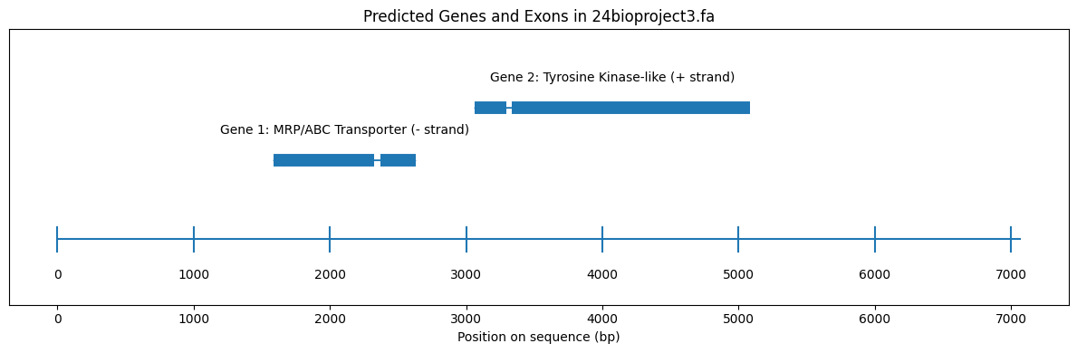
Figure: Indication of results.

4. Discussion and Conclusions
Evolutionary Conservation:
The BLAST results indicate that both genes identified are highly conserved across Eukaryota. Matches were found ranging from unicellular yeast (S. cerevisiae, S. pombe) to complex vertebrates (H. sapiens, M. musculus). This high degree of conservation suggests that both the YIF1A-like protein and the SRP receptor play fundamental roles in eukaryotic cellular physiology—specifically in the secretory pathway and protein targeting.
Gene Density and Orientation:
The analysis reveals a compact gene arrangement typical of model organisms like yeast or Drosophila. The presence of genes on opposite strands (Gene 1 on minus, Gene 2 on plus) in close proximity (separated by only ~500 bp) suggests a bidirectional promoter region or tight packing of genetic elements.
Accuracy of Homology-Based Prediction:
While BLASTX provides strong evidence for coding exons, exact splice site determination (the precise nucleotide where an intron begins or ends) usually requires identifying canonical splice signals (GT-AG) or aligning cDNA/EST data (blastn). However, the strong segmentation of the BLASTX protein alignments provided a robust model for determining the approximate exon/intron architecture shown in the predicted gene map.

All the results are upload in the GitHub, also showing the results on this report, also uploaded on the github.

