HOSPITAL MANAGEMENT SYSTEM
Use Case Diagrams
The system has two primary actors, Admin and Receptionist. The diagrams below show the major use cases associated with each actor based on the project user stories and functional requirements.
Figure 1: Admin Use Case Diagram
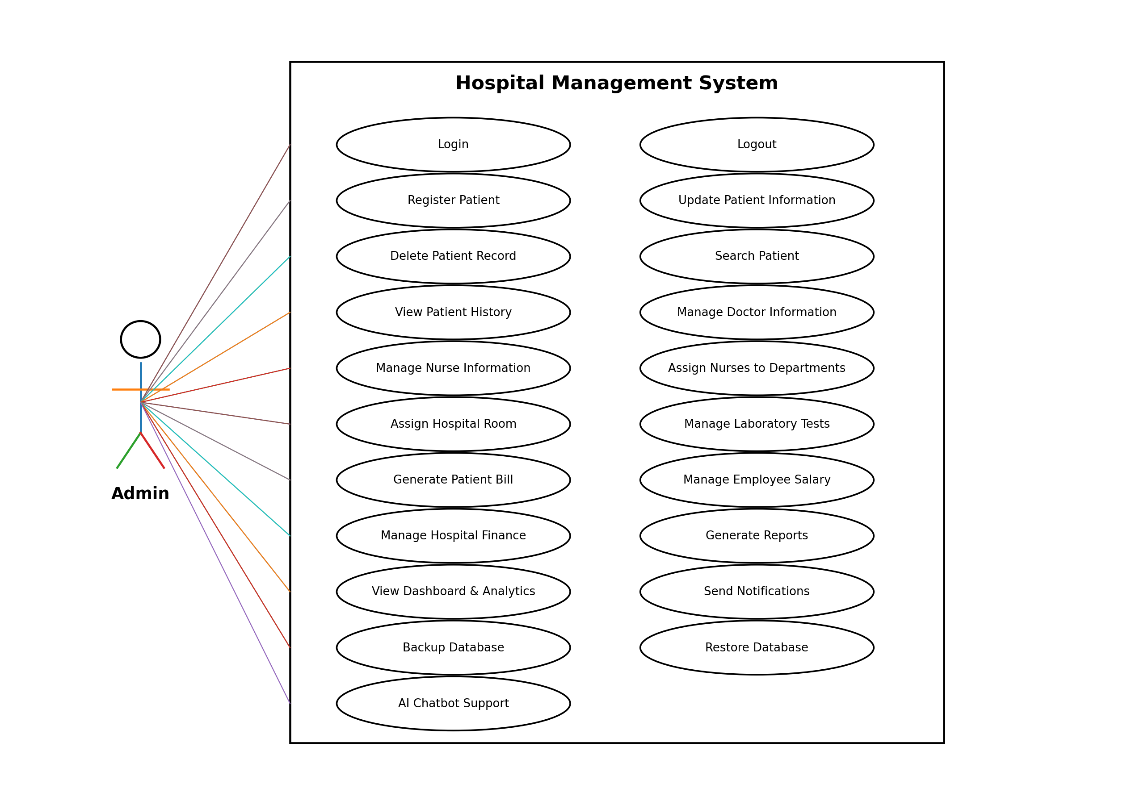

Figure 2: Receptionist Use Case Diagram
