Selected Process Model: Agile Scrum
For our Hospital Management System, we selected the Agile Scrum Model as the software development process model. Our system contains several separate but connected modules, including Patient Management, Doctor and Nurse Management, Appointment Management, Room Management, Laboratory Test Management, Billing, Financial Management, Reports, Notifications, Backup and Recovery, Dashboard and AI Chatbot Assistance.
Developing all of these modules at the same time would be difficult to manage. For this reason, Agile Scrum is suitable for our project because it allows us to divide the whole system into smaller parts and develop them step by step through short development cycles called Sprints.
In Scrum, the project requirements are first organized in a Product Backlog. The Product Backlog contains all required features and development tasks. Before starting Sprint, the team selects several tasks from the Product Backlog during Sprint Planning. These selected tasks become part of the Sprint Backlog.
During the Sprint, the team designs, develops, and tests the selected features. At the end of the Sprint, the completed work is reviewed to check whether it meets the project requirements. If any problem is found, it can be corrected before starting the next Sprint. This process continues until all major modules of the Hospital Management System are completed.
Scrum also supports teamwork because different group members can work on different assigned tasks while following the same Sprint goal. Trello can be used to manage Sprint tasks and user stories, while GitHub can be used to manage the source code and contributions of each group member.
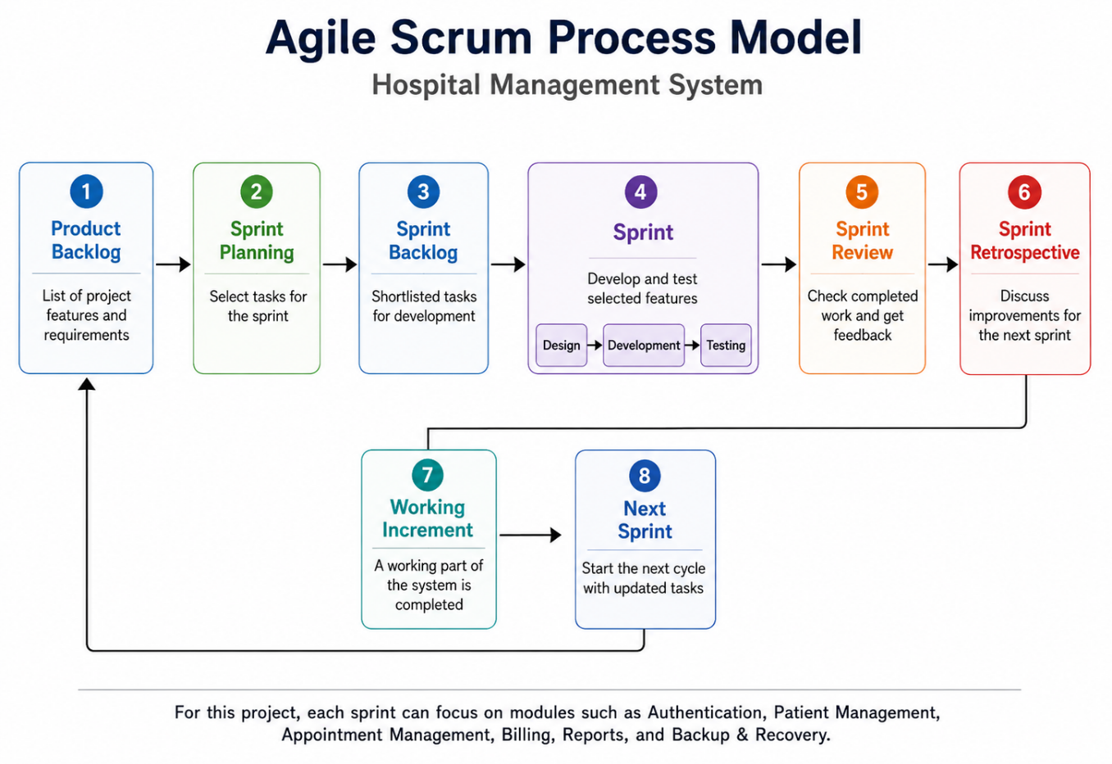
Sprint Distribution
Sprint 1: Project Setup and Authentication
The first Sprint will focus on basic project setup, database preparation, secure login, logout, password authentication, and role-based access control.
Sprint 2: Patient Management
This Sprint will include patient registration, updating patient information, searching patient records, viewing patient history, and maintaining admission and discharge information.
Sprint 3: Doctor and Nurse Management
This Sprint will focus on doctor information, specialization, department assignment, doctor schedule, doctor availability, nurse information, department assignment, and duty-related records.
Sprint 4: Appointment and Room Management
This Sprint will include appointment booking, modification, cancellation, doctor availability checking, room availability, room allocation, and room release.
Sprint 5: Laboratory and Billing Management
This Sprint will cover laboratory test records, test results, patient billing, payment collection, receipt generation, and outstanding payment tracking.
Sprint 6: Salary, Finance and Reports
This Sprint will include employee salary management, hospital income and expense records, financial information, and different hospital reports.
Sprint 7: Dashboard, Notifications and Backup/Recovery
This Sprint will focus on dashboard analytics, appointment reminders, payment notifications, system alerts, database backup, and data recovery.
Sprint 8: AI Chatbot, Integration and Final Testing
The final Sprint will include AI Chatbot assistance, integration of all completed modules, final testing, bug fixing, and preparation of the final system.

Why We Chose Agile Scrum
We chose Agile Scrum because our Hospital Management System contains many different modules that can be developed in separate stages. Working in smaller Sprints allows the team to focus on a limited number of features at a time instead of trying to develop the whole system together.
Another reason is that completed features can be tested early. For example, after finishing Patient Management, we can test patient registration, searching, and updating before moving to another module. This helps us identify and fix problems earlier in the development process.
Scrum is also suitable for team-based development. Tasks can be divided among group members and tracked through Trello, while GitHub can be used to manage source code and individual contributions. This makes it easier to monitor progress and keep the work organized.
Agile Scrum is also flexible when small changes are needed during development. If a requirement needs improvement or additional validation, it can be handled in a later Sprint without changing the entire project plan.
Therefore, Agile Scrum is suitable for our Hospital Management System because it supports modular development, early testing, teamwork, progress tracking, and easier management of changes throughout the project.

2. Timeline Chart / Gantt Chart

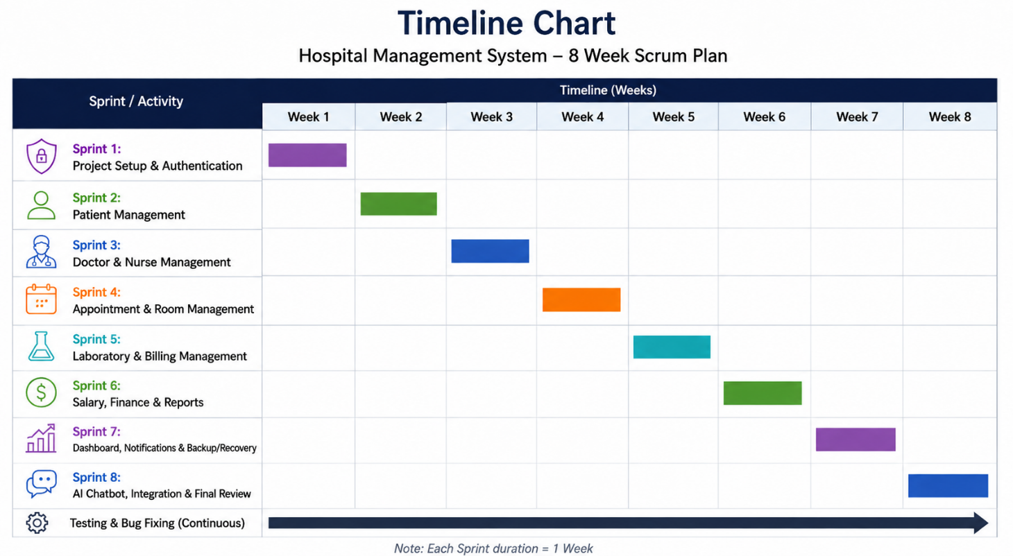

UI / Wireframe Design using Figma
