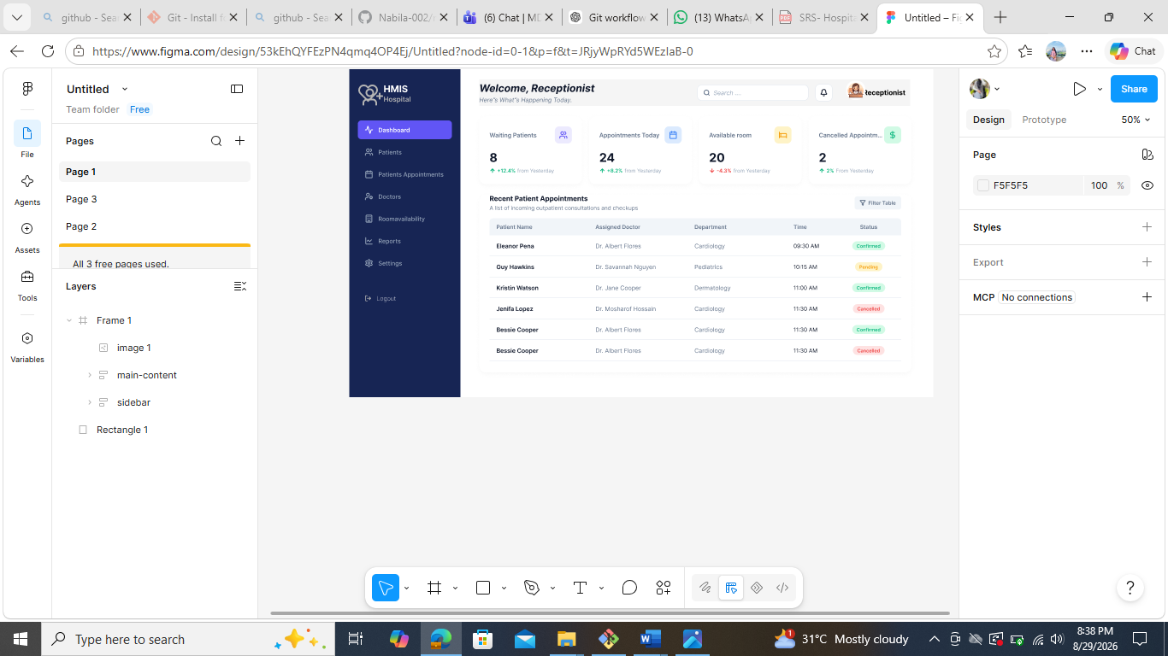
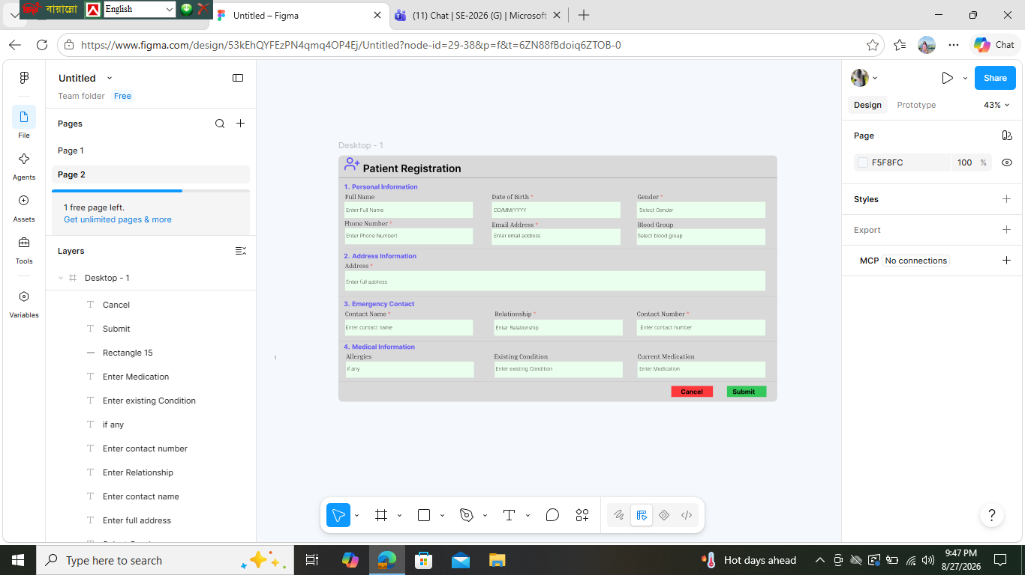
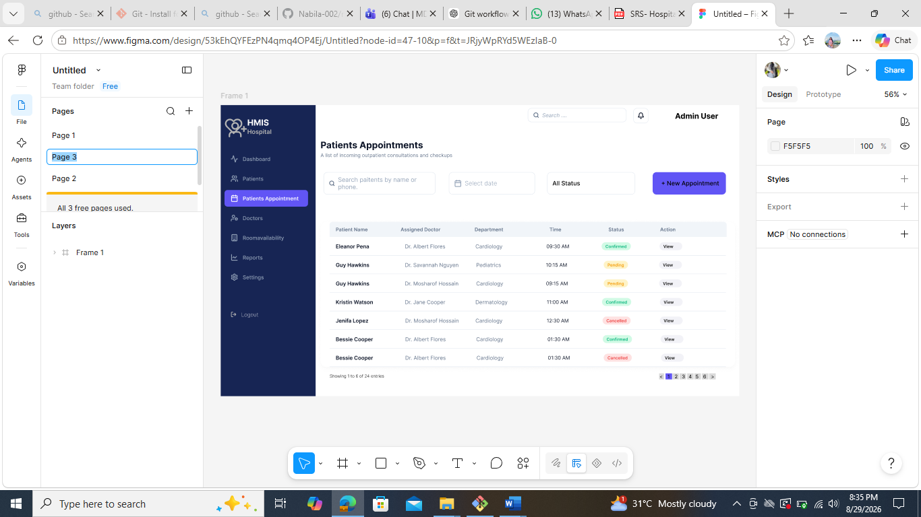

Non-Functional Requirements

Requirement ID | Requirement Category | Non-Functional Requirement
NFR-01 | Usability | The system should be easy to learn and use for both Admin and Receptionist.
NFR-02 | Usability | The system should have a simple and user-friendly interface.
NFR-03 | Performance | The system should respond to user requests within 3 seconds under normal conditions.
NFR-04 | Performance | The system should generate reports within a reasonable time.
NFR-05 | Security | Only authorized users should be able to access the system.
NFR-06 | Security | Users must log in with a valid username and password.
NFR-07 | Security | Patient information should remain private and secure.
NFR-08 | Reliability | The system should work properly during hospital working hours with minimal errors.
NFR-09 | Reliability | The system should save data correctly without losing information.
NFR-10 | Availability | The system should be available whenever hospital staff need it.
NFR-11 | Backup & Recovery | The system should support regular database backup.
NFR-12 | Backup & Recovery | The system should restore data from backup if data is lost or the system fails.
NFR-13 | Maintainability | The system should be easy to update and maintain in the future.
NFR-14 | Scalability | The system should support adding more users, patients, doctors, and hospital services in the future.
NFR-15 | Compatibility | The system should work correctly with the selected database and development platform.
NFR-16 | Data Integrity | The system should store accurate and consistent data.
NFR-17 | Logging | The system should keep a log of important user activities such as login and record updates.
NFR-18 | Notification | The system should send notifications without unnecessary delay.
NFR-19 | AI Support | The AI Chatbot should provide helpful responses for common hospital-related questions.
NFR-20 | Portability | The system should be easy to install and run on another computer with the required software.

