

International University of Business Agriculture and Technology

Assignment title: Adventure Guild Management System
Course Name: Object Oriented Programming Lab
Course Code: CSE-2384

Submitted To:

Name: Dr. Md. Shafenoor Amin
Assistant Professor
Department of CSE (IUBAT)

Submitted By:

Name | Id
Robiul Islam | 25303039
Md. Irfan Khan | 25303040
Masuma Akter | 25303047



Department of Computer Science and Engineering
Table of Content

Topic Name | Page Number
Implemented Class | 03
OOp features Used | 04
Program Output | 05
Reflection | 06

Implemented Class

Class Name | Key Attributes | Key Methods | Purpose
Inventory | owner_name, capacity, inventory_type, items | add_item(), remove_item(), list_items() | Manages equipment and items owned by an adventurer.
Item | name, item_type, value, durability | get_details(), use_item(), repair() | Represents equipment, consumables, or loot rewards.
Reward | gold, experience, bonus_item | add_bonus_gold(), get_total(), display_reward() | Represents rewards granted upon quest completion.
Rank | rank_name, min_exp, tier | get_rank_info(), promote_tier(), update_min_exp() | Tracks adventurer tier status and promotion progress.
Monster | name, monster_type, health_point, attack_power | take_damage(), attack(), get_status() | Encapsulates combat entities encountered on quests.
Quest | title, difficulty, reward, is_active, assigned_adventurers, completed_by | assign_to(), complete_by(), get_status() | Defines objectives, reward allocations, and adventurer assignments.
Adventurer | name, level, health_point, exp, gold, guild, rank, inventory | take_damage(), join_guild(), add_gold(), assign_rank(), perform_action() | Parent class representing generic guild members.
Warrior | stamina (inherits from Adventurer) | shield_block(), attack(), rest(), perform_action() | Melee specialist child class utilizing stamina.
Mage | mana (inherits from Adventurer) | cast_spell(), meditate(), perform_action() | Spellcaster child class utilizing mana resources.
Archer | agility (inherits from Adventurer) | shoot_arrow(), dodge(), perform_action() | Ranged physical specialist child class using agility.
Guild | name, location, total_funds, members, quests | add_member(), remove_member(), add_quest(),get_guild_summary() | Central organizational unit managing members and quests.
OOP Features Used
- Inheritance: Implemented via the base parent class Adventurer and three specialized child classes: Warrior, Mage, and Archer. Each child inherits core functionality while introducing distinct attributes (stamina, mana, agility).
- Composition: Demonstrated by Adventurer, which directly instantiates and owns unique Inventory and Rank objects. The lifecycle of these components is directly tied to the lifetime of the Adventurer.
- Association:
  - Guild maintains lists referencing Adventurer and Quest instances.
  - Quest references assigned Adventurer objects and contains a Reward object.
  - Adventurer keeps a reference to their joined Guild.
- Polymorphism: Demonstrated through method overriding of perform_action() across Warrior, Mage, and Archer. When executing perform_action() across a collection of base Adventurer references, each subclass executes its own unique action.

Program Output

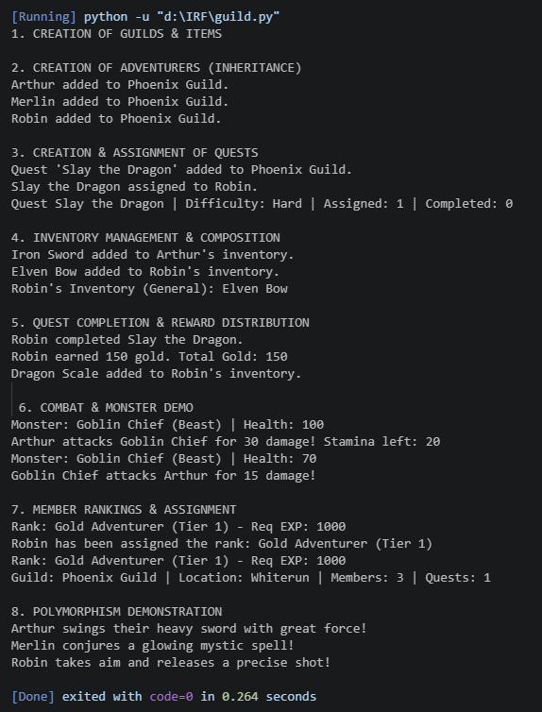
Reflection

- What was the most difficult class to implement?
Answer: The Quest class was the most complex and difficult to implement because it serves as the central orchestration point between dynamic entities. Managing state transitions (such as transitioning a quest from active to completed) required handling multiple edge cases: ensuring an adventurer could not be assigned the same quest twice, handling multi-adventurer dynamic assignments via lists, and properly triggering reward distribution upon completion. Additionally, integrating the Reward object with the Quest class demanded careful memory and variable management to update individual Adventurer inventory and gold balances accurately without duplicating rewards or leaving unhandled null attributes.

- Which object-oriented concept was most useful?
Answer: Inheritance combined with Polymorphism was by far the most valuable concept in this system. Creating an abstract-style parent class Adventurer with child classes (Warrior, Mage, Archer) allowed the implementation of base attributes (name, hp, gold) once, eliminating redundant code. Polymorphism specifically excelled through the perform_action() method override. This enabled the main Guild class and execution loops to process a collection of diverse generic Adventurer objects seamlessly without needing conditional if/else logic to check specific member types at runtime.

- What would you improve if additional time were available?
Answer: Given additional time, the following enhancements would be prioritized:
  - Data Persistence: Implement database integration (SQLite) or file standard persistence (JSON) to save and load guild progress, adventurer states, and inventory data across multiple system runs.

  - Advanced Combat Engine: Expand the Monster interaction into a fully automated round-based combat loop utilizing precise calculations for physical defense, critical hits, evasion stats, and dynamic skill cooldowns.

  - User Interface & Validation: Build a robust Command-Line Interface (CLI) or graphical interface (GUI) with comprehensive input validation and try-except exception handling to gracefully recover from invalid operations (e.g., assigning dead adventurers to quests or overfilling inventory limits).

