Lab Report 2
Conditional Statements (Using Ternary operators)

Name: Md. Irfan Khan
ID: 25303040
Course Code: CSE-1384
Section: D

Date:
Output:
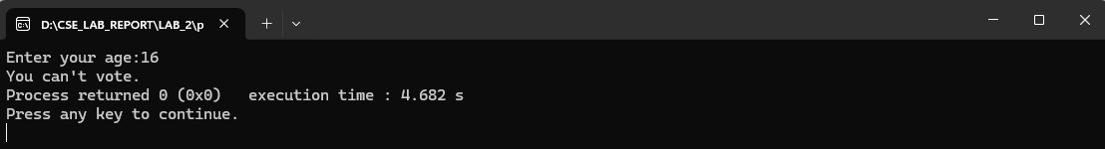
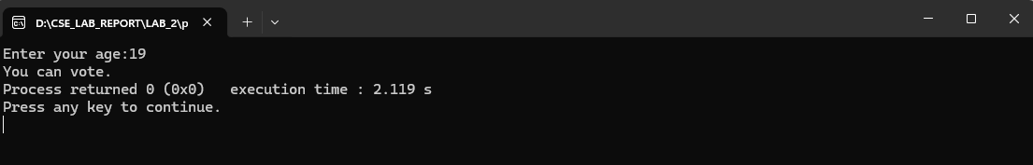
Output:
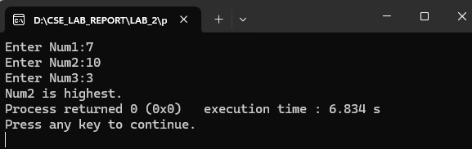

Output:
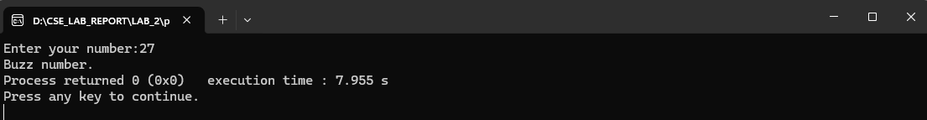

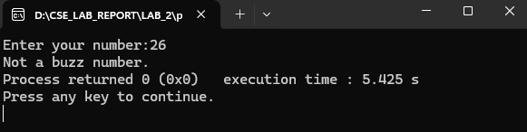

Lab Report 3
If Else Statements

Name: Md. Irfan Khan
ID: 25303040
Course Code: CSE-1384
Section: D

Date:
Output:
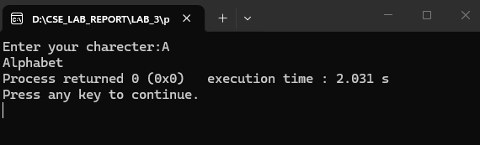
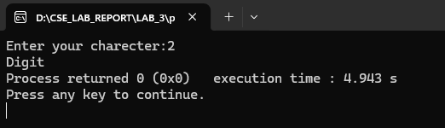
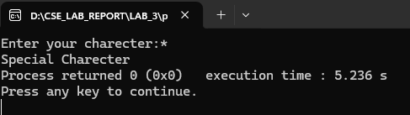

Output:
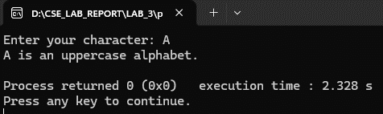
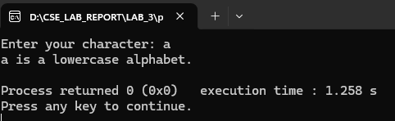

Output:
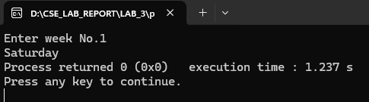

Output:
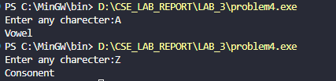

Output:
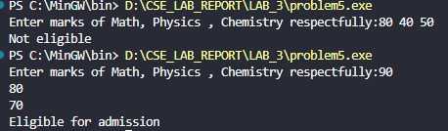

Output:
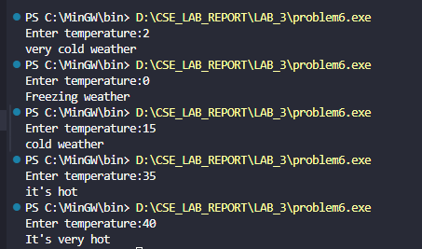
Lab Report 4
Switch Case

Name: Md. Irfan Khan
ID: 25303040
Course Code: CSE-1384
Section: D

Date:

Output:
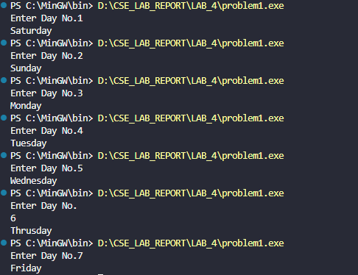

Output:
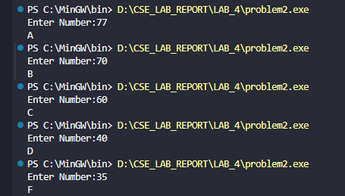

Output:
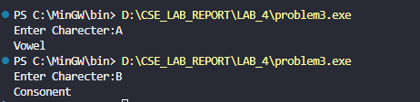

Output:
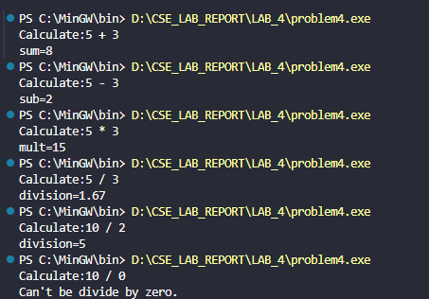

Lab Report 5
While Loop

Name: Md. Irfan Khan
ID: 25303040
Course Code: CSE-1384
Section: D

Date:
Output:

Output:
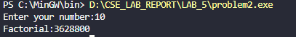

Output:
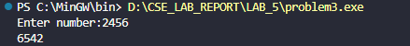

Output:
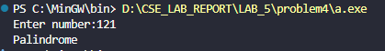

Output:
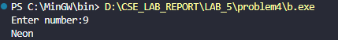

Output:
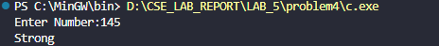

Output:
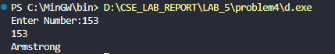

Output:
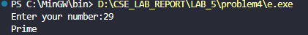

Output:
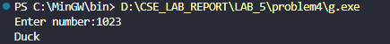

Output:
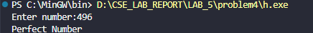

Output:
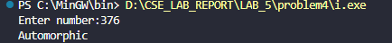

Output:
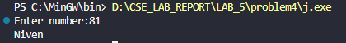
Output:
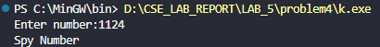

Output:
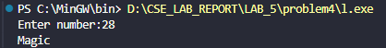

Output:
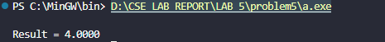

Output:

Lab Report 6
For Loop

Name: Md. Irfan Khan
ID: 25303040
Course Code: CSE-1384
Section: D

Date:

Output:

Output:
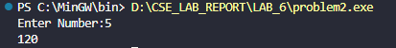

Output:
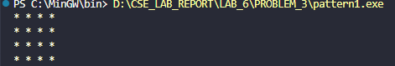

Output:
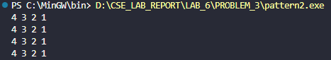

Output:
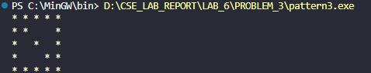

Output:
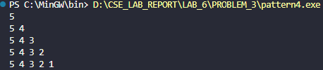

Output:
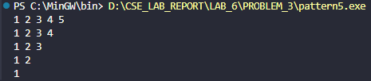

Output:
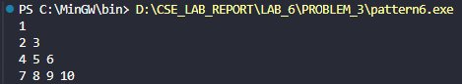

Output:
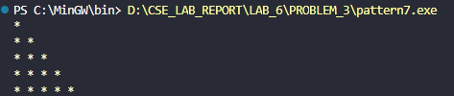

Output:
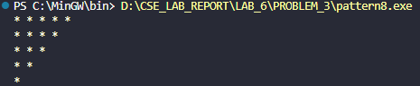

Output:
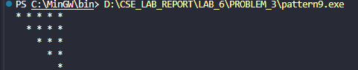

Output:
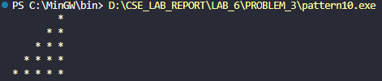

Output:
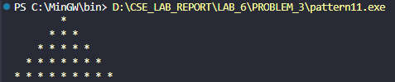

Output:
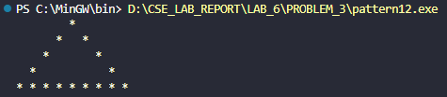

Lab Report 7
Functions

Name: Md. Irfan Khan
ID: 25303040
Course Code: CSE-1384
Section: D

Date:

Output:
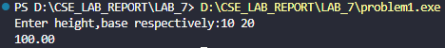

Output:
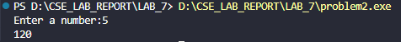

Output:
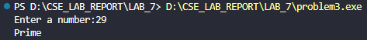

Output:
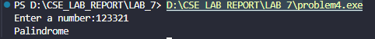

Output:
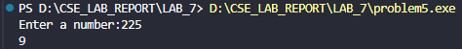

Output:
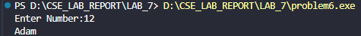
Output:
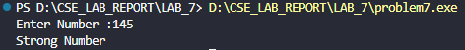

Output:
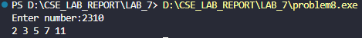

Lab Report 8
Arrays

Name: Md. Irfan Khan
ID: 25303040
Course Code: CSE-1384
Section: D

Date:

Output:
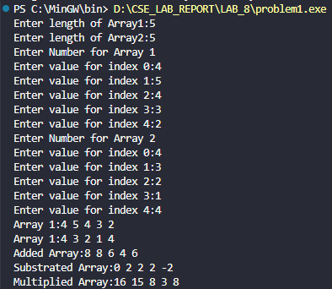

Output:
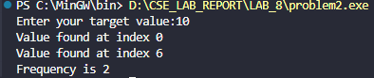

Output:
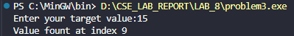

Output:

Output:

