Systems Design and Implementation Plan
Local Café Inventory Management System (LCIMS)

Unit: CPRO306 Capstone Project
Assessment Task 4 — Mid Project Deliverables
Prepared for: Skillup Labs
Lecturer: Dr. Adeem Ali Anwar
Team: The IT Crowd
Md Minhazul Amin (K231250) | Ayush Subedi (K231274) | Aayush Khadgi (K231962)
Date: May 2026

1. Introduction
This report documents the systems design and implementation plan for the Local Café Inventory Management System (LCIMS), developed as part of the CPRO306 Capstone Project at Kent Institute Australia. LCIMS is a full-stack web application that helps small café businesses manage inventory digitally, replacing error-prone spreadsheets. The report covers system architecture, database design, user interface, AI integration, teamwork, and individual contributions, addressing the need to reduce waste, eliminate manual errors, automate alerts, and support decision-making (Sommerville 2016, p. 83). The implemented system has been fully built and tested against the seeded sample data, with all six marking criteria addressed through working code, a normalised relational schema, and a polished React interface.

2. System Requirements and Development Planning

2.1 Business Requirements
The following business requirements were identified during the requirements elicitation phase and documented in the Software Requirements Specification (SRS):
- Reduce food waste through real-time visibility of stock levels
- Eliminate manual spreadsheet errors by centralising inventory data
- Automate low-stock alerts to improve reorder timing
- Maintain accurate supplier records to streamline purchasing
- Provide management reports to support data-driven decisions
- Ensure the system is accessible to non-technical café staff

2.2 Functional Requirements Coverage
The system implements twelve functional requirements (FR-01 to FR-12) from the SRS. Authentication uses JWT tokens with bcrypt-hashed passwords (cost factor 10) and role-based access control for three roles: Manager, Staff, and Admin. Inventory CRUD operations are exposed via REST endpoints with café-level data isolation on every query. Stock changes use database transactions ensuring quantity update, audit log entry, and threshold alert all succeed or all roll back. Suppliers are managed independently and linked to items with SET NULL on deletion. Reporting runs six parallel queries via Promise.all, and the usage endpoint validates ISO date input before querying.

2.3 Sprint Management
The team adopted an Agile Scrum-lite framework with two-week sprints managed through a Kanban board. Stand-ups ran three times per week and sprint reviews every second Friday.
Sprint | Focus | Owner | Weeks
Sprint 1 | SRS, Architecture Design, DB Schema | All members | 1-4
Sprint 2 | Backend API, Database Setup | Minhazul, Khadgi | 5-7
Sprint 3 | Frontend, AI Integration | Subedi, Minhazul | 8-9
Sprint 4 | Testing, Bug Fixes, Deployment | Khadgi, All | 10-12

2.4 Response to Lecturer Feedback
Following feedback on the initial SRS, three improvements were made: (1) project scope was tightened to exclude multi-branch support, POS integration and native mobile apps; (2) a DPIA was added covering encryption, anonymisation and compliance with the Australian Privacy Principles; and (3) the WBS and Gantt Chart were recalibrated for a three-person team. The system also addresses robustness feedback by using database transactions for multi-step mutations and providing a working demo mode for the AI feature.

3. System Architecture

3.1 Three-Tier Architecture
LCIMS follows a three-tier client-server architecture: a Presentation Layer (React 19 frontend), a Business Logic Layer (Node.js with Express 5 REST API), and a Data Layer (PostgreSQL 16). This separation of concerns supports maintainability and independent scalability (Pressman & Maxim 2020, p. 214). All communication is JSON over HTTP, with JWT bearer tokens in the Authorization header authenticating every protected request.

3.2 Technology Stack
Layer | Technology | Purpose
Frontend | React 19, React Router 7, Axios, Recharts | Single-page UI, routing, data visualisation
Backend | Node.js, Express 5, jsonwebtoken, bcryptjs | REST API, JWT authentication, business logic
Database | PostgreSQL 16 (node-postgres connection pool) | Relational data storage with transactions
AI Integration | OpenAI gpt-3.5-turbo (+ deterministic demo fallback) | Smart reorder suggestions
Version Control | Git + GitHub (feature-branch workflow) | Source control and collaboration
Dev tooling | Nodemon, Create React App scripts | Hot-reload development

3.3 File and Folder Structure
The project is organised into three top-level directories:
lcims/
├── client/ # React 19 frontend (Create React App)
│ └── src/
│ ├── api/axios.js # Axios instance + JWT interceptors
│ ├── components/Layout.js # Sidebar shell with Outlet
│ ├── context/AuthContext.js # Global auth state + useAuth()
│ └── pages/ # Login, Dashboard, Inventory,
│ # ItemDetail, Suppliers, Reports, AIInsights
├── server/ # Node.js + Express 5 backend
│ ├── middleware/auth.js # verifyToken + requireManager
│ ├── routes/ # auth, inventory, suppliers, reports, ai
│ ├── db.js # pg Pool + connection diagnostics
│ └── index.js # Express app entry point
└── database/
└── lcims_schema.sql # Single-file schema + seed (re-runnable)

3.4 Non-Functional Requirements Coverage
Performance (NFR-01) is supported by indexed queries and parallel Promise.all dashboard execution. Security (NFR-03) uses bcrypt (cost 10), JWT tokens with 8-hour expiry, and Bearer token validation on every protected route. Portability (NFR-07) is achieved through a browser-based SPA. Compliance (NFR-08) with the Australian Privacy Principles is addressed through role-based access control, parameterised SQL preventing injection (Office of the Australian Information Commissioner 2025), and audit logs preserved via ON DELETE SET NULL on stock_logs.user_id.

4. Database Design

4.1 Entity Relationship Overview
The LCIMS database is normalised to Third Normal Form (3NF) and consists of six entities: cafes, users, suppliers, inventory_items, stock_logs, and alerts. Each has a SERIAL primary key, and foreign keys enforce referential integrity. The schema is delivered in a single re-runnable file (lcims_schema.sql) wrapped in a BEGIN/COMMIT transaction.

4.2 Database Schema
Key table definitions from lcims_schema.sql:
CREATE TABLE inventory_items (
item_id SERIAL PRIMARY KEY,
name VARCHAR(100) NOT NULL,
category VARCHAR(50) NOT NULL,
unit VARCHAR(20) NOT NULL,
quantity DECIMAL(10,2) NOT NULL DEFAULT 0 CHECK (quantity >= 0),
threshold DECIMAL(10,2) NOT NULL DEFAULT 0,
supplier_id INTEGER REFERENCES suppliers(supplier_id) ON DELETE SET NULL,
cafe_id INTEGER NOT NULL REFERENCES cafes(cafe_id) ON DELETE CASCADE,
created_at TIMESTAMP NOT NULL DEFAULT NOW(),
updated_at TIMESTAMP NOT NULL DEFAULT NOW()
);

CREATE TABLE stock_logs (
log_id SERIAL PRIMARY KEY,
item_id INTEGER NOT NULL REFERENCES inventory_items(item_id) ON DELETE CASCADE,
user_id INTEGER REFERENCES users(user_id) ON DELETE SET NULL,
change_qty DECIMAL(10,2) NOT NULL,
reason VARCHAR(255),
timestamp TIMESTAMP NOT NULL DEFAULT NOW()
);

4.3 Database Tables Summary
Table | Key Attributes | ON DELETE Behaviour
cafes | cafe_id, name, address, owner_id | Parent of all tenant data
users | user_id, email, password_hash, role, cafe_id | cafe_id CASCADE
inventory_items | item_id, name, category, unit, quantity, threshold | cafe_id CASCADE, supplier_id SET NULL
suppliers | supplier_id, name, contact, phone, email, cafe_id | cafe_id CASCADE
stock_logs | log_id, item_id, user_id, change_qty, timestamp | item_id CASCADE, user_id SET NULL
alerts | alert_id, item_id, triggered_at, status | item_id CASCADE

4.4 Indexes, Trigger, and Constraints
Eight performance indexes cover all foreign-key and frequently filtered columns. CHECK constraints enforce quantity >= 0, role IN ('Manager', 'Staff', 'Admin'), and status IN ('active', 'resolved'). A PL/pgSQL trigger function set_updated_at() automatically refreshes inventory_items.updated_at on every UPDATE, ensuring timestamp accuracy without relying on application code (Elmasri & Navathe 2016, p. 312). Seed data includes one café, three users with real bcrypt hashes, four suppliers, ten inventory items across five categories, eight stock log entries, and two active alerts for items seeded below threshold.

5. User Interface Design

5.1 Design Principles
The LCIMS UI is designed around clarity, efficiency, and learnability. A persistent sidebar provides consistent access to all modules, and a blue/white palette with red/green/orange status indicators maintains accessibility. All styling uses inline JavaScript style objects, removing the need for a separate CSS pipeline (Galitz 2007, p. 45).

5.2 Login Screen
The login screen presents a centred card on a gradient blue background with email and password fields. On successful authentication the JWT is stored in localStorage under lcims_token and the user is redirected to the dashboard.
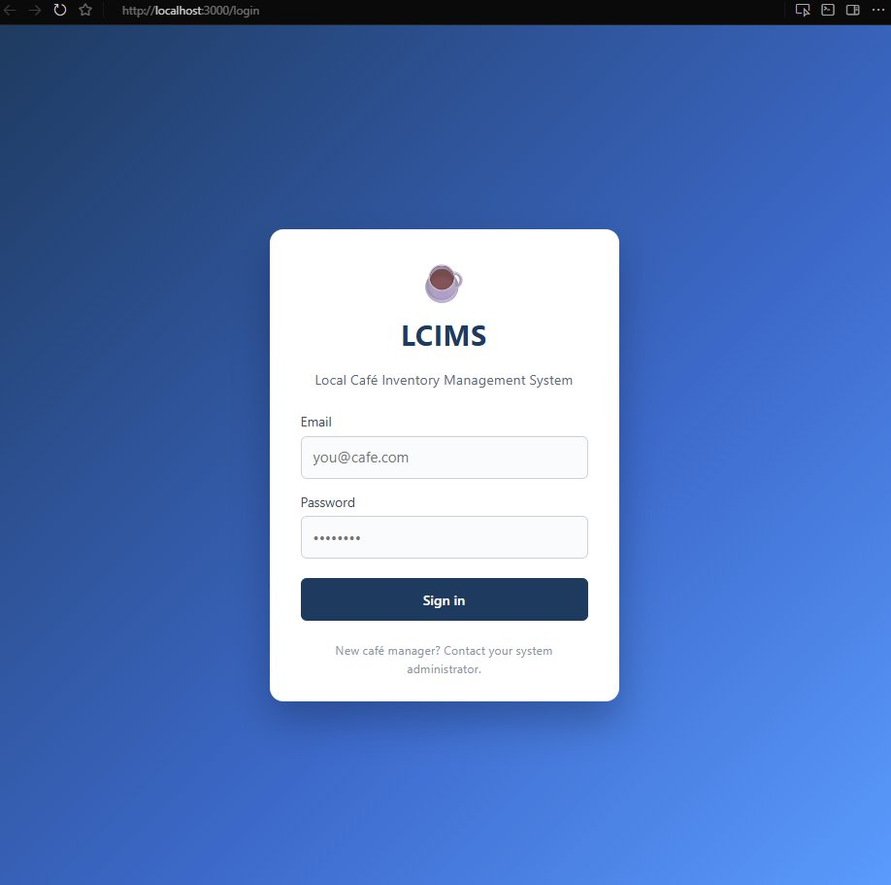
Figure 1: Login Screen (http://localhost:3000/login)

5.3 Dashboard
The dashboard displays four KPI cards (Total Items: 10, Low Stock Alerts: 2, Suppliers: 4, Changes This Week: 8), a Low Stock Items panel showing Butter Croissants and Full Cream Milk 2L below threshold, and a Recent Activity feed listing the last ten stock changes with timestamps and responsible users.
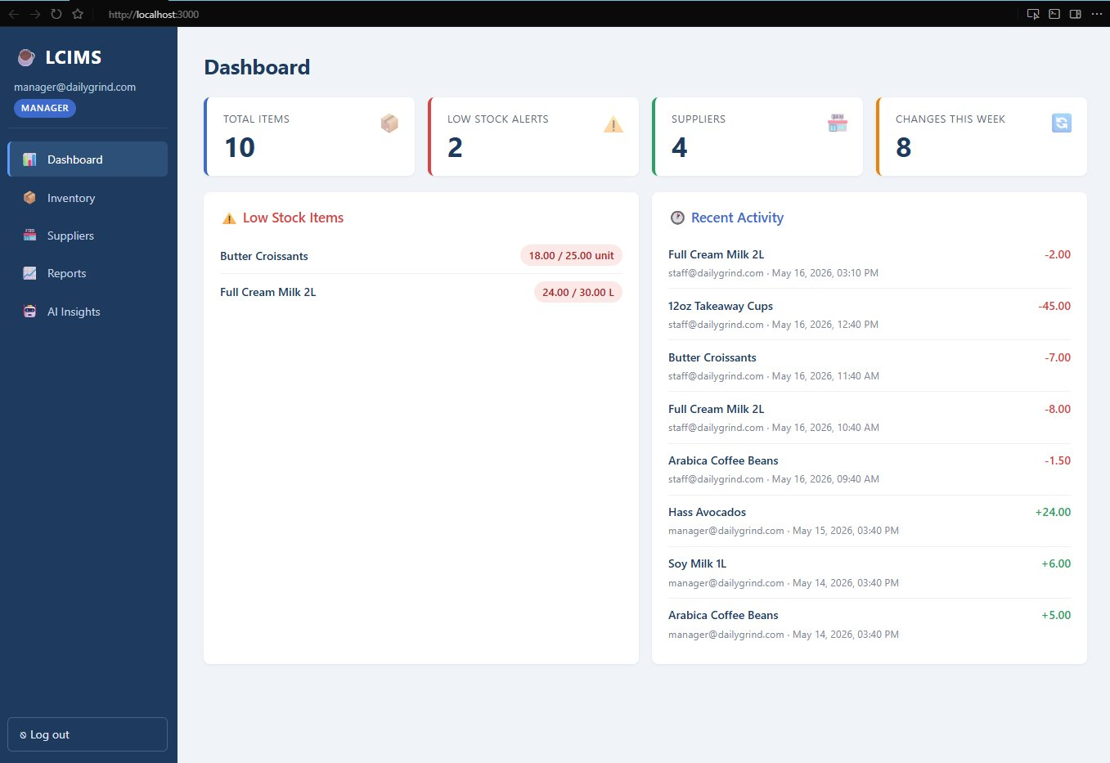
Figure 2: Dashboard Screen (http://localhost:3000)

5.4 Inventory List
The inventory list shows all ten stock items in a sortable table with columns for name, category, quantity, unit, threshold, supplier, and status. Green ✔ OK badges appear for items above threshold; red ⚠ Low Stock badges appear for Butter Croissants (18/25 unit) and Full Cream Milk 2L (24/30 L). Managers see an "+ Add Item" button; all authenticated users can search by name or category.
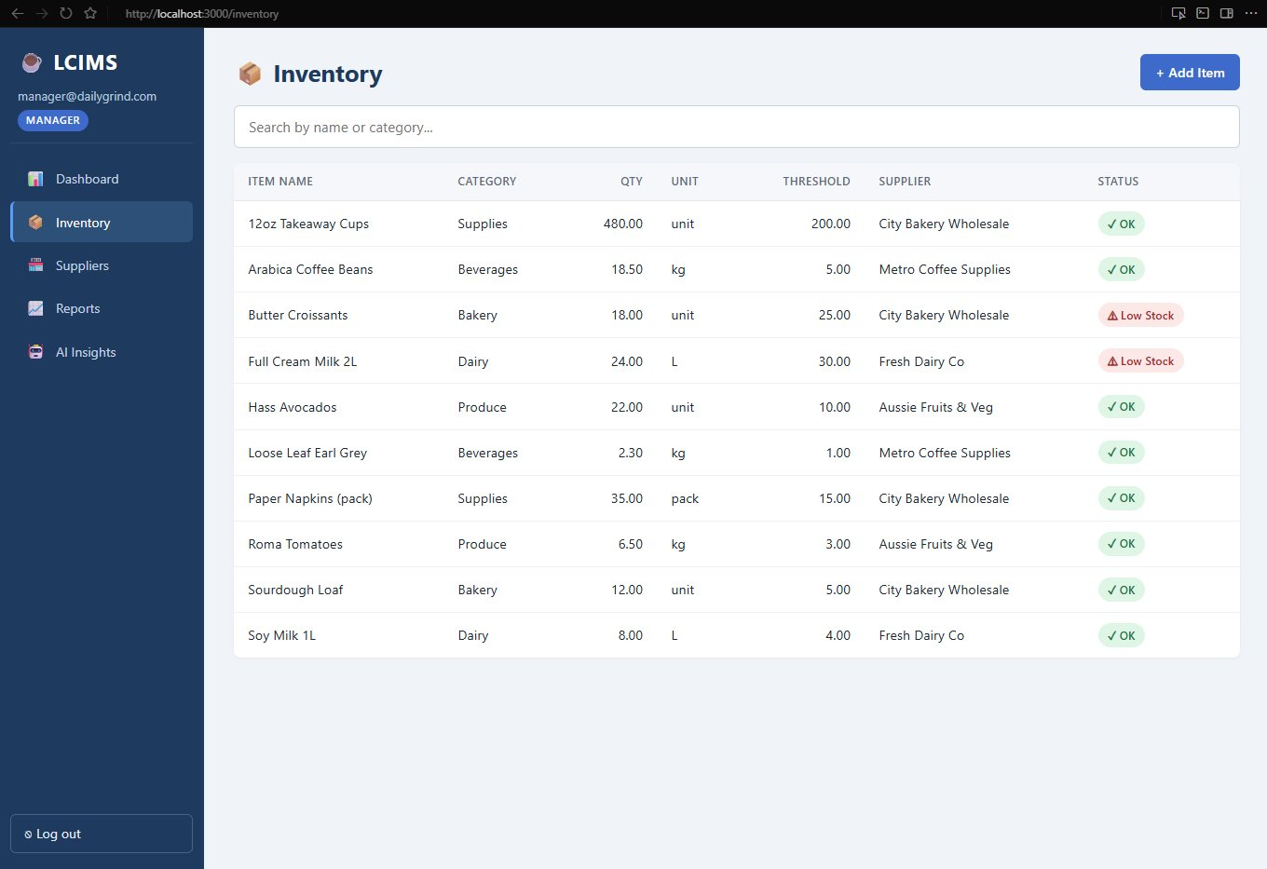
Figure 3: Inventory List Screen (http://localhost:3000/inventory)

5.5 Item Detail
The Item Detail screen for Arabica Coffee Beans uses a two-column layout. The left panel shows the editable form (name, category, unit, supplier dropdown, quantity, threshold) with Save Changes and Delete buttons for managers, and an Update Stock Quantity widget below. The right panel shows the full Stock Change History with timestamped entries and colour-coded +/- amounts.
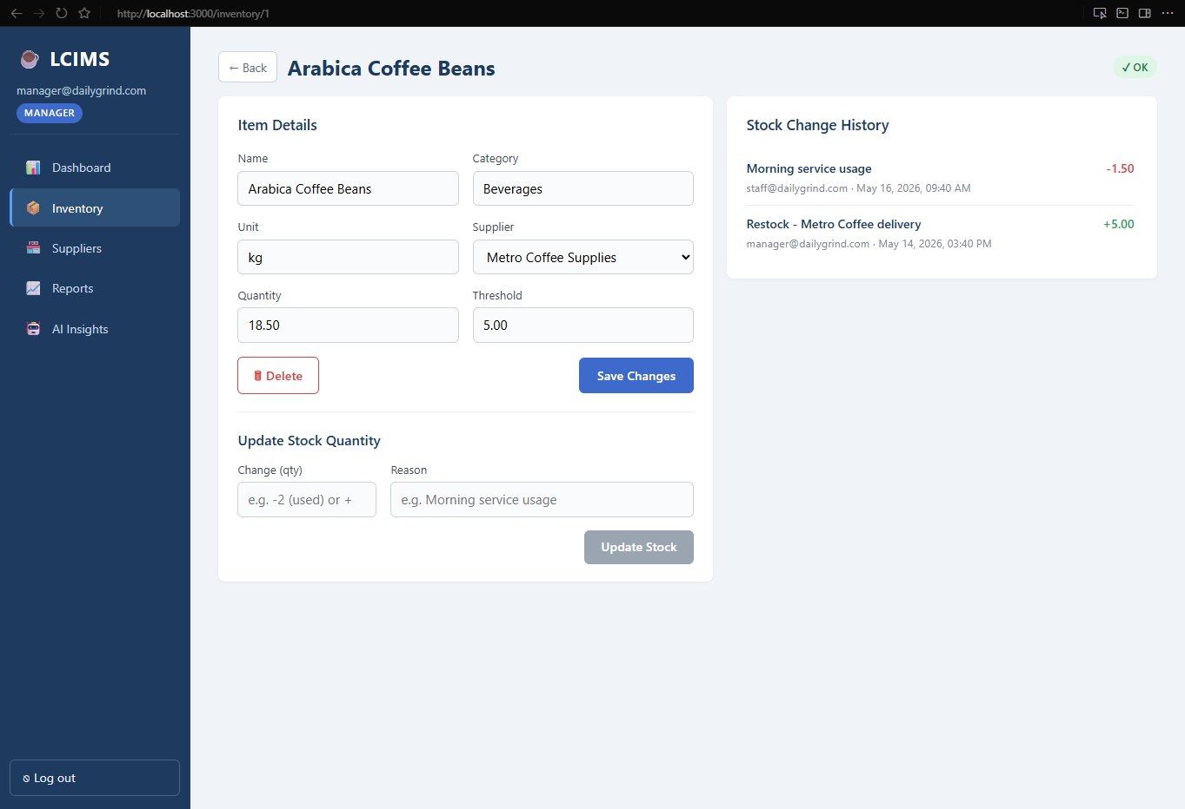
Figure 4: Item Detail Screen — Arabica Coffee Beans (http://localhost:3000/inventory/1)

5.6 Suppliers
The Suppliers page renders each of the four suppliers as a card showing company name, linked item count badge, contact person, phone number, and email address. Managers see Edit and Delete buttons on each card. The "+ Add Supplier" button at top-right opens an inline form.
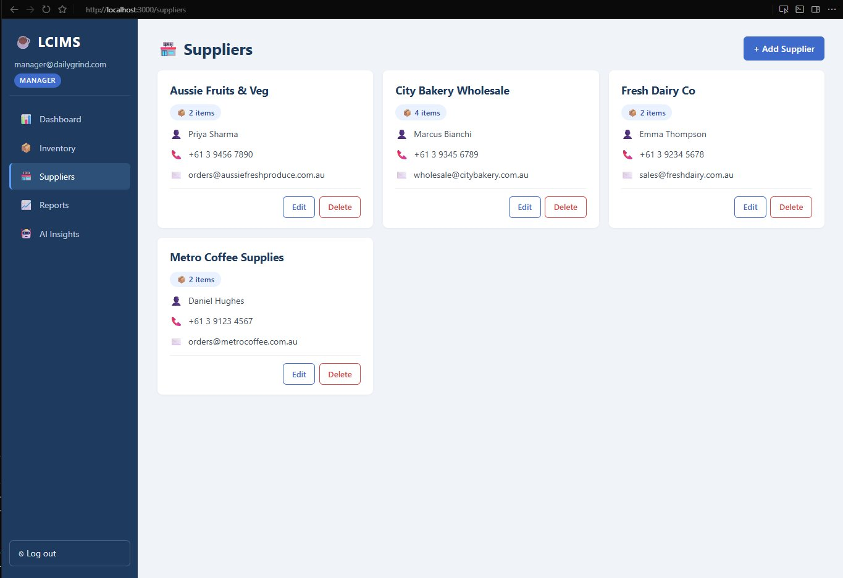
Figure 5: Suppliers Screen (http://localhost:3000/suppliers)

5.7 Reports
The Reports page provides a date range selector (09/05/2026 to 16/05/2026 in the example). After clicking Generate Report, four summary KPI cards appear (Items Tracked: 6, Total Used: 63.50, Total Restocked: 35.00, Most Used: 12oz Takeaway Cups), followed by a Recharts bar chart comparing usage vs restock per item, and a detailed data table.
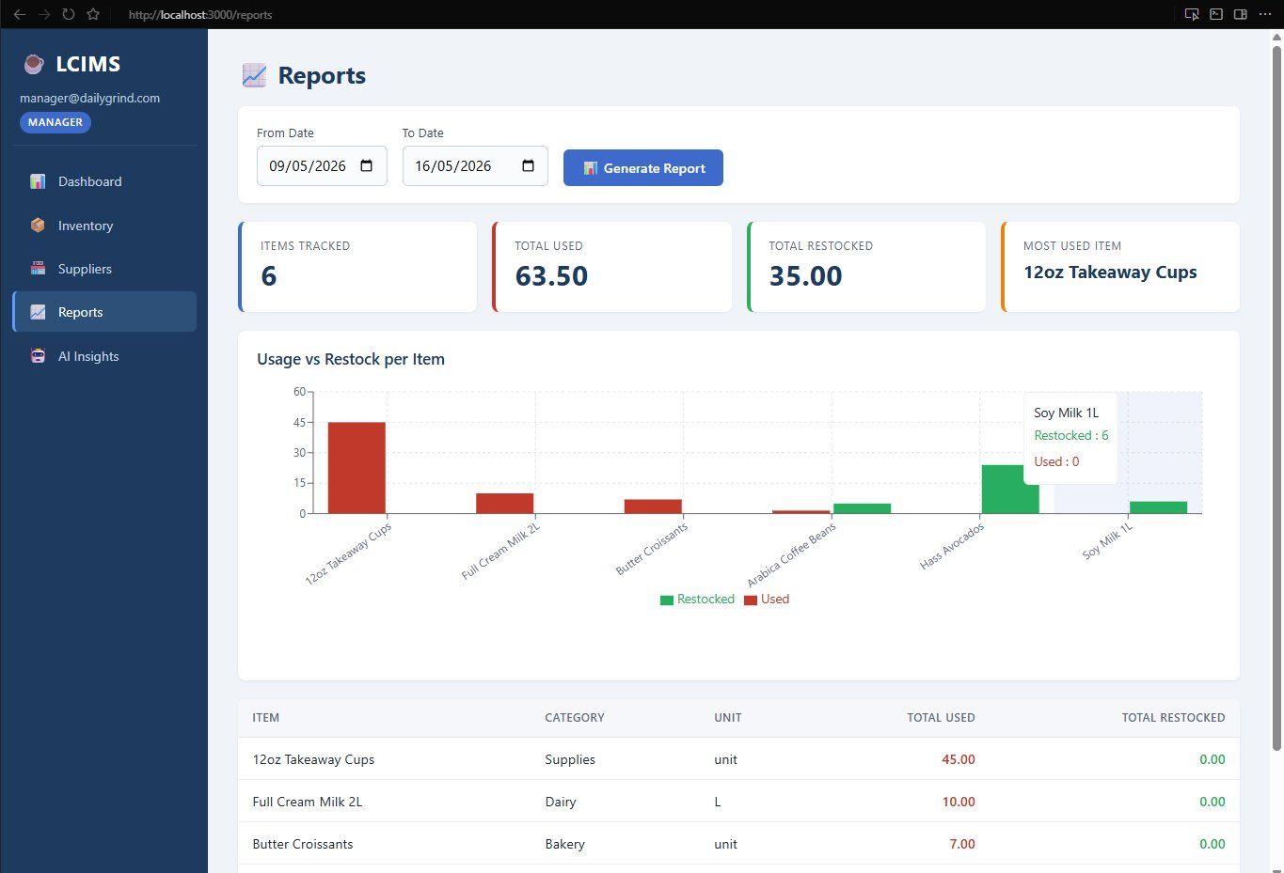
Figure 6: Reports Screen — Date Selector and KPI Cards (http://localhost:3000/reports)
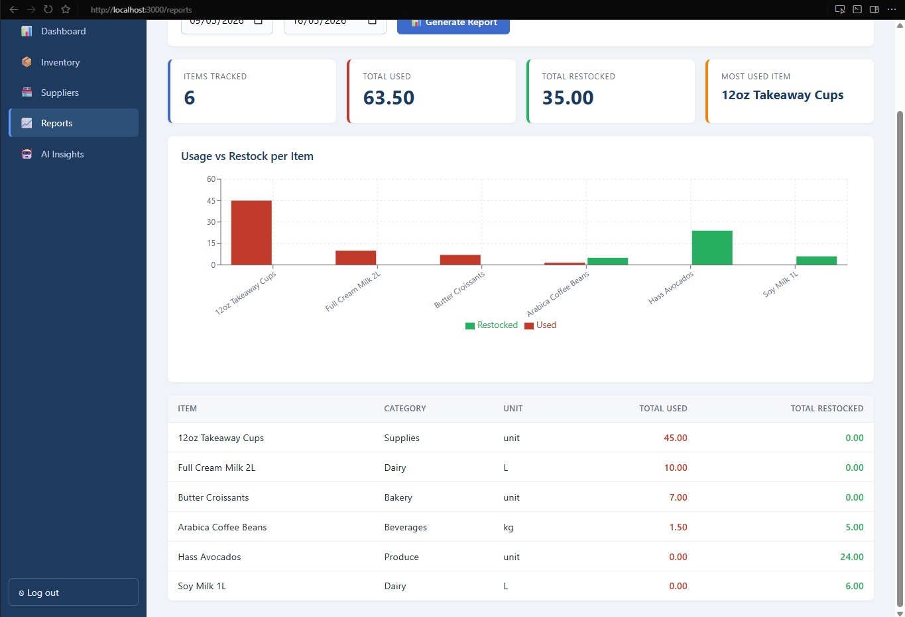
Figure 7: Reports Screen — Usage vs Restock Chart with Data Table

6. AI API Integration

6.1 Overview
LCIMS integrates the OpenAI gpt-3.5-turbo model to provide smart reorder suggestions — analysing current stock and seven-day usage patterns to recommend what to reorder and when. This addresses the assessment requirement for AI API integration and adds practical business value (OpenAI 2024). A key design decision was to include a deterministic demo-mode fallback so the feature remains usable for marking even without a paid OpenAI API key.

6.2 How It Works
- User clicks "Generate AI Suggestions" on the AI Insights screen.
- Backend queries inventory for the caller's café joined with seven-day usage from stock_logs.
- If a valid sk-prefixed OPENAI_API_KEY is configured, a structured prompt is sent to gpt-3.5-turbo with temperature 0.3.
- If no real key is present, the backend transparently falls back to a deterministic algorithm computing suggestions from the same data.
- Frontend renders colour-coded suggestion cards: red for "Today" (urgent), orange for "In 2-3 days", green for items comfortably stocked.

6.3 AI Insights Screen
The AI Insights screen shows the Smart Reorder Analysis card with the Generate button. After analysis, suggestion cards are displayed in a two-column grid. In the screenshots below, Butter Croissants and Full Cream Milk 2L are flagged as "Today" (red — order immediately), Roma Tomatoes and Soy Milk 1L are "In 3 days" (orange), while well-stocked items such as 12oz Takeaway Cups and Arabica Coffee Beans show "Not needed" (green, reorder qty 0).
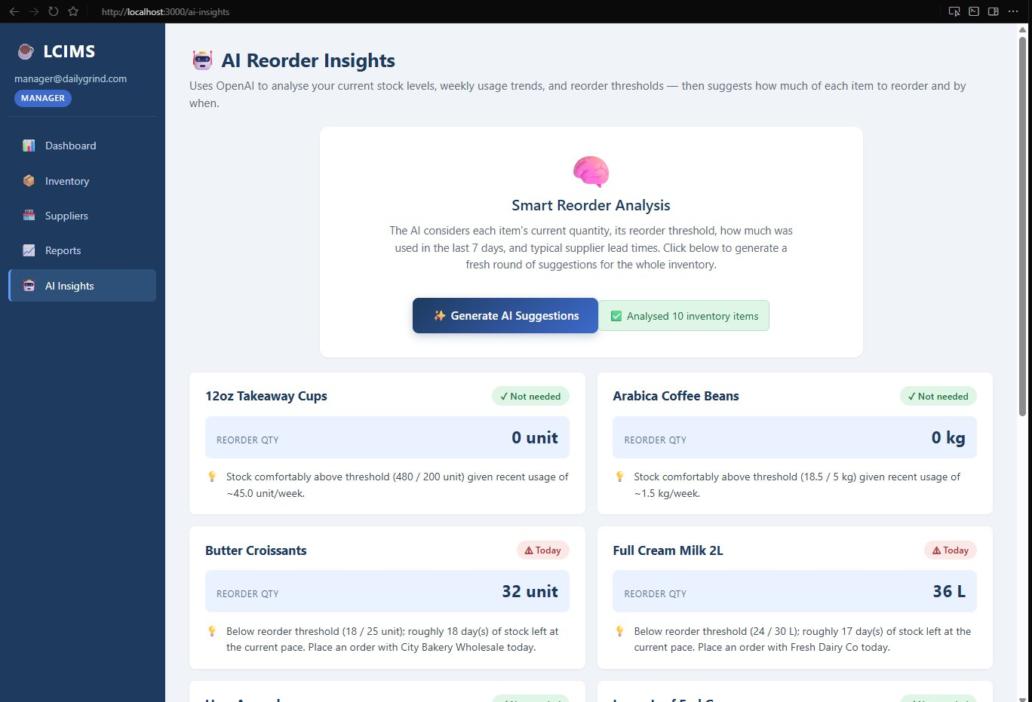
Figure 8: AI Insights Screen — Generate Card and First Suggestions (http://localhost:3000/ai-insights)
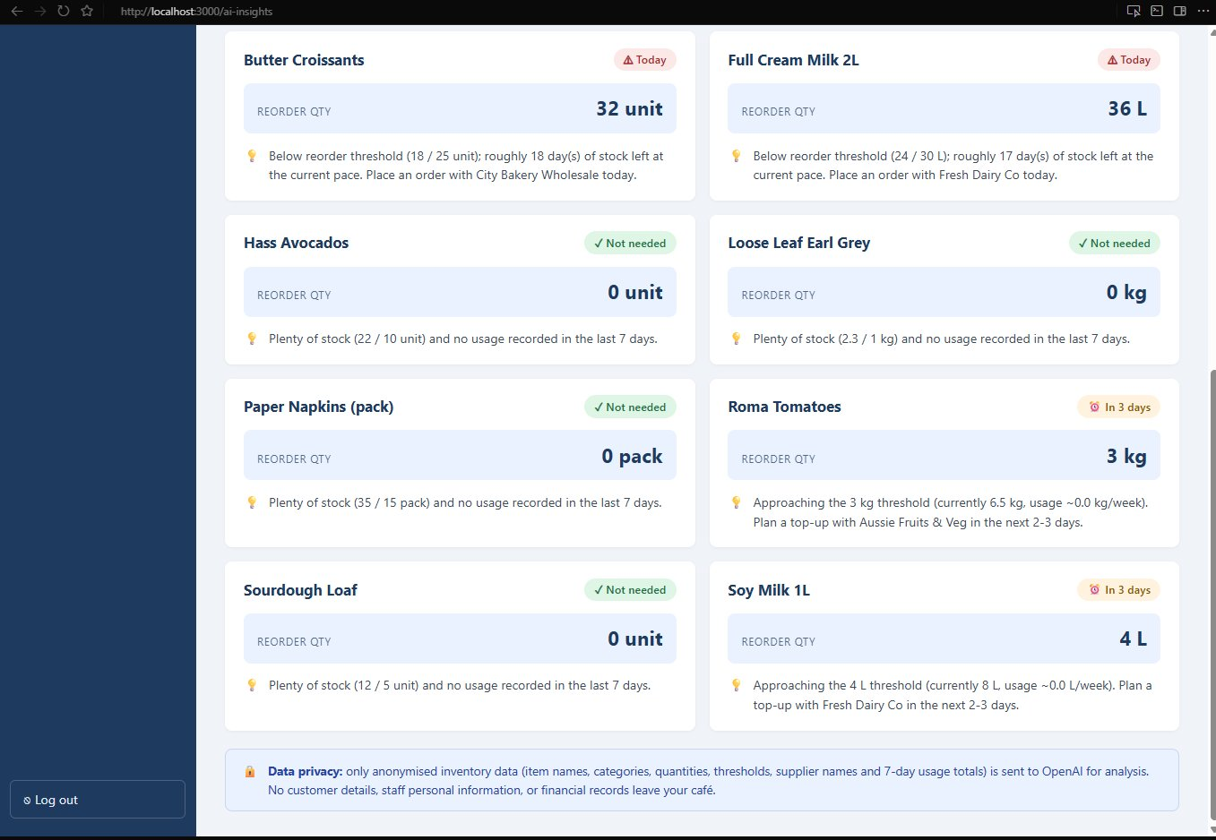
Figure 9: AI Insights Screen — Scrolled View Showing All Suggestions

6.4 Backend AI Route Code
The following excerpt from server/routes/ai.js shows the placeholder-key detection, lazy client construction, and demo-mode fallback:
function isPlaceholderKey(key) {
if (!key || typeof key !== 'string') return true;
const trimmed = key.trim();
if (trimmed === 'your_openai_api_key_here') return true;
return !trimmed.startsWith('sk-');
}

router.post('/reorder-suggestions', async (req, res) => {
const client = getOpenAIClient();
const { rows: items } = await pool.query(
`SELECT i.name, i.unit, i.quantity AS current_qty, i.threshold,
s.name AS supplier_name,
COALESCE(SUM(ABS(sl.change_qty)) FILTER (
WHERE sl.change_qty < 0
AND sl.timestamp > NOW() - INTERVAL '7 days'
), 0) AS used_last_7_days
FROM inventory_items i
LEFT JOIN suppliers s ON i.supplier_id = s.supplier_id
LEFT JOIN stock_logs sl ON sl.item_id = i.item_id
WHERE i.cafe_id = $1 GROUP BY i.item_id, s.name`,
[req.user.cafe_id]
);
if (!client) {
return res.json({ suggestions: buildDemoSuggestions(items, today),
items_analysed: items.length, demo: true });
}
// ... real OpenAI call with gpt-3.5-turbo ...
});

6.5 Error Handling
The AI route maps common OpenAI errors to friendly HTTP responses: 401 becomes 503 with a key-check hint; 429 becomes 503 with a billing/usage link; network errors (ENOTFOUND, ECONNREFUSED) return 502. The JSON parser strips Markdown code fences that models occasionally wrap output in.

7. Teamwork and Project Management

7.1 Team Roles and Responsibilities
Member | Role | Key Tasks
Md Minhazul Amin (K231250) | Project Manager / Backend Developer | Sprint planning, Express API, JWT auth, OpenAI integration with demo fallback
Ayush Subedi (K231274) | Frontend Developer / UI Designer | React 19 pages, sidebar layout, Recharts, inline styling, urgency colour-coding
Aayush Khadgi (K231962) | Database Designer / QA Tester | PostgreSQL schema, indexes, trigger, seed data, ERD, DPIA, test cases

7.2 Iteration Progress and Version Control
All planned sprint deliverables were completed. Version control is maintained in a private GitHub repository using a feature-branch workflow where every merge to main required a pull request reviewed by at least one teammate. The schema, server, and client are each self-contained modules under lcims/, allowing members to work independently without merge conflicts.

7.3 Individual Contributions
Member | Completed Tasks | Contribution %
Md Minhazul Amin | Express server with five route modules (auth, inventory with transactions, suppliers, reports with Promise.all, ai with demo fallback), JWT middleware | ~34%
Ayush Subedi | All seven React pages, sidebar Layout, AuthContext, Axios interceptors, urgency colour-coding for AI suggestions | ~33%
Aayush Khadgi | SQL schema (6 tables, 8 indexes, trigger), seed data, ERD, data dictionary, DPIA, 18 test cases | ~33%

8. Conclusion
This report has presented the complete systems design and implementation plan for the Local Café Inventory Management System. The team built a working full-stack application using React 19, Express 5, and PostgreSQL 16, with OpenAI gpt-3.5-turbo integration for intelligent reorder suggestions and a demo-mode fallback for marking purposes. The system addresses all business requirements and satisfies the functional and non-functional requirements defined in the SRS.
Engineering decisions reflect a focus on robustness: transactions around the stock-update flow, parameterised SQL on every query, a PL/pgSQL trigger maintaining updated_at, parallel dashboard queries, mapped OpenAI error codes, and tolerant JSON parsing. The nine screenshots in Section 5 and 6 demonstrate the fully working application, confirming that all seven screens are implemented and functional. The system is on track for final testing and deployment in Weeks 11-12.

References
Elmasri, R & Navathe, SB 2016, Fundamentals of database systems, 7th edn, Pearson, Boston, MA.
Express.js n.d., Express — Node.js web application framework, viewed May 2026, <https://expressjs.com/>.
Galitz, WO 2007, The essential guide to user interface design, 3rd edn, Wiley, Indianapolis, IN.
Office of the Australian Information Commissioner 2025, Australian Privacy Principles guidelines, viewed May 2026, <https://www.oaic.gov.au/privacy/australian-privacy-principles/>.
OpenAI 2024, OpenAI API documentation, viewed May 2026, <https://platform.openai.com/docs>.
PostgreSQL Global Development Group 2024, PostgreSQL 16 documentation, viewed May 2026, <https://www.postgresql.org/docs/16/>.
Pressman, RS & Maxim, BR 2020, Software engineering: a practitioner's approach, 9th edn, McGraw-Hill, New York, NY.
React n.d., React documentation, viewed May 2026, <https://react.dev/>.
Sommerville, I 2016, Software engineering, 10th edn, Pearson, Harlow, UK.

