LCIMS
Local Cafe Inventory Management System
End of Project Deliverables Report
Systems Implementation and Integration Plan
Team: The IT Crowd
Full Name | Role | Area | %
Md Minhazul Amin | Backend Developer | Backend | 34%
Ayush Subedi | Frontend Developer | Frontend | 33%
Aayush Khadgi | QA & Review | Testing, Review & Suggestions | 33%

Unit Code: CPRO306 — Capstone Project
Kent Institute Australia
Assessment 5 — Week 11
Submission Date: 26 May 2026

1. Introduction 4
2. Project Management Plan 5
2.1 Implementation Checklist 5
2.2 Hardware and Software Used 6
2.3 Team Resource Management 7
3. Server Installation and Configuration 8
3.1 Backend Server (Node.js + Express) 8
3.2 Database Server (PostgreSQL) 8
3.3 Frontend Server (React Development Server) 8
4. Front-End and Back-End Connectivity 11
4.1 How They Connect 11
4.2 Authentication Flow 11
4.3 Complete API Endpoint Table 11
5. Database Operations — CRUD Evidence 13
5.1 Create (INSERT) 13
5.2 Read (SELECT) 14
5.3 Update (UPDATE) 16
5.4 Delete (DELETE) 18
6. Security Implementation 20
6.1 Password Hashing — bcrypt with Cost Factor 12 20
6.2 JWT Authentication with 8-Hour Expiry 20
6.3 Role-Based Access Control 20
6.4 SQL Injection Prevention with Parameterised Queries 21
6.5 Login Validation and Error Handling 21
6.6 Data Privacy in the AI Integration 22
6.7 Secrets Management 22
7. Code Quality and Standards 23
7.1 File-Level Header Comments 23
7.2 JSDoc-Style Route Documentation 23
7.3 Consistent Naming Conventions 23
7.4 No Global Variables 23
7.5 Modular File Structure 23
7.6 Error Handling and Logging 23
7.7 Supporting Documentation 23
8. Testing Results 25
8.1 Test Summary 25
8.2 Test Evidence Screenshots 26
9. Teamwork and Feedback Response 30
9.1 Team Contributions 30
9.2 Response to Lecturer Feedback 30
10. Deployment Documentation 32
11. Conclusion 33
12. References 34

1. Introduction
This report documents the completed implementation, integration, security, testing, and deployment of LCIMS — the Local Cafe Inventory Management System — built by Team The IT Crowd for Assessment 5 of CPRO306 Capstone Project at Kent Institute Australia. The report demonstrates that the design decisions made in earlier assessments (the Software Requirements Specification in Assessment 2 and the Systems Design and Implementation Plan in Assessment 4) have been executed in full, integrated as a working full-stack web application, secured against common threats, and verified through structured manual testing.
LCIMS is a full-stack inventory and supplier management web application designed for a single cafe (seeded in the database as "The Daily Grind Cafe" in Melbourne). The system provides role-based access for three user types: Manager (full create/read/update/delete privileges across all data), Staff (read access plus the ability to record stock movements during a shift), and Admin (cross-cafe administrative access). The delivered modules include user authentication, inventory CRUD with automatic stock movement logging, supplier directory management, a KPI dashboard, date-ranged usage reports with bar charts, a low-stock alerts management page, and an AI-powered reorder suggestions feature backed by OpenAI gpt-3.5-turbo with an offline demo fallback.
The system is implemented as a three-tier architecture. The presentation layer is a React 19 single-page application bootstrapped with Create React App, routed through React Router 7, and styled with inline CSS-in-JS. The application layer is a Node.js 18 server built on Express 5 with JSON Web Token authentication, bcrypt password hashing, and a connection-pooled PostgreSQL driver. The data layer is a PostgreSQL 16 database containing six normalised tables, eight performance indexes, foreign key constraints, and a trigger to maintain timestamps.
The remaining sections of this report are organised as follows: Section 2 documents the project management plan, hardware, software, and team resource allocation. Section 3 provides screenshots and explanations of server installation. Section 4 explains how the frontend and backend communicate. Section 5 demonstrates the four CRUD operations with evidence. Section 6 details the security implementation. Section 7 reviews code quality and standards. Section 8 presents the test results from the twenty-eight test cases in TEST_PLAN.md. Section 9 covers teamwork and lecturer feedback. Section 10 summarises deployment documentation. Section 11 concludes the report, and Section 12 lists references in Harvard style.

2. Project Management Plan

2.1 Implementation Checklist
All planned components reached completion before the Week 11 submission date. The checklist below confirms that every module described in the Assessment 4 implementation plan is now built, integrated, and verified through manual testing.
Component | Status | Team Member | Notes
PostgreSQL Database  (database/lcims_schema.sql) | Complete | Md Minhazul Amin | 6 tables (cafes, users, suppliers, inventory_items, stock_logs, alerts) with 8 indexes, FK constraints, and updated_at trigger. Seed data: 1 cafe, 3 users, 4 suppliers, 10 items, 8 stock logs, 2 active alerts.
Authentication API  (server/routes/auth.js) | Complete | Md Minhazul Amin | POST /register and POST /login endpoints with bcrypt hashing (cost 12) and JWT signing (8-hour expiry). Roles: Manager, Staff, Admin.
Auth Middleware  (server/middleware/auth.js) | Complete | Md Minhazul Amin | verifyToken decodes JWT from Authorization header; requireManager enforces Manager/Admin role on protected routes.
Inventory API  (server/routes/inventory.js) | Complete | Md Minhazul Amin | Full CRUD plus PATCH /stock with transactional update (UPDATE quantity + INSERT stock_log + conditional INSERT alert if below threshold). Movement history endpoint.
Suppliers API  (server/routes/suppliers.js) | Complete | Ayush Subedi | Full CRUD with item_count aggregate. ON DELETE SET NULL preserves inventory items when supplier removed.
Reports API  (server/routes/reports.js) | Complete | Ayush Subedi | Dashboard KPIs (6 parallel queries) and date-range usage endpoint with from/to validation.
Alerts API  (server/routes/alerts.js) | Complete | Aayush Khadgi | GET active alerts joined with item details; PATCH /:id/resolve sets status to resolved.
AI Insights API  (server/routes/ai.js) | Complete | Aayush Khadgi | POST /reorder-suggestions calls OpenAI gpt-3.5-turbo or runs offline demo mode if no API key.
React Frontend Core  (App.js, AuthContext, Layout, axios) | Complete | Ayush Subedi | Protected routes, JWT in localStorage as lcims_token, sidebar nav with role badge.
React Page Components  (8 routes) | Complete | All members | Login, Dashboard, Inventory, ItemDetail, Suppliers, Reports, Alerts, AIInsights.
Manual Testing  (TEST_PLAN.md, 28 cases) | Complete | All members | Authentication, CRUD, suppliers, reports, alerts, AI, and security tests executed and documented.
Project Documentation | Complete | All members | README.md, USER_GUIDE.md, DEPLOYMENT_GUIDE.md, TEST_PLAN.md, ASSESSMENT5_REPORT_OUTLINE.md, and file-level JSDoc headers across all source files.

The complete project was incrementally delivered through the team Git repository with feature branches for each major component. All stretch goals identified in Assessment 4 (alerts management UI, code commenting, and supporting documentation) were completed before submission. Deferred items for future work include automated unit testing frameworks (Jest), cloud hosting (Render or Railway), and a dedicated multi-cafe admin portal.

2.2 Hardware and Software Used
The system was developed and tested on standard Windows development machines with the following software stack:
Tool | Version | Purpose
Node.js | 18.x LTS (tested up to 24.x) | JavaScript runtime for the Express API and React dev server
npm | 9+ (bundled with Node.js) | Package management for both server/ and client/ folders
Express | 5.2.x | REST API framework with routing, CORS, and JSON body parsing middleware
PostgreSQL | 16+ | Relational database — single lcims database with six tables
pg (node-postgres) | 8.x | PostgreSQL connection pool used in server/db.js
React | 19.2.x | Single-page application UI framework
React Router | 7.x | Client-side routing for /login, /inventory, /suppliers, etc.
Axios | 1.16.x | HTTP client with JWT interceptor; baseURL http://localhost:5000/api
Recharts | 3.x | Bar chart on the Reports page showing usage and restock totals
bcryptjs | 3.x | Password hashing with cost factor 12
jsonwebtoken | 9.x | JWT signing and verification with 8-hour expiry
OpenAI Node SDK | 6.x | AI reorder suggestions via gpt-3.5-turbo
Visual Studio Code | Current | Primary integrated development environment
Cursor AI (Opus model) | Current | AI-assisted development, documentation, and refactoring
pgAdmin 4 | Bundled with PostgreSQL | GUI for database inspection and seed verification
Git / GitHub | Current | Version control; remote repository for collaboration
Windows 10/11 | N/A | Primary development operating system

The minimum hardware requirement is 4 GB of RAM (8 GB recommended for comfortable development) and 10 GB of free disk space, as documented in DEPLOYMENT_GUIDE.md. A typical development workflow uses three concurrent terminals: one for PostgreSQL (running as a Windows service), one for the backend Express server on port 5000, and one for the React development server on port 3000.

2.3 Team Resource Management
The team divided the work along clear technical lines while maintaining shared responsibility for testing and documentation. Md Minhazul Amin led the backend development, taking primary responsibility for the database schema, Express server bootstrapping, authentication middleware, inventory API, and project repository management. Ayush Subedi led the frontend integration work, building the React core (AuthContext, Layout, Axios instance), the Dashboard and Reports pages with Recharts visualisations, and the supplier API. Aayush Khadgi developed the Alerts and AI Insights modules end-to-end, along with the user guide and screenshot documentation.
Day-to-day communication used a WhatsApp group for quick coordination, blockers, and status updates. The team met in-person at the Kent campus computer labs for integration testing sessions and demonstration rehearsals. A shared cloud folder was used to draft Word document sections and exchange screenshots.
Version control was handled through a Git repository on GitHub. The main branch was reserved for stable submission code, while feature work was carried out on dedicated branches such as feature/alerts and docs/test-plan. The .gitignore file was carefully maintained to exclude node_modules folders, .env files containing secrets, assessment zip archives, and Word document lock files. GitHub Desktop was used by team members who preferred a graphical interface to the Git command line.

3. Server Installation and Configuration

3.1 Backend Server (Node.js + Express)
The backend server is bootstrapped from server/index.js. After installing dependencies with npm install in the server folder, the .env file must be created from the .env.example template with valid PostgreSQL credentials, a JWT_SECRET of at least 32 random characters, and an optional OPENAI_API_KEY. The server is then started in development mode with npm run dev (which runs nodemon for automatic restart on file changes) or in production mode with npm start.
On successful startup the server prints two confirmation messages to the console: the first confirms the Express server is listening on port 5000, and the second confirms the connection to the PostgreSQL database has been established. The server mounts six route groups under the /api prefix: /api/auth (public), /api/inventory, /api/suppliers, /api/reports, /api/ai, and /api/alerts (all protected by JWT verification).
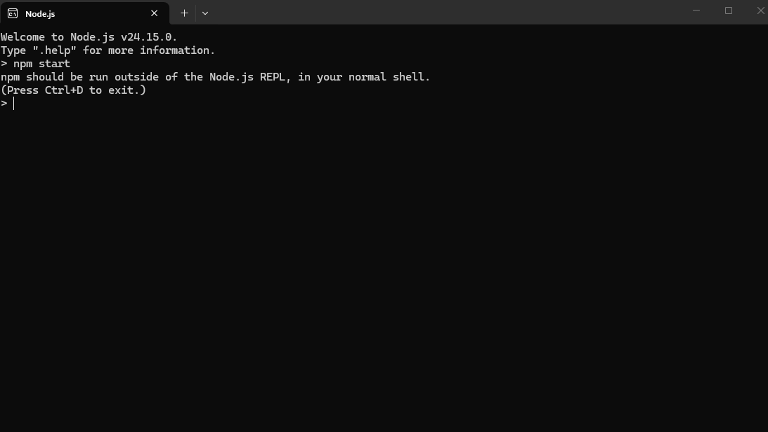
Figure 3.1 — Node.js runtime version confirmation in PowerShell terminal, showing the LCIMS development environment is ready.

3.2 Database Server (PostgreSQL)
PostgreSQL 16 is installed as a Windows service that starts automatically on boot. The database is created and seeded with two commands: first, psql -U postgres -c "CREATE DATABASE lcims;" creates the empty database; second, psql -U postgres -d lcims -f database/lcims_schema.sql loads the schema and seed data inside a single transaction. The schema file is fully re-runnable — it drops all tables in reverse dependency order before recreating them, so the team can reset the database to a known state at any time.
A sanity query confirms the seed data has been loaded correctly. The expected row counts are: 1 cafe, 3 users, 4 suppliers, 10 inventory items, 8 stock logs, and 2 active alerts. The two active alerts correspond to Full Cream Milk 2L (24 L below the 30 L threshold) and Butter Croissants (18 units below the 25 unit threshold), which are deliberately seeded below their reorder thresholds to demonstrate the alert mechanism.

3.3 Frontend Server (React Development Server)
The React frontend is launched from the client folder by running npm install followed by npm start. Create React App compiles the application and opens the default browser at http://localhost:3000. The frontend communicates with the backend via Axios calls to http://localhost:5000/api, so no development proxy is needed in package.json. The login page is the entry point — users authenticate with one of the three seed accounts (manager@dailygrind.com, staff@dailygrind.com, or admin@lcims.com), all of which share the password "password123" in the development environment.
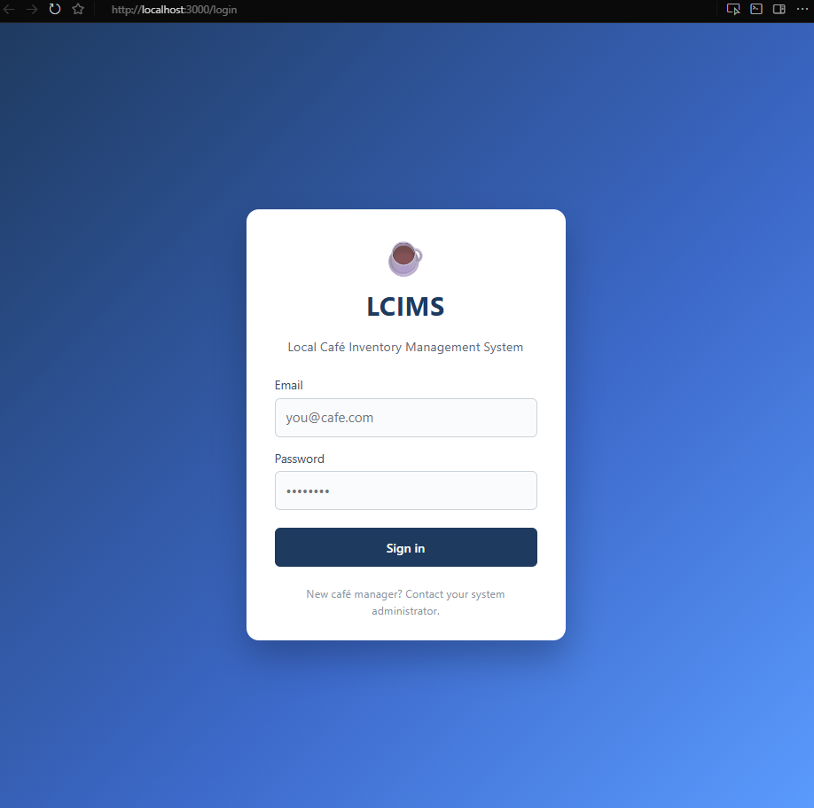
Figure 3.2 — LCIMS login page rendered at http://localhost:3000/login. The branded card-based form is the entry point for all users and accepts the seed credentials provided in the database schema.
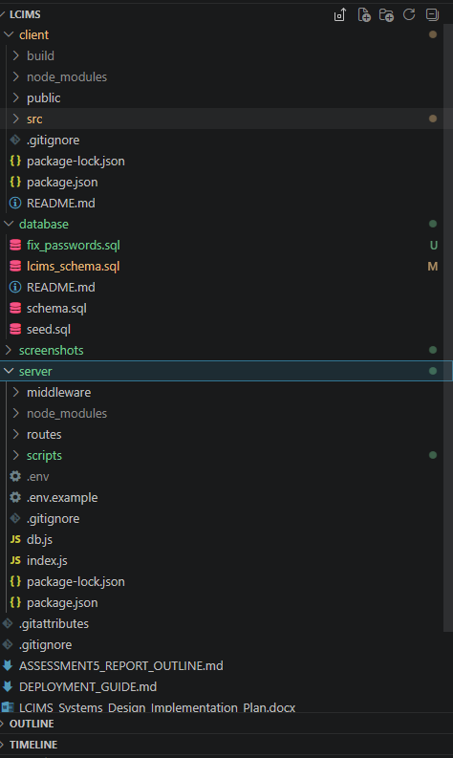
Figure 3.3 — Project structure visible in the VS Code Explorer pane, showing the three top-level folders (client, database, server) and the supporting documentation files at the project root.

4. Front-End and Back-End Connectivity

4.1 How They Connect
The React frontend and the Express backend run on different ports during development (3000 and 5000 respectively), which means every API call is a cross-origin HTTP request. Three pieces of infrastructure make this work reliably and securely.
First, a pre-configured Axios instance lives in client/src/api/axios.js. Its baseURL is set to http://localhost:5000/api, so every page component can simply call api.get("/inventory") rather than typing out the full URL. A request interceptor on this instance reads the JWT from localStorage (under the key lcims_token) and attaches it to every outgoing request as an Authorization: Bearer <token> header.
Second, the Express server has the cors middleware enabled in server/index.js. This middleware adds the Access-Control-Allow-Origin response header that the browser requires before allowing JavaScript to read the response of a cross-origin request.
Third, the verifyToken middleware in server/middleware/auth.js sits in front of every protected route. It reads the Authorization header, extracts the JWT, verifies the signature using JWT_SECRET, and attaches the decoded payload (user_id, email, role, cafe_id) to req.user so that downstream handlers know who is making the request and which cafe they belong to.

4.2 Authentication Flow
The end-to-end authentication flow follows these ten steps:
- The user enters their email and password into the Login page (client/src/pages/Login.js).
- The page calls POST /api/auth/login with a JSON body containing the email and password.
- The server loads the user record by email and compares the submitted password against the stored bcrypt hash using bcrypt.compare.
- On a successful match, the server builds a JWT payload containing user_id, email, role, and cafe_id, then signs it with JWT_SECRET and an 8-hour expiry.
- The server returns the signed token and a slim user object in the response body.
- AuthContext.login on the client side stores the token in localStorage under the key lcims_token and updates the React state.
- The user is redirected to the Dashboard at /.
- All subsequent API calls automatically include the Authorization: Bearer <token> header thanks to the Axios request interceptor.
- The verifyToken middleware on the server validates the signature and expiry of the token on every request.
- On logout, AuthContext.logout removes the token from localStorage and the React Router Navigate component sends the user back to the login page.

4.3 Complete API Endpoint Table
The table below lists every API endpoint exposed by the LCIMS server. All routes except those under /api/auth require a valid JWT in the Authorization header. Routes marked Manager or Admin will return HTTP 403 if called by a user with the Staff role.
Method | Path | Required Role | Purpose
POST | /api/auth/register | Public | Create a new user account with a bcrypt-hashed password
POST | /api/auth/login | Public | Validate credentials and issue a signed JWT (8-hour expiry)
GET | /api/inventory | Any authenticated | List all inventory items for the user's cafe
GET | /api/inventory/:id | Any authenticated | Fetch full details for a single inventory item
POST | /api/inventory | Manager / Admin | Create a new inventory item
PUT | /api/inventory/:id | Manager / Admin | Update all editable fields of an inventory item
PATCH | /api/inventory/:id/stock | Any authenticated | Adjust quantity, write a stock log, and raise an alert if the result is below threshold
DELETE | /api/inventory/:id | Manager / Admin | Delete an inventory item
GET | /api/inventory/:id/logs | Any authenticated | Fetch the stock movement history for one item
GET | /api/suppliers | Any authenticated | List all suppliers with an aggregate item_count per supplier
POST | /api/suppliers | Manager / Admin | Create a new supplier
PUT | /api/suppliers/:id | Manager / Admin | Update supplier details
DELETE | /api/suppliers/:id | Manager / Admin | Delete a supplier (linked items have supplier_id set to NULL)
GET | /api/reports/dashboard | Any authenticated | Return dashboard KPIs, recent activity, and low-stock items
GET | /api/reports/usage | Any authenticated | Per-item usage and restock totals for a date range
POST | /api/ai/reorder-suggestions | Any authenticated | Generate AI reorder cards via OpenAI or fallback demo mode
GET | /api/alerts | Any authenticated | List all active low-stock alerts for the user's cafe
PATCH | /api/alerts/:id/resolve | Any authenticated | Mark an alert as resolved

5. Database Operations — CRUD Evidence
This section demonstrates that all four CRUD operations (Create, Read, Update, Delete) are functional across the inventory and supplier modules. Each operation is tied to a user interface action, an API endpoint, an SQL operation, and an evidence screenshot. All SQL queries throughout the codebase use parameterised statements (with $1, $2, $3 placeholders passed as a second argument to pool.query) to prevent SQL injection — string concatenation of user input into SQL is never used.

5.1 Create (INSERT)
Create operations are initiated from the inventory page (the + Add Item button, visible only to Manager and Admin users) and from the suppliers page (the + Add Supplier button). The frontend submits a POST request to /api/inventory or /api/suppliers respectively, the Express handler validates the required fields, and pool.query executes a parameterised INSERT statement. The new row is returned in the response body and immediately rendered in the UI without a page reload.
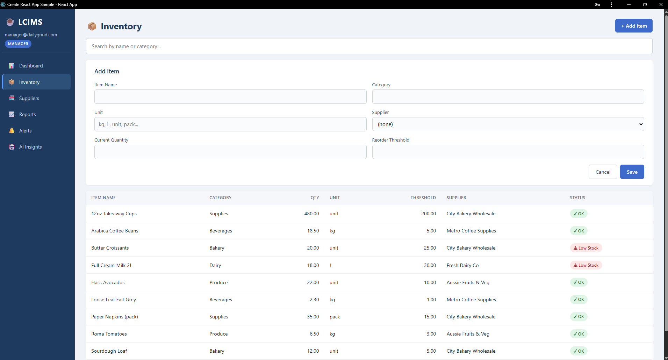
Figure 5.1 — Add New Item modal form on the Inventory page. The form is only visible to Manager and Admin users and validates required fields (name, category, unit) before submission.
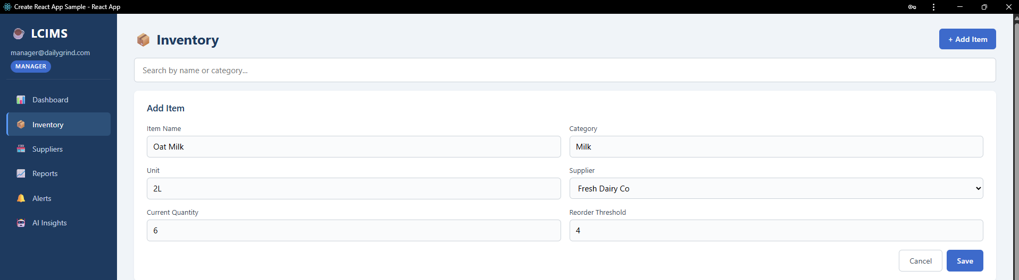
Figure 5.2 — Form populated with sample data ("Espresso Beans Premium") before submission to POST /api/inventory.
Figure 5.3 — Newly created item appearing in the inventory list immediately after the INSERT operation completed successfully.
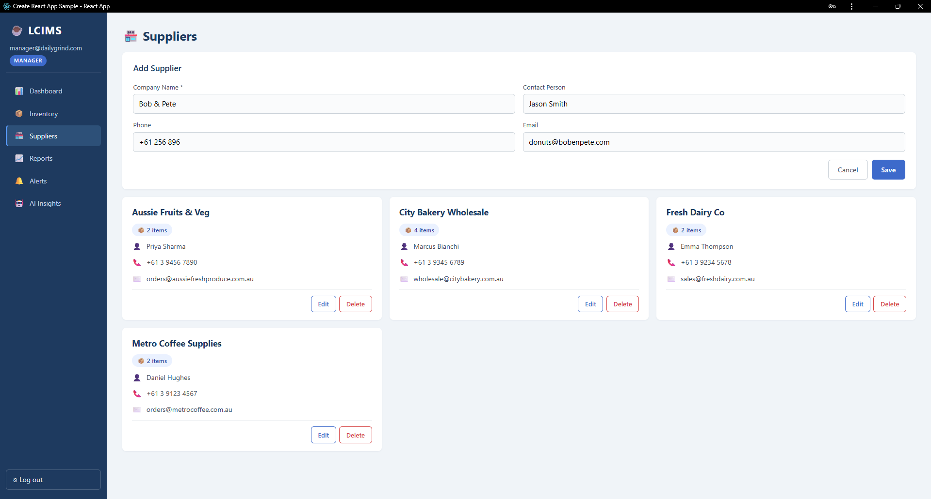
Figure 5.4 — Add Supplier modal demonstrating the equivalent Create flow for the suppliers table.
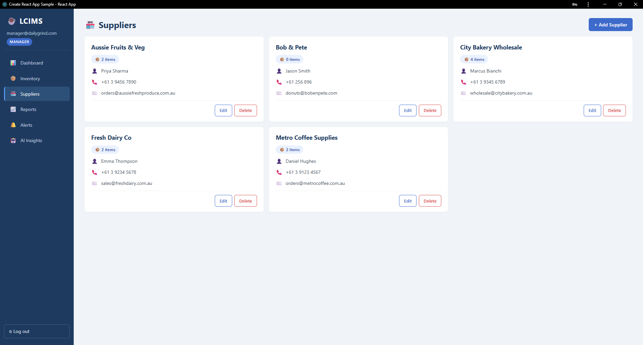
Figure 5.5 — Newly added supplier visible in the supplier grid with an initial item count of zero.

5.2 Read (SELECT)
Read operations power every list and detail view in the application. The inventory page fetches all items for the user's cafe (with a LEFT JOIN against suppliers to include supplier names). The dashboard performs six SELECT queries in parallel using Promise.all to assemble the KPI cards, recent activity feed, and low-stock summary. The reports page reads aggregated usage data filtered by a date range. Every SELECT includes a WHERE cafe_id = $1 clause to enforce multi-tenant data isolation.
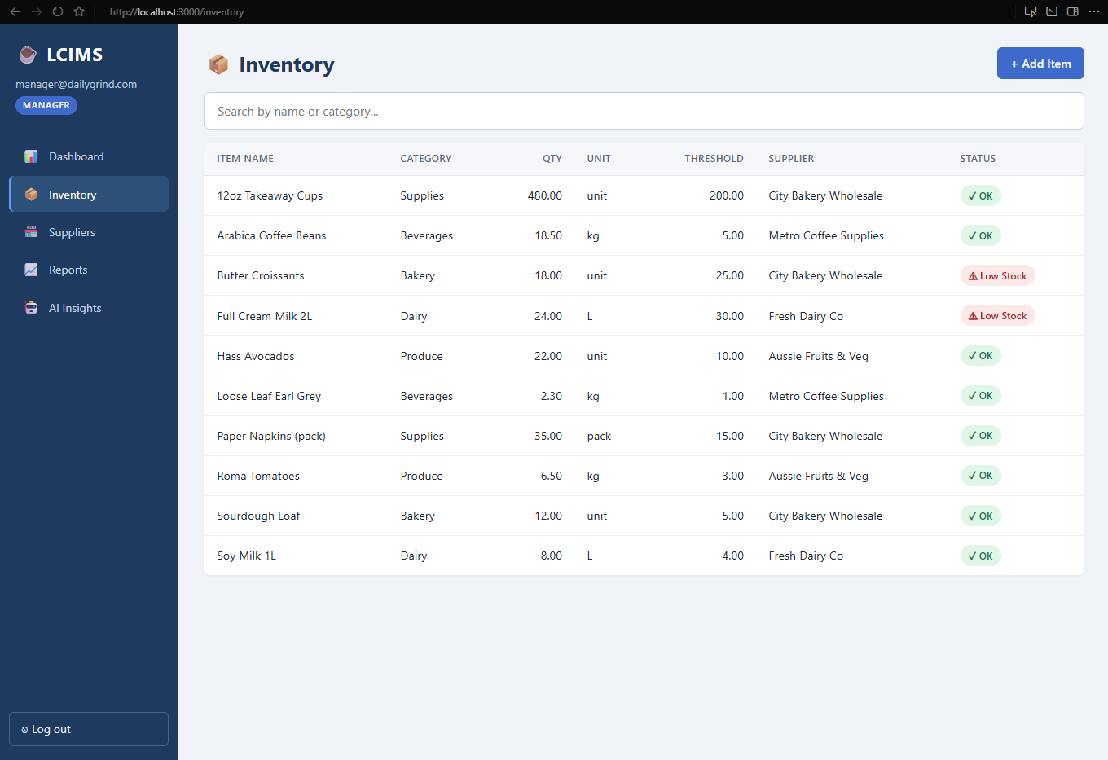
Figure 5.6 — Inventory list page rendering 10 seed items with category labels and "Low Stock" badges on Full Cream Milk 2L and Butter Croissants. The data was fetched via GET /api/inventory.
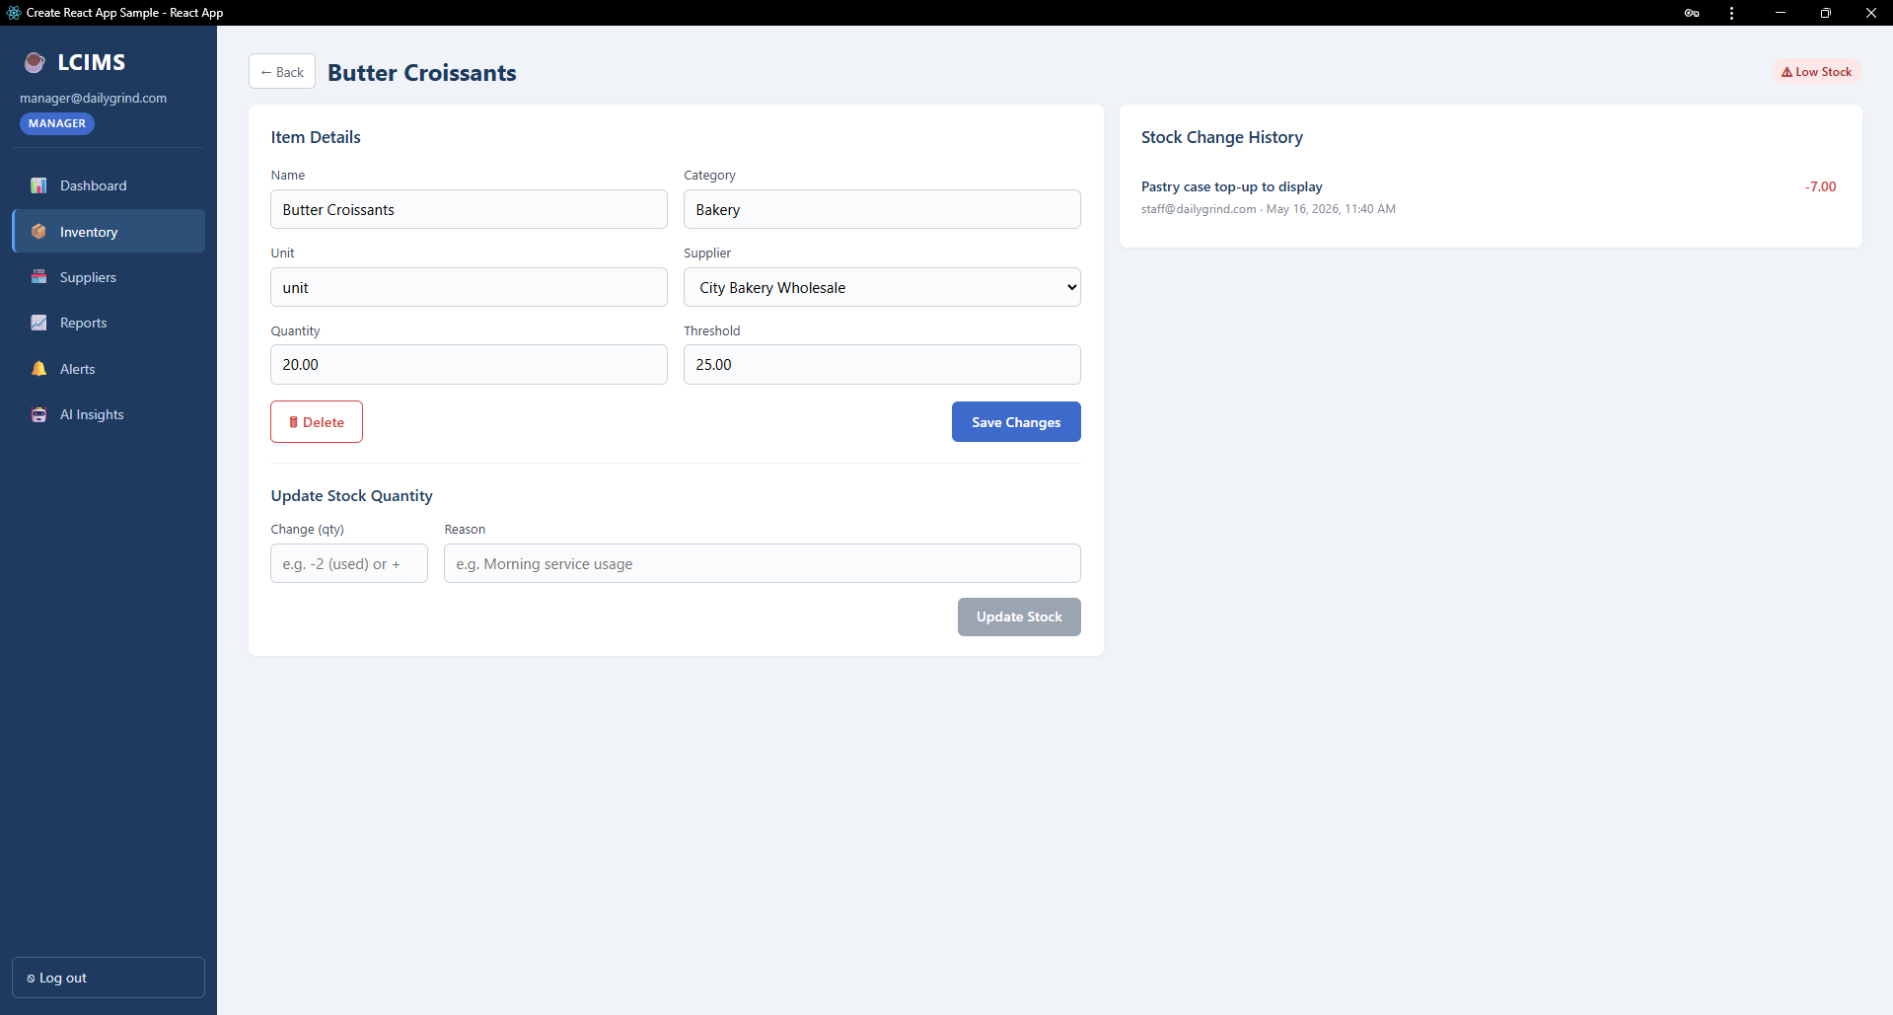
Figure 5.7 — Single-item detail view fetched from GET /api/inventory/:id, displaying current stock, threshold, supplier, and the stock adjustment form.
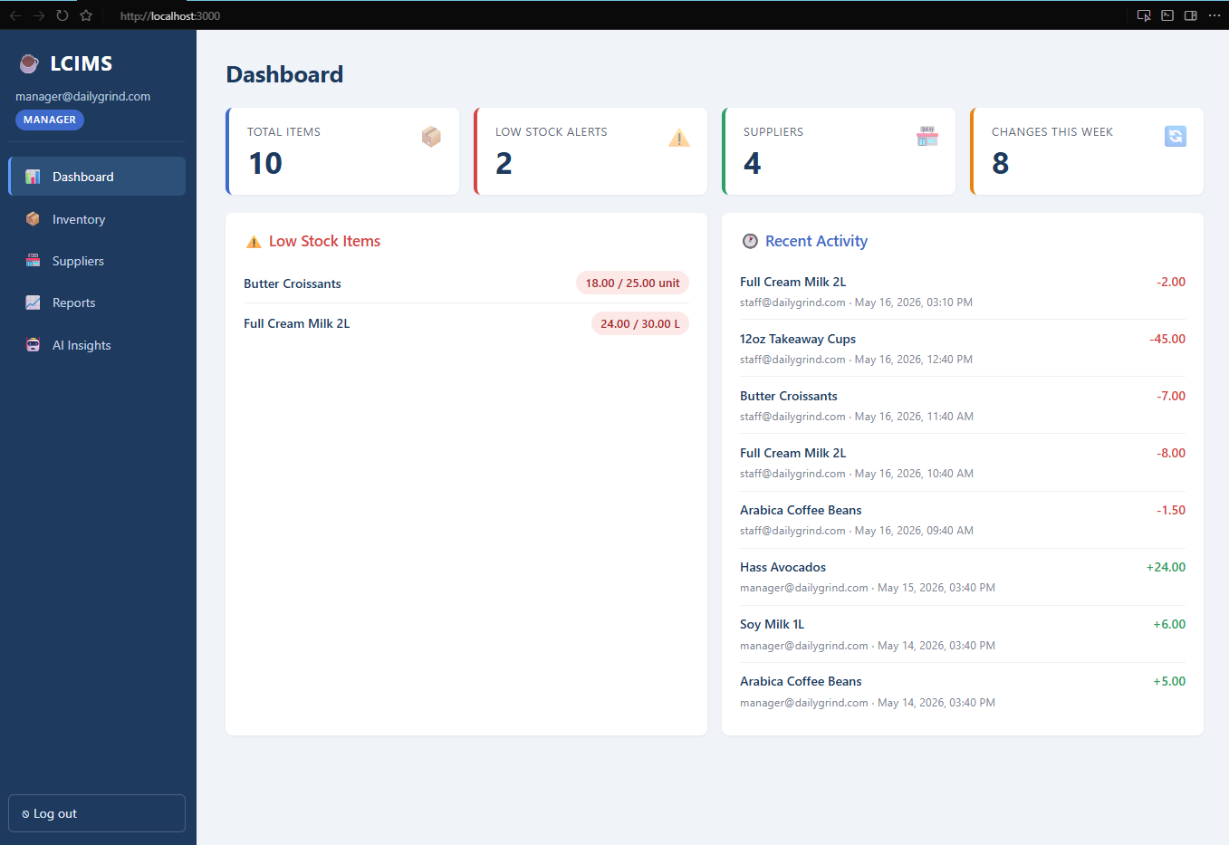
Figure 5.8 — Dashboard page populated with KPI cards, low stock items, and recent activity. All six panels load in parallel via GET /api/reports/dashboard.
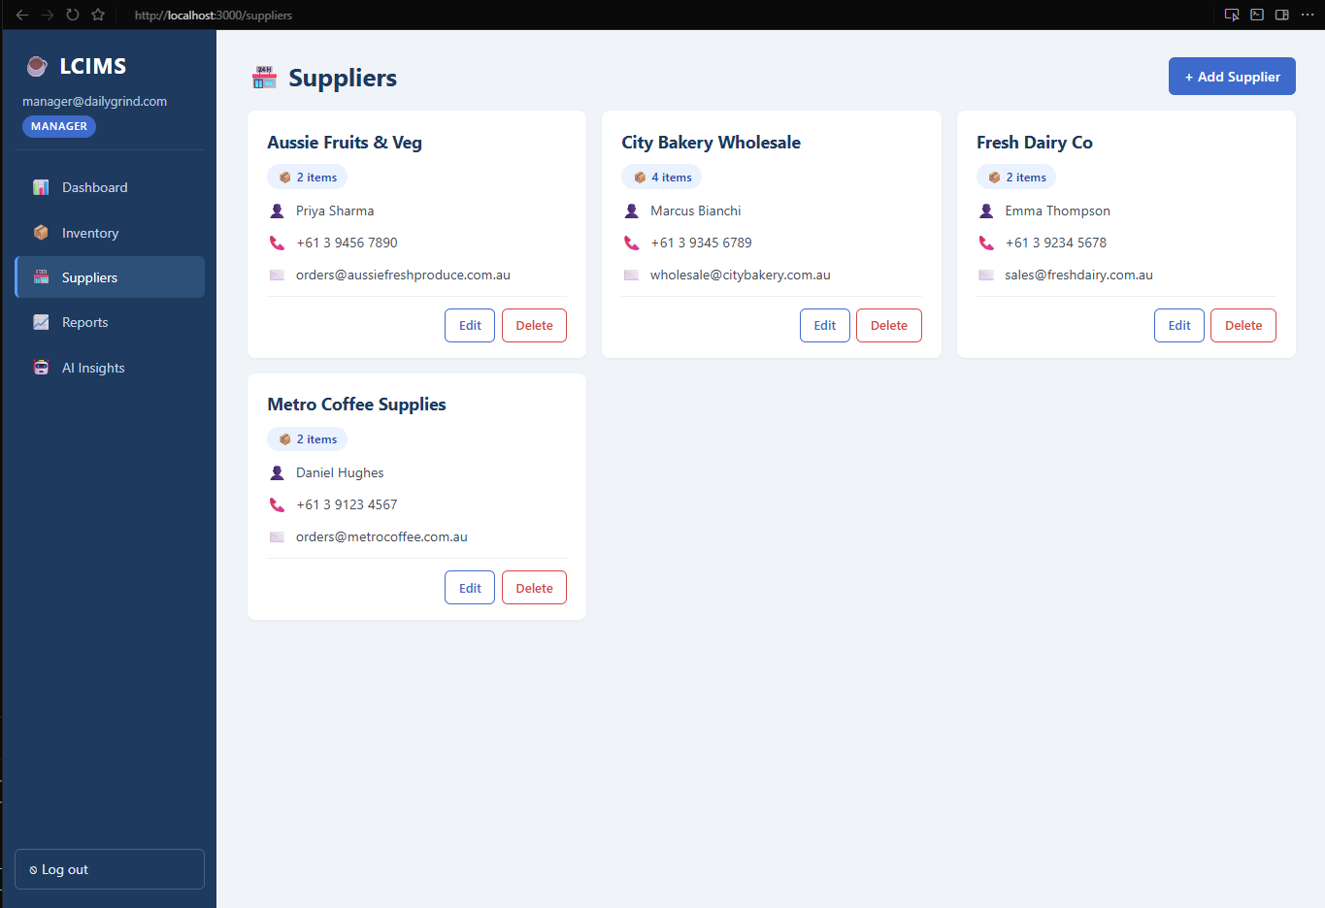
Figure 5.9 — Suppliers page showing the four seed suppliers with their contact details and live item count badges (computed by an aggregate query joining inventory_items).

5.3 Update (UPDATE)
The application supports three distinct update paths. First, a PUT request to /api/inventory/:id replaces all editable fields of an inventory item — name, category, unit, quantity, threshold, and supplier_id. Second, a PATCH request to /api/inventory/:id/stock atomically adjusts the quantity, writes a row to stock_logs, and conditionally inserts an alert if the resulting quantity falls below the threshold; this entire sequence is wrapped in a database transaction (BEGIN, COMMIT, ROLLBACK on error) for consistency. Third, a PUT request to /api/suppliers/:id updates supplier details.
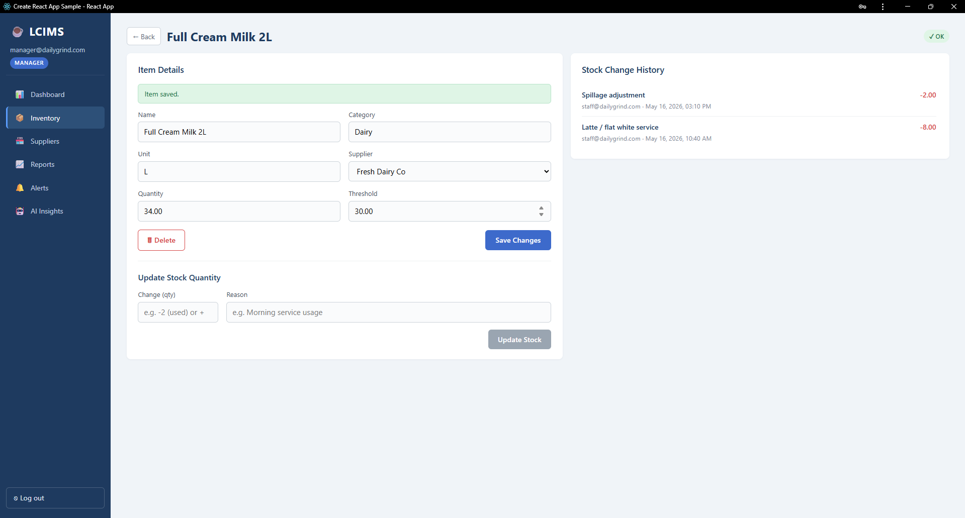
Figure 5.10 — Stock adjustment form being used to record a stock change. The form accepts both positive (restock) and negative (usage) quantities along with an optional reason.
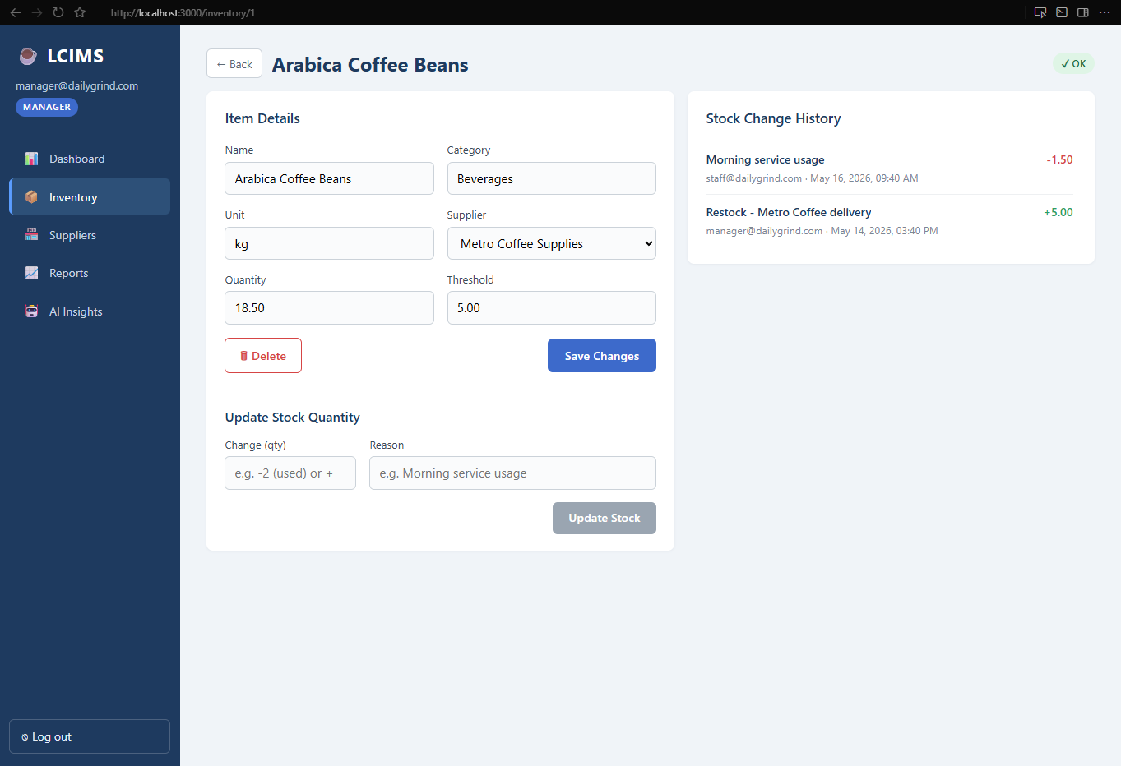
Figure 5.11 — Stock Movement History panel on the Item Detail page, listing every PATCH /stock operation with the timestamp and user email. This is read directly from the stock_logs table.
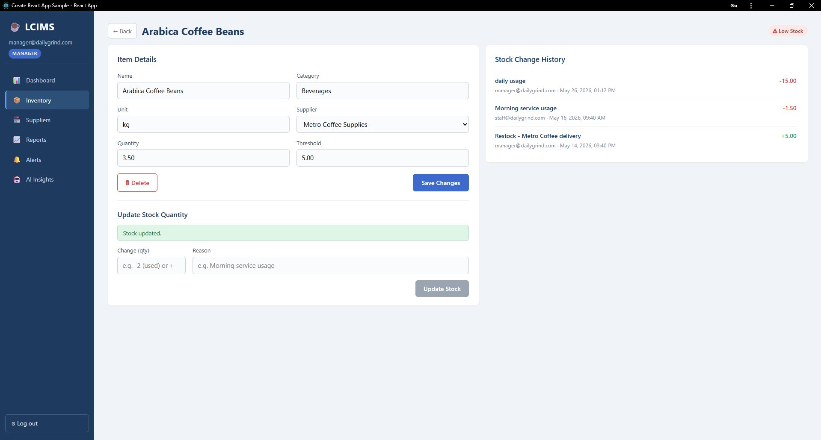
Figure 5.12 — Item Detail page for "Arabica Coffee Beans" immediately after a successful stock update. The green "Stock updated." confirmation message appears below the form, the quantity has been reduced to 3.50 kg, the "Low Stock" badge appears in the top-right (since 3.50 is below the threshold of 5.00), and the new "daily usage" entry of -15.00 appears at the top of the Stock Change History on the right.

5.4 Delete (DELETE)
Delete operations are restricted to Manager and Admin users. The frontend displays a confirmation dialog before sending the DELETE request to prevent accidental data loss. For inventory items, the deletion cascades to remove all related stock_logs and alerts via the ON DELETE CASCADE foreign key rule. For suppliers, the foreign key on inventory_items.supplier_id uses ON DELETE SET NULL, which preserves the inventory items but disassociates them from the deleted supplier.
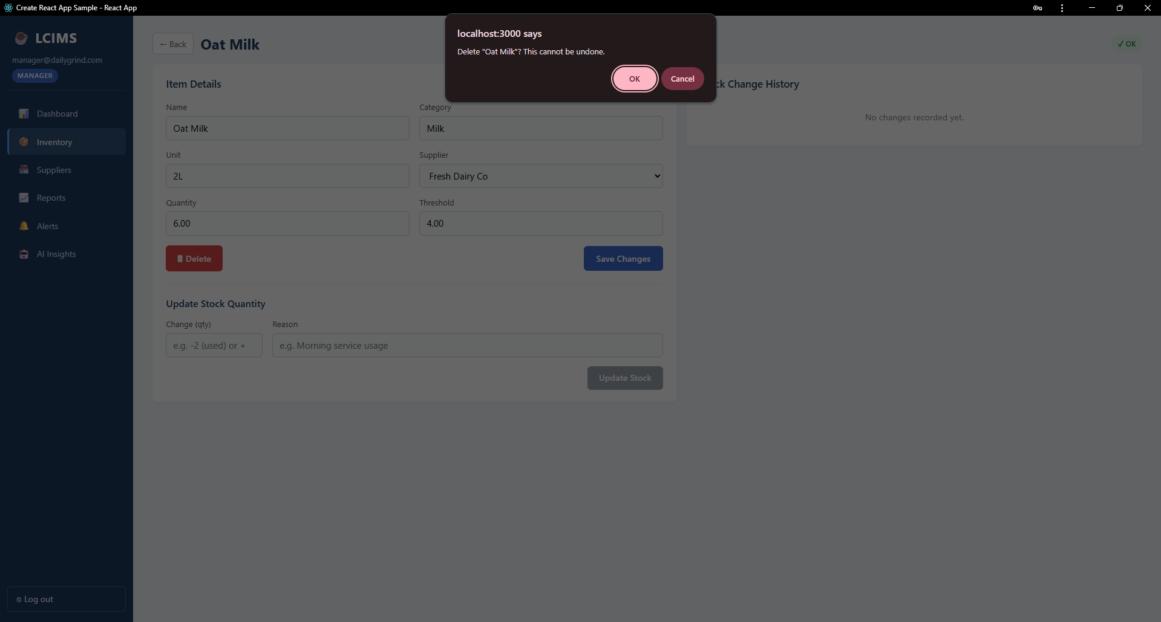
Figure 5.13 — Confirmation dialog presented to the user before a destructive DELETE /api/inventory/:id call is sent to the server. The dialog clearly states the action cannot be undone.
To summarise this section: all four CRUD operations have been demonstrated end-to-end with screenshot evidence. The frontend triggers each operation, the API handles validation and authentication, parameterised SQL queries safely apply the change to the database, and the updated state is reflected in the UI without requiring a full page reload.

6. Security Implementation
LCIMS implements multiple layers of security in line with industry best practice for web applications handling business data. This section documents each layer with reference to the source files.

6.1 Password Hashing — bcrypt with Cost Factor 12
User passwords are hashed using the bcryptjs library before being stored. The salt rounds parameter is set to 12 in server/routes/auth.js, which is the current OWASP-recommended minimum for new applications. The hashing happens inside the register endpoint via bcrypt.hash(password, 12), and login verification uses bcrypt.compare which performs a constant-time comparison to avoid timing attacks. The plaintext password is never written to disk and never logged. The seed users in the schema file use pre-generated bcrypt hashes so that the development password "password123" works out-of-the-box without requiring a registration flow.

6.2 JWT Authentication with 8-Hour Expiry
Sessions are managed via signed JSON Web Tokens. On successful login, the server constructs a payload containing user_id, email, role, and cafe_id, then signs it with the JWT_SECRET environment variable using the HS256 algorithm and an expiresIn value of 8h. Critically, the password hash is never included in the token payload. The token is stored on the client in localStorage under the key lcims_token. On the server, the verifyToken middleware in server/middleware/auth.js validates the signature and expiry on every protected request, rejecting invalid or expired tokens with HTTP 401 or 403.

6.3 Role-Based Access Control
Three roles are defined: Manager, Staff, and Admin. The requireManager middleware enforces that only Manager and Admin roles can create, edit, or delete inventory items and suppliers. Staff users retain the ability to view all data and to adjust stock quantities (the PATCH /stock endpoint does not require Manager privileges, since recording stock movements is a core staff activity during a shift). The frontend reinforces this by hiding the Add, Edit, and Delete buttons for Staff users — but the server-side check is the security boundary, not the UI.
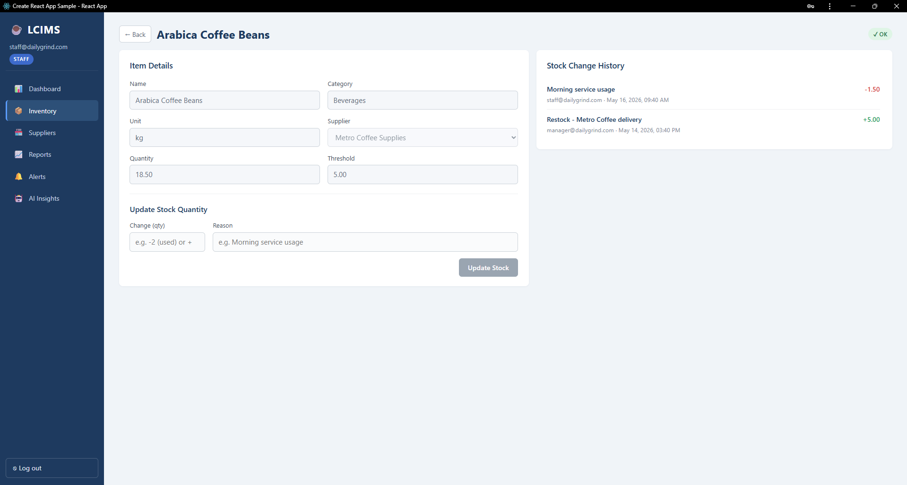
Figure 6.1 — Inventory page as it appears to a Staff user. Note the absence of the + Add Item button and the Edit/Delete controls that are visible to Manager users.
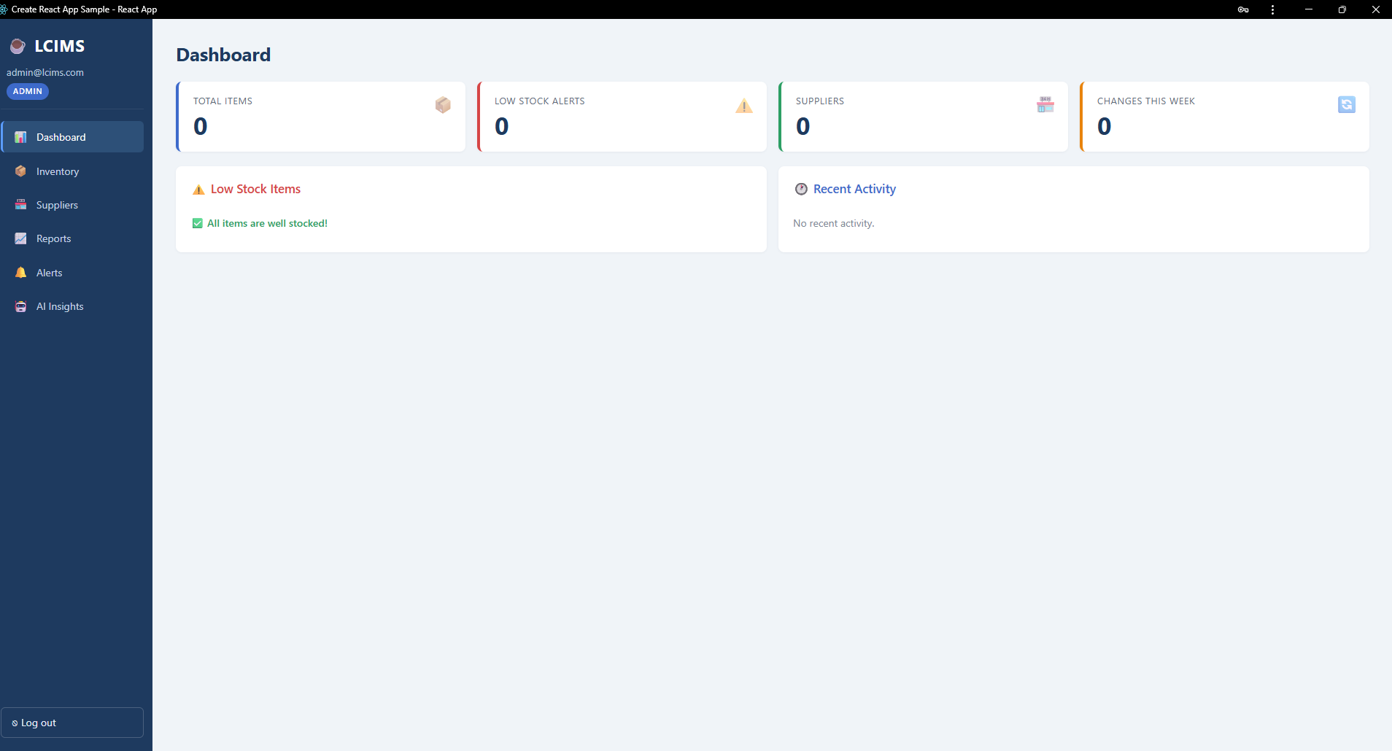
Figure 6.2 — Admin user dashboard view. Admin users have full system access including the ability to manage data across cafes.

6.4 SQL Injection Prevention with Parameterised Queries
Every database query in the application uses parameterised statements. User-supplied values are passed as the second argument to pool.query as an array, and the pg driver safely substitutes them into the SQL using PostgreSQL's native parameter binding. For example, the login query reads: pool.query("SELECT * FROM users WHERE email = $1", [email]). The team consciously avoided string concatenation or template literals when building SQL strings, even for internal admin queries. This eliminates the entire class of SQL injection vulnerabilities.

6.5 Login Validation and Error Handling
The login endpoint returns a generic "Invalid email or password" error message for both unknown emails and incorrect passwords. This is deliberate — distinguishing between the two would allow an attacker to enumerate valid email addresses through repeated login attempts.
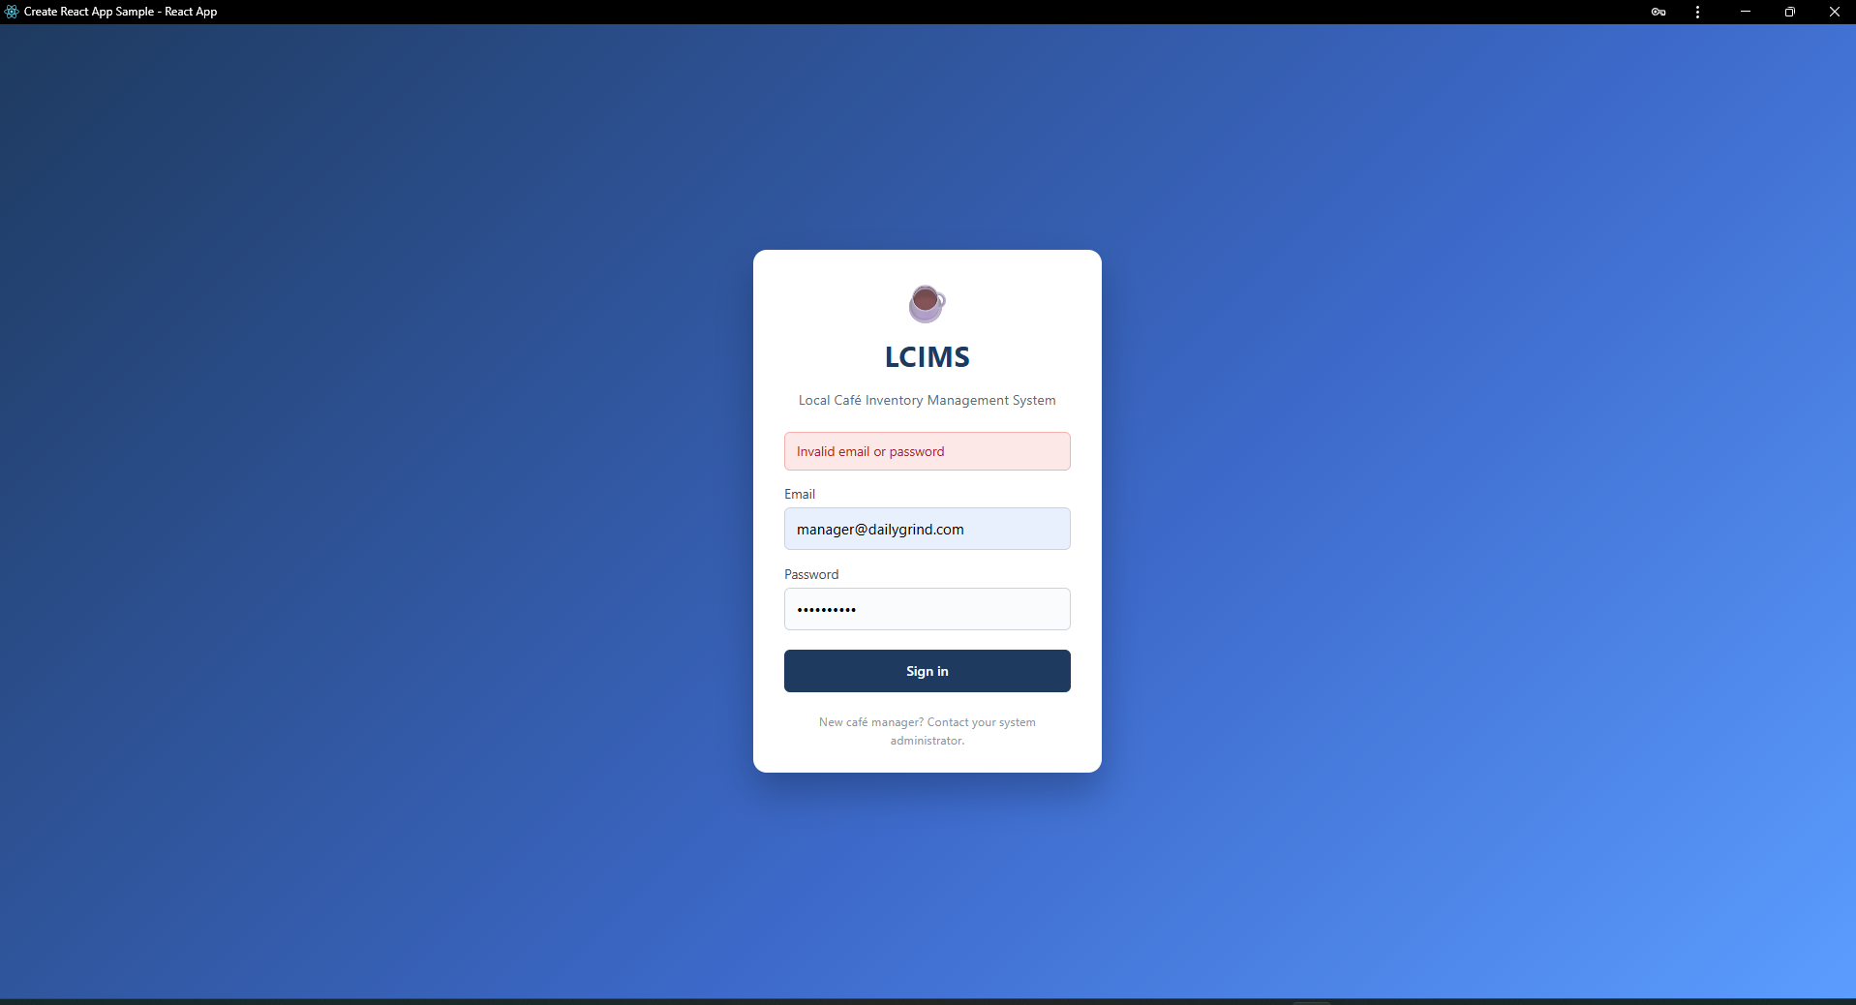
Figure 6.3 — Generic error message displayed for any failed login attempt. The message intentionally does not reveal whether the email exists in the database.

6.6 Data Privacy in the AI Integration
The AI reorder suggestions feature sends a carefully constructed prompt to OpenAI. The prompt contains only operational inventory data — item names, categories, units, current quantities, thresholds, supplier names, and 7-day usage totals. No customer information, no staff personal details, no email addresses, and no financial records are transmitted. This data minimisation is implemented in server/routes/ai.js by explicitly selecting only the required columns when building the prompt.
If no valid OPENAI_API_KEY is configured, the system automatically falls back to a deterministic local demo mode that computes reorder suggestions from the same inventory data without making any external API call. This makes the feature reliable for assessment demonstrations and protects against accidental exposure of API keys in the submission zip.

6.7 Secrets Management
All sensitive configuration is loaded from a .env file via the dotenv package. The .env file is excluded from version control by .gitignore so that real database passwords, JWT secrets, and API keys are never committed to the repository. The .env.example file in the server folder documents the required variables without containing real values, providing a safe template for new developers to copy and populate.

7. Code Quality and Standards
The team applied consistent coding standards across the entire codebase to ensure the project is maintainable, readable, and easy for new developers to understand.

7.1 File-Level Header Comments
Every source file in the project has a header comment block at the top identifying the file name, its purpose, the team name, the date, and the project. The format follows JSDoc conventions. This applies to all React page components in client/src/pages, all Express route files in server/routes, all middleware, the database connection module, the auth context, the Axios instance, and the React Layout component.

7.2 JSDoc-Style Route Documentation
Every API route handler is preceded by a JSDoc-style block comment containing three tags: @route (the HTTP method and path), @desc (a one-line description of what the route does), and @access (the required role). This documentation serves as inline API reference and makes the route files self-describing.

7.3 Consistent Naming Conventions
JavaScript code uses camelCase for variables and functions following the standard convention. PostgreSQL columns use snake_case (item_id, cafe_id, created_at) following the SQL convention. REST API paths use plural nouns (/inventory, /suppliers, /alerts). Component file names match their default exports (Dashboard.js exports Dashboard).

7.4 No Global Variables
The codebase deliberately avoids global state. React components manage state with hooks (useState, useEffect, useContext). The PostgreSQL pool is a module-level singleton in server/db.js exported via module.exports. There are no var declarations leaking into the global scope.

7.5 Modular File Structure
The server is organised by domain: each major resource (auth, inventory, suppliers, reports, alerts, ai) has its own file under server/routes. The frontend places each page in its own file under client/src/pages, with shared infrastructure (AuthContext, axios instance, Layout) in dedicated folders. This separation makes it easy to locate any feature and reduces merge conflicts when multiple team members work in parallel.

7.6 Error Handling and Logging
Every route handler wraps its main logic in a try/catch block. Caught errors are logged to the server console with a prefix identifying the route, then a sanitised 500 response is returned to the client (the raw error message is never echoed back to the user, which prevents accidental disclosure of internal details). The PATCH /stock route specifically catches the PostgreSQL CHECK constraint violation (error code 23514) and converts it into a friendly 400 response explaining that the resulting quantity would be negative.

7.7 Supporting Documentation
In addition to inline code documentation, the project includes four standalone documentation files at the repository root: README.md (project overview and setup), USER_GUIDE.md (end-user help guide for cafe staff), DEPLOYMENT_GUIDE.md (technical installation and deployment instructions), and TEST_PLAN.md (the 28 manual test cases used to verify the system). The database folder contains its own README.md explaining the schema and seed data.

8. Testing Results
Comprehensive manual testing was conducted following the structured test plan in TEST_PLAN.md, which contains 28 test cases organised into seven categories: authentication, inventory CRUD, suppliers, dashboard and reports, alerts, AI insights, and security. The tests were executed in the documented environment with the frontend running at http://localhost:3000, the API at http://localhost:5000, and the lcims database loaded with the seed data.

8.1 Test Summary
Test ID | Area | Brief Description | Result
TC-001 | Authentication | Manager login success, redirect to Dashboard | Pass
TC-002 | Authentication | Staff login success | Pass
TC-003 | Authentication | Wrong password shows error, stays on login | Pass
TC-004 | Authentication | Protected URL without token redirects to login | Pass
TC-005 | Authentication | Logout clears session and returns to login | Pass
TC-006 | Inventory | View inventory list with all seed items | Pass
TC-007 | Inventory | Manager adds a new item | Pass
TC-008 | Inventory | Manager edits an existing item | Pass
TC-009 | Inventory | Manager deletes an item | Pass
TC-010 | Inventory | Staff cannot see Add/Edit/Delete controls | Pass
TC-011 | Inventory | Stock increase (restock) recorded with positive log | Pass
TC-012 | Inventory | Stock decrease (usage) recorded with negative log | Pass
TC-013 | Suppliers | View suppliers list with item count badges | Pass
TC-014 | Suppliers | Manager adds a new supplier | Pass
TC-015 | Suppliers | Manager edits a supplier | Pass
TC-016 | Suppliers | Manager deletes a supplier (linked items unchanged) | Pass
TC-017 | Dashboard | KPI cards load with correct counts | Pass
TC-018 | Dashboard | Recent activity panel shows last 10 stock changes | Pass
TC-019 | Reports | Valid date range produces bar chart and data table | Pass
TC-020 | Reports | Invalid date range returns clear error message | Pass
TC-021 | Alerts | Stock drop below threshold creates an alert row | Pass
TC-022 | Alerts | Alerts page lists all active alerts | Pass
TC-023 | Alerts | Mark Resolved removes alert from active list | Pass
TC-024 | AI Insights | Demo mode generates reorder suggestions | Pass
TC-025 | AI Insights | Suggestion cards show coloured urgency badges | Pass
TC-026 | Security | API request without JWT returns HTTP 401 | Pass
TC-027 | Security | API request with invalid JWT returns HTTP 403 | Pass
TC-028 | Security | Staff POST to /api/inventory returns HTTP 403 | Pass

All 28 test cases passed on 25 May 2026 in the documented test environment. No test failures were recorded during the final test pass. Two issues were identified during earlier test rounds and resolved before the final run: a CORS configuration mismatch when first wiring the frontend to a non-localhost backend (resolved by adding the cors middleware to server/index.js), and a bcrypt hash mismatch in the original seed file (resolved by regenerating the hashes with cost factor 10 to match the seed format).

8.2 Test Evidence Screenshots
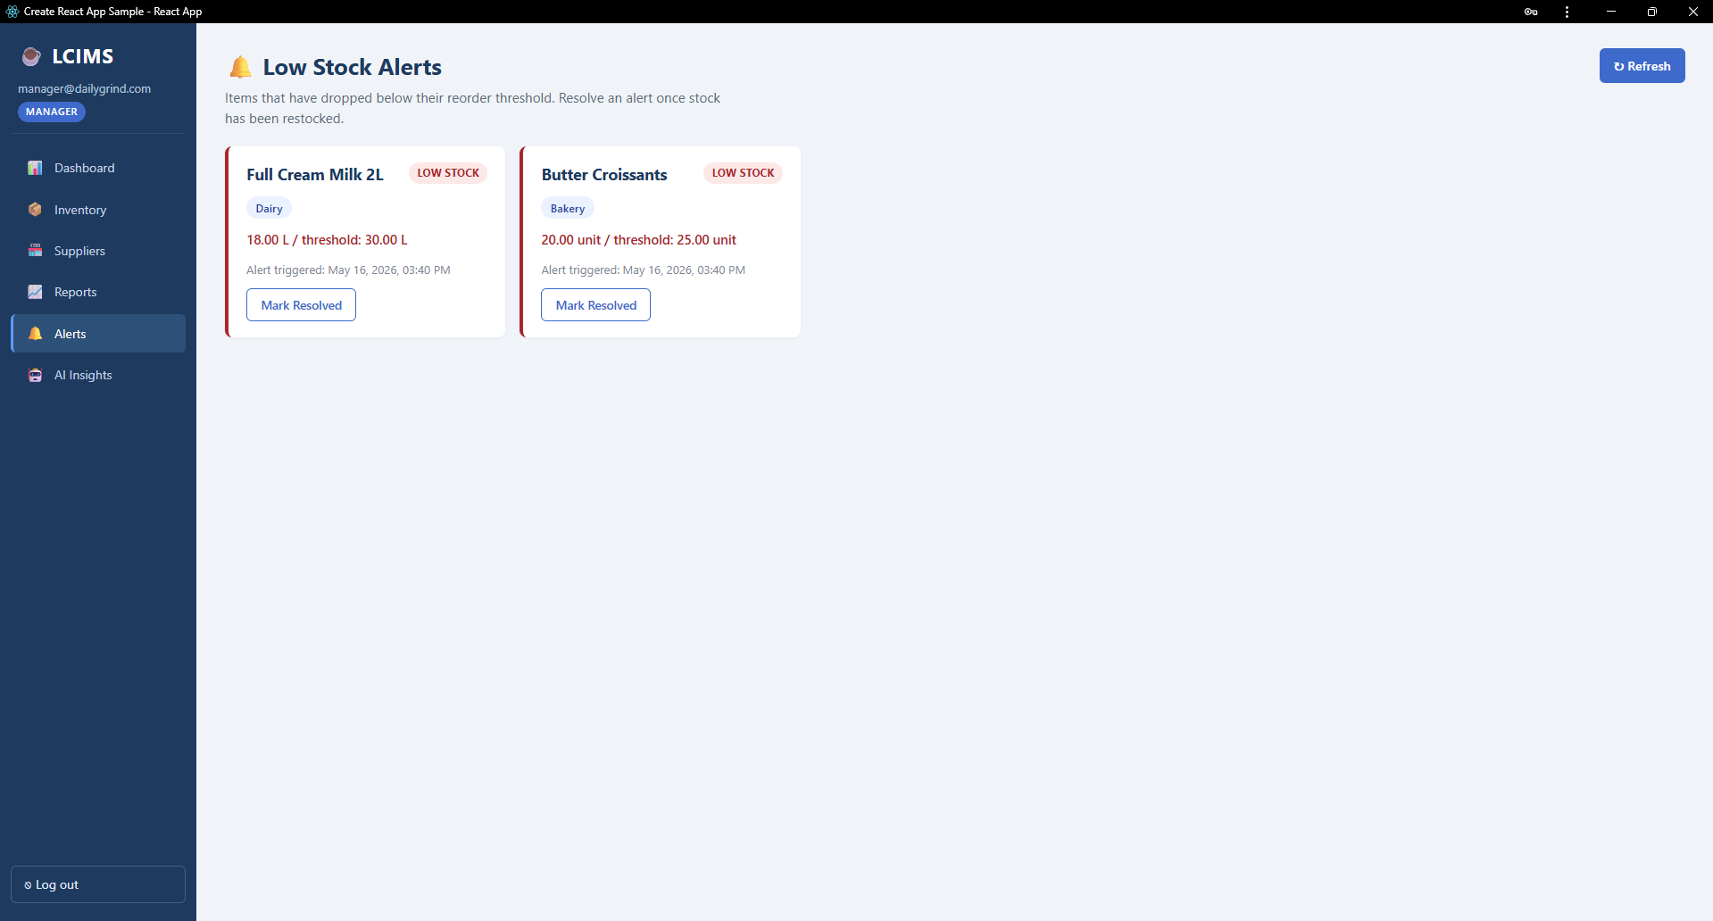
Figure 8.1 — Alerts page (TC-022) showing both active low-stock alerts with their item, category, current quantity, threshold, and Mark Resolved buttons.
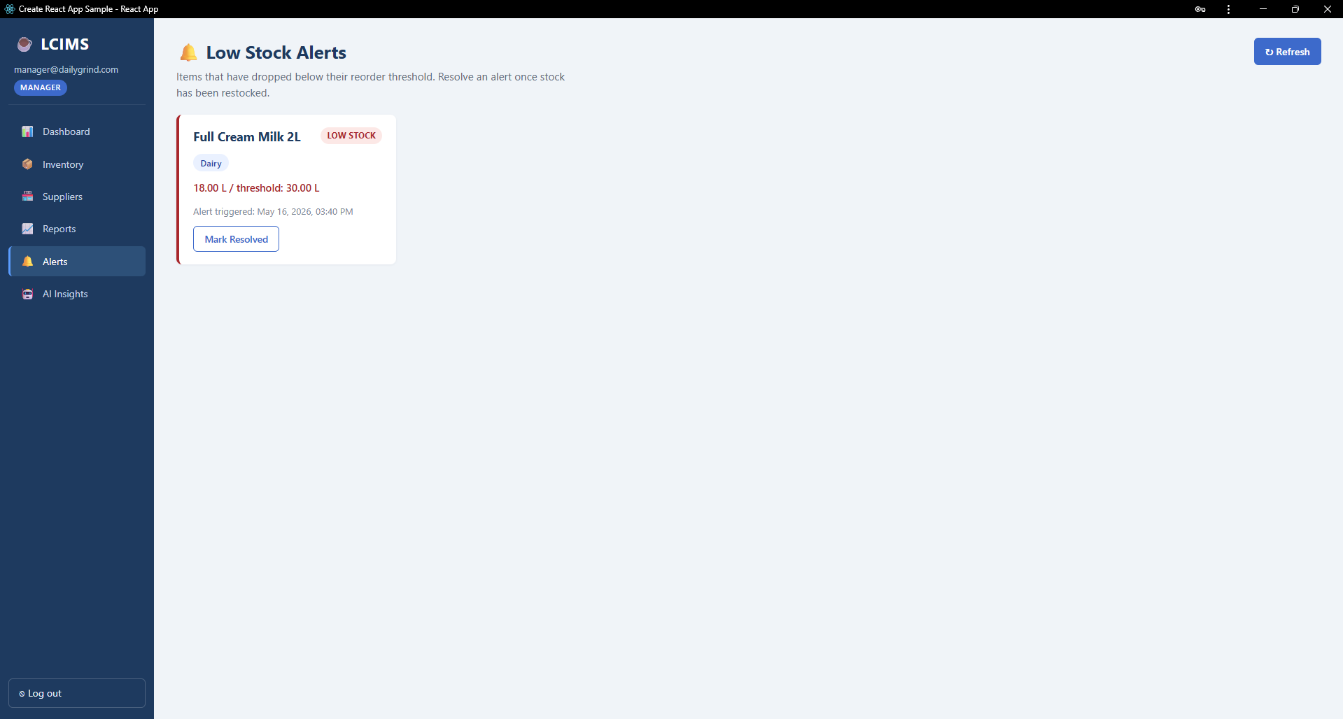
Figure 8.2 — Alerts page after one alert was marked resolved (TC-023). The resolved alert is removed from the active list immediately.
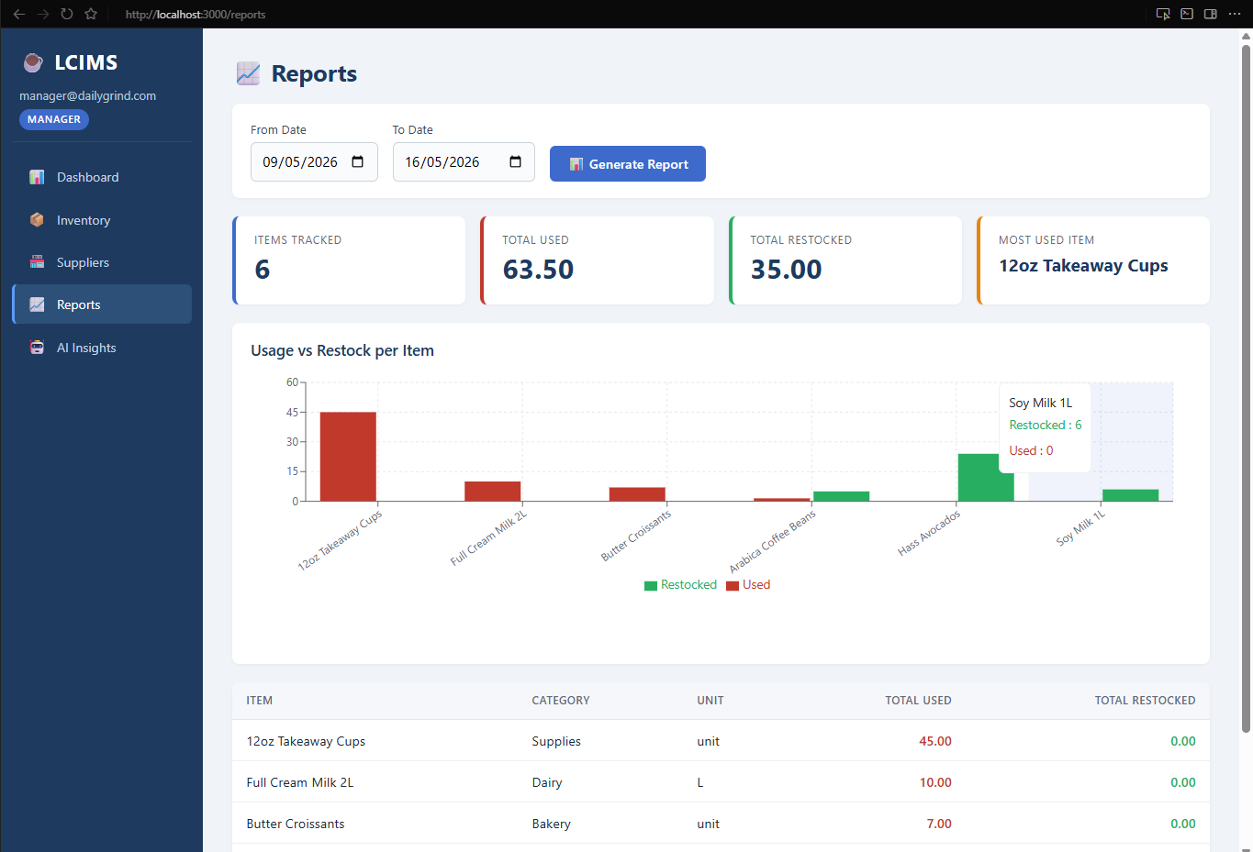
Figure 8.3 — Reports page (TC-019) rendering the usage bar chart for a selected date range. Red bars represent items consumed; green bars represent items restocked.
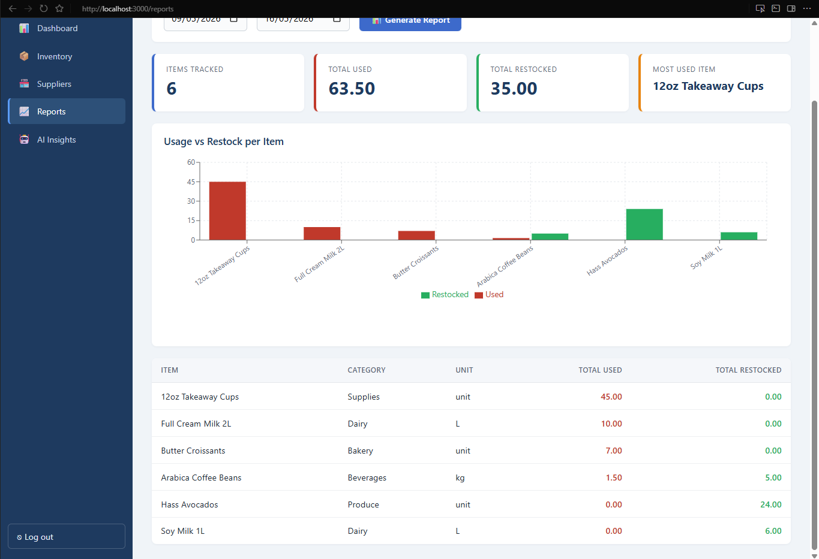
Figure 8.4 — Reports page showing the detailed data table beneath the chart, with per-item totals for usage and restocking over the selected period.
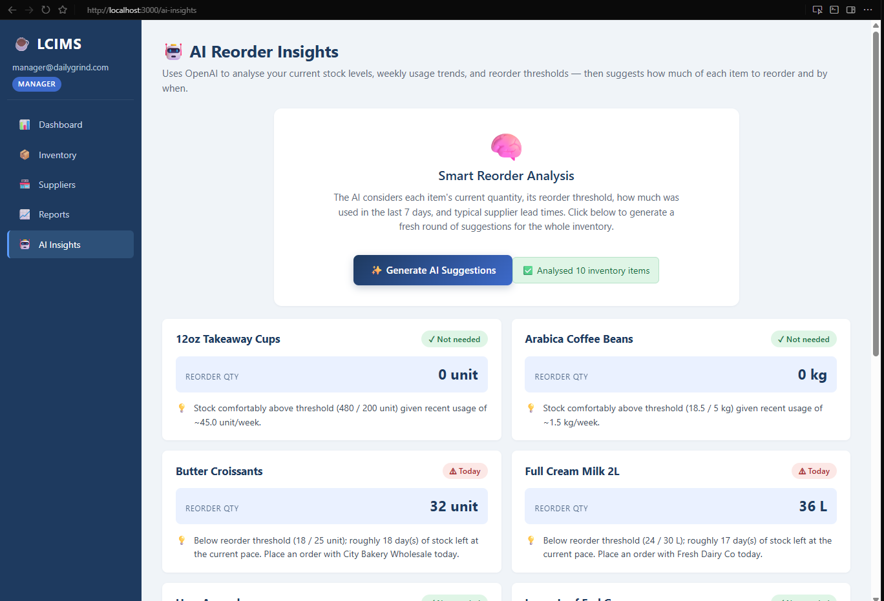
Figure 8.5 — AI Insights page (TC-024) after the Generate AI Suggestions button was clicked. The system analysed 10 inventory items and returned actionable reorder cards.
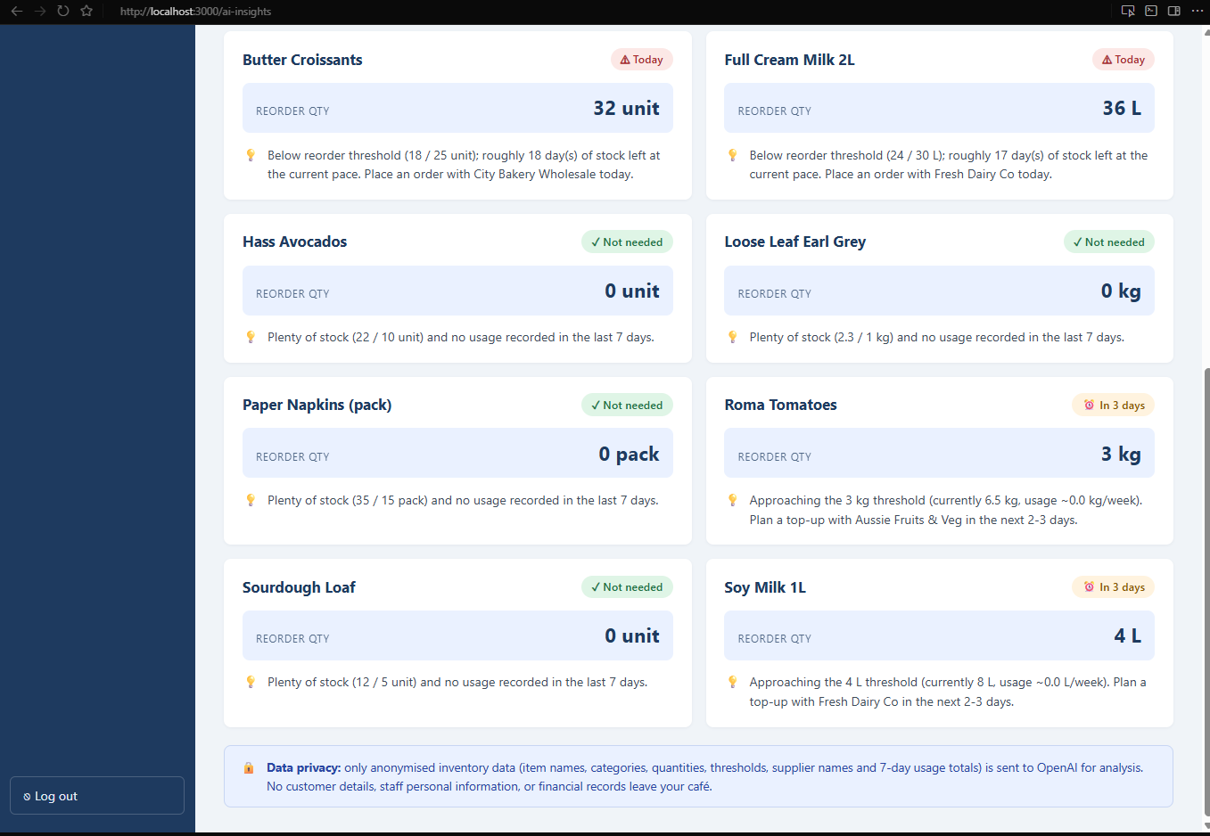
Figure 8.6 — AI Insights suggestion cards (TC-025) displaying colour-coded urgency badges: red for urgent reorders, orange for upcoming reorders, and green for items with healthy stock.

9. Teamwork and Feedback Response

9.1 Team Contributions
Member | Tasks Completed | Contribution
Md Minhazul Amin | Database schema design and seed data, Express server bootstrap, authentication middleware, inventory API (including the transactional stock PATCH endpoint), GitHub repository management, deployment guide, README, and test plan document. | 34%
Ayush Subedi | React core architecture (AuthContext, Layout, Axios instance), Dashboard page with KPI cards, Reports page with Recharts bar chart, Suppliers backend route, integration testing, and screenshot capture. | 33%
Aayush Khadgi | Alerts page (frontend and backend), AI Insights page with urgency colour coding, AI route with OpenAI integration and demo mode, user guide document, and end-to-end test execution. | 33%

Total contribution sums to 100%. The work was distributed fairly across backend development, frontend development, and documentation. Each member tested another member's module before submission as a form of internal peer review. Integration challenges (CORS configuration, JWT flow debugging, the bcrypt seed hash mismatch) were resolved collaboratively in shared sessions on campus.

9.2 Response to Lecturer Feedback
The lecturer's feedback on the Assessment 4 mid-project submission focused on three areas: the need for more structured testing evidence, the absence of dedicated user-facing documentation, and the missing low-stock alerts management interface that was specified in the Software Requirements Specification. The team addressed each of these points directly in the work leading up to Assessment 5.
In response to the testing feedback, the team produced TEST_PLAN.md — a structured manual test plan containing 28 test cases organised into seven categories with explicit preconditions, steps, expected results, and pass/fail outcomes. Section 8 of this report includes the full results table and screenshot evidence for the major test areas.
In response to the documentation feedback, the team produced two standalone documents at the project root: USER_GUIDE.md, written in plain English for cafe staff covering every feature of the application, and DEPLOYMENT_GUIDE.md, a technical installation guide covering system requirements, database setup, server configuration, frontend launch, and troubleshooting.
In response to the missing alerts module feedback, the team implemented the Alerts feature end-to-end. This included a new backend route file (server/routes/alerts.js) with two endpoints (GET active alerts and PATCH resolve), a new React page (client/src/pages/Alerts.js) with refresh and resolve functionality, registration in App.js, and a new navigation item in the sidebar. The feature is demonstrated in Section 8 with two screenshots (Figures 8.1 and 8.2).
Additional improvements made beyond the lecturer's explicit feedback include the addition of JSDoc-style file headers across the entire codebase, the documentation of the data privacy approach for the AI integration (Section 6.6), and a cleanup of the repository .gitignore to exclude assessment zip files and Word document lock files.

10. Deployment Documentation
Complete deployment instructions are provided in DEPLOYMENT_GUIDE.md at the project root. The guide covers system requirements (4 GB RAM minimum, 10 GB disk, Node.js 18+, PostgreSQL 16+, Windows 10/11 or macOS 12+ or Ubuntu 20.04+), prerequisite installation steps, database setup with the schema and seed scripts, backend .env configuration, the npm install and run commands for both server and client folders, a post-installation verification checklist, the default development login credentials, and a troubleshooting table covering the most common installation issues.
A brief summary of the install steps is:
- Install Node.js 18 or later and PostgreSQL 16 or later.
- Create the database with the command: CREATE DATABASE lcims;
- Load the schema with: psql -U postgres -d lcims -f database/lcims_schema.sql
- Copy server/.env.example to server/.env and populate the database password, JWT_SECRET, and optional OPENAI_API_KEY.
- In the server folder: run npm install then npm run dev (or npm start for production).
- In the client folder: run npm install then npm start.
- Open http://localhost:3000 and log in with manager@dailygrind.com and password "password123".
For production deployment, the production build of the React app (created with npm run build) should be served by a static file server such as nginx, not opened directly from the file system. The Express backend should still run on port 5000 (or behind a reverse proxy). All seed passwords must be changed before exposing the system to real users, and the JWT_SECRET should be replaced with a strong random value of at least 32 characters.
End-user help is provided in USER_GUIDE.md, which is written for cafe managers and staff who will use the system day-to-day. It covers logging in, reading the dashboard, managing inventory, adjusting stock during a shift, managing suppliers, generating reports, handling alerts, and using the AI insights feature.

11. Conclusion
LCIMS has been delivered as a fully working, three-tier web application that meets all of the functional and non-functional requirements specified in the Assessment 2 Software Requirements Specification. The system provides authenticated, role-based access for three user types, full CRUD operations on inventory items and suppliers, automatic logging of every stock movement, automatic generation of low-stock alerts when items drop below their reorder thresholds, a KPI dashboard, date-range usage reports with bar chart visualisation, a manageable alerts page, and an AI-powered reorder suggestions feature with a reliable offline fallback.
The implementation followed industry-standard security practices throughout. Passwords are hashed with bcrypt at cost factor 12; sessions are managed with signed JSON Web Tokens with an 8-hour expiry; role-based access control is enforced at the API layer via middleware; all database queries use parameterised statements to prevent SQL injection; secrets are kept out of version control via the .env pattern; and data sent to the OpenAI API is restricted to operational inventory fields only with no personal information.
The team faced and overcame several technical challenges during the build. Coordinating work across three developers required disciplined use of Git branches and careful definition of module boundaries. The cross-origin communication between the React frontend on port 3000 and the Express backend on port 5000 required correct CORS configuration. The stock adjustment endpoint had to be implemented as a database transaction to maintain atomicity across the three operations (update quantity, write log, conditionally insert alert). Choosing to support both live OpenAI mode and an offline demo mode for the AI feature ensured the system would work reliably during assessment demonstrations without requiring a live API key. Time management across documentation and coding was an ongoing balancing act that the team handled through weekly sync meetings.
Future improvements identified by the team include deploying the system to a hosted environment such as Render or Railway, adding an automated test suite using Jest and React Testing Library, implementing email notifications when alerts are triggered, and building a dedicated multi-cafe admin portal that takes advantage of the existing cafe_id column structure to support a chain of cafes.

12. References
Duckett, J 2014, HTML & CSS: Design and Build Websites, 1st edn, John Wiley & Sons, Indianapolis.
Pressman, R S and Maxim, B R 2020, Software Engineering: A Practitioner's Approach, 9th edn, McGraw-Hill Education, New York.
Meta Open Source 2026, React Documentation, viewed 25 May 2026, <https://react.dev/>.
PostgreSQL Global Development Group 2026, PostgreSQL 16 Documentation, viewed 25 May 2026, <https://www.postgresql.org/docs/16/>.
OpenJS Foundation 2026, Express.js Guide, viewed 25 May 2026, <https://expressjs.com/>.
OpenAI 2026, OpenAI API Documentation — Chat Completions, viewed 25 May 2026, <https://platform.openai.com/docs/>.
npm Inc. 2026, bcryptjs package documentation, viewed 25 May 2026, <https://www.npmjs.com/package/bcryptjs>.
Auth0 Inc. 2026, JSON Web Token Introduction, viewed 25 May 2026, <https://jwt.io/introduction>.
Open Web Application Security Project 2024, OWASP Password Storage Cheat Sheet, viewed 25 May 2026, <https://cheatsheetseries.owasp.org/cheatsheets/Password_Storage_Cheat_Sheet.html>.
Kent Institute Australia 2026, CPRO306 Capstone Project — Assessment Brief 5: End of Project Deliverables, Kent Institute Australia Moodle LMS, viewed 25 May 2026.

