**#Index.html**

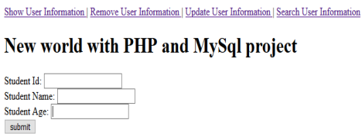

<html>

<head>

<title></title>

</head>

<body>

<a href="display.php"> Show User Information </a> |

<a href="delete.php"> Remove User Information </a> |

<a href="update.php"> Update User Information </a> |

<a href="search1.php"> Search User Information </a>

<h1> New world with PHP and MySql project</h1>

<form name="form" action="save.php" method="post" >

Student Id: <input type="text" name="sid" > <br>

Student Name: <input type="text" name="sn"> <br>

Student Age: <input type="text" name="sa" ><br>

<input type="submit" name="sb" value="submit">

</form>

</body>

</html>

**#Insert.php**

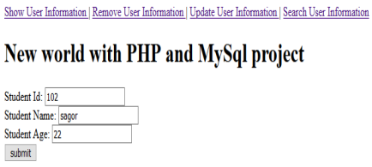

<?php

$con=mysqli_connect('localhost','root', '','seu');

$id=$_POST['sid'];

$name=$_POST['sn'];

$age=$_POST['sa'];

echo $id;

echo $name;

echo $age;

$sql="insert into student(id,name,age)values('$id','$name',$age)"; mysqli_query($con,$sql);

?>

**#Display.php**

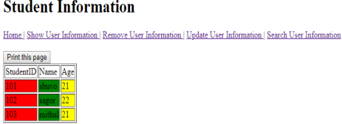

<?php

echo "<h1> Student Information </h1>";

$con=mysqli_connect('localhost','root','','seu');

$sql="select * FROM student";

$res=mysqli_query($con,$sql);

?>

<html>

<body>

<a href="index.html"> Home </a> |

<a href="display.php"> Show User Information </a> | <a href="delete.php"> Remove User Information </a> | <a href="update.php"> Update User Information </a> | <a href="search1.php"> Search User Information </a> <br> <br>

<button onclick="myFunction()">Print this page</button>

<script>

function myFunction() {

window.print();

}

</script>

<table border="1">

<tr>

<td>StudentID</td>

<td>Name</td>

<td>Age</td>

</tr>

<?php

while($row=mysqli_fetch_assoc($res))

{ ?>

<tr>

<td bgcolor="red"><?php echo $row["id"]; ?> </td> <td bgcolor="green"><?php echo $row["name"]; ?> </td> <td td bgcolor="yellow"><?php echo $row["age"]; ?> </td> </tr>

<?php

}

?>

</table>

</body>

</html>

**#Delete.php**

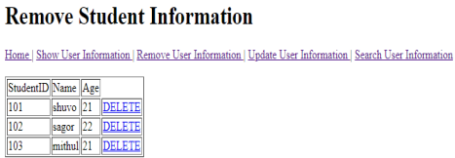<?php

echo "<h1>Remove Student Information </h1>";

$con=mysqli_connect('localhost','root','','seu');

$sql="select * FROM student";

$res=mysqli_query($con,$sql);

?>

<html>

<body>

<a href="index.html"> Home </a> |

<a href="display.php"> Show User Information </a> |

<a href="delete.php"> Remove User Information </a> |

<a href="update.php"> Update User Information </a> |

<a href="search1.php"> Search User Information </a>

<br> <br>

<head> </head>

<table border="1">

<tr>

<td>StudentID</td>

<td>Name</td>

<td>Age</td>

</tr>

<?php

while($row=mysqli_fetch_assoc($res))

{ ?>

<tr>

<td> <?php echo $row["id"]; ?> </td>

<td><?php echo $row["name"]; ?> </td>

<td><?php echo $row["age"]; ?> </td>

<td><a class="glyphicon glyphicon-edit" href="delete1.php? id=<?php echo $row["id"] ?>">DELETE</a></td>

</tr>

<?php } ?>

</table>

</body>

</html>

**#Delete1.php**

<?php

$host_name="localhost";

$username="root";

$password="";

$database_name="seu";

$connect=mysqli_connect($host_name,$username,$password,$database_name); $id=$_GET['id'];

$sql="SELECT * FROM student WHERE id=$id";

$query=mysqli_query($connect,$sql);

$result=mysqli_fetch_assoc($query);

//update

if (isset($_POST['btn'])){

$sqlupdate="DELETE FROM student WHERE id='$id'";

$query=mysqli_query($connect,$sqlupdate);

if ($query) {

echo "<h1>DELETE successfully</h1>";

}

}

?>

<!DOCTYPE html>

<html>

<head>

<title>Book Info Delete Form</title>

</head>

<body>

<body>

<div class="container">

<form action="" method="post">

<h1>Book Info DELETE Form</h1>

<hr>

<table>

<tr>

<td><label for="kid"><b>STUDENT ID</b></label></td>

<td><input type="text" name="sid" value="<?php echo $result["id"]?>" required></td>

</tr>

</table>

<hr>

<input type="submit" name="btn" value="DELETE Info"> </div>

</form>

</div>

</body>

</html>

**#Update.php**

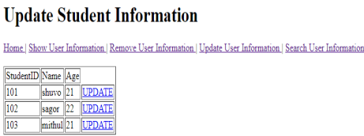

<?php

echo "<h1>Update Student Information </h1>";

$con=mysqli_connect('localhost','root','','seu');

$sql="select * FROM student";

$res=mysqli_query($con,$sql);

?>

<html>

<body>

<a href="index.html"> Home </a> |

<a href="display.php"> Show User Information </a> |

<a href="delete.php"> Remove User Information </a> |

<a href="update.php"> Update User Information </a> |

<a href="search1.php"> Search User Information </a>

<br> <br>

<head>

</head>

<table border="1">

<tr>

<td>StudentID</td>

<td>Name</td>

<td>Age</td>

</tr>

<?php

while($row=mysqli_fetch_assoc($res))

{ ?>

<tr>

<td> <?php echo $row["id"]; ?> </td>

<td> <?php echo $row["name"]; ?> </td>

<td> <?php echo $row["age"]; ?> </td>

<td><a class="glyphicon glyphicon-edit" href="update1.php? id=<?php echo $row["id"] ?>"> UPDATE</a></td>

</tr>

<?php } ?>

</table>

</body>

</html>

**#Update1.php**

<?php

$host_name="localhost";

$username="root";

$password="";

$database_name="seu";

$connect=mysqli_connect($host_name,$username,$password,$database_name); $id=$_GET['id'];

$sql="SELECT * FROM student WHERE id=$id";

$query=mysqli_query($connect,$sql);

$result=mysqli_fetch_assoc($query);

//update

if (isset($_POST['btn'])){

$uID=$_POST['sid'];

$uNAME=$_POST['sn'];

$uAGE=$_POST['sa'];

$sqlupdate="UPDATE student SET id='$uID',name='$uNAME',age='$uAGE' WHERE id='$id'";

$query=mysqli_query($connect,$sqlupdate);

if ($query) {

echo "<h1>Update successfully</h1>";

}

}

?>

<!DOCTYPE html>

<html>

<head>

<title>Book Info Update Form</title>

</head>

<body>

<body>

<div class="container">

<form action="" method="post">

<h1>Book Info Update Form</h1>

<hr>

<table>

<tr>

<td><label for="id"><b>STUDENT ID</b></label></td>

<td><input type="text" name="sid" value="<?php echo

$result["id"]?>" required></td>

</tr>

<tr>

<td><label for="name"><b>STUDENT NAME</b></label></td>

<td><input type="text" name="sn" value="<?php echo

$result["name"]?>" required></td>

</tr>

<tr>

<td><label for="age"><b>AGE</b></label></td>

<td><input type="text" name="sa" value="<?php echo $result["age"]?>" required></td>

</tr>

</table>

<hr>

<input type="submit" name="btn" value="Update Info"> <br> <br> </div>

</form>

</div>

</body>

</html>

**#Search1.php**

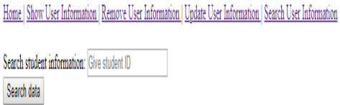

<html>

<body>

<a href="index.html"> Home </a> |

<a href="display.php"> Show User Information </a> |

<a href="delete.php"> Remove User Information </a> |

<a href="update.php"> Update User Information </a> |

<a href="search1.php"> Search User Information </a>

<br> <br>

<form action="" method="post">

Search student information:

<input type="text" name="id" placeholder="Give student ID"> <br> <input type="submit" name="search" value="Search data"> <br> <br> <?php

$host_name="localhost";

$username="root";

$password="";

$database_name="seu";

$connect=mysqli_connect($host_name,$username,$password,$database_name);

if(isset($_POST['search']))

{

$id=$_POST['id'];

$sql="SELECT * FROM student WHERE id='$id'";

$query=mysqli_query($connect,$sql);

while ($row=mysqli_fetch_array($query))

{

?>

<table border="1">

<tr>

<td>StudentID</td>

<td>Name</td>

<td>Age</td>

</tr>

<tr>

<td bgcolor="red"><?php echo $row["id"]; ?> </td>

<td bgcolor="green"><?php echo $row["name"]; ?> </td>

<td td bgcolor="yellow"><?php echo $row["age"]; ?> </td>

</tr>

</body> </table> <?php

}

}

?>

</body> </html>