Assignment No: 01

Title: Allotropic Forms of Carbon, Their Compounds and Reactivity

Course Name: Chemistry-II
Course Code: PHY-207

Date of Perform: 06-04-2021
Date of submission: 15-04- 2021

Submitted to
Md. Mahbub Alam
Lecturer
Department of Chemistry

Submitted by
Group: 06
Roll: 286, 287, 288, 289, 291, 292, 294, 2125, 2126, 2127


Department of Physics
Jahangirnagar University
Savar, Dhaka-1342

Introduction
Allotropy or allotropism is the property of some chemical elements to exist in two or more different forms, in the same physical state, known as allotropes of the elements. Allotropes are different structural modifications of an element,the atoms of the element are bonded together in a different manner. For example, the allotropes of carbon include diamond (the carbon atoms are bonded together in a tetrahedral lattice arrangement), graphite (the carbon atoms are bonded together in sheets of a hexagonal lattice), graphene (single sheets of graphite), and fullerenes (the carbon atoms are bonded together in spherical, tubular, or ellipsoidal formations).
The term allotropy is used for elements only, not for compounds. The more general term, used for any crystalline material, is polymorphism . Allotropy refers only to different forms of an element within the same phase ,the differences between these states would not alone constitute examples of allotropy.
For some elements, allotropes have different molecular formula despite difference in phase.For example, two allotropes of oxygen (Di-oxygen O₂, and Ozone O₃) can both exist in the solid, liquid and gaseous states. Other elements do not maintain distinct allotropes in different phases.For example phosphorus has numerous solid allotropes which all revert to the same P₄ form when melted to the liquid state. [1]

Reference:
1. https://en.wikipedia.org/wiki/Allotropy/

Definition of Allotropic:

The existence of two or more crystalline or molecular structural forms of an element that have different chemical or physical attributes.

The change between allotropic forms is triggered by the same forces that affect other structures, i.e., pressure, light, and temperature. Therefore, the stability of the particular allotropes depends on particular conditions. [1] [2]

Types of Allotropic of Carbon:

There are many types of allotropic of carbons. They are the –
- Diamond – Diamond is probably the most well known carbon allotrope. The carbon atoms are arranged in a lattice, which is a variation of the face-centered cubic crystal structure. It has superlative physical qualities, most of which originate from the strong covalent bonding between its atoms. Each carbon atom in a diamond is covalently bonded to four other carbons in a tetrahedron. These tetrahedrons together form a three-dimensional network of six-membered carbon rings in the chair conformation, allowing for zero bond-angle strain. This stable network of covalent bonds and hexagonal rings is the reason that diamond is so incredibly strong as a substance.[3]
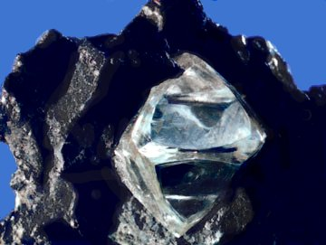
References:
1. https://en.wikipedia.org/wiki/Allotropy/
2. https://www.thefreedictionary.com/allotropic/
3. https://courses.lumenlearning.com/introchem/chapter/allotropes-of-carbon/
- Lonsdaleite – also called hexagonal diamond in reference to the crystal structure, is an allotrope of carbon with a hexagonal lattice. In nature, it forms when meteorites containing graphite strike the Earth. The great heat and stress of the impact transforms the graphite into diamond, but retains graphite's hexagonal crystal lattice.[3]
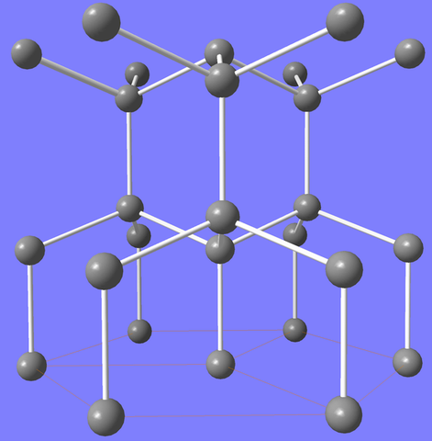

- Graphite – Graphite is another allotrope of carbon; unlike diamond, it is an electrical conductor and a semi-metal. Graphite is the most stable form of carbon under standard conditions and is used in thermochemistry as the standard state for defining the heat of formation of carbon compounds. There are three types of natural graphite:

I: Crystalline flake graphite: isolated, flat, plate-like particles with hexagonal edges.
II: Amorphous graphite: fine particles, the result of thermal metamorphism of coal; sometimes called meta-anthracite.
III: Lump or vein graphite: occurs in fissure veins or fractures, appears as growths of fibrous or acicular crystalline aggregates.
Graphite has a layered, planar structure. In each layer, the carbon atoms are
3. https://courses.lumenlearning.com/introchem/chapter/allotropes-of-carbon/
arranged in a hexagonal lattice with separation of 0.142 nm, and the distance between planes (layers) is 0.335 nm. The two known forms of graphite, alpha (hexagonal) and beta (rhombohedral), have very similar physical properties (except that the layers stack slightly differently). The hexagonal graphite may be either flat or buckled. The alpha form can be converted to the beta form through mechanical treatment, and the beta form reverts to the alpha form when it is heated above 1300 °C. Graphite can conduct electricity due to the vast electron delocalization within the carbon layers; as the electrons are free to move, electricity moves through the plane of the layers. Graphite also has self-lubricating and dry lubricating properties. Graphite has applications in prosthetic blood-containing materials and heat-resistant materials as it can resist temperatures up to 3000 °C. [3]
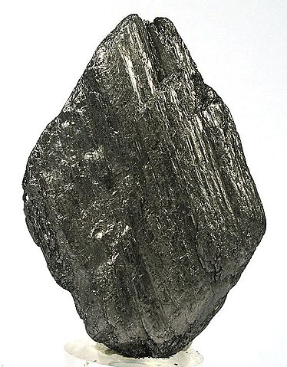

References:
3. https://courses.lumenlearning.com/introchem/chapter/allotropes-of-carbon/

- Amorphous carbon - Amorphous carbon refers to carbon that does not have a crystalline structure. Even though amorphous carbon can be manufactured, there still exist some microscopic crystals of graphite-like or diamond-like carbon. The properties of amorphous carbon depend on the ratio of sp² to sp³ hybridized bonds present in the material. Graphite consists purely of sp² hybridized bonds, whereas diamond consists purely of sp³ hybridized bonds. Materials that are high in sp³ hybridized bonds are referred to as tetrahedral amorphous carbon (owing to the tetrahedral shape formed by sp³ hybridized bonds), or diamond-like carbon (owing to the similarity of many of its physical properties to those of diamond). [3]
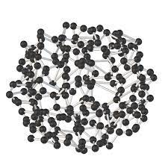
References:
3. https://courses.lumenlearning.com/introchem/chapter/allotropes-of-carbon/

Reactivity
Graphite is thermodynamically the most stable form of carbon. Its standard enthalpy of formation is thus taken as zero. Let us see why it is more stable than all the other given allotropes of carbon.

Graphite is more stable than diamond and fullerene because its enthalpy of formation ΔH f₀ is less than that of both diamond (1.98 kJ mol-1) and fullerene (38.1 kJ mol-1) at room temperature and atmospheric pressure. Also graphite has a layered structure in which all the carbon atoms are sp2 hybridized and bonded to other three carbon atoms forming hexagonal rings. Since only three electrons are used, the fourth valence electron is free to move. Thus it has a delocalized –electron cloud which is responsible for its high electrical conductivity. This delocalization adds up to its thermal stability.

Diamond has a three dimensional rigid structure in which carbon is sp3 hybridized. Each carbon is attached to four carbon atoms through C−C sigma bonds. Because of its compact structure, it has high density and is the hardest substance known.

Coal is an amorphous allotropic form of carbon. It does not have a defined structure or geometry and hence is less stable than graphite. [4]

Structures of diamond and graphite are shown below:
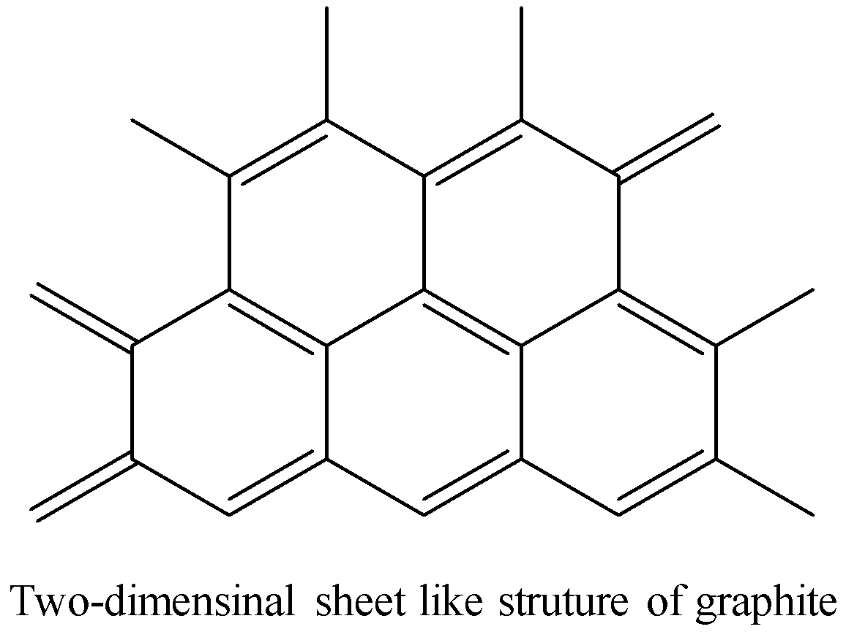
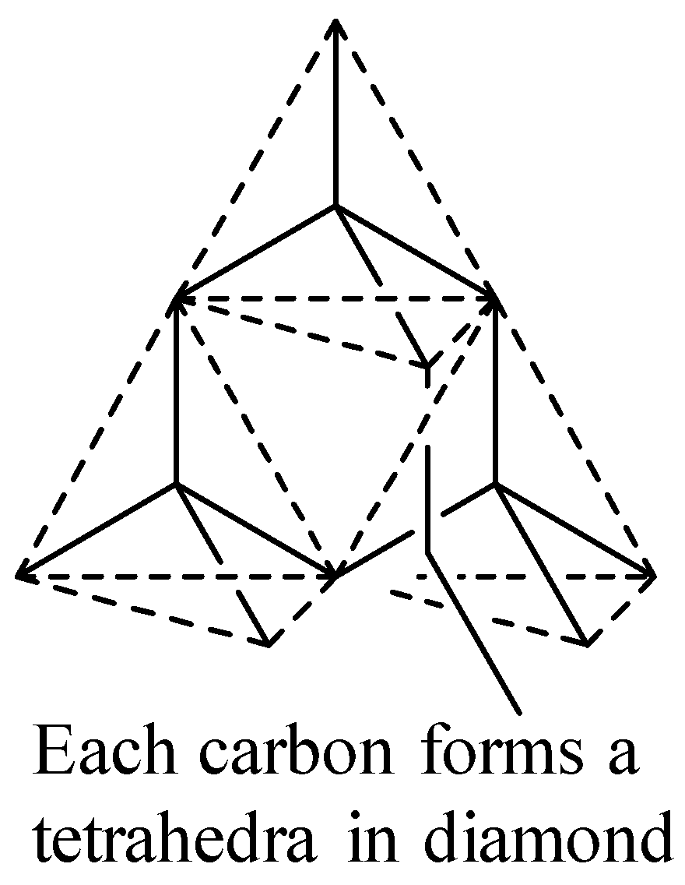

References:
4. https://www.vedantu.com/question-answer/thermodynamically-the-most-stable-form-of-carbon-class-11-chemistry-cbse-5f5669cd6791b91adfa23354/

Conclusion

There are many allotropes of carbon. This makes a large number of carbon compounds which have different property as compared to the non-metal of carbon.
- One of the most common allotrope of carbon is graphite. Graphite is a conductor of heat and electricity. This is because of the presence of an electron which is capable to migrate to itself. It is unlike all non-metals which are non-conductors of heat and electricity. [5]

- Diamond is the hardest substance known in the world. This is the presence of very strong interconnected covalent bond due to which it is very hard. [5]

- Graphite is widely used as a lubricant [5]

- Amorphous carbon is free, reactive carbon that does not have any crystalline structure. Amorphous carbon materials may be stabilized by terminating dangling-π bonds with hydrogen. As with other amorphous solids, some short-range order can be observed. [6]

- The compressive strength, coefficient of stiffness and Young’s modulus of lonsdaleite all exceed the corresponding values for diamond. Moreover, the bulk modulus of lonsdaleite is as good as that of diamond, and its tensile strength is similar to that of diamond. Therefore, lonsdaleite is a stronger and stiffer naturally occurring substance than diamond. [7]
References: 5. https://brainly.in/question/2192071/ 6. https://en.wikipedia.org/wiki/Amorphous_carbon/ 7. https://www.sciencedirect.com/science/article/abs/pii/S1359646211002053/

