**Chemistry II**

**PHY - 207**

**Assignment on:**

The chemical bonds : Electronic theory of valency, Types of bonds (Ionic, Covalent and Coordinate covalent).

**Submitted To:**

Md. Mahbub Alam

Lecturer

Department of Chemistry

Jahangirnagar University

**Submitted By:**

Group - 01

|  |  |  |
| --- | --- | --- |
| Name | Roll Number | Student ID Number |
| Asratun Sarmin Anjum | 224 | 20190448484 |
| Rafiya Binte Alam | 225 | 20190448485 |
| Zarin Tasnim Lubna | 226 | 20190448486 |
| Rafiqunnahar Rifat | 227 | 20190448487 |
| Fatema-tuz Johra | 228 | 20190448488 |
| Esrat Jahan | 229 | 20190448489 |
| Inun Nahar Mimi | 230 | 20190448490 |
| Nafia Nishat | 231 | 20190448491 |
| Morium Akter | 233 | 20190448493 |
| Raisa Nehal | 234 | 20190448494 |

Department of Physics

Jahangirnagar University

**CHAPTER 01**

# **THE CHEMICAL BONDS**

# 

# **Introduction**

Chemical bonds are the connections between atoms in a molecule. These bonds include both strong intramolecular interactions, such as covalent and ionic bonds. They are related to weaker intermolecular forces, such as dipole-dipole interactions and hydrogen bonding. The weaker forces will be discussed in a later concept.

Chemical bonds are forces that hold atoms together to make compounds or molecules.

Atoms with relatively similar electronegativities share electrons between them and are connected by covalent bonds.

Atoms with large differences in electronegativity transfer electrons to form ions. The ions then are attracted to each other. This attraction is known as an ionic bond.

Co-ordinate bond is a type of alternate covalent bond that is formed by sharing an electron pair from a single atom. Both shared electrons are donated by the same atom. It is also called dative bond or dipolar bond.

(Reference:https://byjus.com/jee/co-ordinate-bond/)

# **Electronic Theory of Valency**

The electronic theory of valency was originated by Kossel and Lewis (1916) independently and applied by Langmuir (1919). According to this theory, every element has a tendency to occupy inert electronic configuration (ns^2np^6) of the nearest inert gas, because it is considered as the most stable configuration (stable octet).

This configuration is attained by either

1. Transference of electrons
2. Sharing of electrons or
3. Donation of lone pair of electrons

**Types of bonds in a molecule**

There are three types of bonds between atoms in a molecule which are discussed below:

**Ionic Bond or Electrovalent Bond or Kernel Bond**

Such type of bond is formed by the transference of one or more electrons from one atom to the other and consequently the former becomes cation and the latter becomes anion.

* Ionic bond is called kernel bond because during formation of cation outer-most orbit is destroyed and the remaining part is called core or kernel.
* Nature of the ionic bond is an electrostatic force of attraction and it is a non-directional bond.
* Ionic bonds were introduced by Kossel.

**The formation of ionic bond depends upon three major factors:**

1. **Ionization potential:** The lower the value of ionization potential, the greater will be the ease of formation of cations.
2. **Electron affinity:** The higher the electron affinity the greater is the ease of formation of anions.

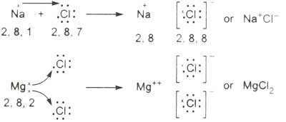

Figure: Formation of NaCl & MgCl2

1. **Lattice energy:** The higher the value of lattice energy of resulting ionic compounds, the greater will be the ease of its formation.

(Reference: https://www.sciencehq.com/chemistry/electronic-theory-of-valency.html)

**Types of chemical bonds**

There are different types of chemical bonds:

**1. Ionic Bond**

An ionic bond is a chemical bond formed by the electrostatic attraction between positive and negative ions. The bond forms between two atoms when one or more electrons are transferred from the valence shell of one atom to the valence shell of the other atom. The atom that loses electrons becomes a cation (positive ion), and the atom that electrons becomes an anion (negative ion).

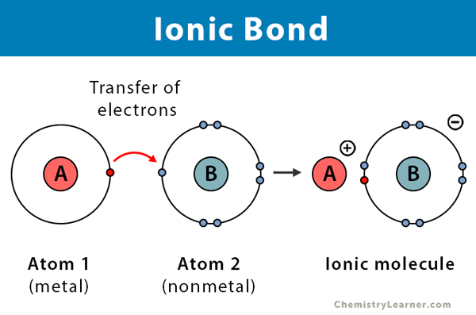

Figure : Formation of ionic bond

**Properties of Ionic Compounds**

The properties of ionic compounds relate to how strongly the positive and negative ions attract each other in an [ionic bond](https://www.thoughtco.com/definition-of-ionic-bond-604536). Ionic compounds also exhibit the following properties:

1. **They form crystals**

Ionic compounds form crystal lattices rather than amorphous solids. Although [molecular compounds](https://www.thoughtco.com/covalent-or-molecular-compound-properties-608495) form crystals, they frequently take other forms plus molecular crystals typically are softer than ionic crystals. At an atomic level, an ionic crystal is a regular structure, with the cation and anion alternating with each other and forming a three-dimensional structure based largely on the smaller ion evenly filling in the gaps between the larger ion.

1. **They have high melting points and high boiling points**

High temperatures are required to overcome the attraction between the positive and negative ions in ionic compounds. Therefore, a lot of energy is required to melt ionic compounds or cause them to boil.

1. **They have higher enthalpies of fusion and vaporization than molecular compounds**

Just as ionic compounds have high melting and [boiling points](https://www.thoughtco.com/definition-of-boiling-point-604390), they usually have enthalpies of fusion and vaporization that can be 10 to 100 times higher than those of most molecular compounds. The enthalpy of fusion is the heat required to melt a single mole of a solid under constant pressure. The [enthalpy of vaporization](https://www.thoughtco.com/definition-of-molar-enthalpy-of-vaporization-605361) is the heat required to vaporize one mole of a liquid compound under constant pressure.

1. **They're hard and brittle**

Ionic crystals are hard because the positive and negative ions are strongly attracted to each other and difficult to separate, however, when pressure is applied to an ionic crystal then ions of like charge may be forced closer to each other. The electrostatic repulsion can be enough to split the crystal, which is why ionic solids also are brittle.

1. **They conduct electricity when they are dissolved in water**

When [ionic compounds](https://www.thoughtco.com/examples-of-ionic-bonds-and-compounds-603982) are dissolved in water the dissociated ions are free to conduct electric charge through the solution. Molten ionic compounds (molten salts) also conduct electricity.

1. **They're good insulators**

Although they [conduct](https://www.thoughtco.com/examples-of-conductors-and-insulators-608318) in molten form or in [aqueous solution](https://www.thoughtco.com/definition-of-aqueous-solution-604370), ionic solids do not conduct electricity very well because the ions are bound so tightly to each other.

(Reference :<https://www.thoughtco.com/ionic-compound-properties-608497>)

**Limitations of Ionic Bonds**

Although ionic compounds are advantageous, they also have several disadvantages. For example, solid ionic compounds are very brittle and tend to shatter when broken. Ionic compounds have low thermal conductivity and are usually solid at room temperature.

**2. Covalent Bond**

Elements having very high [ionisation energies](https://byjus.com/ionization-energy-formula/) are incapable of transferring electrons and elements having very low electron affinity cannot take up electrons. The atoms of such elements tend to share their electrons with the atoms of other elements or with other atoms of the same element in a way that both the atoms obtain octet configuration in their respective valence shell and thus achieve stability. Such association through sharing of electron pairs among different or same kinds is known as Covalent Bond.

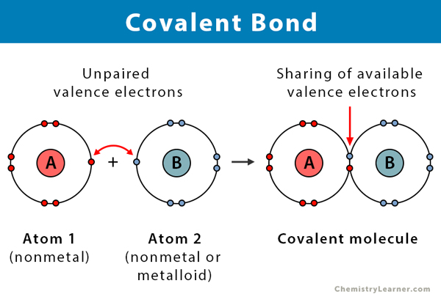Figure : Formation of Covalent Bond

### 

### 

### **Covalent Bonding can be Achieved in two Ways:**

* Sharing of electrons between atoms of the same kind e.g. Formation of H2, Cl2, O2, etc.
* Sharing of electrons between atoms of different kinds e.g. Formation of CH4, H2O, NH3, etc.

**Properties of covalent bond:**

If the normal [valence of an atom](https://byjus.com/chemistry/valency/) is not satisfied by sharing a single electron pair between atoms, the atoms may share more than one electron pair between them. Some of the properties of covalent bonds are:

* Covalent bonding does not result in the formation of new electrons. The bond only pairs them.
* They are very powerful chemical bonds that exist between atoms.
* A covalent bond normally contains the energy of about ~80 kilocalories per mole (kcal/mol).
* Covalent bonds rarely break spontaneously after it is formed.
* Covalent bonds are directional where the atoms that are bonded showcase specific orientations relative to one another.
* Most compounds having covalent bonds exhibit relatively low melting points and boiling points.
* Compounds with covalent bonds usually have lower [enthalpies of vaporization and fusion](https://byjus.com/jee/latent-heat/).
* Compounds formed by covalent bonding don’t conduct electricity due to the lack of free electrons.
* Covalent compounds are not soluble in water.

(Reference : https://byjus.com/jee/covalent-bond/)

**Limitation of Lew’s Concept of Covalent Bonds**

Lewis structures are very useful to predict whether ionic or [covalent bonds](http://www.qsstudy.com/chemistry/covalent-bonding) will form between certain elements, and in what ratio they will combine. VSEPR predicts molecular shape well. However, they assume that pairs of electrons are all localized into bonds. Occasionally the true shape of a molecule (discovered by X-ray crystallography) shows that some electrons must be delocalized over more atoms. The Lewis dot structure approach gives a superior idea of how the electrons are scattered within a molecule when dissimilar atoms bond together. Though, it cannot tell us the form of the molecule will be.

**Lewis concept fails to explain**

* The cause of the covalent bond structure. It could not explain the release of energy during the structure of a covalent bond.
* It could not clarify the shapes of molecules. The amount of enthalpy released during covalent bond formation.
* The nature of attractive forces between the constituent atoms of a molecule.

**Resonance Structures**

* Sometimes a molecule or ion cannot be accurately represented by one electron-sharing [Lewis diagram](http://www.qsstudy.com/chemistry/lewis-diagrams). E.g. carbonate ion CO3-.
* Two or more resonance structures can be drawn, the true structure is a resonance hybrid (an imagined blending) of the different, non-existent resonance structures. X-ray crystallography shows that all three bonds are the same length.
* The geometry of molecules containing covalent bonds. The structure of molecules such as PCI5, SF6, and IF7 in which the central atom has more than 8 electrons in its valence shell (violation of octet rule).
* Lewis structures assume that electrons are either entirely located on one atom (ionic compounds) or shared equally between two atoms (covalent bonding). Ionic bonding and perfect covalency (perfect sharing) are two extremes. Most compounds are neither perfectly ionic nor perfectly covalent, but somewhere in between. The formation of molecules such as BF3, AlC13 in which the central atom has less than 8 electrons in its valence shell. Small highly charged cations (e.g. Mg2+, Al3+) can polarise the electrons in large anions giving covalent nature to some ionic compounds.

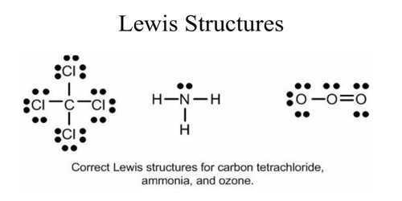 Figure : Lewis structures

(Reference:<https://qsstudy.com/chemistry/limitations-with-lewis-structures#:~:text=Lewis%20concept%20fails%20to%20explain%3A&text=It%20could%20not%20explicate%20the,constituent%20atoms%20of%20a%20molecule>.)

**RECENT THEORY OF COVALENT BOND**

1. Repulsion between electron and electron
2. Attraction between electrons and other protons
3. Repulsion between proton and proton
4. Electronic interaction between the two electron systems

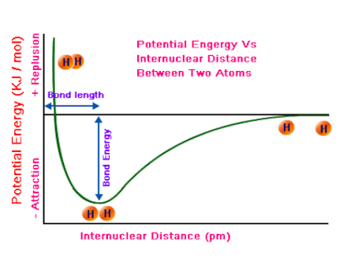

Figure : Potential energy diagram

(Reference : Recommended book)

**3. Coordinate Covalent Bond**

A coordinate covalent bond, also known as a dative bond,dipolar bond,or coordinate bond is a kind of two-center, two-electron [covalent bond](https://en.wikipedia.org/wiki/Covalent_bond) in which the two [electrons](https://en.wikipedia.org/wiki/Electrons) derive from the same [atom](https://en.wikipedia.org/wiki/Atom). The bonding of [metal](https://en.wikipedia.org/wiki/Metal#Chemical) [ions](https://en.wikipedia.org/wiki/Ions) to [ligands](https://en.wikipedia.org/wiki/Ligand) involves this kind of interaction. This type of interaction is central to [Lewis theory](https://en.wikipedia.org/wiki/Lewis_acids_and_bases).

(Reference : <https://en.wikipedia.org/wiki/Coordinate_covalent_bond>)

**Formation of Coordinate Covalent Bond**

* Coordinate covalent bond is a special type of covalent bond.
* When both the electrons of the electron pair, to be shared equally between two atoms, are contributed by a single atom, the bond formed is said to be coordinate covalent bond and the compound thus formed is called a coordinate covalent compound.
* The co-ordinate covalent bond is said to have coordinate valency.
* Among the two atoms in a coordinate covalent bond, one has a complete octet and at the same time possesses at least a pair of unused electrons while the other is short of two electrons.
* The atom which contributes the pair of electrons is called a **donor** and the one which accepts the pair of electrons is known as a **receptor**.
* The unused pair of electrons in a donor is known as lone pair of electrons.
* Coordinate covalent bond is signified by an arrow pointing from the donor atom towards the receptor.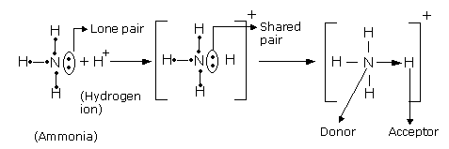Figure : Formation of NH4+

**Formation of Ammonium ion**

* In the formation of coordinate linkage (or bond), a partial positive charge is developed on the donor and a partial negative charge is developed on the receptor atom.
* The co-ordinate covalent bond once formed is indistinguishable from a covalent bond, the only difference being simply in the way of formation of the bond.

**Properties of Coordinate Covalent Bonds**

1. **Physical state:** They are generally liquids and gases.
2. **Melting and boiling points:** The melting and boiling points of such compounds is comparatively higher than that of covalent compounds and lower than that of electrovalent or ionic compounds.
3. **Electrical conductivity:** Since they have semi-ionic nature, they are poor conductors of electricity.
4. **Solubility:** They are sparingly soluble in water but soluble in organic solvents because they have semi-polar behavior.
5. **Directional character:** The co-ordinate covalent bond is also rigid and directional and therefore, the structure of such compounds holds out possibilities for space isomerism just as in pure covalent compounds.

(Reference:[https://onlinesciencenotes.com/co-ordinate-covalent-bond-formation-and-prope](https://onlinesciencenotes.com/co-ordinate-covalent-bond-formation-and-properties/))

**Conclusion**

All chemical bonding is due to electrostatic attraction. When atoms combine through chemical bonding, they form compound’s unique structures composed of two or more atoms. The basic composition of a compound can be indicated using a chemical formula. Compounds can be covalent or ionic. In covalent compounds, atoms form covalent bonds that consist of electron pairs shared between two adjacent atomic nuclei. In ionic compounds, electrons are completely transferred from one atom to another so that a cation positively charged ion and an anion negatively charged ion form. The strong electrostatic attraction between adjacent cations and anions is known as an ionic bond.

(Reference:[Molecules and compounds overview | Atomic structure (article) | Khan Academy](https://www.khanacademy.org/science/ap-chemistry/atoms-compounds-ions-ap/compounds-and-ions-ap/a/paul-article-2#:~:text=Conclusion,of%20two%20or%20more%20atoms.&text=The%20strong%20electrostatic%20attraction%20between,known%20as%20an%20ionic%20bond.))