Assignment No: 01

Title: The chemical bonds: Electronegativity, Types of bonds (Metallic, Hydrogen and Vander Waal Forces)

**Course Name:** Chemistry-II

**Course Code:** PHY-207

Date of Perform: 06-Apr-21

Date of submission: 15-Apr-21

Submitted to

**Md. Mahbub Alam**

Lecturer

Department of Chemistry

**Jahangirnagar University**

Submitted By

Group – 02

|  |  |
| --- | --- |
| Roll No | Name |
| 235 | Fahmida Akter Julie |
| 236 | Lutfa Rahman Upama |
| 237 | Tanjima Nasrin Tonny |
| 238 | Mahfuza Akter |
| 239 | Shahanaz Khatun |
| 240 | Hamima Habib Oishi |
| 241 | Shuborna Jamal |
| 242 | Fatema Tuj Zohora |
| 243 | Umma Habiba Mim |
| 244 | Fahija Farjana Upama |

**Electronegativity**, is a chemical property that describes the ability of an atom (or, more rarely, a functional group) to *attract* electrons (or electron density) towards itself in a covalent bond.

A **chemical bond** is a force between neighboring atoms, ions or molecules that holds atoms together to make compounds or molecules. The bond may result from the electrostatic force of attraction between oppositely charged ions as in ionic bonds or through the sharing of electrons as in covalent bonds. The strength of chemical bonds varies considerably; there are "*strong bonds*" or "primary bonds" such as covalent, ionic and metallic bonds, and "*weak bonds*" or "secondary bonds" such as dipole–dipole interactions, the London dispersion force and hydrogen bonding.

**Electronegativity**

**Definition:** Electronegativity, is the tendency of an atom to attract shared electrons (or electron density) to itself. An atom's electronegativity is affected by both its atomic number and the distance at which its valence electrons reside from the charged nucleus. The higher the associated electronegativity, the more an atom or a substituent group attracts electrons

**Relation with Periodic Table**

The property of electronegativity shows the tendencies of atoms in different elements attract the bond-forming electron pairs.

In a **periodic table**,

(i)Electronegativity tends increase from left to right in a period,

(ii)Electronegativity tends to increase going up a group from bottom to top.

Fluorine(F), is the most electronegative element on the periodic table. Its electronegativity value is 4.0 .The lowest ranking elements are Cesium(Cs) and Francium(Fr) which is 0.7.

**Trends in electronegativity across a period**:

The positively charged protons in the nucleus attract the negatively charged electrons. As the number of protons in the nucleus increases, the electronegativity or attraction will increase. Therefore electronegativity increases from left to right in a row in the periodic table. This effect only holds true for a row in the periodic table because the attraction between charges falls off rapidly with distance. The chart shows electronegativities from sodium to chlorine (ignoring argon since it does not does not form bonds).(Fig -1)

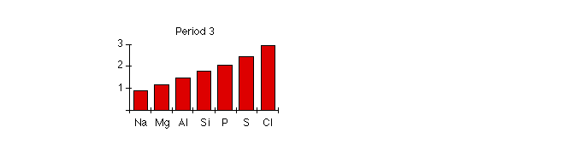 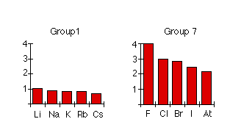

**Fig – 1 Fig - 2**

**Trends in electronegativity down a group**

As you go down a group, **electronegativity decreases**. (If it increases up to fluorine, it must decrease as you go down.) The chart(fig-2) shows the patterns of electronegativity in Groups 1 and 7.

**Patterns in electronegativity**

The attraction that a bonding pair of electrons feels for a particular nucleus depends on:

* the number of protons in the nucleus;
* the distance from the nucleus;
* the amount of screening by inner electrons.

**Electronegativity increases across a period**

Let us consider Sodium(Na) at the beginning of **period 3** and Chlorine(Cl) at the end (ignoring the noble gas, argon). Both sodium and chlorine have their bonding electrons in the 3-level. The electron pair is screened from both nuclei by the 1s, 2s and 2p electrons, but the chlorine nucleus has 6 more protons in it. It is no wonder the electron pair gets dragged so far towards the chlorine that ions are formed. Electronegativity increases across a period because the number of charges on the nucleus increases. That attracts the bonding pair of electrons more strongly.

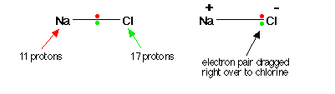

**Fig – 3: Electronegativity of Na and Cl**

**Electronegativity falls from top to down of a group:**

Electronegativity **decreases** from top to bottom of a group because the bonding pair of electrons is increasingly distant from the attraction of the nucleus. Let us consider the hydrogen fluoride(HF) and hydrogen chloride(HCl) molecules. In each case there is a net pull from the center of the fluorine or chlorine of +7. But fluorine has the bonding pair in the 2-level rather than the 3-level as it is in chlorine. If it is closer to the nucleus, the attraction is greater.

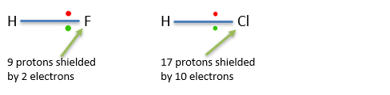

**Fig – 4: Electronegativity of atoms of a group(Group – 17)**

**The factors that affect the strength of a metallic bond**

Electronegativity is a property that describes the tendency of an atom to attract electrons (or electron density) toward itself. An atom’s electronegativity is affected by both its **atomic number** and the **size of the atom**. The higher its electronegativity, the more an element attracts electrons.

Electronegativity is dependent upon the size of the atom, since the attraction for electrons falls rapidly as the distance from the nucleus increases. The larger the atom gets, the more distant electrons become from the nucleus and hence have lesser attraction to the atom.

**Which is the most electronegative element in a periodic table? And why?**

Fluorine is the most electronegative element because it has 5 electrons in its 2P shell. Fluorine's atomic electron configuration is .The optimal electron configuration of the 2P orbital contains 6 electrons, so since Fluorine is so close to ideal electron configuration, the electrons are held very tightly to the nucleus.

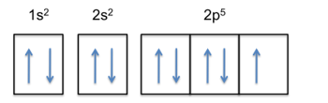

**Fig – 5: Electronic Configuration of Fluorine**

The high electronegativity of fluorine explains its small radius because the positive protons have a very strong attraction to the negative electrons, holding them closer to the nucleus than the bigger and less electronegative elements.

**Electronegativity and Bond Type**

The absolute value of the difference in electronegativity (ΔEN) of two bonded atoms provides a rough measure of the polarity to be expected in the bond and, thus, the bond type. When the difference is very small or zero, the bond is **covalent and nonpolar**.

When it is large, the bond is **polar covalent or ionic**. The absolute values of the electronegativity differences between the atoms in the bonds H–H, H–Cl, and Na–Cl are 0 (nonpolar), 0.9 (polar covalent), and 2.1 (ionic), respectively. The degree to which electrons are shared between atoms varies from completely equal (pure covalent bonding) to not at all (ionic bonding). Figure 6 shows the relationship between electronegativity difference and bond type. Although, exceptions exist here too.

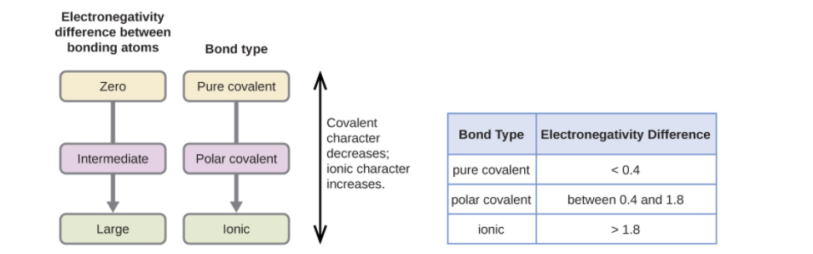

**Fig – 6: As the electronegativity difference increases between two atoms, the bond becomes more ionic.**

**Atoms having same electronegativity**

Let us consider a bond between two atoms(for example ), A and B. If the atoms are equally electronegative, both have the same tendency to attract the bonding pair of electrons, and so it will be found on average half way between the two atoms and hence, form pure covalent bond.



**Atoms having slightly different electronegativity**

If B is a lot more electronegative than A, then the electron pair is dragged right over to B's end of the bond. A polar bond is a covalent bond in which there is a separation of charge between one end and the other - in other words in which one end is slightly positive ( and the other slightly negative(.



Examples include most covalent bonds. The hydrogen-chlorine bond in HCl or the hydrogen-oxygen bonds in water are typical.

**Importance of electronegativity:**

* Because atoms do not exist in isolation and instead form molecular compounds by combining with other atoms, the concept of electronegativity is important because it determines the nature of bonds between atoms.
* Electronegativity tells us how strongly an atom of an element attracts the shared electrons in a bond. Fluorine, for example, has an electronegativity of 4 and attracts bonding electron more strongly than any other elements on the periodic table. The alkali metal has very low electronegativity so they only very weakly attract bonding electrons.
* Electronegativity is not only important to bonding, it is what makes bonding possible. Every atom has a charge: positive or negative. bonding occurs when a positive and negative attract. sometimes there are single elements with an exceptional amount of charge one way or the other. In that case you would need more of the other charge to bond because balance is also important.

**Metallic Bond**

**Definition**: A **metallic bond** is a type of chemical bond formed between positively charged atoms in which the free electrons are shared among a lattice of cations. In contrast, *covalent* and *ionic* bonds form between two discrete atoms. Metallic bonding is the main type of chemical bond that forms between metal atoms. Metallic bond is weaker than ionic and covalent bond

**When Metallic Bond occurs and how it works**?

Metallic bonding occurs when a metal is in the solid or liquid state. The s and p *valence electrons* of metals are loosely held. They leave their “own” metal atoms. This forms a "**sea**" of electrons that surrounds the metal cations. The electrons are free to move throughout this electron sea. The electron sea model is an oversimplification of metallic bonding.

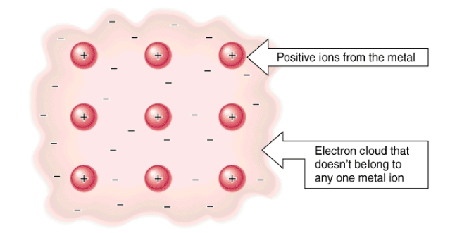

**Fig - 7: Delocalized electrons in Metal**

In this model, the valence electrons are free, delocalized, and mobile. Metallic bonding is the attractive force between the metal cations and the sea of electrons. The electrons can change energy states and move throughout a lattice in any direction.

**Example(**in case of Na**):** The electron configuration of sodium is ; it contains one electron in its valence shell. In the solid-state, metallic sodium features an array of Na+ ions that are surrounded by a sea of 3s electrons. However, it would be incorrect to think of metallic sodium as an ion since the sea of electrons is shared by all the sodium cations, quenching the positive charge.

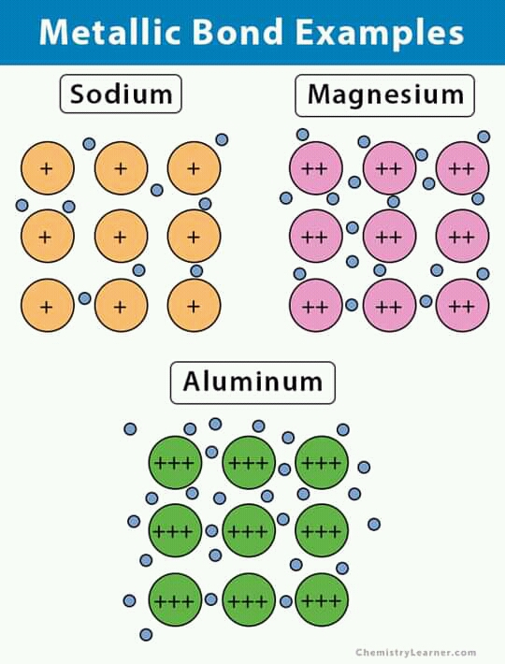

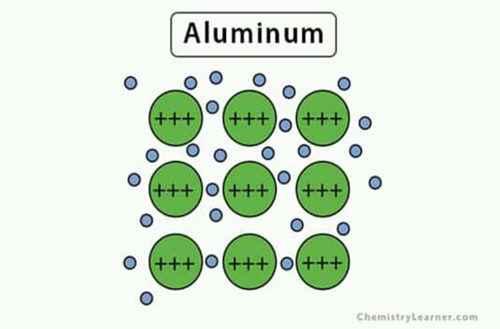

**Fig – 8 : Metallic bonds in Metals (Na, Mg, Al)**

(*Blue dots* are delocalized electrons; *positive symbols* represent positively charged ions)

The *strength* of Metallic Bond increases with the increase of **charge density** in a Metal. For example, in case of Magnesium(Mg) and Aluminum(Al) , the strength of the bond is generally higher than Sodium(Na) due to higher charge density

**The factors that affect the strength of a metallic bond include**

1. Total number of **delocalized** electrons.
2. Magnitude of positive charge held by the metal cation.
3. Ionic radius of the cation.

**Properties Attributed by Metallic Bonding**

Metallic bonds impart several important properties to metals that make them commercially desirable. Some of these properties are briefly described in this subsection.

**Electrical Conductivity**

Most metals are **excellent electrical conductors** because the electrons in the electron sea are free to move and carry charge. Electrical conductivity is a measure of the ability of a substance to allow a charge to move through it. Since the movement of electrons is not restricted in the electron sea, any electric current passed through the metal passes through it. When a potential difference is introduced to the metal, the delocalized electrons start moving towards the positive charge. This is the reason why metals are generally good conductors of electric current.

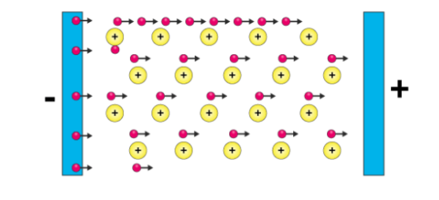

**Fig – 9 : Electricity conduction through free charges**

Conductive nonmetals (such as graphite), molten ionic compounds, and aqueous ionic compounds conduct electricity for the same reason—electrons are free to move around.

**High Melting and Boiling Points**

As a result of powerful metallic bonding, the attractive force between the metal atoms is **quite strong**. In order to overcome this force of attraction, a great deal of energy is required. This is the reason why metals tend to have high melting and boiling points. The exceptions to this include zinc, cadmium, and mercury (explained by their electron configurations, which end with ).

The metallic bond can retain its strength even when the metal is in its melt state. For example, gallium melts at 29.7C but boils only at 240C. Therefore, molten gallium is a nonvolatile liquid.

**Importance of Metallic Bond:**

* Metallic bonds allow the elements to conduct electricity and heat easily.
* Metal can be formed into shapes.
* Compounds formed by metallic bonds do not completely break until the metal is boiled, usually at a very high temperature.
* Without metallic bonds and the properties of metal, modern life wouldn’t be possible. Steel is an example of metallic bond.
* Metal is also used in electronics that form the basic components in computers and other essential modern conveniences.

**Hydrogen Bonds**

**Definition**: **Hydrogen bond** is an interaction involving a Hydrogen atom located between a pair of other atoms having a high affinity for electrons.

This bond is weaker than ionic bond or covalent bond, but stronger than van der walls forces.

The hydrogen bond is represented as (......) bond.

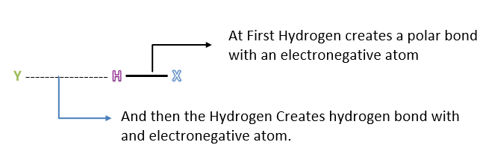

**Fig – 10: Formation of Hydrogen Bond. (where X = F, O, N, Cl.)**

The polar bond is formed with 100-500 kj/mol energy whereas the hydrogen bond internal energy is formed with (10-40) kj/mol.

The bond length of polar bond is more than that of hydrogen bond.

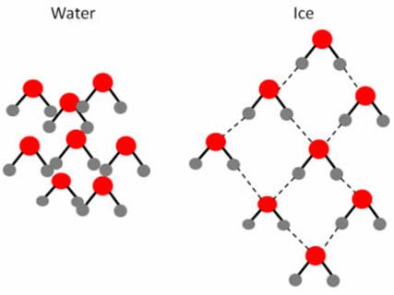

**Condition of hydrogen bond:**

The conditions of hydrogen bond are-

1. **Hydrogen bond donor** :The molecule must contain a highly electronegative atom linked to the hydrogen atom. The higher the electronegativity more is the polarization of the molecules.

2. **Hydrogen bond acceptor** :The size of the electronegative atom should be small. The smaller the size, the greater is the electrostatic attraction.

**Effects of Hydrogen bond in elements:**

**Association:**

The molecules of the carboxylic acids exist as dimer because of the hydrogen bond. The molecule masses of such compounds are found to be double than those calculated from their simple formula.

**Dissociation:**

In aqueous solution, HF dissociates and gives the difluoride ion instead of fluoride ion. This is due to hydrogen bonding in HF. The molecules of HCl, HBr, HI do not form a hydrogen bond.

**Example of Hydrogen bond:**

**1. Hydrogen Fluoride:**

Fluorine having the highest value of electronegativity forms the strongest hydrogen bond.

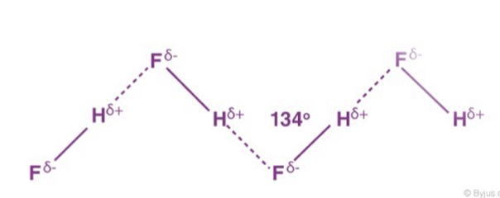

**2. Water:**

A water molecule contains a highly electronegative oxygen atom linked to the hydrogen atom. Oxygen atom attracts the shared pair of electrons more and this end of the molecule becomes negative whereas the hydrogen atoms become positive.

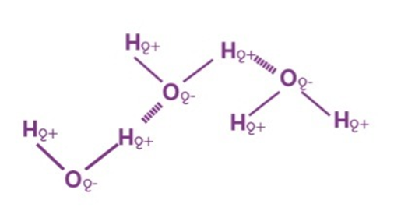

**3. Ammonia:**

It contains highly electronegative atom nitrogen linked to hydrogen atoms.

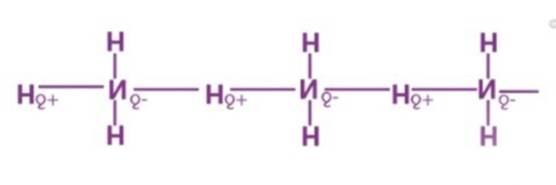

**4. Alcohols and Carboxylic acid:**

Alcohol is a type of an organic molecule which contains an -OH group. Normally if any molecule which contains the hydrogen atom is connected to either oxygen or nitrogen directly then hydrogen bonding is easily formed.

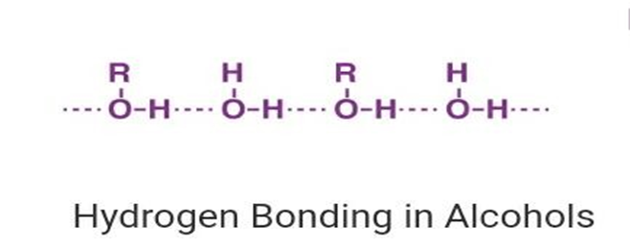

**5. Polymers:**

Hydrogen bond is an important factor in determining the 3D structures and properties that are acquired by synthetic and natural proteins. Hydrogen bonds also play an important role in defining the structure of cellulose and derived polymers such as cotton or flax.

**Classification of Hydrogen bond**

There are two types of Hydrogen bond

**1. Intramolecular Hydrogen bond**

**2. Intermolecular Hydrogen bond**

**Intramolecular Hydrogen Bond:**

The hydrogen bond which takes place within a molecule itself is called intramolecular hydrogen bond. This occurs when two functional groups of molecules can form hydrogen bonds with each other free example: intramolecular hydrogen bonding occurs in ortho Nitrophenol between its Nitro and phenol groups due to the molecular geometry.

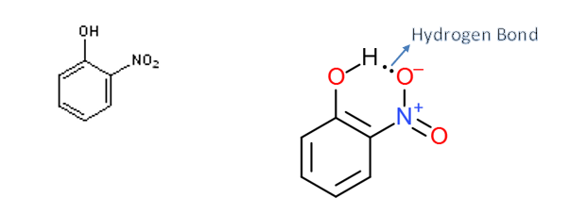

**Intermolecular Hydrogen bond :**

When hydrogen bond takes place between different molecules of the same or different compounds, it is called intermolecular Hydrogen bond.

**Example:** - Hydrogen bond in water, alcohol, ammonia, p-nitrophenol.

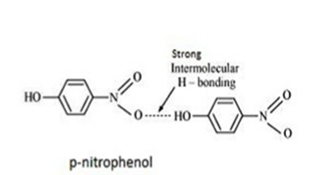

**Properties of Hydrogen bond:**

**1. Solubility:**

Lower alcohols are soluble in water because of the hydrogen bond which can take place between water and alcohol molecule.

**2. High melting and boiling point:**

The compounds having hydrogen bond show abnormally high melting and boiling points. The high melting and boiling point of the compound containing hydrogen bonds is due to the fact that some extra energy is needed to break these bonds.

**3. Volatility:**

As the compounds involving hydrogen bonding between different molecules have a higher boiling point, so they are less volatile.

**4. Viscosity and surface tension:**

The substances which contain hydrogen bond exists as an associated molecule. So, their flow becomes comparatively difficult. They have higher viscosity and higher surface tension.

**5. The lower density of ice than water:**

In the case of solid ice, the hydrogen bonding gives rise to a cage-like structure of water molecules. As a matter of fact, each water molecule is linked tetrahedral of four water molecules. The molecules are not as closely packed as they are in a liquid state. When ice melts, this case like structure collapse and the molecules come closer to each other. Thus, for the same mass of water, the volume decreases and density increases. Therefore, ice has a lower density than water at 273K. That is why ice floats.

**Importance of Hydrogen Bond:**

There is some importance of hydrogen bond. They are given below-

**1. In water:** A simple way to explain hydrogen bonds is with water. The water molecule consists of two hydrogens covalently bound to an oxygen. Since oxygen is more electronegative than hydrogen, oxygen pulls the shared electrons more closely to itself. This gives the oxygen atom a slightly more negative charge than either of the hydrogen atoms. This imbalance is called a dipole, causing the water molecule to have a positive and negative side, almost like a tiny magnet. Water molecule. This gives water a greater viscosity and allows water to dissolve other molecules that have either a slightly positive or negative charge.

**2. In protein folding**: Protein structure is partially determined by hydrogen bonding. Hydrogen bonds can occur between a hydrogen on an amine and an electronegative element, such as oxygen on another residue. As a protein folds into place, a series of hydrogen bond “zips” the molecule together holding it in a specific three-dimensional form that gives the protein its s particular function.

**3. In DNA:** Hydrogen bonds hold complementary stands of DNA together. Nucleotides pair precisely based on the position of available hydrogen bond donors (available, slightly positive hydrogens) and hydrogen bond acceptors (electronegative oxygens). The nucleotide thymine has one donor and one acceptor site that pairs perfectly with the nucleotide adenine’s complementary acceptor and donor site. Cytosine pairs perfectly with guanine through there hydrogen bonds.

**4. In Antibodies:** Antibodies are folded protein structures that precisely target and fit a specific antigen. Once the antibody is produced and attain its three-dimensional shape (aided by hydrogen bonding), the antibody will conform like a key in a lock to its specific antigen. The antibody will lock onto the antigen through a series of interactions including hydrogen bonds. The human body has the capacity to produce over ten billion different types of antibodies in an immunity reaction.

**5. In chelation:** While individual hydrogen bonds are not very strong, a series of hydrogen bonds is very secure. When one molecule hydrogen bonds through two or more sites with another molecule, a ring structure known as a chelate is formed. Chelating compounds are useful for removing or mobilizing molecules and atoms such as metals.

**Van der Waals forces**

**Definition**: Dutch physicist *Johannes Diderik van der Waals* first postulated these intermolecular forces in 1873. Van der Waals forces are the weakest intermolecular force and consist of dipole-dipole forces and dispersion forces. **Van der Waals forces**, relatively weak electric forces that attract neutral molecules to one another in gases, in liquefied and solidified gases, and in almost all organic liquids and solids

**Example**: Once a random dipole is formed in one atom, an induced dipole is formed in an adjacent atom. Van der Waals bond (Dispersion forces) can be found in *molecules*

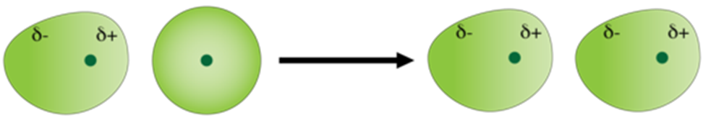

Instantaneous Nonpolar atom Instantaneous dipole Induced dipole

uneven distribution

of electrons.

**Fig: instantaneous dipole in a helium atom**

(***Source***: https://courses.lumenlearning.com/cheminter/chapter/van-der-waals-forces )

**How does the interaction happen actually**

Van der Waals forces arise when the electron density around the nucleus of an atom undergoes a transient shift. For example, when the electron density increases in one side of the nucleus, the resulting transient charge may attract or repel a neighboring atom. The nature of these forces is dependent on the distance between the atoms. Van der Waals forces range from interatomic spacings

(about 0.2 nm) up to large distances (greater than 10 nm).

* When the distance between the atoms is greater than 0.6 nanometers, the forces are extremely weak and cannot be observed.
* When the distance between the atoms ranges from 0.6 to 0.4 nanometers, the forces are attractive.
* At very small interatomic distances, the electron clouds of molecules overlap and a strong repulsive force arises. If the interatomic distance is smaller than 0.4 nanometers, the forces are repulsive in nature.

**Two types of van der Waals forces**

Van der Waals forces' is a general term used to define the attraction of intermolecular forces between molecules. There are two kinds of Van der Waals forces: weak London Dispersion Forces and stronger dipole-dipole forces.

**Dipole – Dipole Interaction (permanent-induced dipoles)**

A molecule with permanent dipole can induce a dipole in a similar neighboring molecule and cause mutual attraction. This kind of interaction can be expected between any polar molecule and non-polar/symmetrical molecule. The induction-interaction force is far weaker than dipole–dipole interaction, but stronger than the London dispersion force.

**Example**: One example of an induction interaction between permanent dipole and induced dipole is the interaction between HCl and Ar. In this system, Ar experiences a dipole as its electrons are attracted (to the H side of HCl) or repelled (from the Cl side) by HCl.

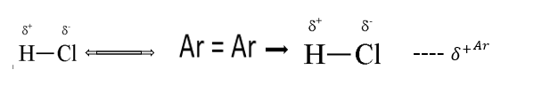

**Fig: Permanent-Induced Dipole Attraction (HCl – Ar)**

**London Dispersion Force**

The London dispersion force is the weakest intermolecular force, and is a temporary attractive force that results when the electrons in two neighboring atoms positions that make the atoms form temporary dipoles. A real gas atom can have instantaneous dipole. Partial Charges on one atom can cause a neighboring atom to distort due to the electrostatic attractions/repulsions of their electron clouds. This force is sometimes called an induced dipole attraction. London forces are the attractive forces that cause nonpolar substances to condense to liquids and to freeze into solids when the temperature is lowered sufficiently.

**Example**: Nitrogen gas (N2) is diatomic and non-polar because both nitrogen atoms have the same degree of electro-negativity. London dispersion forces allows nitrogen atoms stick together to form a liquid.

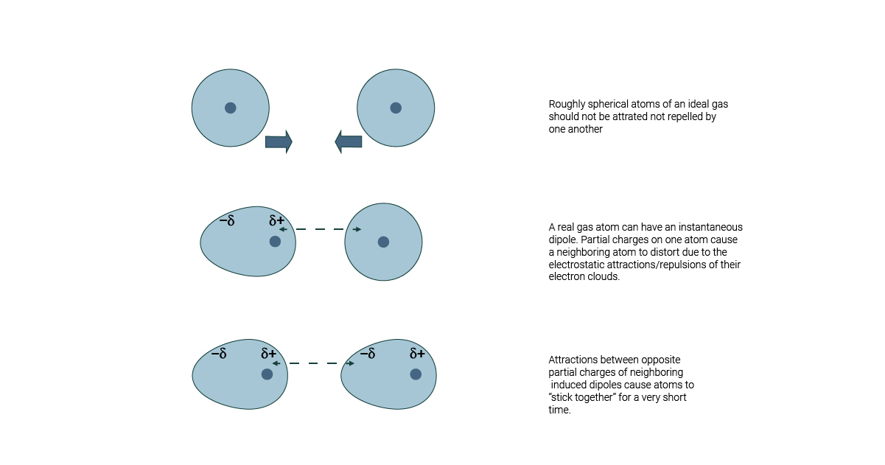

**Fig: Induced-Induced attraction**

( **Source**: https://www.breakingatom.com/learn-the-periodic-table/london-dispersion-forces)

**Importance of van der Waals Forces:**

* Like hydrogen bonds, van der Waals interactions are weak attractions or interactions between molecules. ... These bonds—along with ionic, covalent, and hydrogen bonds—contribute to the three-dimensional structure of proteins that is necessary for their proper function.
* Water molecules in liquid water are attracted to each other by electrostatic forces, and these forces have been described as van der Waals forces or van der Waals bonds. It is attributed to the dipole-dipole interactions with bonds between hydrogen and other atoms.
* From the viewpoint of tribology, repulsive van der Waals force can prevent intimate contact of the relatively sliding surfaces, thus minimize the energy dissipation during sliding. Measurement of the frictional force shows that a gold particle slides on PTFE surface in cyclohexane gives rise to an obvious ultra-low friction.
* A limited number of these forces(repulsive van der Waals) have been found including Teflon thin film and alumina or amorphous silica metal bearings in a PTFE housing with an organic lubricant, and certain combinations of ceramic materials.

**Conclusion**

Electronegativity, is a chemical property, is not only important to bonding, it is what makes bonding possible.

**Chemical bonds** hold molecules together and create temporary connections that are essential to life. All the compounds ( both organic and inorganic ) are created with the help of chemical bonding. Chemical bonding helps to joining atoms or molecules together. It also helps molecules of the same or different substance to get together through joining to each other. Solid , liquid, or gaseous matter can exist in the nature due to chemical bonding .

Consequently, chemical bonding is very much important for the existence of matter in the earth.

**References:**

1. <https://www.quora.com/Why-is-electronegativity-important-in-chemistry>

2.<https://courses.lumenlearning.com/trident-boundless-chemistry/chapter/types-of-chemical-bods/>

3. <https://en.wikipedia.org/wiki/Chemical_bond>

4. <https://en.wikipedia.org/wiki/Electronegativity>

5.https://chem.libretexts.org/Bookshelves/Physical_and_Theoretical_Chemistry_Textbook_Maps/Supplemental_Modules_(Physical_and_Theoretical_Chemistry)/Physical_Properties_of_Matter/Atomic_and_Molecular_Properties/Electronegativity

6. <https://courses.lumenlearning.com/trident-boundless-chemistry/chapter/electronegativity/#:~:text=Electronegativity%20is%20a%20property%20that,more%20an%20element%20attracts%20electrons>.

7.<https://chem.libretexts.org/Bookshelves/Inorganic_Chemistry/Modules_and_Websites_(Inorganic_Chemistry)/Descriptive_Chemistry/Periodic_Trends_of_Elemental_Properties/Periodic_Trends#:~:text=From%20top%20to%20bottom%20down,or%20a%20greater%20atomic%20radius>.

8.https://chem.libretexts.org/Bookshelves/Inorganic_Chemistry/Modules_and_Websites_(Inorganic_Chemistry)/Descriptive_Chemistry/Elements_Organized_by_Block/2_p-Block_Elements/Group_17%3A_The_Halogens/Z009_Chemistry_of_Fluorine_(Z9)

9. <https://chem.libretexts.org/Courses/Oregon_Institute_of_Technology/OIT%3A_CHE_202_-_General_Chemistry_II/Unit_6%3A_Molecular_Polarity/6.1%3A_Electronegativity_and_Polarity#:~:text=Covalent%20bonds%20form%20when%20electrons,the%20electrons%20are%20shared%20equally.&text=The%20ability%20of%20an%20atom,bond%20is%20called%20its%20electronegativity>.

10. https://www.thoughtco.com/metallic-bond-definition-properties-and-examples-4117948#:~:text=A%20metallic%20bond%20is%20a,that%20forms%20between%20metal%20atoms.

11. <https://socratic.org/questions/when-does-metallic-bonding-occur#100259>

12. <https://materialpedia.materialsscience.net/2019/03/18/metallic-bond/>

13. https://byjus.com/chemistry/metallic-bonds/

14. <https://www.brighthubeducation.com/science-homework-help/108502-seven-different-types-of-chemical-bonds-and-why-they-are-important/#metallic-bonds>

15. <https://kgghosh1990.medium.com/chemical-bonding-definition-examples-and-importance-in-chemistry-4e9d7b928078>

16. <https://www.britannica.com/science/hydrogen-bonding>

17.<https://chem.libretexts.org/Courses/University_of_Arkansas_Little_Rock/Chem_1403%3A_General_Chemistry_2/Text/11%3A_Intermolecular_Forces_and_Liquids/11.05%3A__Hydrogen_Bonds#:~:text=There%20are%20two%20requirements%20for,N%2CO%2CF).&text=Second%20molecule%20has%20a%20lone,N%2CO%2CF>).

18. <https://byjus.com/jee/hydrogen-bonding/>

19. <https://sciencing.com/importance-hydrogen-bonding-2514.html>

20.https:www.britannica.com/science/van-der-Waals-forces

21. <https://courses.lumenlearning.com/cheminter/chapter/van-der-waals-forces>

22. <https://www.materials.unsw.edu.au/study-us/high-school-students-and-teachers/online-tutorials/atomic-bonding/secondary-bonds>

23. <https://byjus.com/chemistry/van-der-waals-forces/>

24. <https://sci-hub.st/https://doi.org/10.1007/978-0-387-92897-5_457>

25.<https://chem.libretexts.org/Bookshelves/Physical_and_Theoretical_Chemistry_Textbook_Maps/Supplemental_Modules_(Physical_and_Theoretical_Chemistry)/Physical_Properties_of_Matter/Atomic_and_Molecular_Properties/Intermolecular_Forces/Van_der_Waals_Forces#:~:text=Van%20der%20Waals%20forces'%20is,and%20stronger%20dipole%2Ddipole%20forces>.

26. <https://en.wikipedia.org/wiki/Intermolecular_force>

27. <https://www.quora.com/What-type-of-intermolecular-force-of-attraction-between-N2-and-NH3>

28. <https://www.breakingatom.com/learn-the-periodic-table/london-dispersion-forces>

29.<https://bio.libretexts.org/Bookshelves/Introductory_and_General_Biology/Book%3A_General_Biology_(Boundless)/2%3A_The_Chemical_Foundation_of_Life/2.1%3A_Atoms_Isotopes_Ions_and_Molecules/2.1J%3A_Hydrogen_Bonding_and_Van_der_Waals_Forces>

30. <http://hyperphysics.phy-astr.gsu.edu/hbase/Chemical/waal.html>

31. <https://www.khanacademy.org/science/ap-biology/chemistry-of-life/introduction-to-biological-macromolecules/a/chemical-bonds-article>

32. <https://kgghosh1990.medium.com/chemical-bonding-definition-examples-and-importance-in-chemistry-4e9d7b928078#:~:text=Chemical%20bonding%20helps%20to%20joining,nature%20due%20to%20chemical%20bonding%20>.