 **Assignment**

On

**ELECTRONIC PAIR REPULSION THEORY AND MOLECULAR GEOMETRY**



**Submitted to:**

[**Md. Mahbub Alam**](https://www.juniv.edu/teachers/malam.chem)

Lecturer

Department of Chemistry

Jahangirnagar University

**Submitted by:**

**Group: 3**

**(Roll-245, 246, 247, 248, 250, 251, 252, 253,254, 255)**

B.Sc. 2nd year

Department of Physics

Jahangirnagar University

**1. Introduction:**

The electron pairs around the central atom repel each another and move so far apart from each another that there are no greater repulsions between them [Electron pair](https://www.thoughtco.com/valence-shell-electron-pair-repulsion-theory-605773) repulsion is used to predict the geometry of a [molecule](https://www.thoughtco.com/what-is-a-molecule-definition-examples-608506) or a polyatomic [ion](https://www.thoughtco.com/definition-of-ion-604535). It is used in a wide variety of scientific disciplines. Physics, engineering, and chemistry use this principle especially often. Valence-shell electron-pair repulsion (VSEPR) theory is conventionally used to predict molecular geometry. The VSEPR theory is based on the assumption that the molecule will take a shape such that electronic repulsion in the valence shell of that atom is minimized. Here, we will discuss VSEPR theory and molecular geometry in details.

**2. Electronic Pair Repulsion Theory and Molecular Geometry**

Valence shell electron pair repulsion theory, or VSEPR theory, is a model used in chemistry to predict the geometry of individual molecules from the number of electron pairs surrounding their central atoms. It is also named the Gillespie-Nyholm theory after its two main developers, Ronald Gillespie and Ronald Nyholm.

**2.1. Lewis Electron-Dot Diagrams:**

To determine the shapes of molecules and grasp VSEPR theory properly, we must become acquainted with the Lewis electron dot structure. Although the Lewis theory does not determine the shapes of molecules, it is the first step in predicting shapes of molecules. The Lewis structure helps us identify the bond pairs and the lone pairs. Then, with the Lewis structure, we apply the valence-shell electron-pair repulsion (VSPER) theory to determine the molecular geometry and the electron-group geometry.

Gilbert Lewis Newton introduced a simple way to show the bonding between atoms in a molecule though Lewis’s electron dot diagrams. Creating Lewis diagrams is rather simple and requires only a few steps and some accounting of the valence electrons on each atom. Valence electrons are represented as dots. When two electrons are paired (lone pairs), they are represented by two adjacent dots located on an atom, and when two paired electrons are shared between atoms (bonds), they are shown as lines. For example, below are the electron dot structures of atoms and the Lewis electron dot structures of the molecules. These diagrams are helpful because they allow us to show how atoms are connected, and when coupled with [Valence Shell Electron Repulsion Theory (VSEPR)](https://chem.libretexts.org/Bookshelves/Inorganic_Chemistry/Map%3A_Inorganic_Chemistry_(Miessler_Fischer_Tarr)/03%3A_Simple_Bonding_Theory/3.02%3A_Valence_Shell_Electron-Pair_Repulsion), we can use Lewis structures to predict the shape of the molecule.

The drawing of Lewis electron-dot structures is guided largely by the **octet rule**: that atoms form bonds to achieve eight electrons in their valence shell. For many elements, a full valence shell has an electron configuration of s2p6s2p6, or eight electrons.

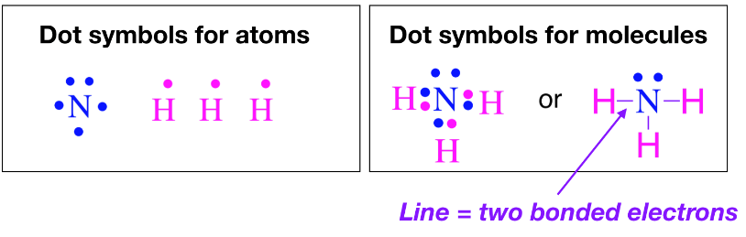Figure:2.1

**2.2. VSEPR Theory**

The **Valence Shell Electron Repulsion (VSEPR)** model can predict the structure of most molecules and polyatomic ions in which the central atom is a nonmetal; it also works for some structures in which the central atom is a metal. VSEPR builds on Lewis’s electron dot structures; Lewis structures alone predict only connectivity while the Lewis structure and VSEPR together can predict the geometry of each atom in a molecule. The main idea of VSEPR theory is that pairs of electrons (in bonds and in lone pairs) repel each other. The pairs of electrons (in bonds and in lone pairs) are called "groups". Because electrons repel each other electrostatically, the most stable arrangement of electron groups (i.e., the one with the lowest energy) is the one that minimizes repulsion. Groups are positioned around the central atom in a way that produces the molecular structure with the lowest energy. In other words, the repulsion between groups around an atom favors a geometry in which the groups are as far apart from each other as possible. Although VSEPR is simplistic because it does not account for the subtleties of orbital interactions that influence molecular shapes, it accurately predicts the three-dimensional structures of a large number of compounds.

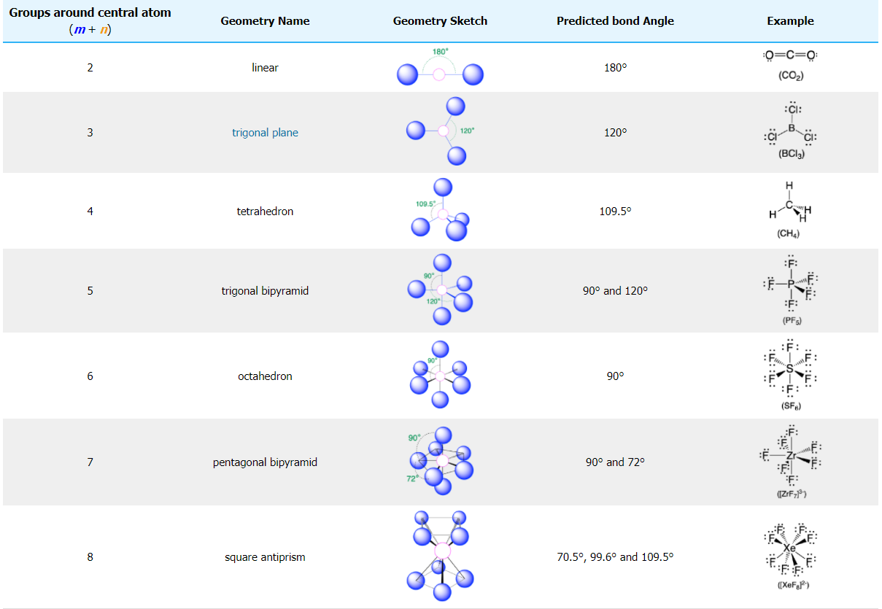

Figure: 2.2

We can use the VSEPR model to predict the geometry around the atoms in a polyatomic molecule or ion by focusing on the number of electron pairs (groups) around a *central atom*of interest. Groups include bonded and unbonded electrons; a single bond, a double bond, a triple bond, a lone pair of electrons, or even a single unpaired electron each count as one group. The molecule or polyatomic ion is given an AX*m*E*n* designation, where A is the central atom, X is a bonded atom, E is a nonbonding valence electron group (usually a lone pair of electrons), and *m* and *n* are integers. The number of groups is equal to the sum of *m* and *n*. Using this information, we can describe the molecular geometry around a central atom, the arrangement of the *bonded atoms* in a molecule or polyatomic ion. The geometries that are predicted from VSEPR when a central atom has only bonded groups (*n*= 0) are listed above in Table 2.2. The cases where lone pairs contribute to the total groups (*n* ≥≥ 1) are discussed in the [next section about lone pair repulsion](https://chem.libretexts.org/Bookshelves/Inorganic_Chemistry/Map%3A_Inorganic_Chemistry_(Miessler_Fischer_Tarr)/03%3A_Simple_Bonding_Theory/3.02%3A_Valence_Shell_Electron-Pair_Repulsion/3.2.01%3A_Lone_Pair_Repulsion).

**2.2.1. Postulates of VSEPR Theory:**

The postulates of the VSEPR theory are listed below

* In polyatomic molecules (i.e. molecules made up of three or more atoms), one of the constituent atoms is identified as the central atom to which all other [atoms belonging to the molecule](https://byjus.com/chemistry/atoms-and-molecules/) are linked.
* The total number of valence shell electron pairs decides the shape of the molecule.
* The electron pairs have a tendency to orient themselves in a way that minimizes the electron-electron repulsion between them and maximizes the distance between them.
* The valence shell can be thought of as a sphere wherein the electron pairs are localized on the surface in such a way that the distance between them is maximized.
* Should the central atom of the molecule be surrounded by bond pairs of electrons, then, the asymmetrically shaped molecule can be expected.
* Should the central atom be surrounded by both lone pairs and bond pairs of electrons, the molecule would tend to have a distorted shape.
* The VSEPR theory can be applied to each [resonance structure](https://byjus.com/chemistry/resonance-structures/) of a molecule.
* The strength of the repulsion is strongest in two lone pairs and weakest in two bond pairs.
* If electron pairs around the central atom are closer to each other, they will repel each other. This results in an increase in the energy of the molecules.
* If the electron pairs lie far from each other, the repulsions between them will be less and eventually, the [energy of the molecule](https://byjus.com/physics/energy-level/) will be low.

**2.2.2 Limitations of VSEPR Theory**

Some significant limitations of the VSEPR theory include:

* This theory fails to explain isoelectronic species (i.e. elements having the same number of electrons). The species may vary in shapes despite having the same number of electrons.
* The VSEPR theory does not shed any light on the compounds of [transition metals](https://byjus.com/chemistry/transition-elements/). The structure of several such compounds cannot be correctly described by this theory. This is because the VSEPR theory does not take into account the associated sizes of the substituent groups and the lone pairs that are inactive.
* Another limitation of VSEPR theory is that it predicts that halides of group 2 elements will have a linear structure, whereas their actual structure is a bent one.

**2.3. Lone pair repulsion**

Lone pairs have stronger repulsive force than bonded groups. When one or more of the groups is a lone pair of electrons (non-bonded electrons), the experimentally-observed geometry around an atom is slightly different than in the case where all groups are bonds. The actual bond angles are similar, but not exactly the same, as those predicted based on the *total number of groups* (the "parent" geometry). When there is a mixture of group types (lone pairs (E) *and* bonded groups (X)) there are three different types of angles to consider: bond angles between two bonded atoms (X-X angles), angles between a bonded atom and a lone pair (X-E angles), and angles between two lone pairs (E-E angles). Empirical evidence shows the following trend in the degree of bond angles in around atoms with a mixture of group types:

*Trend in bond angles*:

E-E >X-E >X-X

Using empirical evidence as a guide, we can predict that lone pairs repel other electron groups more strongly than bonded pairs. The molecular geometry of molecules with lone pairs of electrons are better predicted when we consider that electronic repulsion created by lone pairs is stronger than the repulsion from bonded groups. It is difficult to predict the exact bond angle based on this principle, but we can predict approximate angles, as described and summarized below in Table 2.2.2

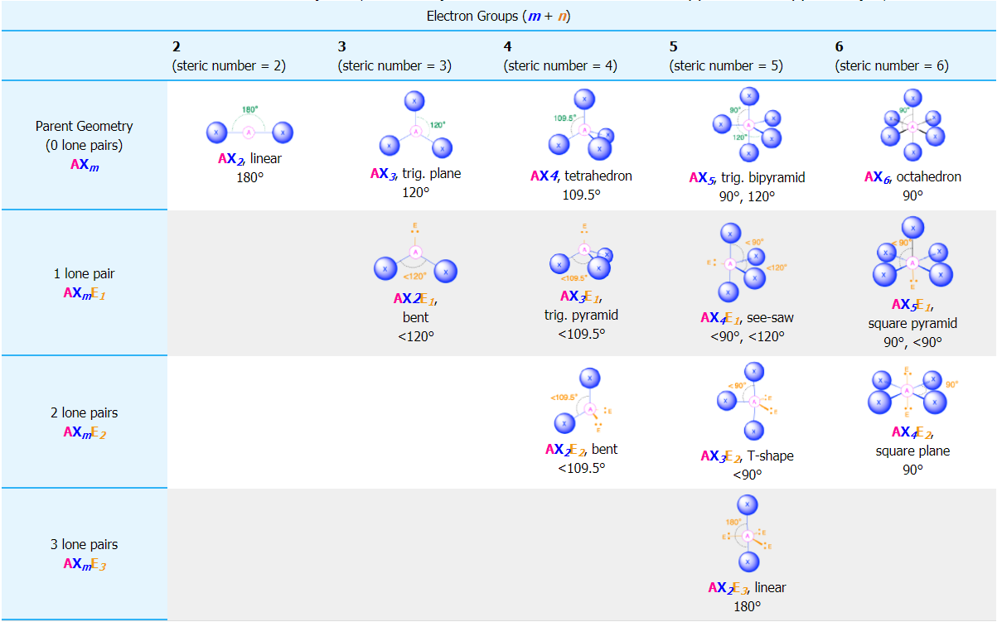

Figure:2.2.2

Table 2.2.2 summarizes the geometries and bond angles predicted for nearest-neighboring bonded groups on central atoms with a mixture of lone pairs and bonded groups. The table is not comprehensive of all possible situations; it only includes cases where there are two bonded groups in which an X-X angle is measurable between nearest-neighbors. A more detailed description of some selected cases is given below.

**Two Electron Groups (m + n = 2)**

(Steric number = 2) In the case that there are only two electron groups around a central atom, those groups will lie 180° from one another. This results in a linear molecular geometry with 180° bond angles. ***Example: CO***

**Three Electron Groups (m + n = 3)**

(Steric number = 3) In the case that there are three electron groups around a central atom, those groups will lie approximately 120° from one another in space. This results in an electronic geometry that is approximately **trigonal planar**. There are two different molecular geometries that are possible in this category:

When all of the electron groups are bonds (m = 3 or AX3), the molecular geometry is a ***trigonal plane*** with **120°** bond angles. When there is one lone pair (m=2, n=1 or AX2E1), the molecular geometry is ***bent*** with a bond angle that is slightly **less than 120°**.

***Examples: AX2E Molecules: SO2***

## Four Electron Groups (m + n = 4)

(Steric number = 4) In the case that there are four electron groups around a central atom, those groups will lie approximately 109.5° from one another in space. This results in an electronic geometry that is approximately **tetrahedral**. There are three different molecular geometries that are possible in this category:

* When all electron groups are bonds (m=4 or AX4), the molecular geometry is a ***tetrahedron*** with bond angles of **109.5°**.
* When there is one lone pair (m=3, n=1 or AX3E1), the molecular geometry is a ***trigonal pyramid*** with bond angles of **slightly less than 109.5°**.
* When there are two lone pairs (m=2, n=2 or AX2E2), the molecular geometry is ***bent*** with bond angles of **slightly less than 109.5°**.

### ***Examples: AX3EMolecules: NH3, AX2E2Molecules: Example H2O***

**Five Electron Groups (m + n = 5)**

Steric number = 5) In the case that there are five electron groups around a central atom, there are two different types of positions around the central atom: equatorial positions and axial positions. The three equatorial ligands are 120° from one another and are 90° from each of the two axial ligands. The axial positions have three adjacent groups oriented 90° away in space. Axial groups are thus more crowded than the equatorial positions with only two adjacent groups at 90°. The crowding of axial positions results in slight differences in bond distances; crowded axial groups have longer bonds than the less crowded equatorial groups. Lone pairs of electrons generally prefer to occupy equatorial positions rather than axial positions. The justification for this preference, according to VSEPR theory, is that the lone electron pairs are more repulsive than bonding electron pairs, and thus the lone pairs prefer the less crowded equatorial positions.

The arrangement of five groups around a central atom result in a **trigonal bipyramidal** electronic geometry. There are four different molecular geometries that are possible in this category, depending upon the number of bonded groups and lone pairs of electrons:

* When all electron groups are bonds (m=5 or AX5), the molecular geometry is a ***trigonal bipyramid*** with bond angles of **120°**and **90°**between adjacent ligands.
* When there is one lone pair (m=4, n=1 or AX4E1), the lone pair occupies one of the equatorial positions. The molecular geometry is called a ***see saw*** with bond angles of **slightly less than 120°**and **slightly less than 90°**.
* When there are two lone pairs (m=3, n=2 or AX3E2), each lone pair occupies one of the three equatorial positions. The molecular geometry is ***T-shaped*** with bond angles of **slightly less than 120°**and **slightly less than 90°**.
* When there are three lone pairs (m=1, n=3 or AX3E2), the lone pairs occupy the three equatorial positions. The molecular geometry is ***linear*** with bond angles of **180°**.

***Example: AX4EMolecules: SF4 , AX3E2Molecules: BrF3 , AX2E3Molecules: I3−***

## Six Electron Groups (m + n = 6)

(Steric number = 6) In the case that there are six electron groups around a central atom, the nearest groups will lie approximately 90° from one another in space. This results in an electronic geometry that is approximately **octahedral**. There are three relevant molecular geometries in this category:

* When all electron groups are bonds (m=6 or AX6), the molecular geometry is an ***octahedron*** with bond angles of **90°**between adjacent bonds.
* When there is one lone pair (m=5, n=1 or AX5E1) we now distinguish between the axial and equatorial positions; the lone pair is considered to be in one of the axial positions, while the bond directly opposite of the lone pair is the axial bond. The molecular geometry is a ***square pyramid*** with bond angles of **90°**between adjacent equatorial bonds and **slightly less than 90°**between the axial bond and equatorial groups.
* When there are two lone pairs (m=4, n=2 or AX4E2), the lone pairs are opposite of one another and each occupy an axial position. The molecular geometry is ***square planar*** with bond angles of**90°**.

***Example: AX5EMolecules: BrF5, AX4E2Molecules: ICl4−***

**2.4. Molecular geometry:**

Molecular geometry is the three-dimensional arrangement of the atoms that constitute a molecule. It includes the general shape of the molecule as well as bond lengths, bond angles, torsional angles and any other geometrical parameters that determine the position of each atom.

**2.4.1. Predicting the Shapes of Molecules:**

The following steps must be followed in order to decide the shape of a molecule.

•The least electronegative atom must be selected as the central atom (since this atom has the highest ability to share its electrons with the other atoms belonging to the molecule).

•The total number of electrons belonging to the outermost shell of the central atom must be counted.

•The total number of electrons belonging to other atoms and used in bonds with the central atom must be counted.

•These two values must be added in order to obtain the valence shell electron pair number or the VSEP number.

**2.4.2 VSEP Number:**

The VSEP number describes the shape of the molecule, as described in the table provided below.

|  |  |
| --- | --- |
| **VSEP Number** | **Shape of the Molecule** |
| 2 | Linear |
| 3 | Trigonal Planar |
| 4 | Tetrahedral |
| 5 | Trigonal Bipyramidal |
| 6 | Octahedral |
| 7 | Pentagonal Bipyramidal |

However, the VSEPR theory cannot be used to obtain the exact bond angles between the atoms in a molecule.

**2.4.3. Types of molecular structure:**

Some common shapes of simple molecules include:

**Linear:** In this type of molecule, we find two places in the valence shell of the central atom. They should be arranged in such a manner such that repulsion can be minimized (pointing in the opposite direction). In a linear model, atoms are connected in a straight line. The bond angles are set at 180°. For example, carbon dioxide and nitric oxide have a linear molecular shape.

**Trigonal planar:** In this type of molecule, we find three molecules attached to a central atom. They are arranged in such a manner such that repulsion between the electrons can be minimized (toward the corners of an equilateral triangle). Molecules with the trigonal planar shape are somewhat triangular and in one plane (flat). Consequently, the bond angles are set at 120°. For example, boron trifluoride.

**Angular**: Angular molecules (also called bent or V-shaped) have a non-linear shape. For example, water (H2O), which has an angle of about 105°. A water molecule has two pairs of bonded electrons and two unshared lone pairs.

**Tetrahedral**: Tetra- signifies four, and -hedral relates to a face of a solid, so "tetrahedral" literally means "having four faces". This shape is found when there are four bonds all on one central atom, with no extra unshared electron pairs. In accordance with the VSEPR (valence-shell electron pair repulsion theory), the bond angles between the electron bonds are arccos(−1/3) = 109.47°. For example, methane (CH4) is a tetrahedral molecule.

**Octahedral**: Octa- signifies eight, and -hedral relates to a face of a solid, so "octahedral" means "having eight faces". The bond angle is 90 degrees. For example, sulfur hexafluoride (SF6) is an octahedral molecule.

**Trigonal pyramidal:** A trigonal pyramidal molecule has a pyramid-like shape with a triangular base. Unlike the linear and trigonal planar shapes but similar to the tetrahedral orientation, pyramidal shapes require three dimensions in order to fully separate the electrons. Here, there are only three pairs of bonded electrons, leaving one unshared lone pair. Lone pair – bond pair repulsions change the bond angle from the tetrahedral angle to a slightly lower value.[9] For example, ammonia (NH3).

**2.5. Related problems and solutions**

**1.** Predict the geometry around the central atom in BeH2, CO2, BCl3, CO32-,CH4, PCl5

**Answer BeH2**



Here,

* The central atom, beryllium, contributes two valence electrons, and each hydrogen atom contributes one. The Lewis electron structure is
* There are two groups around the central atom, and both groups are single bonds. Thus, BeH2 is designated as AX2.
* We see from Table 2.2 that the arrangement that minimizes repulsions places the groups 180° apart.
* From Table 2.2 we see that with two bonding pairs, the molecular geometry that minimizes repulsions in BeH2 is *linear.*

**Answer CO2**



Here,

* The central atom, carbon, contributes four valence electrons, and each oxygen atom contributes six.
* The carbon atom forms two double bonds. Each double bond is counted as one group, so there are two groups around the central atom. Once again, both groups around the central atom are bonds, so CO2 is designated as AX2.
* Like BeH2, the arrangement that minimizes repulsions places the groups 180° apart.
* VSEPR only recognizes groups around the *central* atom (the carbon). Thus, the lone pairs on the oxygen atoms do not influence the molecular geometry. With two bonded groups on the central atom and no lone pairs, the molecular geometry of CO2 is linear (figure 2.2).

**Answer BCl3**

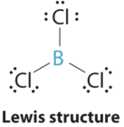

Here,

* The central atom, boron, contributes three valence electrons, and each chlorine atom contributes seven valence electrons. The Lewis electron structure is
* There are three groups around the central atom and all are single bonds. The structure is designated as AX3.
* To minimize repulsions, the groups are placed 120° apart (figure 2.2).
* From figure 2.2 we see that with three bonding pairs around the central atom, the molecular geometry of BCl3 is *trigonal planar*.

**Answer CO32-**

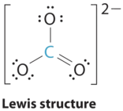

Here,

* + The central atom, carbon, has four valence electrons, and each oxygen atom has six valence electrons. The Lewis electron structure of one of three resonance forms is represented as
  + The structure of CO32− is a resonance hybrid. It has three identical bonds. With three bonding groups around the central atom, the structure is designated as AX3.
  + We minimize repulsions by placing the three groups 120° apart (Table 2.2).
  + We see from Table 2.2 that the molecular geometry of CO32− is trigonal planar with bond angles of 120°.

**Answer CH4**

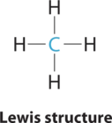

Here,

* The central atom, carbon, contributes four valence electrons, and each hydrogen atom has one valence electron, so the full Lewis electron structure is
* There are four electron groups around the central atom. All electron groups are bonding pairs, so the structure is designated as AX4.
* As shown in Table 2.2, repulsions are minimized by placing the groups in the corners of a tetrahedron with bond angles of 109.5°.
* With four bonding pairs, the molecular geometry of methane is *tetrahedral* (figure-2.2).

**Answer PCl5**

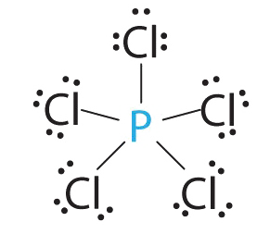

* Phosphorus has five valence electrons and each chlorine has seven valence electrons, so the Lewis electron structure of PCl5 is
* There are five bonding groups around phosphorus, the central atom. All electron groups are bonds, so the structure is designated as AX5.
* The structure that minimizes repulsions is a *trigonal bipyramid*, which consists of two trigonal pyramids that share a base (figure-2.2).
* The molecular geometry of PCl5 is *trigonal bipyramidal*, as shown below. The molecule has three atoms in a plane in *equatorial* positions and two atoms above and below the plane in *axial* positions. The three equatorial positions are separated by 120° from one another, and the two axial positions are at 90° to the equatorial plane. The axial and equatorial positions are not chemically equivalent.

**3. Conclusion**

The main postulate for the **ELECTRONIC PAIR REPULSION THEORY AND MOLECULAR GEOMETRY**  is that the geometrical structure around a given atom is principally determined by minimizing the repulsion between effective electron pairs. Both the molecular geometry and the polarity of individual bonds then determine whether the molecule is polar or not.

**4. Reference**

1. https://chem.libretexts.org/Bookshelves/Inorganic_Chemistry/Map%3A_Inorganic_Chemistry_(Miessler_Fischer_Tarr)/03%3A_Simple_Bonding_Theory/3.02%3A_Valence_Shell_Electron-Pair_Repulsion
2. https://byjus.com/jee/vsepr-theory/
3. https://chemed.chem.purdue.edu/genchem/topicreview/bp/ch8/vsepr.html#:~:text=The%20VSEPR%20theory%20assumes%20that,valence%20shell%20of%20that%20atom.&text=The%20VSEPR%20theory%20therefore%20predicts,bond%20angle%20of%20120o

