**Assignment No: 01**

**Assignment on Group III elements & Chemistry of Boron**

Course Name:Chemistry-II

Course Code: **PHY-207**

Submitted to

**Md.Mahbub Alam**

Lecturer

Department of Chemistry

Submitted by

**Group 05**

**Roll no: 271,272,273,274,275,276,279,280,283,284**

B.sc(honors), Second year

Session: 2018-2019

Department of Physics



**Department of Physics**

Jahangirnagar University

Savar, Dhaka-1342

Date of submission:15/04/2021

Introduction: Group III of the periodic table includes the metalloid boron, as well as the metals aluminium(Al),gallium(Ga),indium(In),and thallium(Ti).Boron forms mostly covalent bonds,while the other elements in the group 3A form mostly ionic bonds.

Elements of group IIIA & their properties:

Group III*A* has five (5) elements. These are mentioned below with their electronic configuration.

B(5): 1s22s22p1

Al(13):Ne 3s2 3p1

Ga(31): Ar 3d04s24p1

In(49):Kr 4d105s25p1

Tl(81):Xe 4f145d106s26p1

We have noticed that, all the elements of this group have the some electronic confiinguration at the end of it .like: ns2 np1 .

Among these five, only boron is metalloid and the rest are metal.

Sources of group III elements:

1. Boron is always combined with oxygen in nature. Boron can be produced by the reaction of its oxide with magnesium metal.

B2O5 (s)+3Mg(s)=2B(s)+3MgO(s).

1. Bauxite is common ore of aluminium. The primary mineral in bauxite is aluminia, Al2O3, which is reduced to aluminium by electrolysis.
2. Gallium, indium and thallium are quite rare. They are typically extracted from ores being processed to extract other metals.

Physical properties of group III elements:

There are notable dissimilarities among the characteristics of these elements. A chart is presented below which shows the atomic density, covalent radius and atomic radius increases with the increase in atomic number, But there are no such gradual change observed in other characteristics.

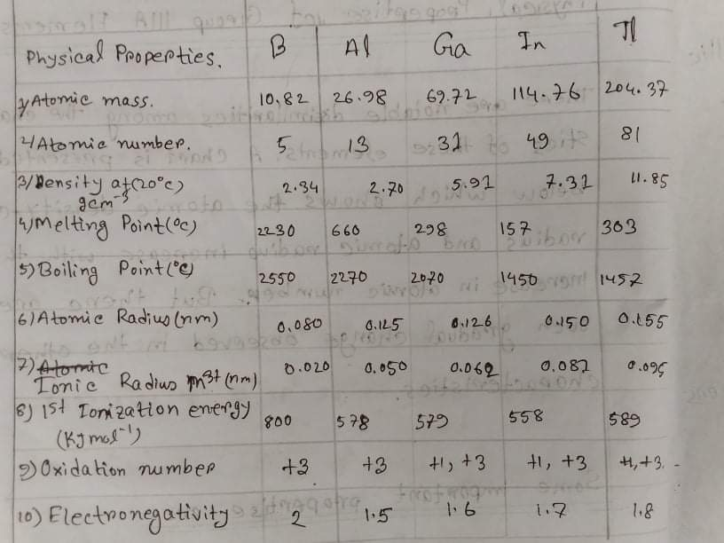

Some Important Properties are:

1. Boron is a metalloid. The rest of the group IIIA elements are metals.
2. Aluminium is a valuable structural material because of its strength, especially in alloys with silicon or iron. These alloys have a low density and resist corrosion.
3. Gallium has an extremely wide liquid temperature range (). Solid gallium floats in liquid gallium which is unusual for a metal.
4. Oxidation number: Group IIIA elements, leaving 3 electrons , can construct M3+ trivalent positive ion. Which results in full octet in their outmost shell. That is why they have an oxidation number of +3.
5. Atomic Propertise:
6. Group IIIA elementssoftea electronic configuration that ends in an2 np1
7. The most common oxidation number for boron, aluminium, gallium, indium and thallium is +3. Gallium, indium and thallium also include +1.
8. Group IIIA elemens become more metallic from top to bottom within the group.
9. Thallium -201 is radioactiv.

Reactions and Important Compounds:

1. Group IIIa elements react with halogens to form halides,

2Al(s) + 3Cl2(g) = 2AlCl3(s)

AlCl3 is used as a catalyst in organic reactions.

1. These elements react with oxygen to form oxides,

4Al + 3O2 = 2 Al2O3;

Because this reaction is so exothermic, powdered aluminium is a component of some explosieves, fireworks, and rocket fuels.

1. Aluminium sulfate (alum) Al2(SO4)3 18H20 is used in water treatment plants.
2. Gallium arsenide GaAs, converts electric current to light in LED. It is produced as follows,

(CH3)3Ga + AsH3 = GaAs + 3CH4.

1. Borax, Na2B4O7 10H2O is used to soften water.

Chemistry of Boron:

Boron: Boron is a chemical element with atomic number five and it is a low abundant element that is found in the earth’s crust and solar system. Boron is a metalloid.

Boron was first isolated (1808) by French chemists Joseph-Louis Gay-Lussac and Louis-Jacques Thenard and independently by British chemist Sir Humphry Davy by heating boron oxide (B2O3) with potassium metal. The impure amorphous product, a brownish black powder, was the only form of boron known for more than a century. Pure crystalline boron may be prepared with difficulty by reduction of its bromide or chloride (BBr3, BCl3) with hydrogen on an electrically heated tantalum filament.

Uses of Boron:

Sodium tetraborate decahydrate or borax is the most important compound of boron, which is used to insulate fibreglass and sodium perborate bleach. Boric acid is one of the important compounds in textile products. Boron compounds are also used in organic synthesis, a particular type of glass manufacture and as a wood preservative. Borax was earlier used to make perborate, which is the bleaching agent widely used in some detergents. Boron compounds are also found in homes in the form of food preservatives, especially for fish and margarine.

Properties of boron:

It’s a poor conductor of electricity and can also be found in ceramics, flare guns, and fibre glasses. Boron has several forms and amorphous boron which are a dark powder and unreactive to oxygen, water, alkalis, and acids are the most common. It forms borides when reacts with metals.

Reactions of Boron:

Reaction of boron with acids

Crystalline boron does not react with boiling hydrochloric acid, HCl, or boiling hydrofluoric acid, HF. Powdered boron oxidizes slowly when treated with concentrated nitric acid, HNO3.

Reaction of boron with air

Boron does not react with air at room temperature. At higher temperatures, boron reacts with oxygen, forming boron(III)oxide, B2O3.

4 B(s) + 3 O2(g) =2B203(g)

Reaction of boron with halogens:

Boron reacts with the halogens fluorine, chlorine and bromine, forming the respective boron(III)trihalides.

2 B(s) + 3 F2(g) =2BF3(g)

2 B(s) + 3 Cl2(g) =2BCl3(l)

2 B(s) + 3 Br2(g) =2BF3(l)

Reaction of boron with water:

Boron does not react with water under normal conditions.

Conclusion: Group IIIA elements have great significances in chemical analysis. These elements are very useful in chemical industries to lead certain chemical reactions,produce essential products. Especially boron is a necessary metalloid. By the help of this group assignment we can learn properties of group IIIA elements and thus can be benefited.

References: To complete this assignment i took help from a Google website, HSC Chemistry Textbook written by Haradhon Nag.

Conclusion : Group IIIA elements are of great significances in chemical analysis. These elements are very useful in chemical industries to lead certain chemical reactions,produce essential products. Especially boron is a necessary metalloid. By help of this assignment file we can learn properties of group IIIA elements and thus can be benefited.

References: To complete this assignment we took help from a Google website, HSC Chemistry Textbook written by Haradhon Nag.