**Assignment No: 01**

# **Title: Orbital representation of hydrocarbon, nomenclature and characteristics reaction of alkanes .**

**Course Name:** Chemistry-II

**Course Code:** PHY-207

*Date of Perform: 06-04-2021*

*Date of submission: 15-04- 2021*

Submitted to

**Md. Mahbub Alam**

Lecturer

Department of Chemistry

Submitted by

Group: 07

Roll:2128,2129,2130,2131, 2132, 2133,2134,2135, 2137,2209



Department of Physics

Jahangirnagar University

Savar, Dhaka-1342

## **Introduction**

**Nomenclature is** a system of [names](https://en.wikipedia.org/wiki/Names) or terms, or the rules for forming these terms in a particular field of arts or sciences.The principles of naming vary from the relatively informal [conventions](https://en.wikipedia.org/wiki/Naming_conventions) of everyday speech to the internationally agreed principles, rules and recommendations that govern the formation and use of the specialist terms used in scientific and any other disciplines

The increasingly large number of organic compounds identified with each passing day, together with the fact that many of these compounds are isomers of other compounds, requires that a systematic nomenclature system be developed. Just as each distinct compound has a unique molecular structure which can be designated by a structural formula, each compound must be given a characteristic and unique name.

A rational nomenclature system should do at least two things. First, it should indicate how the carbon atoms of a given compound are bonded together in a characteristic lattice of chains and rings. Second, it should identify and locate any functional groups present in the compound. Since hydrogen is such a common component of organic compounds, its amount and locations can be assumed from the tetravalency of carbon, and need not be specified in most cases.

The IUPAC nomenclature system is a set of logical rules devised and used by organic chemists to circumvent problems caused by arbitrary nomenclature. Knowing these rules and given a structural formula, one should be able to write a unique name for every distinct compound. Likewise, given a IUPAC name, one should be able to write a structural formula. In general, an IUPAC name will have three essential features:

* A root or base indicating a major chain or ring of carbon atoms found in the molecular structure.
* A suffix or other element(s) designating functional groups that may be present in the compound.
* Names of substituent groups, other than hydrogen, that complete the molecular structure.

As an introduction to the IUPAC nomenclature system, we shall first consider compounds that have no specific functional groups. Such compounds are composed only of carbon and hydrogen atoms bonded together by sigma bonds .

* The materials covered here are intended as a programmed *introduction* to organic nomenclature and aimed at high school students or first year university general chemistry. A more complete and advanced overview of organic nomenclature is also available suitable for 2nd year students taking a full year of college organic chemistry.
* The list of topics shown below will introduce and then step you through an *introduction* to basic organic nomenclature. It starts off by exploring each of the basic rules that are required to build up the organic compound names systematically and then works through recognising and naming the functional groups.
* At the end of each section there are a few practice questions designed to test and expand your knowledge of the subject through immediate application.
* Some pages use interactive 3D JMOL images that can be used to help visualise important issues.
* The most important application of alkanes is in oxidation reactions; they are used in internal combustion engines as fuel.
* Applying heat and a catalyst can crack larger, more complex alkanes and produce smaller, more useful Alkanes (the most basic of all organic compounds) that undergo very few reactions. The two reactions of more importance are combustion and halogenation, (i.e., substitution of a single hydrogen on the alkane for a single halogen) to form a haloalkane. The halogen reaction is very important in organic chemistry because it opens a gateway to further chemical reactions.alkanes Physical Properties of Alkanes:
* Alkanes are colourless.
* Alkanes are less [dense](https://www.ausetute.com.au/density.html) than water (alkanes float on top of water).
* Alkanes are nonpolar molecules so they are more [soluble](https://www.ausetute.com.au/intermof.html) in non-polar solvents than they are in polar solvents. Alkanes are insoluble in water.
* The melting and boiling points of the shorter chain alkanes is low, but the melting and boilings of alkanes increase as the number of carbon atoms in the carbon chain increases.

**Orbital representation of hydrocarbon**

**What Is a Hydrocarbon?**

## A hydrocarbon is an organic chemical compound composed exclusively of hydrogen and carbon atoms. Hydrocarbons are naturally occurring compounds and form the basis of crude oil, natural gas, coal, and other important energy sources.

There are two types of hydrocarbon aliphatic, aromatic.

1. Aliphatic hydrocarbon:

Aliphatic hydrocarbons are hydrocarbons based on chains of C atoms. There are three types of aliphatic hydrocarbons. alkanes are aliphatic hydrocarbons with only single covalent bonds.

1. Aromatic hydrocarbon :

Aromatic Hydrocarbons are circularly structured organic compounds that contain sigma bonds along with delocalized pi electrons. They are also referred to as arenes or aryl hydrocarbons.

.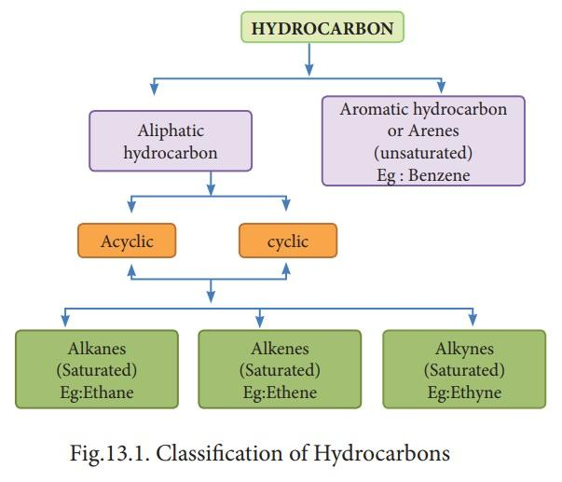

**NOMENCLATURE :**

The purpose of the IUPAC system of nomenclature is to establish an international standard of naming compounds to facilitate communication. The goal of the system is to give each structure a unique and unambiguous name and to correlate each name with a unique and unambiguous structure.

**Fundamental Principle:**

IUPAC nomenclature is based on naming a molecule’s longest chain of carbons connected by single bonds, whether in a continuous chain or in a ring. All deviations, either multiple bond atoms other than carbon and hydrogen, are indicated by prefixes or suffixes according to a specific set of priorities.

**Alkanes and Cycloalkanes:**

Alkanes are the family of saturated hydrocarbons, that is, molecules containing carbon and hydrogen connected by single bonds only. These molecules can be in continuous chains (called linear or acyclic), or in rings (called cyclic or acyclic). The names of alkanes and cycloalkanes are the root names of organic compounds. Beginning with the five-carbon alkane, the number of carbons in the chain is indicated by the Greek or Latin prefix. Rings are designated by the prefix“cyclo''.

CH4  methane

CH3CH3 ethane

CH3CH2CH3 propane

CH3[CH2]2CH3 butane

CH3[CH2]3CH3 pentane

CH3[CH2]4CH3  hexane

CH3[CH2]5CH3 heptane

CH3[CH2]6CH3  octane

CH3[CH2]7CH3  nonane

CH3[CH2]8CH3 decane

The alkanes are classified as "continuous chain" (that is, "unbranched") if all the carbon atoms in the chain are linked to no more than two other carbons; or "branched-chain" if one or more carbon atoms are linked to more than two other carbons.

CH3-CH2-CH2-CH2-CH3  pentane (n-pentane)

The prefixes used to designate the number of substituents follow up to ten.

1 mone-

2 di-

3 tri-

4 tetra-

5 penta-

6 hexa-

7 hepta-

8 octa-

9 nona-

10 deca-

Several hydrocarbons, called alkynes or acetylenes, have triple bonds between carbon atoms.3 They conform to the general formula C,, H,,,-, for one triple bond. The IUPAC system for naming alkynes employs the ending -yne instead of the -nne used for naming the corresponding saturated hydrocarbon.

**Naming Substituted Alkanes and Cycloalkanes**:

Group C Substituents Only1. Organic compounds containing substituents from Group C are named following this sequence of steps, as indicated in the examples below:

**•Step 1.**

Find the longest continuous carbon chain. Determine the root name for this parent chain. In cyclic compounds, the ring is usually considered the parent chain, unless it is attached to a long chain of carbons; indicate a ring with the prefix “cyclo” before the root name. (When there are two longest chains of equal length, use the chain with the greater number of substituents.)

**•Step 2.**

Number the chain in the direction such that the position number of the first substituent is the smaller number. If the first substituents from either end have the same number, then number so that the second substituent has the smaller number, etc.

**•Step 3.**

Determine the name and position number of each substituent. (A substituent on nitrogen is designated with an “N” instead of a number; see Section III.D.1. below.)

**•Step 4.**

Indicate the number of identical groups by the prefixes di, tri, tetra, etc.

**•Step 5.**

Place the position numbers and names of the substituent groups, in alphabetical order, before the root name. In alphabetizing, ignore prefixes like sec-, test-, di, tri, etc., but include iso and cyclo. Always include a position number for each substituent, regardless of redundancies.

**Amines:**

Prefix: amino-; suffix: -amine—substituents on nitrogen denoted by “N”

Ex: CH3CH2CH2NH2 - propan-1**-**amine

**Alcohols**:

prefix: hydroxy-; suffix: -ol

CH3CH2OH - Ethanol

Naming Carboxylic Acid DerivativesThe six common groups derived from carboxylic acids are salts, anhydrides, esters, acyl halides, amides, and nitriles. Salts and esters are most important.

**Nomenclature of Aromatic:**

Compounds“Aromatic” compounds are those derived from benzene and similar ring systems. As with the aliphatic nomenclature described above, the process is: determining the root name of the parenting; determining priority, name, and position number of substituents; and assembling the name in alphabetical order. Functional group priorities are the same in aliphatic and aromatic nomenclature.

**Aromatic Ketones**:

A special group of aromatic compounds is ketones where the carbonyl is attached to at least one benzene ring. Such compounds are named “phenones”, the prefix depending on the size and nature of the group on the other side of the carbonyl.

**Hybridization of Hydrocarbon**

**What is Hybridization?**

Redistribution of the energy of orbitals of individual atoms to give orbitals of equivalent energy happens when two atomic orbitals combine to form a hybrid orbital in a molecule. This process is called hybridization. The new orbitals thus formed are known as hybrid orbitals.

**Types of Hybridization :**

Based on the types of orbitals involved in mixing, the hybridization can be classified as sp3, sp2, sp, sp3d, sp3d2, sp3d3. Let us now discuss the various types of hybridization, along with their examples.

**sp Hybridization :**

sp hybridization is observed when one s and one p orbital in the same main shell of an atom mix to form two new equivalent orbitals. The new orbitals formed are called sp hybridized orbitals. It forms linear molecules with an angle of 180°

* This type of hybridization involves the mixing of one ‘s’ orbital and one ‘p’ orbital of equal energy to give a new hybrid orbital known as a “sp” hybridized orbital.
* sp hybridization is also called diagonal hybridization.
* Each sp hybridized orbital has an equal amount of s and p character, i.e., 50% s and p character.

**Examples of sp Hybridization:**

* All compounds of beryllium like BeF2, BeH2,BeCl2
* All compounds of carbon-containing triple Bond-like C2H2.

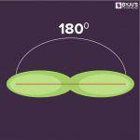

sp2 Hybridization :

sp2 hybridization is observed when one s and two p orbitals of the same shell of an atom mix to form 3 equivalent orbital. The new orbitals formed are called sp2 hybrid orbitals.

* Hybridization is also called trigonal hybridization.
* It involves mixing one ‘s’ orbital and two ‘p’ orbitals of equal energy to give a new hybrid orbital known as sp2.
* A mixture of s and p orbital formed in trigonal symmetry and is maintained at 1200.
* All the three hybrid orbitals remain in one plane and make an angle of 120° with one another. Each of the hybrid orbitals formed has 33.33% s character and 66.66% ‘p’ character.
* The molecules in which the central atom is linked to 3 atoms and is sp2 hybridized have a triangular planar shape.

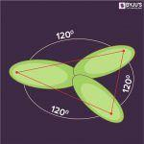

**Examples of sp2 Hybridization :**

* All the compounds of Boron i.e. BF3, BH3
* All the compounds of carbon-containing a carbon-carbon double bond, Ethylene (C2H4)

**sp3 Hybridization:**

When one ‘s’ orbital and 3 ‘p’ orbitals belonging to the same shell of an atom mix together to form four new equivalent orbits, the type of hybridization is called a tetrahedral hybridization or sp3. The new orbitals formed are called sp3 hybrid orbitals.

* These are directed towards the four corners of a regular tetrahedron and make an angle of 109°28’ with one another.
* The angle between the sp3 hybrid orbitals is 109.280
* Each sp3 hybrid orbital has 25% s character and 75% p character.
* Example of sp3 hybridization: ethane (C2H6), methane.

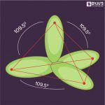

**sp3d Hybridization :**

sp3d hybridization involves the mixing of 3p orbitals and 1d orbital to form 5 sp3d hybridized orbitals of equal energy. They have trigonal bipyramidal geometry.

* The mixture of s, p, and d orbital forms trigonal bipyramidal symmetry.
* Three hybrid orbitals lie in the horizontal plane inclined at an angle of 120° to each other known as the equatorial orbitals.
* The remaining two orbitals lie in the vertical plane at 90 degrees plane of the equatorial orbitals known as axial orbitals.
* **Example:**Hybridization in Phosphorus pentachloride (PCl5)

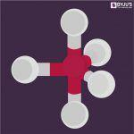

**sp3d2Hybridization :**

* Sp3d2 hybridization has 1s, 3p, and 2d orbitals, that undergo intermixing to form 6 identical sp3d2 hybrid orbitals.
* These 6 orbitals are directed towards the corners of an octahedron.
* They are inclined at an angle of 90 degrees to one another.

**Key Features of Hybridization:**

* Atomic orbitals with equal energies undergo hybridization.
* The number of hybrid orbitals formed is equal to the number of atomic orbitals mixing.
* It is not necessary that all the half-filled orbitals must participate in hybridization. Even completely filled orbitals with slightly different energies can also participate.
* Hybridization happens only during the bond formation and not in an isolated gaseous atom.
* The shape of the molecule can be predicted if the hybridization of the molecule is known.
* The bigger lobe of the hybrid orbital always has a positive sign, while the smaller lobe on the opposite side has a negative sign.

**What is VSEPR Theory?**

The Valence Shell Electron Pair Repulsion Theory abbreviated as VSEPR theory is based on the premise that there is a repulsion between the pairs of valence electrons in all atoms, and the atoms will always tend to arrange themselves in a manner in which this electron pair repulsion is minimalized. This arrangement of the atom determines the geometry of the resulting molecule.

**What is the VSEPR Number?**

The VSEPR number describes the shape of the molecule, as described in the table provided below.

|  |  |
| --- | --- |
| **VSEPR Number** | **Shape of the Molecule** |
| 2 | Linear |
| 3 | Trigonal Planar |
| 4 | Tetrahedral |
| 5 | Trigonal Bipyramidal |
| 6 | Octahedral |
| 7 | Pentagonal Bipyramidal |

**Linear Shape of Molecule:**

* In this type of molecule, we find two places in the valence shell of the central atom.
* They should be arranged in such a manner that repulsion can be minimized (pointing in the opposite direction).
* **Example:** BeF3

**Trigonal Planar Shape of Molecule:**

* In this type of molecule, we find three molecules attached to a central atom.
* They are arranged in such a manner that repulsion between the electrons can be minimized (toward the corners of an equilateral triangle).
* **Example:** BF3

**Tetrahedral Shape of Molecule:**

* In two-dimensional molecules, atoms lie in the same plane and if we place these conditions on methane, we will get a square planar geometry in which the bond angle between H-C-H is 900.
* Now, if we consider all these conditions for a three-dimensional molecule, we will get a tetrahedral molecule in which the bond angle between H-C-H is 109028’ (toward the corners of an equilateral triangle) CH4

**Trigonal Bipyramid Shape of Molecule:**

* Let’s take the example of PF5. Here, repulsion can be minimized by even the distribution of electrons towards the corner of a trigonal pyramid. In a trigonal bipyramid, three positions lie along the equator of the molecule. The two positions lie along an axis perpendicular to the equatorial plane.

⇨ The different geometries that molecules can assume following the VSEPR theory can be seen in the illustration provided below.

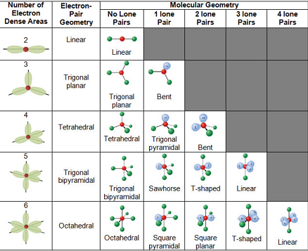

**Physical Properties of Alkane:**

* All alkanes are colorless.
* Alkanes with the lowest molecular weights are gasses, those of intermediate molecular weight are liquids, and the heaviest are waxy solids.

**Boiling Point:**

As the intermolecular Van Der Waals forces increase with the increase of the molecular size or the surface area of the molecule we observe

* The boiling point of alkanes increases with increasing molecular weight.
* The straight-chain alkanes are observed to have a higher boiling point in comparison to their structural isomers.

**Melting Point:**

* The melting point of alkanes follows the same trend as their boiling point that is, it increases with an increase in molecular weight.
* This is attributed to the fact that higher alkanes are solids and it’s difficult to overcome intermolecular forces of attraction between them.

**Solubility:**

* Due to very little difference in electronegativity between carbon and hydrogen and the covalent nature of C-C bond or C-H bond, alkanes are generally non-polar molecules.
* As we generally observe, polar molecules are soluble in polar solvents whereas non-polar molecules are soluble in non-polar solvents. Hence, alkanes are hydrophobic that is, alkanes are insoluble in water.
* However, they are soluble in organic solvents as the energy required to overcome the existing Van Der Waals forces and generate new Van Der Waals forces is quite comparable.

**Bond Lengths and Bond Angles:**

An alkane has only C–H and C–C single bonds. The former result from the overlap of an sp3 orbital of carbon with the 1s orbital of hydrogen; the latter by the overlap of two sp3 orbitals on adjacent carbon atoms. The bond lengths amount to 1.09 × 10−10 m for a C–H bond and 1.54 × 10−10 m for a C–C bond.

The spatial arrangement of the bonds is similar to that of the four sp3 orbitals—they are tetrahedrally arranged, with an angle of 109.47° between them. Structural formulae that represent the bonds as being at right angles to one another, while both common and useful, do not correspond with reality.

**Structures of Alkane:**

All the carbon atoms present in an alkane are sp3 hybridized that is, every carbon atom forms four sigma bonds with carbon or hydrogen atoms. The General configuration of an alkane is CnH2n+2. They exhibit tetrahedral geometry with a bond angle of 109.47° between them.

The methane molecule has a symmetrical tetrahedral structure.

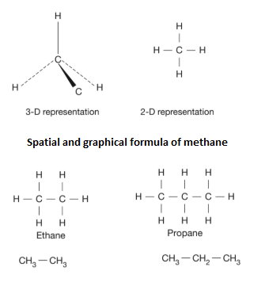

Structures of Alkanes – Methane, Ethane & Propane.

**Some Example of Alkane with Physical Properties:**

|  |  |  |  |  |  |
| --- | --- | --- | --- | --- | --- |
| Alkane | Formula | Boiling Point  [°C] | Melting Point  [°C] | Density[kg/m3]  (at 20**°**C) | Isomers |
| Methane | CH4 | -162 | -182 | 0.656(gas) | 1 |
| Ethane | C2H6 | -89 | -183 | 1.26(gas) | 1 |
| Propane | C3H8 | -42 | -188 | 2.01(gas) | 1 |
| Butane | C4H10 | 0 | -138 | 2.48(gas) | 1 |
| Pantainne | C5H12 | 36 | -130 | 626(liquid) | 1 |

**Chemical Reaction of Alkane:**

* Preparation of Alkanes from unsaturated hydrocarbon:

Alkane can be prepared from alkene and alkyne through the process of hydrogenation. In this process, dihydrogen gas is added to alkynes and alkenes in the present catalyst. With the help of nickel as the catalyst, this reaction takes place at an elevated temperature, whereas the reaction takes place at room temperature with platinum as the catalyst.Preparation of alkanes from alkyl halides

**Preparation of Alkanes from alkyl halides:**

Alkane can be produced from alkyl halides predominantly in two ways:

* 1. Alkanes can be prepared from alkyl halides (except fluorides) through reduction with zinc and dilute hydrochloric acid.

1. **Wurtz reaction**: Wurtz reaction

In dry ethereal solution, on treating alkyl halides with sodium metal, production of alkanes is higher. By this reaction, we can achieve higher alkanes with an even number of carbon atoms.

**Preparation of Alkanes from Carboxylic acids:**

Preparation of alkanes from carboxylic acids mainly happens via two means:

**1.**Alkanes can be prepared from carboxylic acid via the removal of carbon dioxide. This process is known as decarboxylation. It produces alkane with a carbon atom lesser than that present in the carboxylic a

**2.**Kolbe’s electrolytic method: In this process, the alkane is produced through electrolysis of sodium or potassium salt of carboxylic acid.

2CH3COONa + 2H2O ⟶ CH3─CH3 +2CO2+H2+2NaOH

Sodium acetate

**Preparation of Alkane from Alkene and Alkyne:**

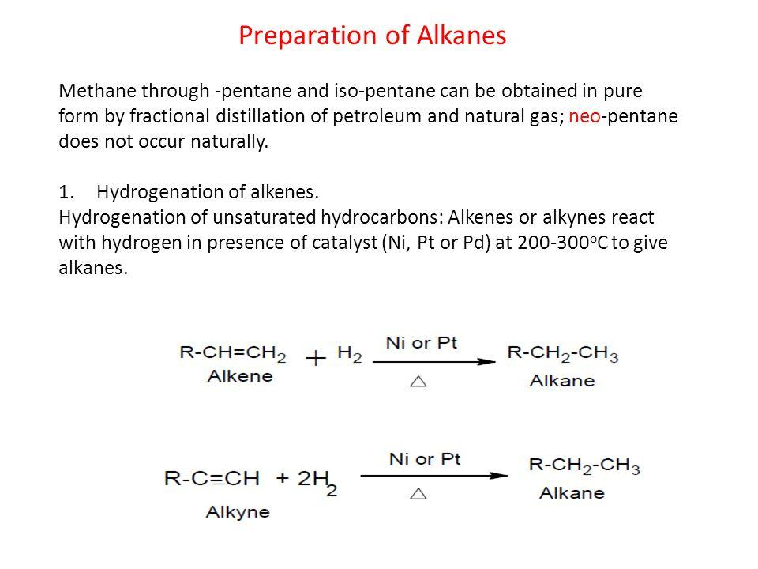

**Reaction with Oxygen:**

All alkanes react with oxygen in a combustion reaction, although they become increasingly difficult to ignite as the number of carbon atoms increases. The general equation for complete combustion is:

C*n*H2*n*+2 + (3/2*n* + 1/2) O2 → (*n* + 1) H2O + *n* CO2

or C*n*H2*n*+2 + (3*n* + 1/2) O2 → (*n* + 1) H2O + *n* CO2

In the absence of sufficient oxygen, carbon monoxide or even soot can be formed, as shown below:

C*n*H2*n*+2 + (*n* + 1/2) O2 → (*n* + 1) H2O + *n* CO

C*n*H2*n*+2 + (1/2*n* + 1/2) O2 → (*n* + 1) H2O + *n* C

For example, methane:

2 CH4 + 3 O2 → 2 CO + 4 H2O

CH4 + 3/2 O2 → CO + 2 H2O

Conclusion

* Organic chemistry is the chemistry of carbon compounds, and inorganic chemistry is the chemistry of all the other elements. Carbon atoms can form stable covalent bonds with other carbon atoms and with atoms of other elements, and this property allows the formation of tens of millions of organic compounds. Hydrocarbons contain only hydrogen and carbon atoms..
* Hydrocarbons in which each carbon atom is bonded to four other atoms are called alkanes or saturated hydrocarbons. They have the general formula C*n*H2*n* + 2. Any given alkane differs from the next one in a series by a CH2 unit. Any family of compounds in which adjacent members differ from each other by a definite factor is called a homologous series.
* Cycloalkanes are hydrocarbons whose molecules are closed rings rather than straight or branched chains. A cyclic hydrocarbon is a hydrocarbon with a ring of carbon atoms.
* The physical properties of alkanes reflect the fact that alkane molecules are nonpolar. Alkanes are insoluble in water and less dense than water.
* Alkanes are generally unreactive toward laboratory acids, bases, oxidizing agents, and reducing agents. They do burn (undergo combustion reactions).
* Alkanes react with halogens by substituting one or more halogen atoms for hydrogen atoms to form halogenated hydrocarbons. This reaction is called *halogenation*. An alkyl halide (haloalkane) is a compound resulting from the replacement of a hydrogen atom of an alkane with a halogen atom.
* Larger alkanes can be broken into smaller alkanes and alkenes using high heat or catalysts. These reactions are called cracking reactions.

**Reference:**

1. <https://chem.libretexts.org/Bookshelves/Organic_Chemistry/Map%3A_Organic_Chemistry_(Smith)/Chapter_04%3A_Alkanes/4.03_An_Introduction_to_Nomenclatur>e
2. <https://en.wikipedia.org/wiki/Nomenclature>
3. [https://www.chem.ucalgary.ca/courses/351/WebContent/ion/orgnom/index.htmlAlkanes are stable compounds and are generally unreactive.](https://www.chem.ucalgary.ca/courses/351/WebContent/ion/orgnom/index.htmlAlkanes)
4. <https://courses.lumenlearning.com/introchem/chapter/reactions-of-alkanes/>
5. [**https://www.britannica.com/science/hydrocarbon**](https://www.britannica.com/science/hydrocarbon)
6. <https://www.ck12.org/book/ck-12-chemistry-basic/section/25.1/>
7. <https://byjus.com/jee/hydrocarbons/>
8. <https://energyeducation.ca/encyclopedia/Hydrocarbon>