

**Assignment** on : **A Brief Introduction of Carbohydrate and Proteins and their special Bonding**

**Course Name:** Chemistry-II

**Course Code:** PHY-207

***Date of Perform****: 06-04-2021*

***Date of submission****: 15-04- 2021*

Submitted to :

**Md MahbubAlam**

Lecturer

Department of Chemistry

Jahangirnagar University.

Submitted By:

Md. Abdul Quader (2225)

Akash Chandra Das (2226)

Shafiqul Islam (2227)

Mahjabin Akter Fabiha (2228)

Mousofa Eshaq Shorna (2232)

Tasmia Islam (2233)

Md.Sifat Karim (2238)

Moriyam khatun Sumi (2239)

Mohammad hossain sharif (2240)

Ayesha Siddika (2241)

What are Carbohydrates?

Carbohydrates is a group of organic compounds occurring in living tissues and foods in the form of starch, cellulose, and sugars. Carbohydrates represent a broad group of substances which include the sugars, starches, gums and celluloses.

The ratio of oxygen and hydrogen in carbohydrates is the same as in water i.e. 2:1. It typically breaks down in the animal body to release energy.

**The General Formula of Carbohydrates:**

The general formula for carbohydrates is Cx(H2O)y.

They originate as products of **photosynthesis**

n CO2 + n H2O + energy http://www2.chemistry.msu.edu/faculty/reusch/VirtTxtJml/Images/arrow2.gif CnH2nOn + n O2

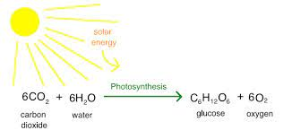

## Definition of Carbohydrates in Chemistry

***optically active polyhydroxy aldehydes or ketones or the compounds which produce units of such type on hydrolysis.***

There are two types of Carbohydrates :

1. Reducing Sugar

2. Non-Reducing Sugar

## Sources of Carbohydrates:

We know carbohydrates are an important part of any human’s diet. Some common sources of carbohydrates are:

1. Potatoes
2. Maze
3. Milk
4. Popcorn
5. Bread

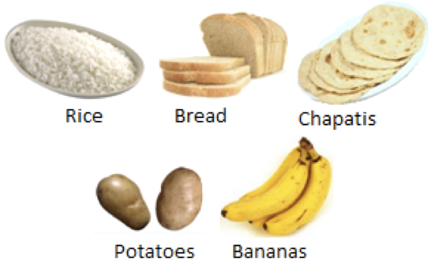

## Types of Carbohydrates:

## Carbohydrates can be divided into two main types:

## 1. Simple Carbohydrates

## 2. Complex. Carbohydrates

**Simple Carbohydrates :** Simple Carbohydrates are sometimes called “ Sugars” or “Simple Sugars ” **.**

**Example:** Monosaccharides , Disaccharides

**Complex. Carbohydrates :** Complex carbohydrates are also called polysaccharides, because they contain many sugars.

**Example:** Oligosaccharides , polysaccharides

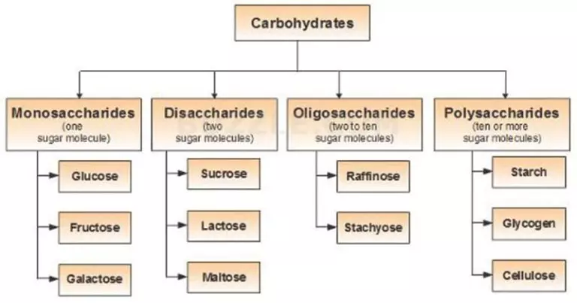

## Monosaccharides:

Monosaccharide carbohydrates are those carbohydrates that cannot be hydrolyzed further to give simpler units of polyhydroxy [aldehyde or ketone](https://byjus.com/chemistry/aldehydes-ketones/).

If a monosaccharide contains an aldehyde group then it is called aldose .

if it contains a keto group then it is called a ketose.

Each simple sugar has a cyclic structure and is composed of carbon, hydrogen and oxygen in ratios of 1:2:1 respectively

**Source Of Monosaccharides:**

* Fruite Juice
* Sugar cane
* Hydrolysis Of Starch
* Honey
* Hydrolysis of lactose

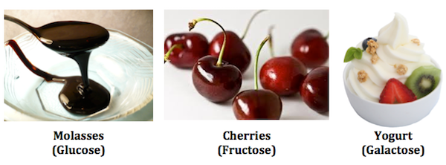

**Kinds Of Monosaccharides:**

* Glucose
* Fructose
* Galactose

## Structure of Monosaccharides :

Glucose : Glucose is a simple sugar with six carbon atoms and one aldehyde group. This [monosaccharide](https://byjus.com/chemistry/monosaccharides/) has a chemical formula C6H12O6

The primary source of energy required for living organisms is glucose. Plants and algae prepare glucose during the process of photosynthesis with the help of water, sunlight, and carbon dioxide. It is naturally found in fruits, honey. Glucose in animals is obtained by the process of glycogenolysis.

## Structure of Glucose:

**Glucose is a group of carbohydrates which is a simple sugar with a chemical formula C6H12O6.**

 It is made of six carbon atoms and an [aldehyde group](https://byjus.com/chemistry/aldehydes-ketones/). Therefore, it is referred to as an aldohexose.

It exists in two forms viz open-chain (acyclic) form or ring (cyclic) form.

**Open Chain Glucose:**

There are two types of Open Chain Glucose

1. D-Glucose

2. L-glucose

Since glucose is an optically active molecule, therefore it can show optical isomers and exist as Enantiomers known as L-(-) glucose and D(-) glucose. Here (+ve) and (-ve) sign indicates its optical rotation, i.e. dextrorotatory and levorotatory.

However D & L are not related with their optical rotation but they indicate their configurations.

Hence D-configuration can be dextrorotatory or levorotatory and vice versa.

The D and L configuration assigned on the basis of configuration of glyceraldehyde molecule which contains one chiral atom. If the OH group of glyceraldehyde molecule lies towards right side, it called as D- configuration and if it is on left side, it will be L-configuration.

The D glucose can be digested in our body but L glucose can not be digested.

**D-Glucose:** D-glucose occurs more abundantly in nature than L-glucose. D-glucose is a short form of dextrorotatory glucose.

It is one of the two stereoisomers of [glucose](https://www.biologyonline.com/dictionary/glucose), and is the one that is biologically active. It occurs in [plants](https://www.biologyonline.com/dictionary/plants) as a product of [photosynthesis](https://www.biologyonline.com/dictionary/photosynthesis).

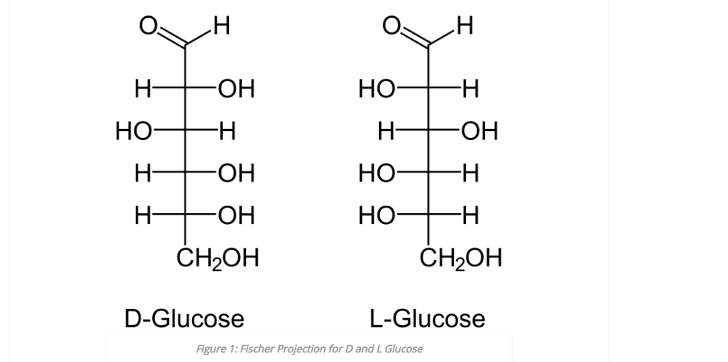

**L-Glucose:**L-Glucose is the mirror image of D-Glucose .But this mirror image is non-super imposeable **.**Therefore , L-Glucose is considered as the enantiomer of D-Glucose .Since it is the mirror image ,the –OH groups of the Fischer projection are located in completely opposite directions .This structure also has three –OH groups at the same side and other –OH group on the opposite side .But unlike in D-Glucose ,there –OH groups are on the left side of the main carbon chain whereas other –OH group is located on the right side

**Chain Glucose:** In the chain form the carbon makes round with other carbon.

**α-D Glucose and β-D Glucose:**

α-D Glucose and β-D Glucose are the cyclic form of carbohydrates .The designation α means that the hydroxyl group is carbon-1 in below the plane of the ring and β means that the hydroxyl group is above the plane of the ring .

The enantiomers are the chiral molecules that are mirror images of one another and are non-superimposable on each other.

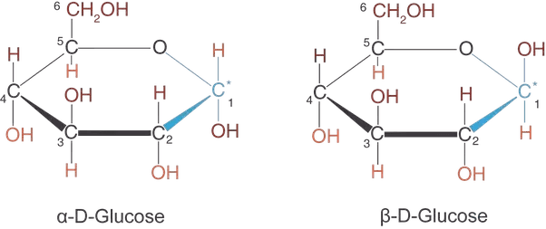

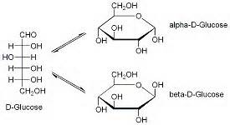

Now the α-D Glucose and β-D Glucose are non-superimposeable as they do differ in the position of the hydroxyl group at carbon-1 but they are not the exact mirror image of each other. Thus ,they are not enantiomers. The tautomers are known as the isomers which differ only in the position of the protons and electrons .

Since α-D Glucose and β-D Glucose not only the protons and electrons but the whole hydroxyl group is different ,thus they can not be classed as tautomers

The anomer is a stereoisomer that differs in configuration at carbon 1 in a cyclic saccharide

α-D Glucose and β-D Glucose are anomers as they differ at carbon 1 only.the epimers are diastereomers that contain more than one chiral centre but differ from each other in the absolute configuration at only one chiral centre.

The α-D Glucose and β-D Glucose differ each other in their ability to rotate planes of polarized light

## Structure of Fructose:

## Fructose, also called fruit sugar, is the only naturally occurring ketohexose . It is also referred to as levulose because it has an optical rotation that is strongly levorotatory.***Fructose is a simple ketonic monosaccharide.***

 The ***molecular formula of fructose is C6H12O6 and contains ketonic***[*functional group*](https://byjus.com/chemistry/functional-groups/)***at carbon number 2 and has six carbon atoms in a straight chain.*** The ring member of fructose is in analogy to the compound Furan and is named as furanose.

There are also two kinds of Fructose

1. Chain Fructose
2. Cyclic Fructose

Fructose has a cyclic or chair-like structure. The chair form of fructose is similar to that of glucose but in the structure of fructose, there are few exceptions. Fructose has a ketone functional group and the ring closure occurs from 2nd carbon position. This result in the rise to 5-membered ring or there is a formation of intramolecular hemiacetal in fructose. The OH at 5th carbon combines with carbon in the 2nd position.

The five-membered ring has four carbons and one oxygen. There is basically a formation of chiral carbon and two arrangements of CH2OH and OH group. In essence, fructose displays stereoisomerism.

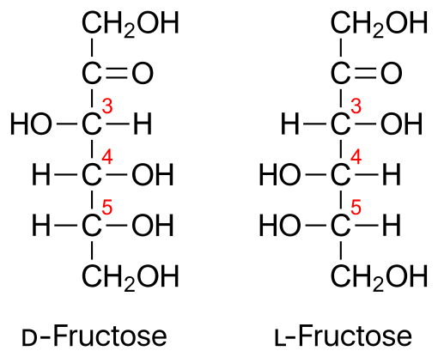

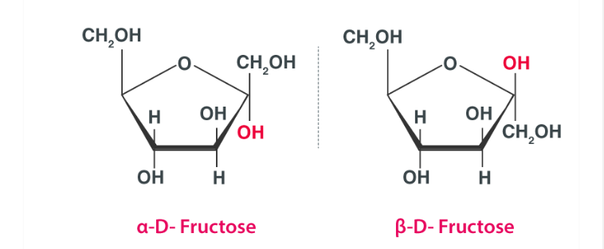

Properties Of Fructose

* The fructose is a white crystalline compound.
* It melts at a temperature of 102⁰C.
* Fructose absorbs moisture rapidly and loses it slowly to form hydroxymethylfurfural into the environment in comparison to other sugars.
* It can be fermented anaerobically using yeast or bacteria by which they are converted into ethanol and carbon dioxide

## Structure of Galactose:

## Galactose is a simple sugar belonging to simple carbohydrates which occurs in D-form in [lactose](https://byjus.com/chemistry/lactose/).

## Charles Weissman coined the word galactose which is derived from the Greek word galaktos meaning milk and for sugars ose is used. It is an odourless white solid.

The molecular formula of galactose is C6H12O6.

Galactose is a monosaccharide and epimer of glucose. The property values of hydrogen bond donor and hydrogen bond acceptor are 5 and 6 respectively.

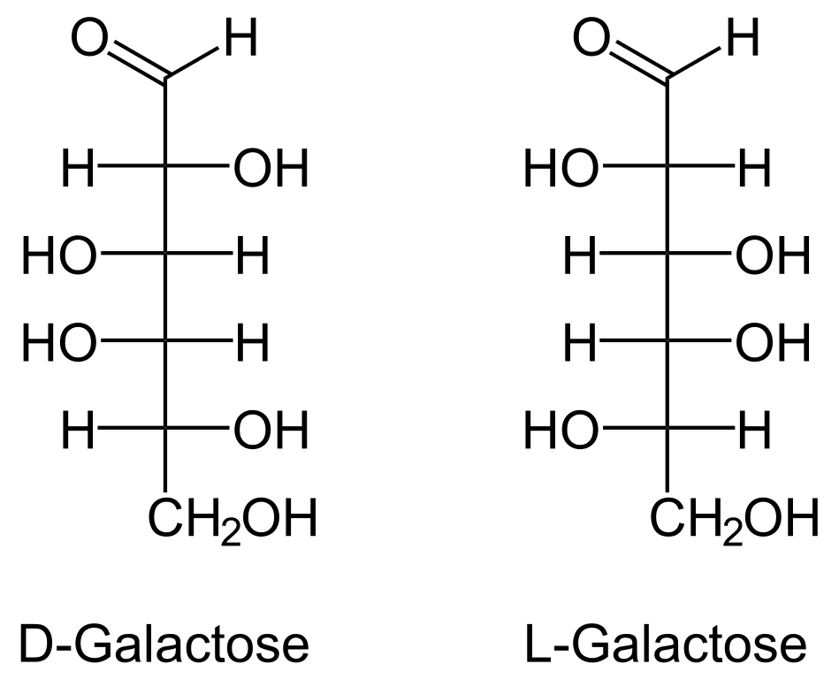

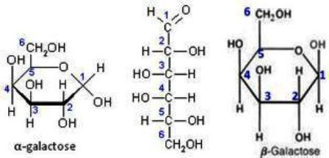

* Most of the galactose ingested by humans gets converted to glucose.
* Galactose binds to glucose to make lactose, to lipids to make glycolipids and to proteins to make glycoproteins.

## Disaccharides:

Disaccharides are those carbohydrates that on hydrolysis with acids or enzymes give two molecules of monosaccharides which can either be the same or different.

The oxide linkage is formed after the loss of the water molecule and then the two monosaccharides are formed by that linkage.

When two [monosaccharide](https://byjus.com/chemistry/monosaccharides/) units are joined via the oxygen atom then that linkage is called a ***glycosidic linkage***.

## Sucrose: Sucrose is a molecule composed of two monosaccharides, namely glucose and fructose. This non-reducing disaccharide has a chemical formula of C12H22O11.

Sucrose is *commonly referred to as table sugar or cane sugar*.

In a C12H22O11 molecule, the fructose and glucose molecules are connected via a glycosidic bond.

This type of linking of two monosaccharides called glycosidic linkage. Sucrose has a monoclinic crystal structure and is quite soluble in water.

It is characterized by its sweet taste.

Sucrose is commonly referred to as table sugar or cane sugar. In a C12H22O11 molecule, the fructose and glucose molecules are connected via a glycosidic bond.

## Structure of Sucrose: As discussed earlier, sucrose is a disaccharide which is made up of two monosaccharides. The structure of a sucrose molecule is illustrated below.

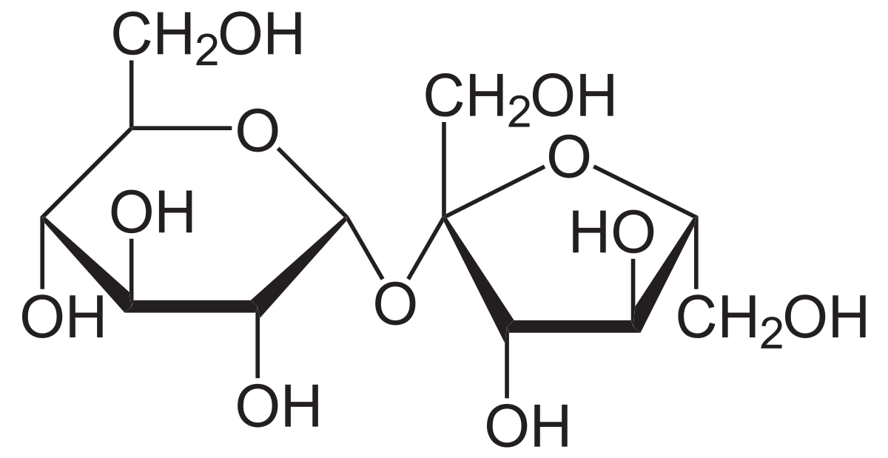

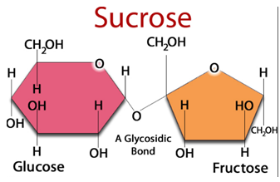

## Properties of Sucrose: Chemical Data

|  |  |
| --- | --- |
| Chemical Formula of Sucrose | C12H22O11 |
| Molar Mass or Molecular Weight | 342.30 g/mol |
| Density | 1.587 g/cm3 |
| Physical Appearance | White, crystalline solid |
| Melting Point | Decomposes at 459 K |

### **Chemical Properties:**

* Sucrose can undergo a combustion reaction to yield carbon dioxide and water.
* When reacted with chloric acid, this compound yields hydrochloric acid, carbon dioxide, and water.
* Upon hydrolysis, the glycosidic bond linking the two carbohydrates in a C12H22O11 molecule is broken, yielding glucose and fructose.
* Sucrose can be dehydrated with the help of H2SO4 (which acts as a catalyst) to give rise to a black solid which is rich in carbon.

## Uses of Sucrose

Some of the important uses of this compound are listed below.

* Sucrose is one of the most important components of soft drinks and other beverages.
* This compound is used in many pharmaceutical products.
* It serves as a chemical intermediate for many emulsifying agents and detergents.
* It also serves as a food thickening agent and as a food stabilizer.
* The shelf lives of many food products, such as jams and jellies, are extended with the help of this compound.
* The use of sucrose in baking results in the brown colour of the baked products.
* This compound also serves as an [antioxidant](https://byjus.com/chemistry/antioxidants/) (a compound that inhibits oxidation).
* Sucrose is widely used as a food preservative.

## Lactose:

Lactose is a disaccharide that contains units of galactose and glucose.

***Lactose is a sugar present in the milk***. One of the essential classes of biomolecules is carbohydrates. These biomolecules have a significant role in daily life by providing three requirements, i.e., food (starch), shelter (cellulose) and cloth (cellulose).

Carbohydrates belong to optically active compounds with hydroxyl and carbonyl functional groups and bearing the general formula Cx(H2O)y. These are also called saccharides and classified based on the product of hydrolysis.

## Lactose Structural Formula

The structural formula of lactose is as shown in the picture. Lactose is commonly used in the pharmacy sector for manufacturing tablets.

It is a non-hygroscopic solid with a sweet taste. Milk products like yoghurt, cream and fresh cheeses are also the source of lactose.

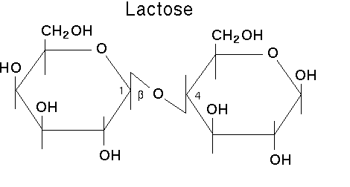

## Properties Of Lactose

|  |  |
| --- | --- |
| **Chemical formula** | C12H22O11 |
| **Molecular weight** | 342.297 g/mol |
| **Density** | 1.525 g/cm3 |
| **Melting point** | 202.8 °C |
| **Chemical names** | Milk sugar, 4-O-β-D-galactopyranosyl-D-glucose |

## Maltose:

Maltose which is also known as malt is a disaccharide made up of two alpha D glucose unit. The two-unit of glucose are linked with an alpha 1,4 glycosidic bond. In the small intestinal lining in humans, the enzyme maltase and isomaltase break down the molecules of maltose into two glucose molecule, which is then absorbed by the body. Starch is the most abundant polysaccharide in plant cells after cellulose.

## Maltose Structure

Maltose is a disaccharide made up of two alpha D glucose in which C1 of first glucose unit is bonded to C4 of second glucose unit as shown figure below. The bond that joined two alpha glucose unit is called alpha 1,4 glycosidic linkage.

At C1 of the second glucose unit, aldehyde group can be formed in solution which makes maltose a reducing sugar.

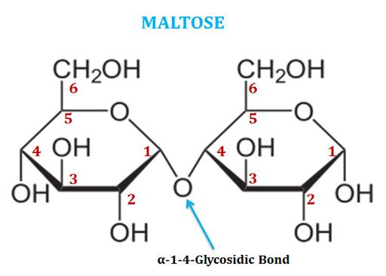

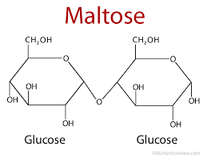

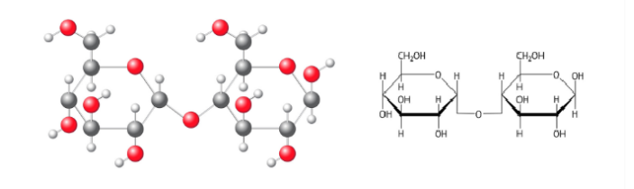

Properties Of Maltose

* Maltose is a reducing sugar. It tastes sweet but is only 30-60% as sweet as sugar.
* The hydrolysis reaction of maltose in the presence of an acid catalyst gives two molecules – alpha D-glucose.
* There is a free anomeric carbon present in the structure of maltose which can undergo mutarotation in solution. The resultant solution will be a mixture of alpha and beta maltose.
* Since the aldehydic group is formed in the solution, therefore, maltose gives a positive test with Benedicts and Tollens reagent.

|  |  |
| --- | --- |
| Odour | No odour |
| Appearance | White powder or crystals |
| Covalently-Bonded Unit | 1 |
| Heat capacity | 298.15 K |
| Complexity | 382 |
| Solubility | Soluble in water |

## Chemical Properties of Maltose – C12H22O11

* + Maltose undergoes hydrolysis results in the formation of ethanol and carbon dioxide. The chemical equation is given below.

**C12H22O11 + H2O → 4C2H5OH + 4CO2**

* + Maltose reacts with sulphuric acid forms carbon dioxide, water and [sulphur dioxide](https://byjus.com/chemistry/sulphur-dioxide/). The chemical equation is given below.

**C12H22O11 + 24H2SO4 → 12CO2 + 35H2O + 24SO2**

**Uses Of Maltose**

* Disaccharide such as sucrose is very sweet and is used as a sweetener in the food product, but maltose lacks sweetness and is not used as a sweetener. Instead, it is used in the malting of barley for the manufacturing of beer.
* Used extensively in alcohol production.
* Free maltose as well as maltose formed by the digestion of starch in the mouth, can cause dental caries.
* Enzyme maltase and isomaltase present in the small intestine break down maltose into two glucose units which are then absorbed. Our body has the capacity to absorb maltose directly which later on can be broken down into glucose unit for producing energy
* Due to a high glycemic index, maltose increases blood sugar level.

## Polysaccharides:

Polysaccharides are major classes of biomolecules. They are long chains of carbohydrate molecules, composed of several smaller monosaccharides. These complex bio-macromolecules functions as an important source of energy in [**animal cell**](https://byjus.com/biology/animal-cell/) and form a structural component of a plant cell

Polysaccharides can be a straight chain of monosaccharides known as linear polysaccharides, or it can be branched known as a branched polysaccharide.

**Characteristics Of Polysaccharides**

Polysaccharides have the following properties:

1. They are not sweet in taste.
2. Many are insoluble in water.
3. They are hydrophobic in nature.
4. They do not form crystals on desiccation.
5. Can be extracted to form a white powder.
6. They are high molecular weight carbohydrates.
7. Inside the cells, they are compact and osmotically inactive.
8. They consist of hydrogen, carbon, and oxygen. The hydrogen to oxygen ratio being 2:1.

**Oligosaccharides:**

An oligosaccharide is a carbohydrate whose molecule, upon hydrolysis, yields two to ten [Monosaccharid](https://chem.libretexts.org/Bookshelves/Biological_Chemistry/Supplemental_Modules_(Biological_Chemistry)/Carbohydrates/Monosaccharides)e molecules. Oligosaccharides are classified into subclasses based on the number of monosaccharide molecules that form when one molecule of the oligosaccharide is hydrolyzed. Oligosaccharides can have many functions including cell recognition and cell binding.

There are twokind of Oligosaccharides:

1.Rafinose

2.Stachyose

**1.Rafinose:**

**Raffinose(C18H32O16) is a trisaccharide as it contains 3 monosaccharide units. On hydrolysis it gives glucose+fructose+galactose. It is mostly found in beans, cabbage, broccoli etc. Refer the above figure for the structure of raffinose.**

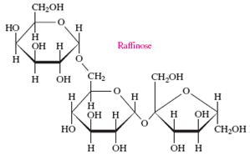

**2.Stachyose:**

Stachyose is included in oligosaccharides because it contains four monosaccharides units .It consists of two α-D Glucose and one β-D Glucose unit and one β-D fructose unit.

These monosaccharide units are linked together through glycosidic bonds.

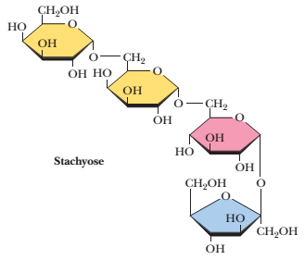

### **Polysaccharides:**

These are referred to the complex biomolecules which are made of a chain of monosaccharides. The bonds in which are being formed here are glycosidic in nature. In here the commonly formed monomers are simple sugars such as glucose, fructose etc.

**Polysaccharide are nothing but complex carbohydrates , formed with a chain of monosaccharides.Glycosidic linkage is what keeps the chain of monosaccharides bonded together.Naturally there are three main polysaccharide. They are**

**1.Starch**

**2.Glycogen**

**3.Cellulose**

**Characteristics Of Polysaccharides**

Polysaccharides have the following properties:

1. They are not sweet in taste.
2. Many are insoluble in water.
3. They are hydrophobic in nature.
4. They do not form crystals on desiccation.
5. Can be extracted to form a white powder.
6. They are high molecular weight carbohydrates.
7. Inside the cells, they are compact and osmotically inactive.
8. They consist of hydrogen, carbon, and oxygen. The hydrogen to oxygen ratio being 2:1.

**Starch:**

Starch is the most important source of carbohydrates in the human diet and accounts for more than 50% of our carbohydrate intake. It occurs in plants in the form of granules, and these are particularly abundant in seeds (especially the cereal grains) and tubers, where they serve as a storage form of carbohydrates. The breakdown of starch to glucose nourishes the plant during periods of reduced photosynthetic activity

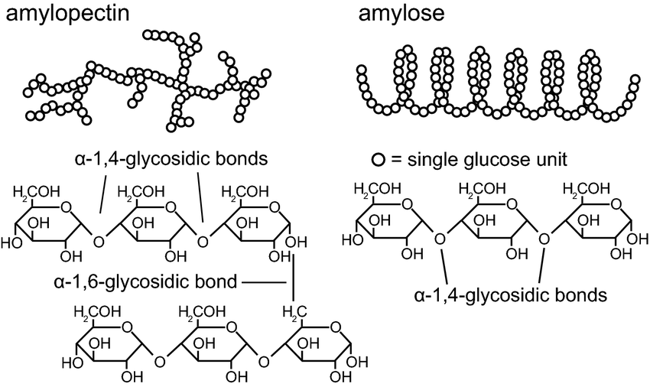

**2.Glycogen:**

Glycogen is a polysaccharide of glucose that serves as a form of energy storage in fungi and animals. The polysaccharide structure of glucose shows the primary storage form of glucose in the body. Glycogen is made and stored in the cells of liver and muscles that are hydrated with the four parts of water.

**Structure of Glycogen:**

Glycogen is composed of long polymer chains of glucose units which are bonded with an alpha acetal linkage. This acetal linkage forms by the combination of the carbonyl group and alcoholic group.

If the carbonyl group is an aldehyde group i.e (-CHO) and also termed as hemiacetal if there is a ketonic group.

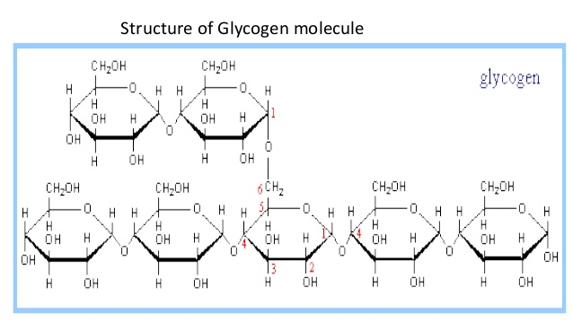

## 3.Cellulose:

Cellulose is the most abundant organic compound on earth with a chemical formula (C6H10O5)n.

Cellulose is a [complex carbohydrate](https://byjus.com/chemistry/complex-carbohydrates/) consisting of ***oxygen, carbon, and hydrogen***. It is chiral, tasteless and has no odour.This organic compound is water-soluble and biodegradable. Amount of cellulose present in cotton is 90%. The amount of cellulose present in the wood is 40-45% and dried hemp is 57% respectively.

## Properties of Cellulose – (C6H10O5)n

Many Properties of cellulose depend upon the degree of polymerization or chain length and the number of glucose molecules constituting the [polymer](https://byjus.com/jee/polymers/) molecule.

Cellulose is odourless and is insoluble in water and most organic solvents. It is biodegradable and chiral.

|  |  |
| --- | --- |
| (C6H10O5)n | Cellulose |
| Molecular Weight/ Molar Mass | 162.1406 g/mol |
| Density | 1.5 g/cm³ |
| Appears | White powder |
| Melting Point | 260–270 °C |

Uses of Cellulose (C6H10O5)n

* It is used in the diet as a fibre supplement
* It is used to produce paperboard and paper products
* It helps as an additive in various food items
* It is used in the production of rayon
* It is used as a preservative in cheese as it plays the role of an anti-clumping agent
* It is used in making explosives
* It is used in the manufacturing of nitrocellulose

**Structure Of Cellulose:**

Beta glucose is the monomer unit in cellulose. As a result of the bond angles in the beta acetal linkage, cellulose is mostly a linear chain. Starch: Alpha glucose is the monomer unit in starch. As a result of the bond angles in the alpha acetal linkage, starch-amylose actually forms a spiral much like a coiled spring.

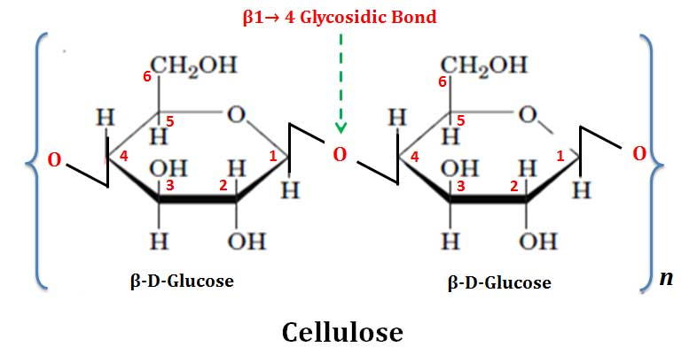

**The tests to identify the presence of carbohydrates:**

The following are the tests to identify the presence of carbohydrates.

1. Molisch’s test
2. Fehling’s test
3. [Benedict’s test](https://byjus.com/chemistry/benedicts-test/)
4. Tollen’s test
5. Iodine test

### **(a) Molisch’s Test:**

[Molisch’s test](https://byjus.com/chemistry/molischs-test/) is a general test for carbohydrates. This test is given by almost all of the carbohydrates. In this test, concentrated sulfuric acid converts the given carbohydrate into furfural or its derivatives, which react with α-naphthol to form a purple coloured product.

The chemical reaction is given below.

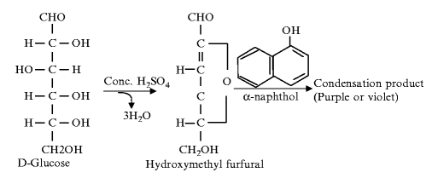

**Note:** The appearance of purple or violet ring confirms the presence of carbohydrate.

### **(b) Fehling’s Test:**

This test is given by reducing sugars. To the aqueous solution of carbohydrate fehling’s solution is added and heated in water bath. Formation of red precipitate confirms the presence of reducing sugars. The copper ions present in fehling’s solution in +3 state is reduced to +2 oxidation state and in alkaline medium it is precipitated as red [cuprous oxide](https://byjus.com/chemistry/copper-oxide/).

The chemical reaction is given below.

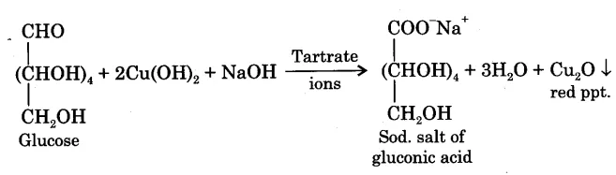

**Note:** The appearance of red precipitate confirms the presence of carbohydrates.

### **(c) Benedict’s Test:**

This test is given by reducing sugars. in alkaline medium, sodium carbonate converts glucose to enediol and this enediol reduce cupric to cuprous forming cuprous hydroxide. This solution is kept in sodium citrate and on boiling, red precipitate of cuprous oxide is formed.

The chemical reaction is given below.

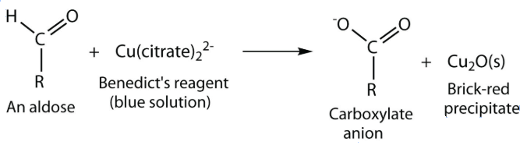

**Note:** The appearance of red precipitate confirms the presence of carbohydrates.

### **(d) Tollen’s Test:**

This test is given by reducing sugars. Carbohydrates react with Tollens reagent and forms a silver mirror on the inner walls of the test tube. This confirms the presence of reducing sugars. Silver ions are reduced to metallic silver.

The chemical reaction is given below.

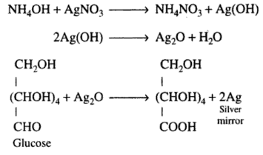

**Note:**The appearance of silver mirror confirms the presence of reducing sugars.

### **(e) Iodine Test:**

This test is only given by starch. Starch reacts with [iodine solution](https://byjus.com/chemistry/iodide/) forms complex blue colour solution. On heating the blue colour disappears and on cooling the blue colour reappears.

The chemical reaction is given below.  
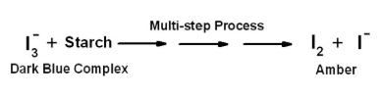

**Protein:**

Proteins are very large molecules composed of basic units called amino acids. In addition to containing carbon, hydrogen, and oxygen amino acids contain nitrogen.

Protein molecules are large, complex molecules formed by one or more twisted and folded strands of [amino acids](https://byjus.com/chemistry/asparagine-amino-acid/). Proteins are biological polymers of small molecules called amino acids. Their moleculer masses range from about 6000 amu to 250,000 amu, so proteins can be very large molecules.

Classification of Proteins

Protein molecules are large, complex molecules formed by one or more twisted and folded strands of amino acids. Each amino acid is connected to the next amino acid by covalent bonds.

1. **Primary (first level) –** Protein structure is a sequence of amino acids in a chain.
2. **Secondary (secondary level) –** Protein structure is formed by folding and twisting of the amino acid chain.
3. **Tertiary (third level) –** Protein structure is formed when the twists and folds of the secondary structure fold again to form a larger three dimensional structure.
4. **Quaternary (fourth level) –** Protein structure is a protein consisting of more than one folded amino acid chain.

## **Protein Structure:**

Proteins are a polymeric chain of amino acid residues. The structure of a protein is mainly composed of long chains of [amino acids](https://byjus.com/biology/amino-acids/). The structure and position of amino acids give particular properties to the proteins. Amino acids are made up of an amino functional group (-NH2) and a carboxyl group (-COOH).

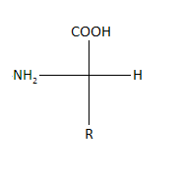

Amino acids are linked together to form polypeptide chains.

# α-Amino acids:

Asparagine is an alpha-amino acid among twenty amino acids that are found in animal proteins. It is used in the biosynthesis of [proteins](https://byjus.com/biology/proteins-structure-and-functions/). It comprises of an alpha carboxyl group, alpha-amino group, and a  carboxamide – a side chain further distributing it as polar aliphatic amino acids.

# **Α**

# **Ds**

## Physical and Chemical Properties

* The chemical formula of asparagine is C4H8N2O3.
* This compound has a molar mass of 132.119 grams per mole.
* Under standard conditions, asparagine has a white, crystalline appearance.
* The density of this compound corresponds to 1.543 grams per cubic centimeter.
* The melting and boiling point of asparagine correspond to 507 K and 711 K respectively.
* Asparagine is somewhat soluble in water – it has a solubility of 2.94 g/100 mL.
* This compound has an orthorhombic crystal structure.

# **β amino acid:**

# The amino acid is an amino acid, in the molecule of which there is an amine group on the carbon beta (see beta carbon) to a carboxylic acid group.

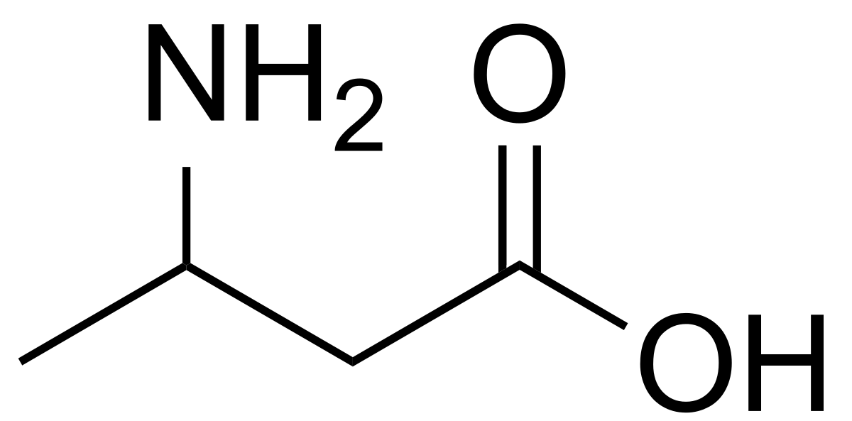

**Special Bonding of Proteins:**

Three types of chemical bonds in proteins include-

**1. Hydrogen bonds**

2. **peptide bonds**

**3. Hydrophobic/hydrophilic interactions.**

**1.Hydrogen Bond:**

Hydrogen bond is an electrostatic attraction between a hydrogen atom,which is covalently bound to a high electronegative atom( Such as Oxygen and Nitrogen) to another electronegative atom of same or different molecules of their close vicinity

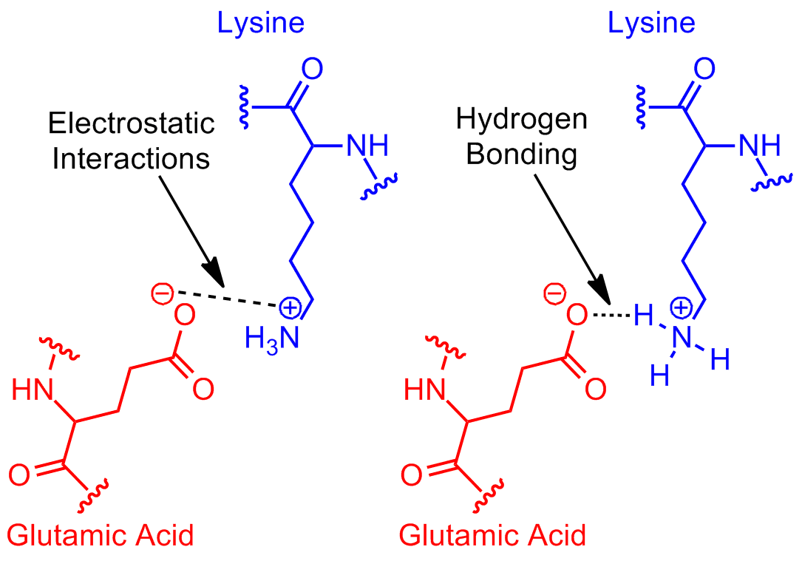

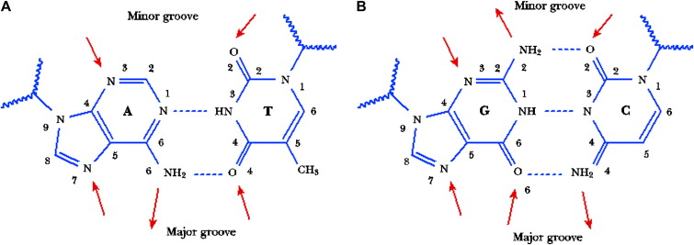

**2. Peptide Bonds**

Peptides are naturally occurring short chains of amino acid monomers connected by amide bonds.

In other words, any substance which resembles the molecular structure of smaller proteins. Peptides include many antibiotics, hormones and other substances that involve in the biological functions of living beings.

There are many types of peptides; Di-peptide is the shortest peptides which consist of only two [amino acids](https://byjus.com/chemistry/asparagine-amino-acid/) connected by one peptide bond. A polypeptide is a continuous long and single peptide chain.

* Peptide bond is a strong covalent bond with high bond dissociation energy
* It is formed by the joining of two amino acid residues during protein synthesis.
* The carboxylic group( -COOH) of one amino acid combine with the amino group (-NH2) of another amino acid tp form the peptide bond.

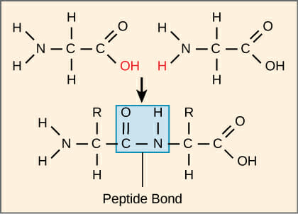

**3.Hydrophobic Interactions:**

Some **R** groups in the aminoacids are non-polar (Example- Alanine , Valine , isoleucine , Leucine).

The non-polar R groups are hydrophobic and they try to stay away from water In a long polypeptide chain , there may be many such non-polar amino acids whichmay be adjacent to eachother or separated by polar **R** groups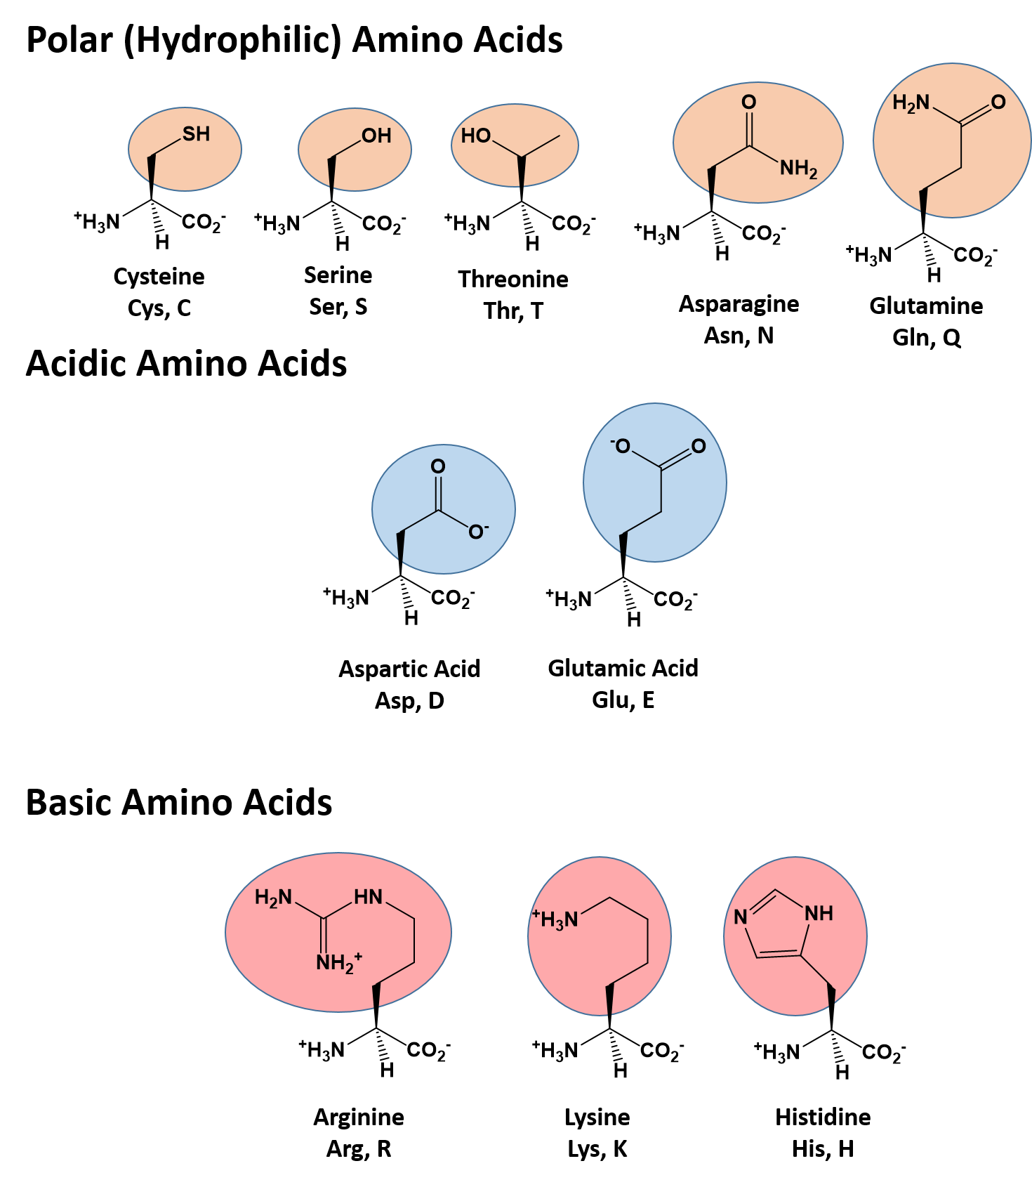

There are also Ionic bond and Disulfide bond in Protein structure but they are non-major .

**Conclusion:**

* Carbohydrates are the most abundant biomolecules in nature,having a direct link between solar energy and the chemcal bond energy in living organisms

Sourse of rapid energy production.

* Structural building block
* The fiber of the carbohydrates helps promote good digestive health and lower the risk of disease and diabetes.
* Proteins are necessary to make antibiotics which fight against infection and illness.
* Carbohydrates store energy,build macromolecules and spare proteins and fat for other uses.
* Without carbohydrates energy for living animal and plants can not go even a single day
* Proteins provide the body with essential amino acids,nitrogen and sulfur.
* Most hormones and enzymes are protein so it is very essential for living life.
* For Hydrogen bonding water molecules are attracted to each other and become liquid
* Hydrogen bond holds DNA stands together

**References:**

**1.** [**https://byjus.com/chemistry/classification-of-carbohydrates-and-its-structure/**](https://byjus.com/chemistry/classification-of-carbohydrates-and-its-structure/)

**2.** [**http://www.fao.org/3/x5738e/x5738e06.htm**](http://www.fao.org/3/x5738e/x5738e06.htm)

**3.** [**https://www.quora.com/What-is-difference-between-d-glucose-and-l-glucose**](https://www.quora.com/What-is-difference-between-d-glucose-and-l-glucose)

**4.** [**https://www.biologyonline.com/dictionary/d-glucose**](https://www.biologyonline.com/dictionary/d-glucose)

**5.** [**https://www.vedantu.com/question-answer/raffinose-on-hydrolysis-forms-a-glucose-b-class-12-chemistry-cbse-5f9f88b701044e34ceb95ca8**](https://www.vedantu.com/question-answer/raffinose-on-hydrolysis-forms-a-glucose-b-class-12-chemistry-cbse-5f9f88b701044e34ceb95ca8)

**6 .https://www.toppr.com/guides/biology/biomolecules/proteins/**

**7.** [**https://quizlet.com/276315898/free-response-flash-cards/**](https://quizlet.com/276315898/free-response-flash-cards/)

**8.** [**https://www.easybiologyclass.com/bonds-involved-in-protein-structure-and-conformation/**](https://www.easybiologyclass.com/bonds-involved-in-protein-structure-and-conformation/)