**Assignment No: 01**

**Assignment on:** Synthesis involving Grignard reagents, Malonic ester and Diazonium salts.

Course Name: Chemistry-II

Course Code: PHY-207

Submitted to:

Md. Mahbub Alam

Lecturer

Department of Chemistry

Jahangirnagar University

Submitted by:

Group-09



**Department of Physics**

Jahangirnagar University

Savar, Dhaka-1342

 Introduction:

**Grignard reagents** are formed by the reaction of magnesium metal with alkyl or alkenyl halides. They’re extremely good nucleophiles, reacting with electrophiles such as carbonyl compounds (aldehydes, ketones, esters, carbon dioxide, etc.) and epoxides. They’re also very strong bases and will react with acidic hydrogens (such as alcohols, water, and carboxylic acids). Grignard reagents are made through the addition of magnesium metal to alkyl or alkenyl halides. The halide can be Cl, Br, or I (not F).

One of the most common methods of preparation of diazonium salt is by the reaction of nitrous acid with aromatic amines. The reaction of aniline (aromatic amine) with nitrous acid results in the formation of the diazonium salt. This salt is the benzene diazonium chloride. Nitrous acid is a highly toxic gas.

The malonic ester synthesis is a chemical reaction where diethyl malonate or another ester of malonic acid is alkylated at the carbon alpha (directly adjacent) to both carbonyl groups, and then converted to a substituted acetic acid.

Grignard reagent  
A Grignard reagent is basically an organ magnesium halide having a formula of RMgX, where X is a halogen, and R is an alkyl or aryl (based on a benzene ring) group.

Example: [Methyl magnesium chloride](https://en.wikipedia.org/wiki/Methylmagnesium_chloride) CH3-Mg-Cl, phenyl magnesium bromide C6H5-Mg-Br and so many.

Grignard reagent is an organometallic compound, Grignard compounds are popular reagents in [organic synthesis](https://en.wikipedia.org/wiki/Organic_synthesis) for creating new carbon-carbon bonds. For example, when reacted with another halogenated compound R'−X' in the presence of a suitable [catalyst](https://en.wikipedia.org/wiki/Catalysis), they typically yield R−R' and the magnesium halide MgXX' as a byproduct; and the latter is insoluble in the solvents normally used. In this aspect, they are similar to [organolithium reagents](https://en.wikipedia.org/wiki/Organolithium_reagent).

Pure Grignard reagents are extremely reactive solids. They are normally handled as solutions in solvents such as [diethyl ether](https://en.wikipedia.org/wiki/Diethyl_ether) or [tetrahydrofuran](https://en.wikipedia.org/wiki/Tetrahydrofuran); which are relatively stable as long as water is excluded. In such a medium, a Grignard reagent is invariably present as a [complex](https://en.wikipedia.org/wiki/Coordination_complex) with the magnesium atom connected to the two ether oxygens by [coordination bonds](https://en.wikipedia.org/wiki/Coordination_bond).

The discovery of the Grignard reaction in 1900 was awarded with the Nobel prize in 1912.

<https://www.toppr.com/guides/chemistry/amines/diazonium-salts/#:~:text=One%20of%20the%20most%20common,is%20a%20highly%20toxic%20gas>.

Synthesis

Grignard reagents are prepared by treating an organic halide (normally organ bromine) with magnesium metal. Cyclic or acyclic [ethers](https://en.wikipedia.org/wiki/Ether) are required to stabilize the organ magnesium compound Water and air, which rapidly destroy the reagent by [proton lysis](https://en.wikipedia.org/wiki/Protonolysis) or oxidation, are excluded using  [air free techniques](https://en.wikipedia.org/wiki/Air-free_technique). Although the reagents still need to be dry, ultrasound can allow Grignard reagents to form in wet solvents by activating the magnesium such that it consumes the water.[1]

Ref:[1] <https://en.wikipedia.org/wiki/Grignard_reagent>

Making of Grignard reagent:

Grignard reagents are produced from the heated combination of halogenoalkane and magnesium in the presence of diethyl ether (ethoxyethane). The reaction should be kept dry to avoid the resulting Grignard reagent from reacting with water.

Magnesium reacts with alkyl halayed in presence of dry ether to form Grignard reagents.

R-X + Mg 🡪 R-Mg-X (in presence of dry ether)

Ar-X + Mg 🡪 Ar-Mg-X (in presence of dry ether)

CH3-Cl + Mg 🡪 CH3-Mg-Cl (in presence of dry ether)

C6H5-Br + Mg 🡪 C6H5-Mg-Br (in presence of dry ether)

Grignard reactions:

On the event of Grignard Reaction, Grignard reagent is added to a ketone or aldehyde, to form a tertiary or secondary alcohol, respectively. The reaction with formaldehyde leads to a primary alcohol. Grignard reagent can be used for determining the number of halogen atoms present in a halogen compound. Currently, Grignard degradation is used for the chemical analysis of certain triacylglycerols. Industrially, the Grignard reaction is the key step in the production of Tamoxifen, which is used in the treatment of breast cancer. [2]

Ref: [2] <https://www.sigmaaldrich.com/chemistry/chemistry-products.html?TablePage=16243454&gclid=Cj0KCQjwpdqDBhCSARIsAEUJ0hOQ73Lg5oxaiH6zBdFWJKLE4M9729mmpp8kA7MokfB0XFkmzcrS6GQaAhwVEALw_wcB>

Preparation of alkane from Grignard reagent:

Grignard reagents react with water to produce alkynes and Mg(OH)X.

R-Mg-X + H-OH 🡪 R-H + Mg(OH)X

Ar-Mg-X + H-OH 🡪 Ar-H + Mg(OH)X

CH3-CH2-Mg-Cl + H-OH 🡪 CH3-CH3 + Mg(OH)Cl

Synthesis of Alcohols Using Grignard reagents:

1o Alcohol:

In presence of dry ether and H2O, a primary alcohol is synthesized by reacting the Grignard reagent, R─MgX, with formaldehyde.

CH3-Mg-Cl + H-CHO 🡪 CH3-CH2-OH + Mg(OH)Cl

2o Alcohol:

In presence of dry ether and H2O, reacting a Grignard reagent with an aldehyde gives a secondary alcohol (R2-CH-OH)

CH3-Mg-Cl + CH3-CHO 🡪 (CH3)2-CH-OH + Mg(OH)Cl

3o Alcohol:

In presence of dry ether and H2O, reacting a Grignard reagent with a ketone gives a tertiary alcohol (R3-C-OH)

CH3-Mg-Cl + CH3-CO-CH3  🡪 (CH3)3-C-OH + Mg(OH)Cl

Preparation of acid from Grignard reagent:

In presence of dry ether and H2O, reacting a Grignard reagent with carbon dioxide gives an organic acid.

CH3-Mg-Cl + CO2 🡪 CH3-COOH + Mg(OH)Cl

## Importance of Grignard Reactions

The value of the Grignard reaction cannot be overstated. In general, Grignard reactions represent one of the best ways in organic chemistry to produce C-C bonds and enable the coupling of alkyl chains. For example, Grignard reagents are frequently used to alkylate aldehydes and ketones. There are few reagents available to the chemist that are as effective as Grignard’s for C-C bond formation.

Carbon is more electronegative than magnesium, and the metal-carbon bond in Grignard regents is quite ionic. These carbanions are quite nucleophilic and readily react with electrophilic groups such as carbonyl moieties. Thus, Grignard reagents react with formaldehyde to form primary alcohols, with aldehydes to form secondary alcohols and ketones, and esters and acid halides to form tertiary alcohols.

Reactions of various organic compounds with Grignard reagents yield amines, ketones, nitriles, thiols, aldehydes, etc. Grignard reagents can react with a variety of halides to form carbon-hetero atom bonds. [3]

Disadvantage of Grignard reagents

The disadvantage of Grignard reagents is that they readily react with protic solvents (such as water), or with functional groups with acidic protons, such as alcohols and amines. Atmospheric humidity can alter the yield of making a Grignard reagent from magnesium turnings and an alkyl halide. [4]

Ref: [3] <https://www.mt.com/ph/en/home/applications/L1_AutoChem_Applications/L2_PAT/Grignard_application.html#:~:text=Grignard%20reactions%20are%20important%20due,valuable%20tools%20for%20organic%20synthesis>.

Ref: [4] <https://simple.wikipedia.org/wiki/Grignard_reaction#:~:text=The%20disadvantage%20of%20Grignard%20reagents,turnings%20and%20an%20alkyl%20halide>

Diazonium salts

The diazonium salts (di refers to ‘two’, azo is indicative of ‘nitrogen’ and ium implies that it is cationic in nature), or diazonium compounds,  are the class of organic compounds with general formula R−N2+X− where X is an organic or inorganic anion (for example, Cl–, Br–, BF4–, etc.) and R is an alkyl or aryl group.

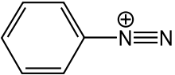

Diazonium salts are one of the most versatile combinations of organic and inorganic components. Its general way of representation is R−N2+X−. The R is an organic group, generally an aryl group while X represents ion.

Generally, diazonium salts have Cl–, Br–, BF4–, as X. The name of these salts is based on the presence of the N2+group or the diazonium group.

The naming of these salts is done by adding the suffix diazonium to the parent hydrocarbon from which they are derived and then it is followed by the anion X such as bromide.

Diazonium salts preparation

* The process of converting an organic compound, generally primary aromatic amines, into diazonium salts is referred to as diazotization or dissociation.
* The diazonium group is highly unstable under normal conditions and hence it is not generally stored, most of the time it is used just after its preparation.
* One of the most common methods of preparation of diazonium salt is by reacting nitrous acid with aromatic amines. The reaction of aniline (aromatic amine) with nitrous acid results in the diazonium salt formation that is benzene diazonium chloride.
* Nitrous acid is a highly toxic gas and hence it is generally prepared during the reaction itself (in situ) by reacting NaNO2 with a mineral acid (usually aqueous HCl, H2SO4, *p*-H3CC6H4SO3H, or HBF4).
* Another important parameter that governs the product formation during the preparation of these salts is temperature; most diazonium salts are stable below the temperature of 5o C.
* It is, therefore, important to keep the reaction conditions below 5oC or else the diazonium group will decompose to give N2 as soon as it is formed.

The reaction of aniline with NaNO2 and hydrochloric acid is given below, the product of the reaction is benzene diazonium chloride.



The diazonium group finds application in many ways. From dyes and pigment industry to synthesis of various organic compounds, this combination of organic and inorganic components has been a boon for the scientists.

Properties of Diazonium salts

1. They are ionic in nature.
2. They are water-soluble.
3. Aryl diazonium salts are colorless crystalline solids.
4. Benzene diazonium chloride is soluble in water but reacts with it only when warmed.
5. Benzene diazonium fluoroborate is not soluble in water. It is pretty stable at room temperature.

Reactions of Diazonium salts

Diazonium salts undergo two types of reactions:

* Reactions which involve the replacement of nitrogen
* Reactions which involve retention of the diazo group.

This article deals with the reactions which involve the replacement of nitrogen. Diazonium group is a good leaving group. They are substituted by other groups such as Cl–, Br–, CN–, OH– which easily displace nitrogen from the aromatic ring. This nitrogen escapes from the reaction mixture in the form of a gas.

**Replacement by halide or cyanide ion:**

In the Sandmeyer reactions, diazonium groups are replaced by chloride, bromide or cyanide in the presence of copper (I) ions.

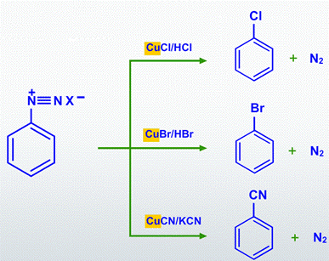

In the Gattermann reactions, diazonium groups are replaced with Chlorine (or) Bromine by treating the diazonium salt solution with halo acid in the presence of copper powder.

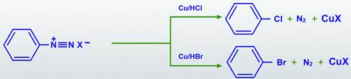

Diazonium group may be replaced by iodine by treatment with potassium iodide.

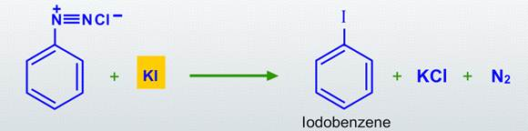

**Replacement by hydrogen**

The Schliemann reaction is a method for the production of aryl fluorides. In reductive deamination, the diazonium group is replaced by hydrogen after treatment with mild reducing agents such as hypo phosphorous acid (or) ethanol.

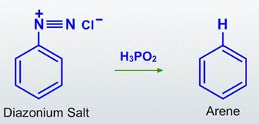

**Replacement by a nitro group**

In nitration reactions, the diazonium group is replaced by an -NO2 group.

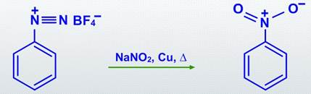

**Replacement by a hydroxyl group**

Phenols can be prepared from diazonium salts by hydrolysing with dilute sulphuric acid and heating.

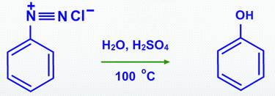

**Replacement by an aryl group**

Aryl diazonium salts are produced by reacting aniline with nitrous acid, generated in situ (must be prepared freshly before use) at 273-278 K.

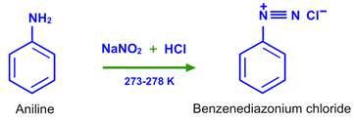

**Diazo coupling reactions**

Azo coupling reactions occur when diazonium salts react with phenol (or) aniline.

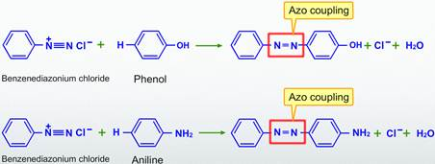

Importance of Diazonium salts:

* They find application in the dye and pigment industries and are used to produce dyed fabrics.
* Due to their property of breaking down near the ultraviolet light, they are used in document reproduction
* They are useful in the synthesis of a large variety of organic compounds, especially aryl derivatives.
* Direct halogenation is not a suitable method for preparing aryl iodides and fluorides. Nucleophilic substitution of chlorine in chlorobenzene by a cyano group is not possible. However, diazonium salts can easily be used to produce cyan benzene.
* It is not possible to prepare substituted aromatic compounds by direct substitution in benzene. For these compounds, we use the replacement of the diazo group in diazonium salts.
* They are used as intermediates for introducing –F, –Br, –Cl, –I, –NO2, –OH and –CN groups into the aromatic ring.

Reference

<https://byjus.com/chemistry/diazonium-salts-application/>

<https://www.nextgurukul.in/wiki/concept/cbse/class-12/chemistry/amines/diazonium-salts/3961635>

<https://en.wikipedia.org/wiki/Diazonium_compound>

Malonic ester synthesis

The malonic ester synthesis is a chemical reaction where diethyl malonate or another ester of malonic acid is alkylated at the carbon alpha (directly adjacent) to both carbonyl groups, and then converted to a substituted acetic acid. The major drawback of malonic ester synthesis is that the alkylation stage can also produce dialkylated structures. This makes separation of products difficult and yields lower.

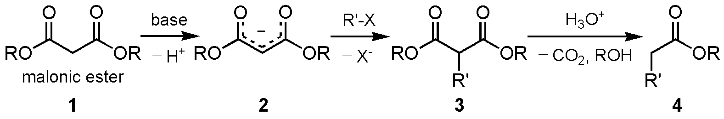

Mechanism

The carbons alpha to carbonyl groups can be deprotonated by a strong base. The carbanion formed can undergo nucleophilic substitution on the alkyl halide, to give the alkylated compound. On heating, the di-ester undergoes thermal decarboxylation, yielding an acetic acid substituted by the appropriate R group. Thus, the malonic ester can be thought of being equivalent to the −CH2COOH synthon.

The esters chosen are usually the same as the base used, i.e. ethyl esters with sodium ethoxide. This is to prevent scrambling by transesterification.

[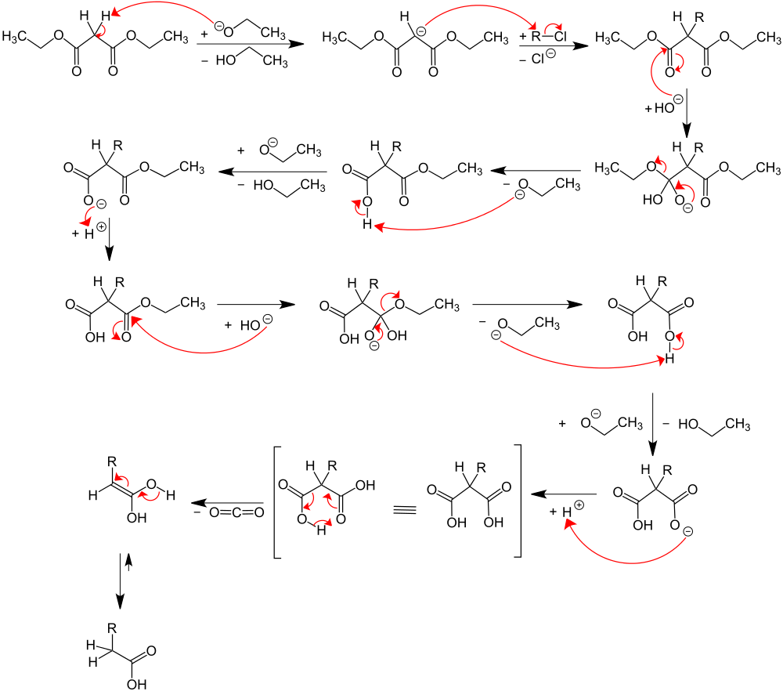](https://en.wikipedia.org/wiki/File:Mechanismus_Malonestersynthese_V4.svg)

## The Malonic Ester Synthesis Is Comprised of Five Separate Reactions

These processes are built out of five reactions in total:

1. **deprotonation**of the ester to form an enolate
2. **SN2**of the enolate upon an alkyl halide, forming a new C-C bond
3. **acidic hydrolysis**of the ester to give a carboxylic acid
4. **decarboxylation**of the carboxylic acid to give an enol
5. **tautomerization** of the resulting enol to a carboxylic acid

<https://www.masterorganicchemistry.com/2012/08/14/the-malonic-ester-synthesis/>

## Step 1: Deprotonation To Give An Enolate

In the first step, a base (CH3O– in this case) removes the most acidic proton from the ester (on C2 here, with a pKa of about 13) to give an enolate. The resulting enolate can be drawn as one of two resonance forms.

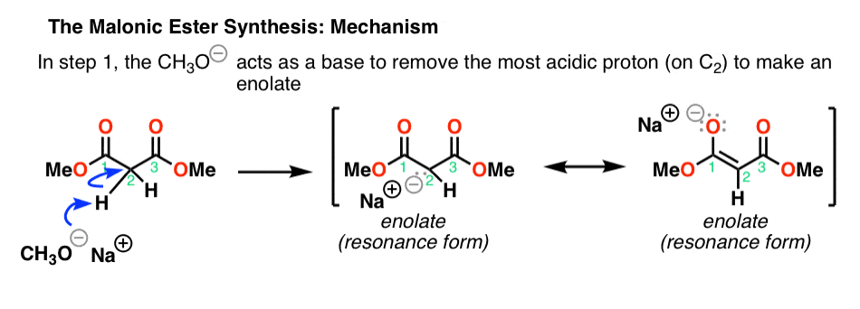

## Step 2: SN2 Reaction Of The Enolate Nucleophile With An Alkyl Halide Electrophile

Enolates are great nucleophiles. In the second step, the enolate acts as a nucleophile in an SN2 reaction to form a new C-C bond:

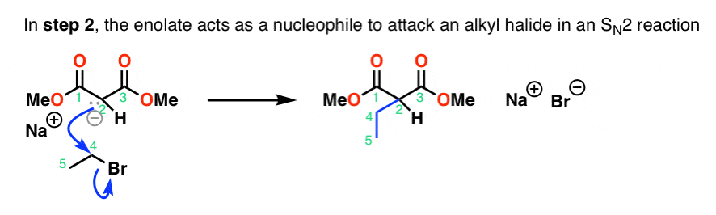

## Step 3: Acidic Ester Hydrolysis

Next (step 3), acid and water are added to perform the aqueous hydrolysis of the ester to a carboxylic acid.

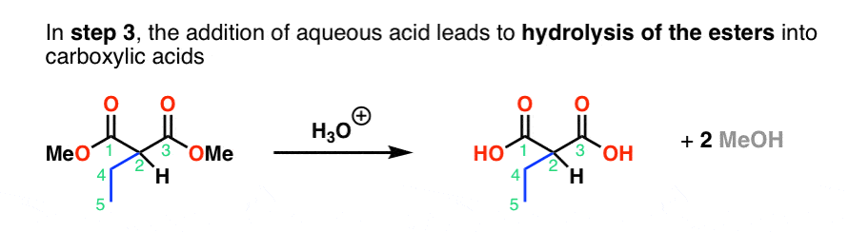

## Step 4: Decarboxylation to Give An Enol

Now comes the part which often gives students trouble. When carboxylic acids have a carbonyl group (C=O) two bonds away, they can readily lose carbon dioxide. Why? Because the carbonyl can act as an electron “sink” for the pair of electrons coming from the breaking C–C bond, forming an **enol.**This is called “decarboxylation”. Note how this is also the case for carboxylic acids with a ketone two bonds away, so-called “β-keto acids”.

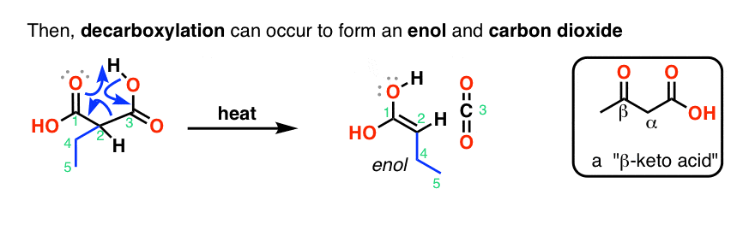

## Step 5: Tautomerization Of The Enol Back To The Carboxylic Acid

Finally, the enol that is formed is **not a stable species**. It can undergo transformation into its constitutional isomer: in this case, a carboxylic acid. These two constitutional isomers are in equilibrium with each other, although the “keto” form (with the carbonyl group) is greatly favored. This process is called “tauto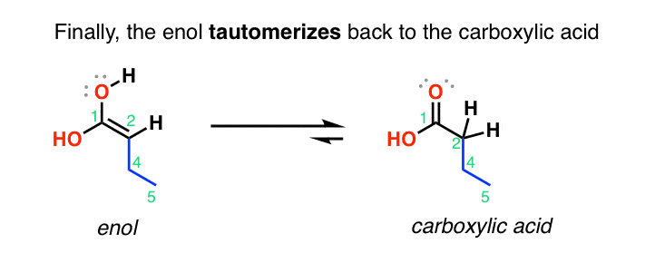

Conclusion:

Malonic acid is used as a building block chemical to produce numerous valuable compounds, including the flavor and fragrance compounds gamma-Nona lactone, cinnamic acid, and the pharmaceutical compound valproate. The malonic ester synthesis is a chemical reaction where diethyl malonate or another ester of malonic acid is alkylated at the carbon alpha (directly adjacent) to both carbonyl groups, and then converted to a substituted acetic acid. [7] Inhalation Toxic if inhaled. Causes respiratory tract irritation. Ingestion Harmful if swallowed. Skin Harmful if absorbed through skin.[8] More complicated structures can be prepared by the malonate ester synthesis. It is possible to introduce a second [alkyl group](https://www.sciencedirect.com/topics/chemistry/alkyl-group) by repeating the steps outlined above using either the same alkyl group or a different one.[9]

Ref: [7] <https://en.wikipedia.org/wiki/Malonic_acid>

Ref: [8] <https://www.nwmissouri.edu/naturalsciences/sds/m/Malonic%20acid.pdf>

Ref: [9] <https://www.sciencedirect.com/topics/chemistry/malonate-ester>