# User Manual

## Homepage Explanation

3

1

5

4

2



1-5: Each of the following button in the Navigation Bar is a clickable button that will take you to the respective page, more on the individual pages themselves can be found below

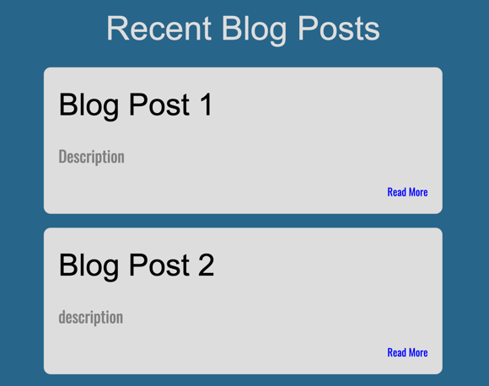

**Blog Posts:**

8

7

6

6: Blogpost Title

7: Brief outline of the respective post

8: The ‘Read More’

1. Linked button bringing the user to the RefugeeEAP Facebook page.
2. Linked button bringing the user to the RefugeeEAP Twitter page.
3. Linked button bringing the user the RefugeeEAP Instagram page.
4. Graphical user interface

   Description automatically generatedShape, rectangle

   Description automatically generated- 6. Linked buttons in the footer giving the user the options to change to a different page on the website.
5. Month/Year of events.
6. Listed events to inform the user of any upcoming events.
7. Link to view all the events.

**Contact Us**

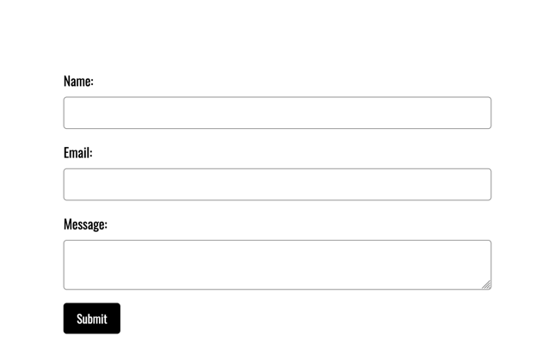

9-11: This form is available on the contact us page this will allow a user to submit any questions that they may have directly to you through an online form.

10

9

11



12

12: Other contact information is also available on this page, this can be updated with new information should it be required.

# User Manual Sprint 2

## Blog Page

The navigation bar, header and footer of the blog page are similar to all the other pages across the website. There will be three blog post in each row of the main page.

Bottom of the blog there will be tags included for author to categorise their blogs and readers to be able to identify the blogs that they are interested in.

The blog page will be divided in multiple section where user can include subheadings for the blog.

The top part of the blog section will include the main given title, below the title it will show the date & time the blog was posted with the name of the author.

At the bottom section of the blog page there is a section where people can contribute to the blog by submitting this form.

User needs to enter their name.

After user has entered the content, title and email for the blog page they need to press on the ‘submit’ button and the admin will get the request to put verify and put the blog post on the page.

User needs to enter the content of the blog in this section.

Title of the blog post

User’s email

All the input fields in the form are validated so that the form is filled properly with all the required details and content of the blog.

## Admin Login Page

The admin login page is very simple where admin will be presented with a form to enter their Username and password.

Admin needs to enter their password which will behind asterisk**.

Here the admin needs to enter their username for the login.

## Admin secure portal

After logging in successfully the admin will be taken to the admin side of the page where they will be able manage the website.

Admin will be able to click on ‘Users Management’ to manage the number of users, their roles and their password.

Then next to that there is the navigation link to ‘Event Management’ where admin can manage, add, delete events. (Under development)

This is the navigation link to ‘Blog Management’ where admin will be able to approve, reject blog post and remove blog post.

This ‘Home’ navigation link will take the admin out of the admin site and back to client-side homepage.

This is the interface for users management section in admin site, here admin can manage the admin users and add admin specific role to the users.

At the bottom of the webpage there is a section with a table that will have the username, role and status for each admin.

To add new user as admin, username, password and role blanks in the form must be filled. Then the ‘Add New User’ button will work to add new user, the form is validated for input.

The ‘Logout’ navigation button will take the admin out of the users management page back to the client side homepage.

# User Manual Sprint 3

## Blog Submission / Management Page

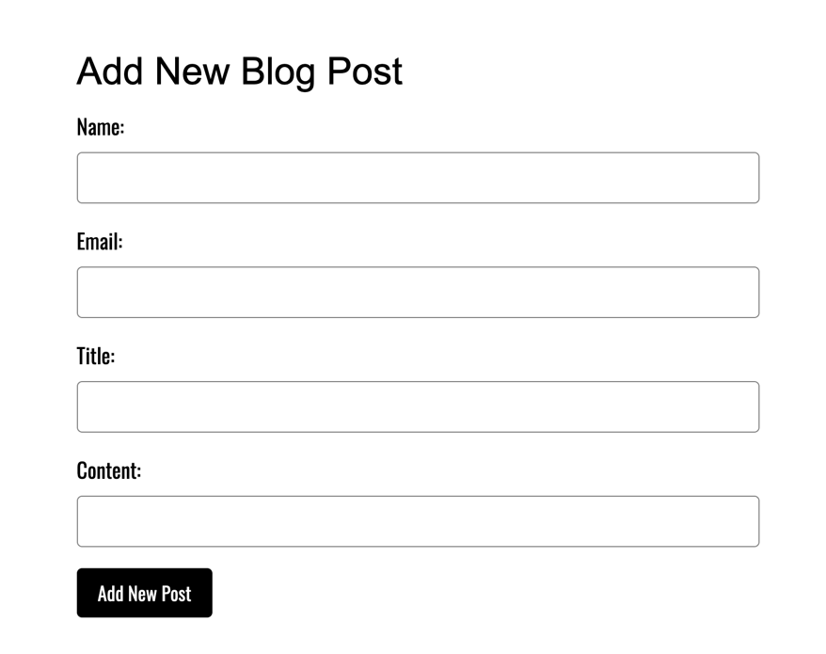

This field will provide the user with a place to enter the main blog page content of their blog

This field will allow the user to enter the title of their blog when submitting

This field will allow the user to enter their email, this will allow an admin to contact the user should they need to do so

This field will allow the user to enter their name, when creating a new blog post

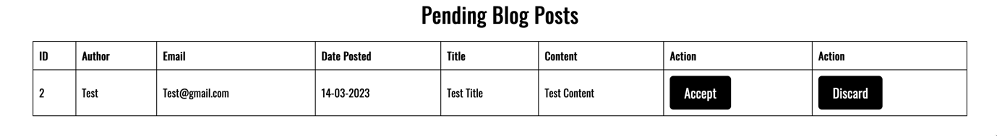

The two buttons marked in red allow an admin to approve or deny a blog before it is posted on the blog page

This field on the blog management page aligns with the name field on the blog submission page

This field provides the admin user with access to the email of a user who has submitted the blog, allowing them to further contact the user should it be necessary

The following two fields provide the user with information about the blog post, including its content in full and the proposed title of said blog

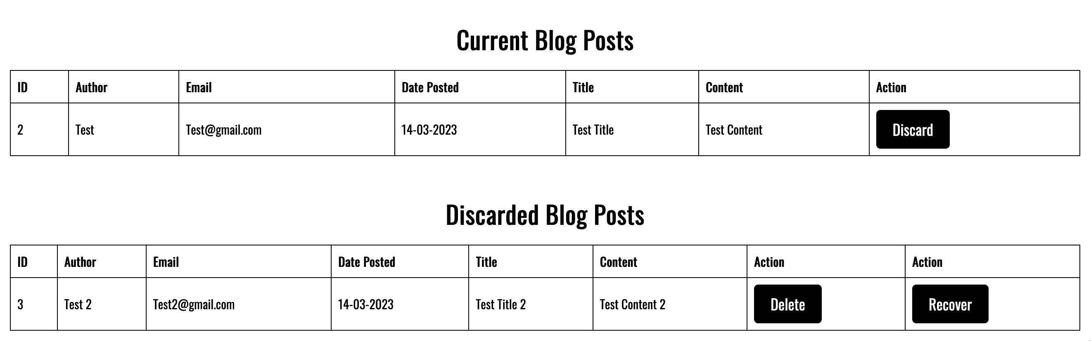

Using the discard button an admin can remove any blogs currently posted on the website, this will move them to the discarded blog posts section

Clicking the recover button will move a discarded blogpost into the ‘pending blog posts’ section allowing an admin to then re-review the post to see if they want to post it to the main page of the website

Clicking the delete button will remove the discarded blog post from this section. Permanently deleting it.

As can be seen here the current blog posts will be presented on the blog page. All of these posts can be managed in the above-mentioned blog management page in the admin panel

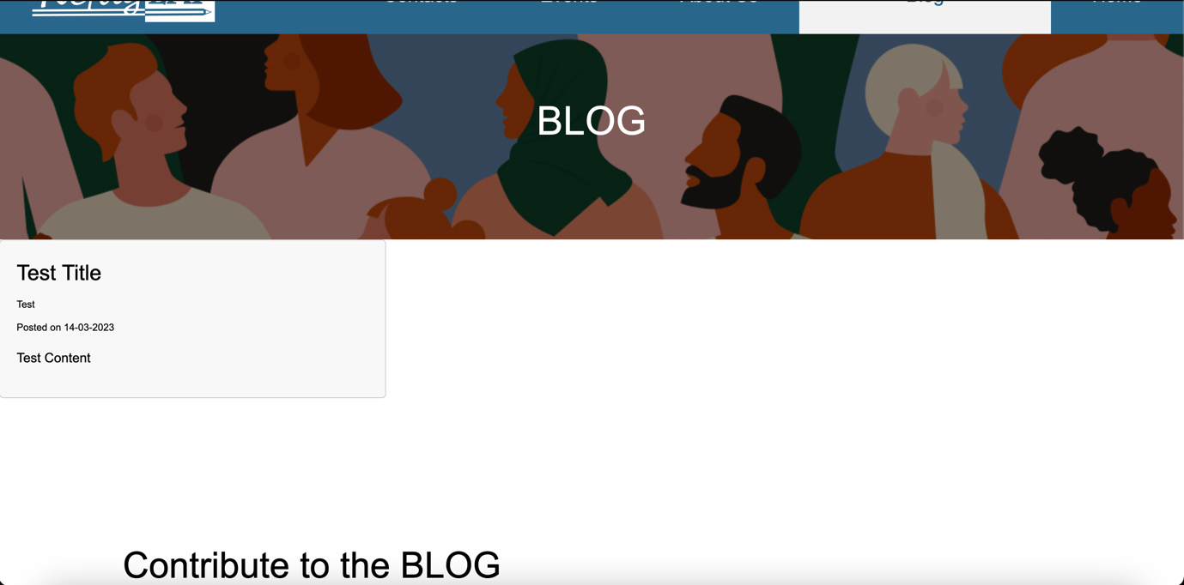

## Events Page

This allows the user to change the layout of the calendar to show the events throughout the day, week, or month.

This allows the user to quickly change the date of which the calendar is showing.

This is presented as a list showing the times and duration of the events. These can be edited if the user wishes to change, add or remove events to that day.

As seen on the 12th there is an “event”, when the user clicks on this day it will bring up more details regarding the events that take place on that day.

To add an event the user must enter their name, email, the event title and the date and time of the event want to add. They have the option to add more info regarding the event below these details.

For the user to add the event time and date they must clock on the drop down under the heading “Event Date and Time” and select the year, month, day and time of the event. This is displayed as shown.

The admin can then go down the list of requested events and choose to either “Accept” or “Discard” them. This then splits the events respectively into two lists.

The event can be submitted once the user has filled in the event details. When the user clicks the “Submit” button it will add their event to the ”Requests to add events” list further down the page.

# User Manual Sprint 4

The contact us form has been updated with validation and a new management page. Each of these fields is required and validated

## Contact Us Page

## 

Here the user is able to type their name for an admin to be able to respond to them

Here the user is able to type their email so that they can receive a response (this is required)

Once a user submits this form admins will now be emailed with details of this, they can quickly look at message content, name, etc. here but will need to go to the admin management panel to make any changes to its status (below)

Any message content that the user wishes to send will go here

## Contact Us Management Page

This field on the contact management page displays the message content that has been submitted allowing an admin to get an overview of the reasons for this person getting in contact

This field on the contact management page aligns with the name field on the contact us page

The final two fields allow an admin to mark a pending contact as either having been accepted (therefore being reviewed) or discard a contact they do not wish to respond to or have already responded to, more information on this below

This field on the contact management page will display the submitted email address, this allows an admin to get into contact with the person submitting should it be necessary

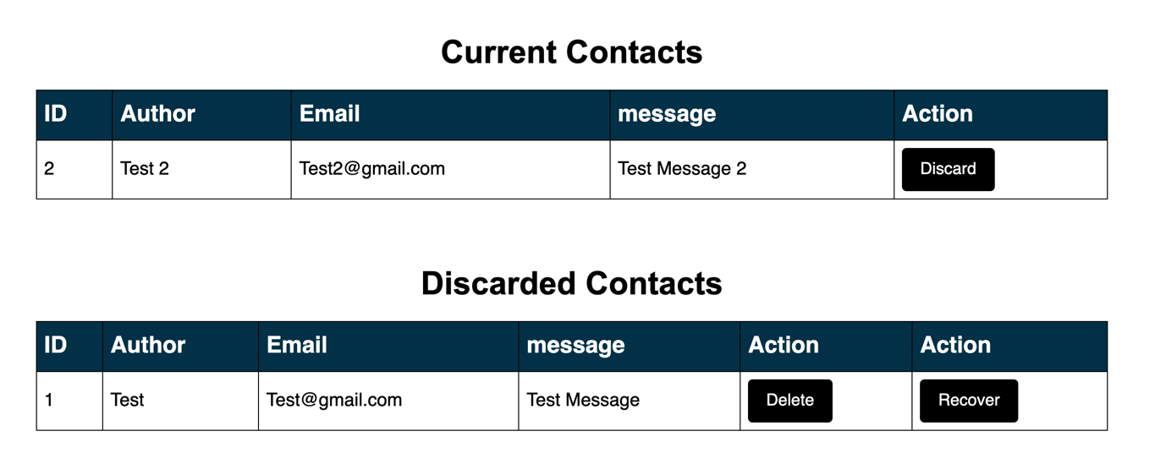

Once a contact has been discarded it will appear in this section where an admin can either delete the contact permanently or choose to recover it should it be necessary to do so.

Once a contact has been accepted it will appear here, clearly stating that it is currently being responded to/ reviewed. An admin can then click the discard button to discard the contact once they are done communicating, more information to the left.

NAV bar - Drop down options

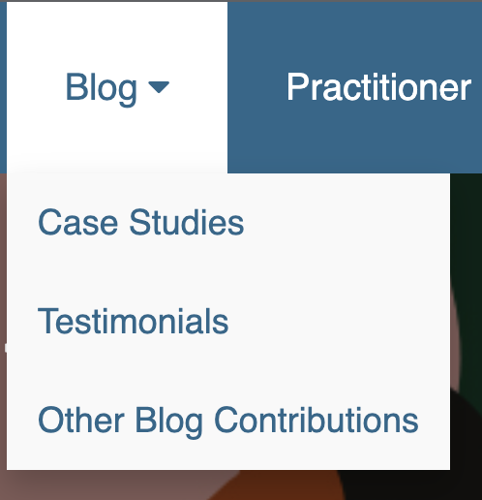

When the user hovers over the Blog button the following dropdown will appear. The user can then decide to click on the buttons Case Studies, Testimonials or Other Blog Contributions. If the user was to choose Case Studies, this will bring them through to a page where they can contribute to the blog. The other two buttons bring the user to the same page however only contributes to either the Testimonials or Other.

When the user hovers over the Connect button on the nav bar, the following dropdown will appear. This allows the user to decide whether they want to get in touch with the ambassador through the “Contact Us” button. Sign up to the network through the “Join Us” button. Find out more information regarding the current Working Group of the organisation.

If the user clicks on

* English Language Provision
* It will bring them through to a page that outlines examples of different pathways for refugees to reach Higher Education in English Language.
* RefugEAP Programme
* This page outlines what a RefugEAP Programme is and how individuals and organisations can support it.

The Practitioner Resources drop down includes.

* Developing Provision
* This brings the user through to a page where there is in depth information and tips on developing successful sanctuary provision.
* Evidence Base
* This shows the RefugEAP networks collated evidence through Case Studies, Testimonials and Other forms of evidence.
* Practical Resources
* This page displays all of the RefugEAP Network Resource Bank.