*Choose any one of the following stacks to complete the algorithm:*

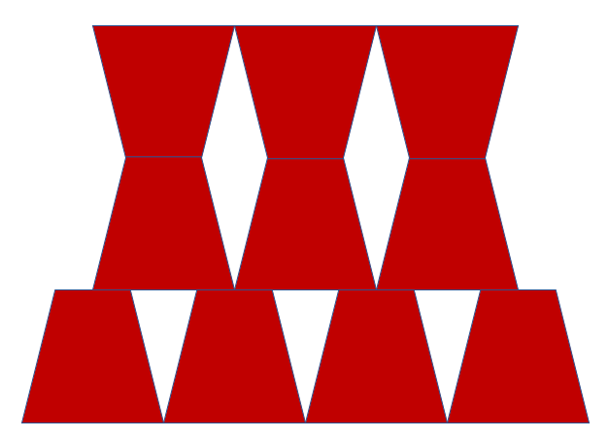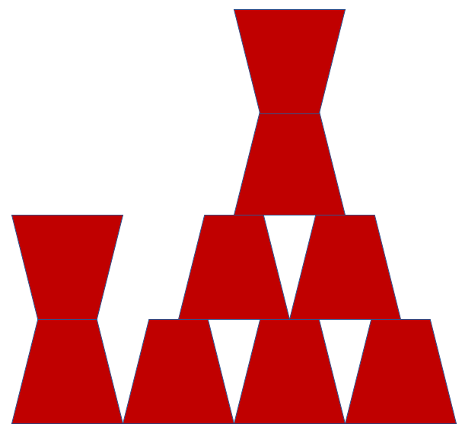

Your algorithm:

* _____________________________________________________________
* _____________________________________________________________
* _____________________________________________________________
* _____________________________________________________________
* _____________________________________________________________
* _____________________________________________________________
* _____________________________________________________________
* _____________________________________________________________
* _____________________________________________________________
* _____________________________________________________________