31-05-2025

Mekapothula Durga Venkateswara Reddy (22BCB7296)

1.inserting into products collection

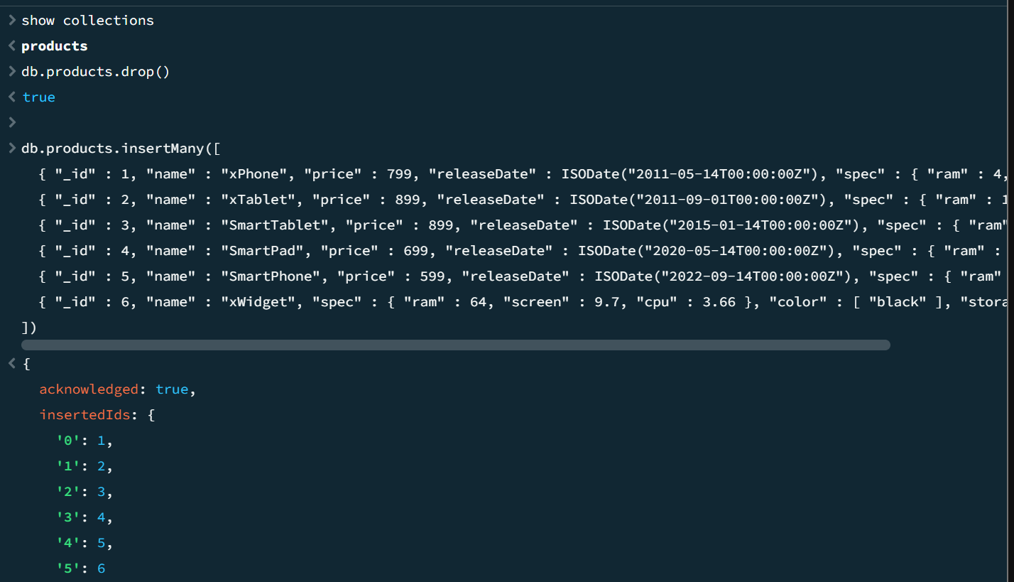

2.And operator

3.or operator

4. and & exists

5.and operator another example

6.not operator

7.not operator another example

8.nor operator

9.nor operator another example

10.exists,true

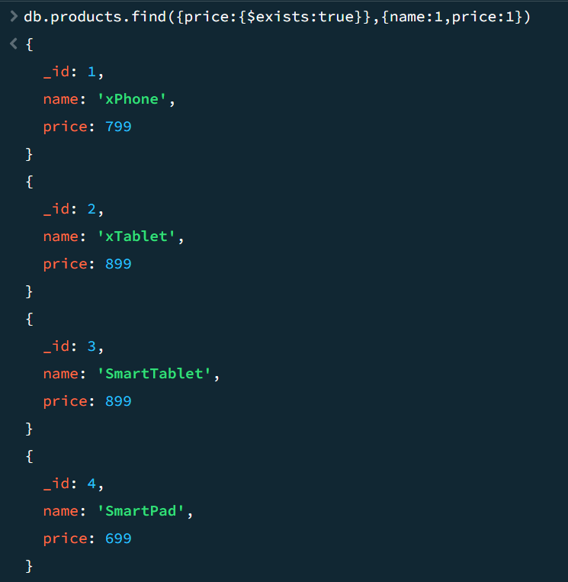

11.exists,true & another condition

12.exists,false

13.size

