APP INSIGHTS UNLOCKED
Google Play Store Analysis | Power BI Project Documentation
Prepared by: Md Ziaul Haque
Tools: Power Query, DAX, Power BI
Dataset: Kaggle, Google Play Store Apps (googleplaystore.csv)
Overview dashboard
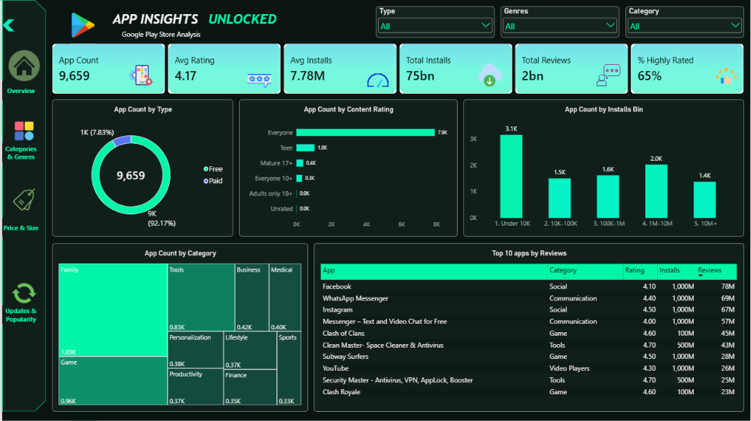
The finished dashboard: four views, three slicers and a collapsible navigation panel.

Executive Summary
Success on the Play Store goes with a free model, larger feature-rich apps and steady updates, while installs and ratings are only weakly linked app by app. These findings come from 9,659 cleaned apps and are shown in four dashboard views.

9,659  Apps analyzed | 4.17  Average rating (median 4.3) | 65.08%  Apps rated 4.0 or above | 92.17%  Free apps (8,903)
75.1bn  Total installs (lower bound) | 7.78M  Average installs per app | 6,284  Apps updated in 2018 (65.1%) | 2.09bn  Total reviews

Five findings that answer the brief
- Demand is concentrated. Five categories hold 58.8% of installs: Game 13.9bn, Communication 11.0bn, Tools 8.0bn, Productivity 5.8bn, Social 5.5bn.
- Quality is highest where competition is lighter. Education (4.36), Books and Reference (4.34) and Personalization (4.33) lead. Tools (4.04) and Dating (3.97) trail.
- Free wins adoption. Free apps average 8.4M installs, against under 0.14M for any paid price group. Paid apps rate only slightly higher (4.26 vs 4.17).
- Bigger and fresher apps get more installs. Apps of 50 MB and over average 12.9M installs, and apps updated in 2018 average 11.2M, against 1.7M or less for earlier years.
- Popularity does not guarantee quality. The installs-rating correlation is 0.04, yet apps with 10M+ installs rate highest (4.32).

Coverage of the 25 brief questions: 20 answered in full, 4 answered with a stated workaround (B6, M6, A1, A2), and 1 not answerable from this file (A4, sentiment). Section 8 explains each gap.

1. Project Overview
Business problem. A mobile app company wants to know what drives app success on the Google Play Store, so it can improve its app development strategy, user experience, downloads and revenue.
Objective. Analyze 9,659 unique apps to answer three questions:
- What factors contribute to an app’s success (ratings, installs, reviews)?
- How can the company use those factors to improve its own apps?
- What do the data say about user preferences and behavior?

Stakeholders. Internal: app developers, product managers, marketing team, senior management. External: app users, advertisers, partners.
Success metrics. Average rating, total installs, average installs, total reviews, share of apps rated 4.0 and above.

2. Data Dictionary (after cleaning)
Column | Type | Description
App | Text | App name, unique after cleaning
Category | Text | 33 categories with cleaned labels (for example Art And Design)
Rating | Decimal | 1 to 5. Blank for 1,463 unrated apps (15.1%)
Reviews | Whole number | Number of user reviews
Size | Decimal (MB) | Converted from text. Blank for 1,227 apps listed as Varies with device (12.7%)
Installs | Whole number | Lower bound of the install bracket (1,000,000 means 1,000,000+)
Type | Text | Free or Paid
Price | Decimal (USD) | 0 for free apps
Content Rating | Text | 6 values, led by Everyone
Genres | Text | Primary genre only (48 values)
Last Updated | Date | 21 May 2010 to 8 Aug 2018
Current Ver, Android Ver | Text | Not used in the analysis

Derived fields: Installs Bin, Size Bin, Price Bin, Update Year.

3. Data Cleaning Log
Issue found | Fix | Result
1 corrupted row (a rating value sitting in Category) | Filtered out | 10,841 to 10,840 rows
Duplicate apps | Removed duplicates on App, first occurrence kept | 10,840 to 9,659 rows (1,181 removed)
Rating stored as NaN (not a true blank) | Converted to null, never filled with 0 or the average | 1,463 nulls, average now calculates (4.17)
Price rounded to whole numbers by automatic type detection | Removed the automatic type step, set Price to decimal | Cents restored (0.99, 4.99)
Size stored as text (19M, 201k, Varies with device) | Converted to MB (k divided by 1,024). Varies with device kept as null | 8,432 numeric sizes
Type had 1 missing value | Set to Free (its price is 0) | Free 8,903, Paid 756
Category in upper case with underscores | Replaced underscores, capitalized each word | 33 clean categories
Genres with combined values (Art & Design;Pretend Play) | Kept the text before the first semicolon | 118 values reduced to 48
Last Updated stored as text | Converted to Date | 0 errors

4. Metrics and Model (DAX)
- App Count = COUNTROWS(googleplaystore)
- Avg Rating = AVERAGE(googleplaystore[Rating])
- Total Installs = SUM(googleplaystore[Installs]) and Avg Installs = AVERAGE(googleplaystore[Installs])
- Total Reviews = SUM(googleplaystore[Reviews])
- % Highly Rated = DIVIDE(CALCULATE(COUNTROWS(googleplaystore), googleplaystore[Rating] >= 4), COUNTROWS(googleplaystore))
- Avg Rating (100+ Apps) = IF([App Count] >= 100, [Avg Rating]), which hides small categories whose averages are unreliable
- Bins (calculated columns): Installs Bin (under 10K, 10K-100K, 100K-1M, 1M-10M, 10M+), Size Bin (under 10 MB, 10-25, 25-50, 50+, Varies with device), Price Bin (Free, under $1, $1-5, over $5), and Update Year.

Headline numbers: 9,659 apps | average rating 4.17 | average installs 7.78M | total installs 75.1bn | total reviews 2.09bn | 65.08% of apps rated 4.0 or above.

5. Dashboard Walkthrough
The report has four views, switched with a collapsible navigation panel built from bookmarks. Three slicers (Type, Genres, Category) filter every view.
View | Business question | Visuals
Overview | What does the market look like? | 6 KPI cards, Free vs Paid donut, content rating bars, installs bins, category treemap, top 10 apps by reviews
Categories and Genres | Where are demand, quality and opportunity? | Top categories by installs, top 10 categories by rating (100+ apps), competition vs quality scatter
Price, Size and Type | Do price and size affect adoption and ratings? | Avg installs by price bin, avg rating by price bin, avg installs by size bin
Updates and Popularity | Are apps maintained, and do popular apps rate better? | Apps by update year, avg installs by update year, avg rating by installs bin

View 1: Overview
The market at a glance. Answers B1, B2, B4, B5, B7 and M8, and the top 10 table supports the B6 tie-break.

View 2: Categories and Genres
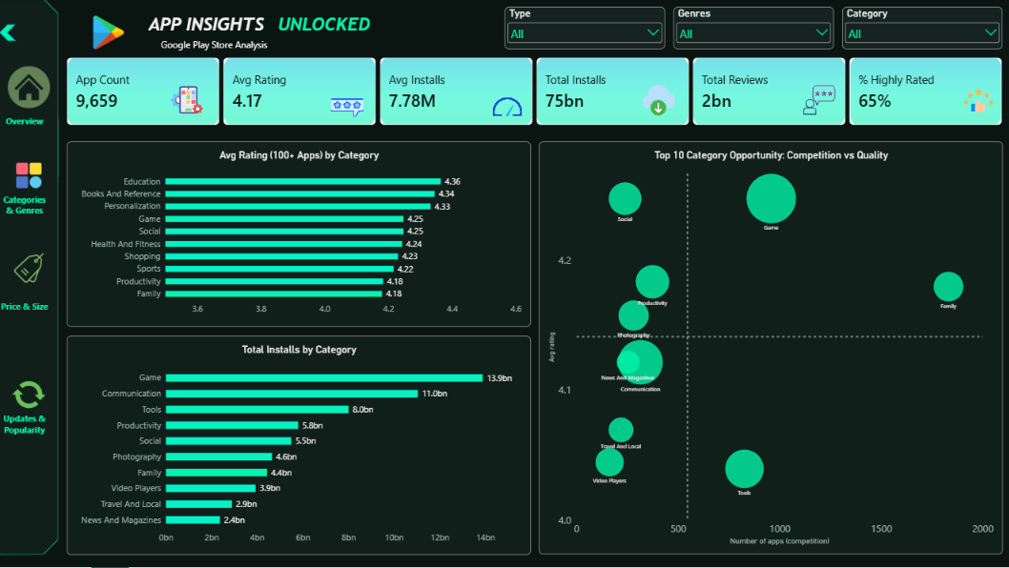
Where demand, quality and opportunity sit. Answers M2 and M10, and the scatter separates crowded categories from underserved ones.

View 3: Price, Size and Type
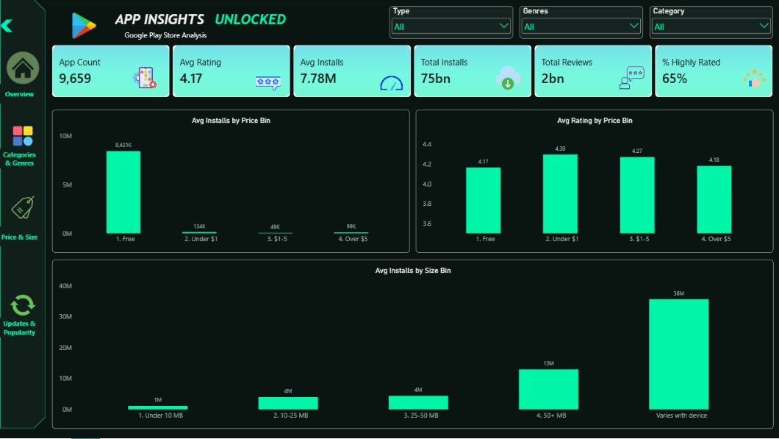
How price and app size relate to adoption and ratings. Answers M3 and M7.

View 4: Updates and Popularity
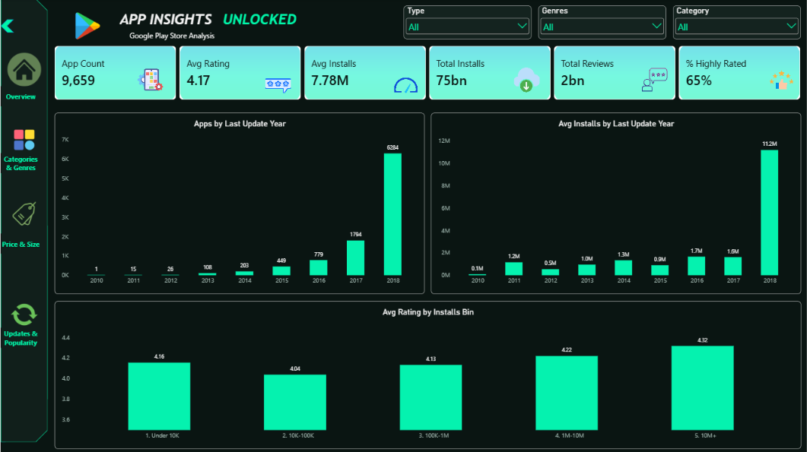
Whether apps are maintained and whether popular apps rate better. Answers B10, A2 and A3.
Questions B3, B8, B9, M1, M4, M5, M6, M9, A1 and A5 are answered from the cleaned dataset directly, because they need detail the four views do not show.

6. Business Questions: Answers and Insights
Each answer was calculated from the cleaned dataset and agrees with the dashboard, and each ends with an action for the business. Questions marked with a note in brackets needed a workaround, explained in section 8.

Basic-level questions
B1. What is the average rating of apps?
Answer: 4.17 across the 8,196 rated apps (median 4.3).
Insight: The median sits above the mean, so a tail of poorly rated apps pulls the average down.
Action: Use 4.2 as the minimum quality benchmark for a new app, and aim for 4.3 or higher.
B2. How many unique categories are there?
Answer: 33. The largest by app count are Family (about 1.83K), Game (959) and Tools (827).
Insight: The market is broad but concentrated: three categories hold over a quarter of all apps.
Action: Look beyond the crowded top three for niches with fewer competitors.
B3. What is the distribution of app sizes?
Answer: Median 12 MB, mean 20.4 MB, middle half between 4.6 and 28 MB, maximum 100 MB. Under 10 MB: 3,793 apps (39.3%). 10-25 MB: 2,121 (22.0%). 25-50 MB: 1,606 (16.6%). 50 MB and over: 912 (9.4%). Another 1,227 apps (12.7%) list Varies with device.
Insight: About 61% of apps are under 25 MB, and only about 1 in 10 is over 50 MB.
Action: Plan for a lean build by default, and treat anything over 50 MB as a deliberate, feature-heavy product.
B4. How many free vs paid apps are there?
Answer: Free 8,903 (92.17%), Paid 756 (7.83%).
Insight: Free is the default business model on the Play Store.
Action: Position a new app as free and plan monetization through ads or in-app purchases.
B5. What is the most common content rating?
Answer: Everyone, with 7,903 apps (81.8%). Then Teen 1,036 (10.7%), Mature 17+ 393 (4.1%), Everyone 10+ 322 (3.3%).
Insight: The mass market is general-audience content.
Action: Design for the Everyone rating first, as it reaches the widest user base and avoids age-restriction friction.
B6. What are the top 5 most installed apps? (answered with a tie-break)
Answer: Installs are stored as brackets, and 20 apps tie at the top bracket of 1 billion+. Ranked by reviews within that tie: Facebook (78.2M reviews, rating 4.1), WhatsApp Messenger (69.1M, 4.4), Instagram (66.6M, 4.5), Messenger (56.6M, 4.0) and Subway Surfers (27.7M, 4.5). YouTube is next (25.7M, 4.3).
Insight: The leaders are social and communication apps, with one game.
Action: Study their network effects and retention features rather than copying their category.
B7. How many apps have a rating of 4.0 and above?
Answer: 6,286 apps. That is 65.08% of all apps, or 76.7% of the apps that have a rating.
Insight: Most rated apps clear 4.0, so 4.0 is a baseline, not a differentiator.
Action: Target 4.3 and above to stand out.
B8. What is the average number of reviews for free vs paid apps?
Answer: Free 234,244 reviews on average, Paid 8,725 (about 27 times lower). Medians are 1,369 and 88.
Insight: Free apps attract far more feedback. The averages are inflated by a few giant apps, which is why the medians are much lower.
Action: Expect a smaller feedback loop for paid apps, and build in-app prompts to collect reviews.
B9. What is the average app size for each category?
Answer: Largest: Game 41.9 MB, Family 27.2, Travel and Local 24.2, Sports 24.1, Entertainment 23.0. Smallest: Tools 8.8 MB, Libraries and Demo 10.6, Personalization 11.2, Communication 11.3, Productivity 12.3. (Apps listed as Varies with device are excluded.)
Insight: Size follows content richness: games carry graphics and media, utilities stay light.
Action: Set size budgets per category, and prioritize performance optimization for games.
B10. How many apps were last updated in 2018?
Answer: 6,284 apps (65.1%), counting up to 8 August 2018.
Insight: Most apps on the store are actively maintained.
Action: Plan regular updates, because an app that goes stale stands out against this norm.

Medium-level questions
M1. What is the correlation between installs and rating?
Answer: Very weak. Pearson 0.04 (0.085 using log installs, Spearman 0.03).
Insight: A popular app is not automatically a well-rated one, and a well-rated app is not automatically popular. The binned view (A3) shows a modest rise only above 10K installs.
Action: Treat quality and user acquisition as two separate workstreams.
M2. Which categories have the highest average rating?
Answer: Events 4.44 (64 apps), Education 4.36 (119), Art and Design 4.36 (64), Books and Reference 4.35 (222), Personalization 4.33 (376). Among categories with 100+ apps the leaders are Education 4.36, Books and Reference 4.34 and Personalization 4.33. The lowest are Dating 3.97, Maps and Navigation 4.04 and Tools 4.04.
Insight: Smaller, purpose-driven categories rate higher than crowded utility categories. Small categories are shown with a caution because few apps can swing an average.
Action: Prefer Education, Books and Reference, or Personalization for a quality-led strategy.
M3. How does price affect the average rating (paid apps only)?
Answer: Across 604 rated paid apps the average is 4.26, against 4.17 for free apps. By price: up to $1 is 4.30 (106 apps), $1-5 is 4.27 (383), over $5 is 4.18 (115). Correlation between price and rating is -0.11.
Insight: Paying users rate slightly higher, but ratings slip as prices rise, which suggests expectations grow with price.
Action: Price under $5 and over-deliver, since a premium price raises the bar.
M4. What is the distribution of ratings across content ratings?
Answer: Everyone 4.17 (6,618 rated apps), Everyone 10+ 4.23 (305), Teen 4.23 (912), Mature 17+ 4.12 (357). Adults only 18+ (3 apps) and Unrated (1 app) are too small to read.
Insight: The spread is only about 0.1, so audience rating barely changes satisfaction. Mature 17+ is the lowest.
Action: Choose a content rating for reach, not for ratings.
M5. Which genres have the most apps with over 1 million installs?
Answer: 3,395 apps (35.1%) are in the 1M+ brackets. By primary genre: Tools 273, Action 189, Entertainment 179, Photography 173, Productivity 147, Communication 140.
Insight: Utility genres dominate the high-install group, which fits with their huge volume of apps.
Action: Tools, Action and Entertainment are proven genres for scale, but also the most competitive.
M6. How frequently do apps get updated? (answered with a proxy)
Answer: The dataset holds only one last-update date per app, so the time between consecutive updates cannot be calculated. As a proxy, using 8 August 2018 as the snapshot date: median 96 days since the last update, mean 281 days. 61.3% were updated within 180 days, 75.0% within a year, and 12.5% not for over two years.
Insight: Most live apps are updated within a few months.
Action: Aim for an update at least every 3 to 6 months to match the market norm.
M7. What is the impact of app size on installs?
Answer: Average installs rise with size: under 10 MB 1.1M, 10-25 MB 4.0M, 25-50 MB 4.4M, 50 MB and over 12.9M, Varies with device 35.6M. Median installs rise from 10K to 1M. Correlation between size and log installs is +0.30.
Insight: Bigger apps tend to get more installs, mostly because they offer more features and come from established publishers. Varies with device is mostly flagship apps.
Action: Do not chase the smallest size. Optimize size, but never at the cost of features.
M8. Which apps have the most reviews, and what are their ratings?
Answer: Facebook 78.2M (4.1), WhatsApp 69.1M (4.4), Instagram 66.6M (4.5), Messenger 56.6M (4.0), Clash of Clans 44.9M (4.6), Clean Master 42.9M (4.7), Subway Surfers 27.7M (4.5), YouTube 25.7M (4.3), Security Master 24.9M (4.7), Clash Royale 23.1M (4.6). Their average rating is 4.44.
Insight: The most reviewed apps rate above the market average (4.17), so scale and quality can go together.
Action: Learn from their feature depth, and from the engagement loops in the games.
M9. How does the content rating mix differ between free and paid apps?
Answer: Everyone: 81.4% of free vs 86.6% of paid. Teen: 11.1% vs 6.9%. Mature 17+: 4.2% vs 2.4%. Everyone 10+: 3.3% vs 4.1%.
Insight: Paid apps skew toward general-audience utilities and education. Free apps carry more Teen and Mature content, such as games and social apps.
Action: Market paid apps to families and general users, and free apps to teen audiences.
M10. What are the top 5 categories by installs?
Answer: Game 13.88bn, Communication 11.04bn, Tools 8.00bn, Productivity 5.79bn, Social 5.49bn. Together they account for 44.2bn installs, 58.8% of all 75.1bn.
Insight: Demand is concentrated in a handful of categories.
Action: Prioritize these for reach, with differentiation to cope with heavy competition.

Advanced-level questions
A1. What are the top 10 highest-rated apps, and how do their reviews and installs compare? (answered with a reliability filter)
Answer: 271 apps have a perfect 5.0 rating, but their median is only 4 reviews and 100 installs, so the rating is not reliable. After requiring at least 100,000 reviews, the leaders are: JW Library 4.9 (922,752 reviews, 10M installs), Six Pack in 30 Days 4.9 (272,337, 10M), Tickets + PDA 2018 Exam 4.9 (197,136, 1M), Learn Japanese, Korean, Chinese Offline 4.9 (133,136, 1M), Period Tracker 4.8 (4.56M, 100M), DU Recorder 4.8 (2.59M, 50M), Eternium 4.8 (1.51M, 10M), PewDiePie's Tuber Simulator 4.8 (1.50M, 10M), Vlogger Go Viral 4.8 (1.30M, 10M), Amino 4.8 (1.26M, 10M).
Insight: A rating means little without volume. The credible top performers are focused apps in health, learning and community, with 1M to 100M installs.
Action: Benchmark against these, and always judge ratings together with review counts.
A2. What is the trend of app updates over time? Any seasonal patterns? (partly answerable)
Answer: Apps by last-update year: 2010: 1, 2011: 15, 2012: 26, 2013: 108, 2014: 203, 2015: 449, 2016: 779, 2017: 1,794, 2018: 6,284 (partial year). Average installs by update year are 0.5M to 1.7M for 2011-2017, against 11.2M for 2018. In 2016 and 2017, Q4 was the busiest period (33% and 37% of the year's updates, against 25% if evenly spread).
Insight: Recent updates go together with high installs. The July 2018 spike (2,320 apps, 36.9% of 2018) is probably a data-collection effect, because the snapshot was taken in August 2018, so it should not be read as seasonality. A Q4 lift in 2016 and 2017 is a possible real pattern.
Action: Maintain steady updates, and consider timing major releases before Q4.
A3. How does the average rating change with installs? (binned analysis)
Answer: Under 10K: 4.16 (1,761 rated apps). 10K-100K: 4.04 (1,444). 100K-1M: 4.13 (1,598). 1M-10M: 4.22 (2,022). 10M and over: 4.32 (1,371).
Insight: Ratings dip at the early stage, then rise steadily with scale, and the biggest apps rate best. Survivorship plays a part, since poorly rated apps struggle to reach large audiences.
Action: Invest in quality early, especially between 10K and 100K installs, where ratings are weakest.
A4. Sentiment analysis on app reviews (not answerable with this file)
Answer: Not possible with this file, because it holds no review text. It needs the separate user-reviews file from the same Kaggle dataset.
Action: Treat as a future extension: classify reviews as positive, neutral or negative and extract common themes for high and low rated apps.
A5. What is the relationship between genre and rating?
Answer: Among the 40 primary genres with at least 50 apps, the highest average ratings are Puzzle 4.37 (median 4.4), Art and Design 4.35, Books and Reference 4.34, Personalization 4.33, Parenting 4.30 and Education 4.29. The lowest are Dating 3.97, Maps and Navigation 4.04, Tools 4.04, Video Players and Editors 4.05, Travel and Local 4.07 and Entertainment 4.09. The overall median rating is 4.3.
Insight: Genres are consistently rated higher or lower. Medians show the same ranking, so it is not just outliers. Creative and learning genres rate well, while utility and navigation genres lag.
Action: Build in the high-rated genres, and in the low-rated ones where a clear quality gap can be closed.

7. Key Findings and Recommendations by Stakeholder
What drives success on the Play Store? Category choice, a free entry model, feature depth (larger apps), and steady maintenance go together with higher installs. Quality matters most at scale. Installs and ratings are only weakly related app by app.
Stakeholder | Finding | Recommendation
App developers | Bigger, feature-rich apps and recently updated apps get more installs. Tools and Dating rate lowest | Invest in features, update every 3 to 6 months, and fix quality gaps in weak categories
Product managers | Education, Books and Reference, and Personalization rate highest with less competition than Game or Tools | Prioritize underserved, high-rated niches, using the opportunity scatter
Marketing team | 92% of apps are free. Free apps average about 8.4M installs against under 0.14M for any paid price group | Lead with free, monetize with ads or in-app purchases, and market to the Everyone audience
Senior management | Five categories hold 58.8% of all installs, and ratings above 4.0 are the norm | Weigh reach against competition, and set a 4.3 rating target

8. Data Gaps and Limitations
Five questions needed a workaround because of what the dataset holds. Each is covered below, with how it was handled and how to close the gap.
Question | Why the data falls short | How it was handled | How to close the gap
B6 Top 5 most installed | Installs are brackets, and 20 apps tie at 1 billion+ | Ranked the tied apps by review count | Needs exact install counts from another source
M6 Time between updates | One last-update date per app, no update history | Measured days since last update against the 8 Aug 2018 snapshot (median 96 days) | Needs version history, or repeated snapshots of the store
A1 Top 10 highest rated | 271 apps have a 5.0 rating with a median of 4 reviews | Required 100,000+ reviews so ratings are credible | Set the review threshold to fit the business context
A2 Seasonality | One snapshot ending 8 Aug 2018, and July 2018 is inflated by collection timing | Reported the yearly trend and the Q4 share for 2016 and 2017, and flagged July 2018 as a collection effect | Needs several full years of data, or monthly snapshots
A4 Sentiment analysis | No review text in googleplaystore.csv | Not calculated | Use googleplaystore_user_reviews.csv from the same Kaggle dataset: score each review, then compare themes for high and low rated apps

General limitations
- Installs are brackets (for example 1,000,000+), so install totals are lower-bound estimates.
- 15.1% of apps have no rating and 12.7% have no numeric size.
- The data ends on 8 August 2018, so 2018 is a partial year and findings may not reflect today’s store.
- Each app has a single last-update date, so update frequency is approximated.
- Averages are pulled up by a few giant apps, so medians are quoted where it matters.
- Duplicates were removed by keeping the first record, and only the primary genre is used.
- The relationships shown are correlations, not proof of cause.
- Sentiment analysis was not performed because review text is not in this file.

