ADECCO HR ANALYTICS

Employee Attrition
& Workforce Insights
Excel analytics project report | IBM HR Employee Attrition case study

Executive summary
This project reviews employee attrition and selected workforce measures in a supplied HR case-study dataset. The workbook combines data checks, PivotTables, association calculations, and an interactive dashboard to show where attrition differs across employee groups.
The dataset contains 1,470 employee records. Of these, 237 are marked as having left (16.12%) and 1,233 are marked as staying. The largest observed difference is by overtime status: attrition is 30.53% among employees recorded as working overtime and 10.44% among those not recorded as working overtime. This is a descriptive comparison and does not establish that overtime caused employees to leave.
1,470 | 237 | 16.12% | 2.47 / 4 | 5.13 years
Employees | Attrition cases | Overall attrition | Leaver job satisfaction | Leaver average tenure

Project question
Which employee characteristics are associated with attrition and job satisfaction, and where could management investigate retention improvements?

How to read this report
Findings describe patterns in this dataset. They are useful for prioritizing questions for follow-up, but they do not identify individual employees at risk or prove why a person left. The file has no reporting-period field, so the 16.12% figure is an overall dataset share, not an annual rate or a trend over time.

01 | DATA & APPROACH

Dataset, checks, and method
A transparent foundation for interpreting the dashboard.

Dataset and unit of analysis
The analysis uses the user-provided WA_Fn-UseC_-HR-Employee-Attrition.csv case-study file. Each row represents one employee; EmployeeNumber is the employee-level identifier. The workbook preserves the source records on Raw_Data and formats the validated source range as the tblHR Excel Table.

Data quality review
Review item | Result | Treatment / note
Employee records and source columns | 1,470 records; 35 columns | One employee per row; headers are unique.
Blank cells | 0 found | No blanks in the supplied employee records.
Duplicate identifiers / rows | 0 / 0 | EmployeeNumber is unique; no exact duplicate rows.
Checked numeric fields / formulas | No non-numeric values; 0 formula cells | Source data is stored as values.
Attrition split | 237 Yes; 1,233 No | Overall attrition share: 16.12%.
Constant fields | EmployeeCount=1; Over18=Y; StandardHours=80 | Retained in Raw_Data, excluded from comparisons because they do not vary.

The review found no issues in the checks performed. This is a scoped validation of the supplied file, not a guarantee that every possible data-quality issue has been ruled out.

Analysis method
- Group comparisons use employee counts and within-group attrition percentages (Attrition = Yes divided by the number of employees in that group).
- A binary attrition flag was used for Pearson correlations: Yes = 1 and No = 0. The reported coefficients cover selected numeric measures only.
- PivotTables and dashboard visuals summarize the supplied records; slicers allow selected views by Department, OverTime, Gender, and JobLevel.
- No causal model, significance test, or time-series analysis was performed. Differences should be interpreted as descriptive associations.

Workbook map
Sheet | Role
Read_Me | Project question, scope, interpretation notes, and planned analysis.
Raw_Data / Data_QA | Source records and data-quality checks.
PVT_Attrition / PVT_Workforce | Attrition splits and workforce profile comparisons.
PVT_Engagement / PVT_Performance | Job satisfaction, work-life balance, and performance summaries.
Association_Analysis / PVT_KPI | Selected numeric correlations and dashboard KPI values.
Dashboard | Interactive summary with KPI cards, charts, and slicers.

02 | ATTRITION PATTERNS

Where attrition differs
Percentages are calculated within each group, so groups of different sizes can be compared more fairly.

Department
Department | Leavers / employees | Attrition rate
Sales | 92 / 446 | 20.63%
Human Resources | 12 / 63 | 19.05%
Research & Development | 133 / 961 | 13.84%

Sales has the highest observed department rate, while Research & Development has the largest number of leavers because it is the largest department. The rate and the count answer different questions; both are shown to avoid conflating them.

Overtime status
OverTime | Attrition rate | Stayed
No | 10.44% | 89.56%
Yes | 30.53% | 69.47%

The overtime-group difference is 20.09 percentage points (30.53% minus 10.44%). This is the clearest contrast among the featured dashboard segments. Further review could examine workload, scheduling, role, and tenure together before deciding on any intervention.

Job level
Job level | Attrition rate
1 | 26.34%
2 | 9.74%
3 | 14.68%
4 | 4.72%
5 | 7.25%

Level 1 has the highest rate among the five levels shown; levels 4 and 5 have lower observed rates. The pattern is not strictly monotonic, so it should not be simplified to “attrition falls at every higher level.” Group sizes are not shown in this compact comparison and should be checked before action.

Tenure bands
Years at company | Attrition rate | Leavers / employees
0–4 | 24.31% | 141 / 580
5–9 | 11.07% | 58 / 524
10–14 | 11.54% | 24 / 208
15–19 | 7.69% | 5 / 65
20–24 | 7.81% | 5 / 64
25–29 | 0.00% | 0 / 12
30–34 | 23.08% | 3 / 13
35–40 | 25.00% | 1 / 4

The first four years have a comparatively high rate and the largest leaver count. Rates fluctuate in longer-tenure bands, but groups of 12 or fewer employees at 25+ years make those percentages unstable; do not treat them as reliable signals.

03 | ASSOCIATION & ENGAGEMENT

What the numeric comparisons suggest
Small correlation coefficients indicate weak linear relationships in this dataset.

Correlation with the attrition flag
All selected correlations are weak in magnitude. The largest absolute coefficient is −0.171 for TotalWorkingYears. This does not identify a strong numeric reason for attrition. A negative coefficient means higher values tend to coincide with a lower 0/1 attrition flag in this dataset; it does not show cause or individual risk.
Selected numeric measure | Correlation
TotalWorkingYears | −0.171
JobLevel | −0.169
YearsInCurrentRole | −0.161
MonthlyIncome | −0.160
Age | −0.159
YearsWithCurrManager | −0.156
YearsAtCompany | −0.134
JobSatisfaction | −0.103
WorkLifeBalance | −0.064
DistanceFromHome | +0.078
NumCompaniesWorked | +0.043
PerformanceRating | +0.003

Because many workforce measures overlap (for example, age, tenure, job level, and income), pairwise correlations should not be read as independent effects. Correlation also captures only a linear relationship and may miss more complex patterns.

Job satisfaction and work-life balance
Measure | Employees who stayed | Employees who left | Overall
Average job satisfaction (1–4) | 2.78 | 2.47 | 2.73
Average work-life balance (1–4) | 2.78 | 2.66 | 2.76
Average performance rating | 3.15 | 3.16 | 3.15

Leavers report a lower average job-satisfaction score than employees who stayed (2.47 vs 2.78). The work-life-balance difference is smaller (2.66 vs 2.78), while average performance ratings are nearly the same. These are group averages and do not establish why individuals left.

Job satisfaction by role
The dashboard ranges from 2.56 for Human Resources to 2.79 for Healthcare Representative, with an overall average of 2.73 on the 1–4 scale. The role differences are modest. Role-level headcounts and distributions should be considered alongside averages, especially for smaller roles.

04 | PRACTICAL RESPONSE

Evidence-led next steps
Use the analysis to focus further investigation, then evaluate changes with better operational data.

Recommended areas to investigate
- Review overtime workload. Compare overtime frequency and hours with role, shift, staffing levels, tenure, and satisfaction. Ask employees about scheduling and recovery time before changing policy.
- Examine early-tenure experience. Review onboarding, manager check-ins, role clarity, and expectations during the first four years, where the supplied data shows a relatively high attrition share.
- Explore department differences. Start with Sales and Human Resources because their observed rates are higher than Research & Development. Validate the pattern against team sizes, job mix, and work arrangements.
- Listen to employees. Use confidential engagement feedback and recorded exit reasons if available. The current dataset has no departure-reason field, so the analysis cannot explain employees’ stated motivations.
- Track outcomes over time. Add consistent snapshot dates and define a standard attrition-rate denominator. This would enable period-to-period monitoring and evaluation of retention actions.

Responsible use
- Use these group-level patterns to guide questions and support programs, not to label or rank individual employees.
- Avoid discriminatory recommendations based on demographic attributes. Review any proposed action for fairness and applicable policy.
- Validate findings with employees and managers and consider operational context before making decisions.

Limitations
Limitation | Implication
No reporting period or date field | Cannot calculate annual attrition or trends over time.
No departure-reason field | Cannot infer employees’ stated reasons for leaving.
One supplied case-study dataset | Findings may not generalize to another organization, time, or workforce.
Descriptive comparisons and simple correlations | No causal conclusion or strong “reason” is established.
Small counts in some groups | Percentages in small groups can change sharply with one or two employees.

05 | DASHBOARD & CLOSE

The finished dashboard
A quick visual summary of the completed workbook analysis.
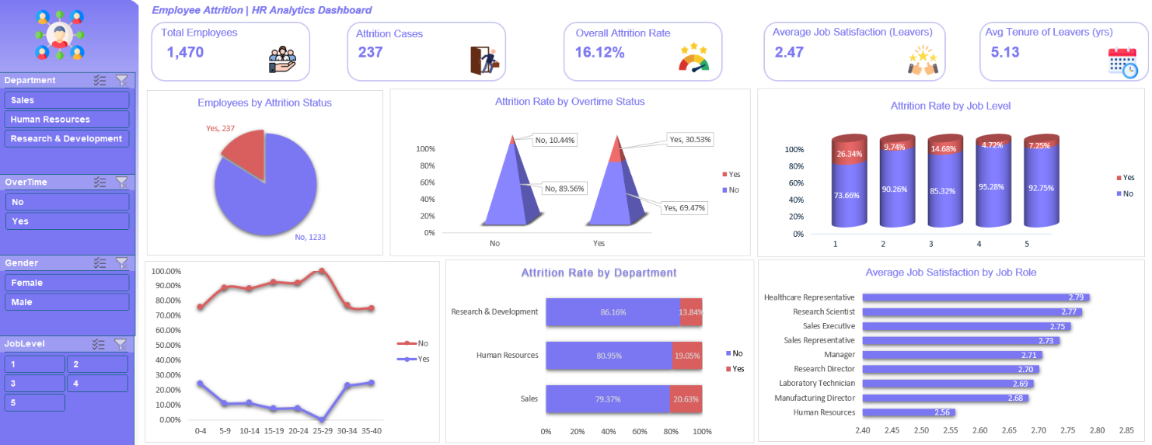
Figure 1. Final interactive HR attrition dashboard shared for this project.

Dashboard contents
Element | What it shows
Five KPI cards | Employee count, leaver count, overall attrition share, leaver average job satisfaction, and leaver average tenure.
Six charts | Attrition split; attrition by overtime, job level, department, and tenure band; average job satisfaction by job role.
Four slicers | Department, OverTime, Gender, and JobLevel. Use slicers to filter connected PivotTables/charts and KPI values where connections are configured.

Before presenting, select “All” on slicers if you want the cards and charts to show the full dataset. When a slicer is active, interpret the displayed KPI values as applying to the filtered selection, provided the corresponding PivotTables are connected to that slicer.

Conclusion
The workbook is complete as a descriptive HR analytics case study. Its strongest practical signal is the higher observed attrition rate in the overtime group, alongside higher attrition in the earliest tenure band and selected department differences. Numeric correlations remain weak, and the dataset does not establish a cause of attrition. A useful next step for the organization would be to validate these patterns with employee feedback and time-based HR data.

Source and calculation notes
Source: user-provided WA_Fn-UseC_-HR-Employee-Attrition.csv and the DACS12 – Adecco HR Analytics project brief. Attrition rate is the number of records marked Attrition = Yes divided by all employee records in the comparison group. Correlations use the binary flag Yes = 1 and No = 0. Scores shown as averages use the dataset’s original rating scales.

