IBM HR Attrition Analysis
Insights and Recommendations
Prepared by: Md Ziaul Haque
Date: 10 November 2026
Tool: Google Data Studio (Looker Studio): 2-page interactive dashboard
Data: IBM HR Analytics dataset, 1,470 employees, 35 fields
Live dashboard: https://datastudio.google.com/reporting/de210e6d-390c-498b-8c4d-6d9c4aec04ba

1. Executive Summary
Of the 1,470 employees in the dataset, 237 left the company, an overall attrition rate of 16.1%. Attrition is not spread evenly: it is concentrated in specific groups. The dashboard shows that the groups most likely to leave are employees who work overtime, employees aged 18-25, employees earning under ₹3,000 a month, frequent business travellers, and those with low job satisfaction. Sales is the department with the highest attrition rate.
Key figure | Value
Total employees | 1,470
Employees who left | 237
Overall attrition rate | 16.1%
Average monthly income | ₹6,503
Average employee age | 36.9

Highest-risk group for each factor
Factor | Highest-risk group | Rate | Lowest-risk group | Rate
Overtime | Works overtime | 30.5% | No overtime | 10.4%
Age group | 18-25 | 35.8% | 36-45 | 9.2%
Income bracket | Low (< 3K) | 28.6% | High (10K+) | 8.9%
Business travel | Travel_Frequently | 24.9% | Non-Travel | 8.0%
Job satisfaction | 1 - Low | 22.8% | 4 - Very High | 11.3%
Department | Sales | 20.6% | R&D | 13.8%
Job role | Sales Representative | 39.8% | Research Director | 2.5%

2. Dashboard Overview
The report has two pages. Page 1 gives the overall picture and Page 2 breaks attrition down by calculated segments. Colours are consistent: red always means employees who left, teal means employees who stayed, and blue marks headcount.
Page | Contents | Filters
1. HR Overview Dashboard | 4 KPI cards; attrition donut; attrition count by department; headcount by job role; gender pie; attrition status by business travel (100% stacked) | OverTime, Gender, Department
2. Advanced Attrition Analysis | Attrition rate by department, job satisfaction, age group and income bracket; Department x Gender pivot table with green-to-red colour scale | OverTime, Income Bracket, Age Group, JobRole

Page 2 relies on five calculated fields (Attrition Flag, Attrition Rate, Age Group, Income Bracket, Satisfaction Level), listed in Appendix B.

3. Key Insights
Rates below are the share of employees in each group who left, which is the fair way to compare groups of different sizes.

3.1 Overall attrition and gender
237 of 1,470 employees left (16.1%). Men leave slightly more often than women, but the gap is small.
Gender | Employees | Left | Rate
Male | 882 | 150 | 17.0%
Female | 588 | 87 | 14.8%

3.2 Department: counts and rates tell different stories
R&D has the most leavers (133) simply because it is the largest department. Measured by rate, Sales is the highest at 20.6%, followed by Human Resources at 19.0%.
Department | Employees | Left | Rate
Sales | 446 | 92 | 20.6%
Human Resources | 63 | 12 | 19.0%
Research & Development | 961 | 133 | 13.8%
Insight: Count charts show where the volume of leavers is. Rate charts show where an individual is most likely to leave. Both are needed, and Sales needs attention on rate.

3.3 Overtime is the strongest single driver
Employees who work overtime leave at about three times the rate of those who do not.
Overtime | Employees | Left | Rate
Yes | 416 | 127 | 30.5%
No | 1,054 | 110 | 10.4%
Combining two Page 2 filters sharpens this: employees on overtime who earn under ₹3,000 a month leave at 56.1% (64 of 114), while employees without overtime who earn ₹10,000 or more leave at 6.6% (13 of 196).

3.4 Age: the youngest employees are most likely to leave
Age group | Employees | Left | Rate
18-25 | 123 | 44 | 35.8%
26-35 | 606 | 116 | 19.1%
36-45 | 468 | 43 | 9.2%
46-60 | 273 | 34 | 12.5%
Insight: Attrition falls steeply up to age 45 and ticks up slightly after that. The average age (36.9) hides this pattern. The 26-35 group has the most leavers (116), while 18-25 has the highest individual risk.

3.5 Income: lower pay, higher attrition
Income bracket (monthly) | Employees | Left | Rate
Low (< 3K) | 395 | 113 | 28.6%
Mid (3K-6K) | 519 | 66 | 12.7%
Upper-Mid (6K-10K) | 275 | 33 | 12.0%
High (10K+) | 281 | 25 | 8.9%
Attrition falls as income rises. The lowest bracket leaves at about three times the rate of the highest, and the two middle brackets are almost identical.

3.6 Business travel
Business travel | Employees | Left | Rate
Non-Travel | 150 | 12 | 8.0%
Travel_Rarely | 1,043 | 156 | 15.0%
Travel_Frequently | 277 | 69 | 24.9%
Attrition rises with travel frequency: frequent travellers leave at about three times the rate of non-travellers.

3.7 Job satisfaction
Satisfaction level | Employees | Left | Rate
1 - Low | 289 | 66 | 22.8%
2 - Medium | 280 | 46 | 16.4%
3 - High | 442 | 73 | 16.5%
4 - Very High | 459 | 52 | 11.3%
Insight: Low satisfaction clearly stands out and Very High is the lowest, but Medium and High are almost identical (16.4% vs 16.5%). The pattern is real but weaker than for overtime, age or income.

3.8 Job role
Page 1 shows headcount by role (a measure of workforce composition, not risk). Rates by role, which can be explored with the JobRole filter on Page 2, give a different ranking.
Job role | Employees | Left | Rate
Sales Representative | 83 | 33 | 39.8%
Laboratory Technician | 259 | 62 | 23.9%
Human Resources | 52 | 12 | 23.1%
Sales Executive | 326 | 57 | 17.5%
Research Scientist | 292 | 47 | 16.1%
Healthcare Representative | 131 | 9 | 6.9%
Manufacturing Director | 145 | 10 | 6.9%
Manager | 102 | 5 | 4.9%
Research Director | 80 | 2 | 2.5%
Insight: Sales Representative is near the bottom of the headcount chart but has the highest attrition rate of any role. Laboratory Technician combines a high rate with a large team, so it accounts for the most leavers (62) among the high-rate roles.

3.9 Department x Gender (pivot table)
Department | Male | Female | All
Sales | 21.0% | 20.1% | 20.6%
Human Resources | 14.0% | 30.0% | 19.0%
Research & Development | 15.5% | 11.3% | 13.8%
Grand total | 17.0% | 14.8% | 16.1%
Caution: Human Resources female staff show 30.0%, but this rests on only 20 employees (6 left). Treat it as something to monitor, not a conclusion. Sales shows no meaningful gender gap.

4. Recommendations
These actions follow from the patterns above. They are suggestions for HR to test, not proven causes, because the data shows association only.
# | Recommendation | Evidence | Suggested actions | Priority
1 | Review overtime workload | 30.5% vs 10.4%; 56.1% for low-income staff on overtime | Cap and monitor overtime hours; rebalance staffing in teams with repeat overtime; start with low-income overtime staff | High
2 | Review pay in the lowest bracket | 28.6% under ₹3,000 vs 8.9% at ₹10,000+ | Benchmark pay for roles in the Low bracket; review increments or retention bonuses | High
3 | Strengthen early-career retention | 35.8% for ages 18-25 | Structured onboarding, mentoring, a visible career path, and check-ins at 6 and 12 months | High
4 | Focus on Sales and the Sales Representative role | Sales 20.6%; Sales Representative 39.8% | Review targets, incentives and workload for the role; run exit and stay interviews | High
5 | Reduce the burden of frequent travel | 24.9% vs 8.0% for non-travel | Rotate travel duties, set travel limits, and use remote options where possible | Medium
6 | Support the Laboratory Technician role | 23.9% across 259 employees (62 leavers) | Review shifts, workload and pay for the role | Medium
7 | Act on low job satisfaction | 22.8% at satisfaction level 1 | Run regular pulse surveys; manager one-to-ones for employees who score 1 or 2 | Medium
8 | Track attrition over time and capture exit reasons | The data is a single snapshot | Refresh the dashboard monthly; add exit reasons and tenure so causes can be tested | Medium
9 | Monitor Human Resources | 19.0% on 63 employees; female 30.0% on 20 | Track quarterly before drawing conclusions | Watch

5. Limitations
- Association, not causation. The charts show which groups leave more often, not why.
- Overlapping factors. Age, income, role and overtime are related to each other, so a single-factor chart can overstate any one driver. The overtime plus income result in section 3.3 shows how factors combine.
- Small groups. Some segments are small (HR female, n=20; Sales Representative, n=83; HR department, n=63), so their rates can swing widely.
- Snapshot data. There is no time dimension, so the dashboard cannot show whether attrition is rising or falling.
- Sample dataset. The data is a publicly available HR sample dataset, so the findings illustrate the analysis method and should not be read as a real company's results. Income is shown in ₹ on the dashboard.

Appendix A: Dashboard Views
Interactive version (view only): https://datastudio.google.com/reporting/de210e6d-390c-498b-8c4d-6d9c4aec04ba
Page 1: HR Overview Dashboard
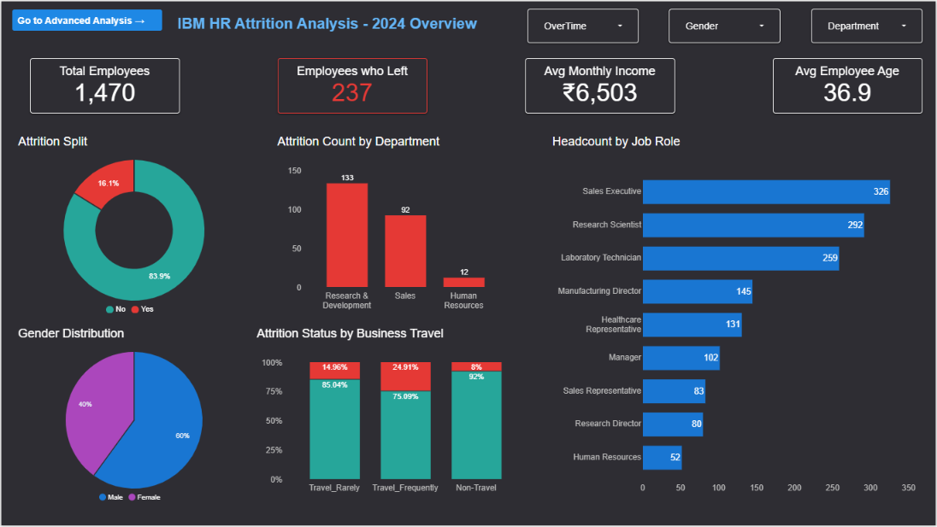
Page 2: Advanced Attrition Analysis
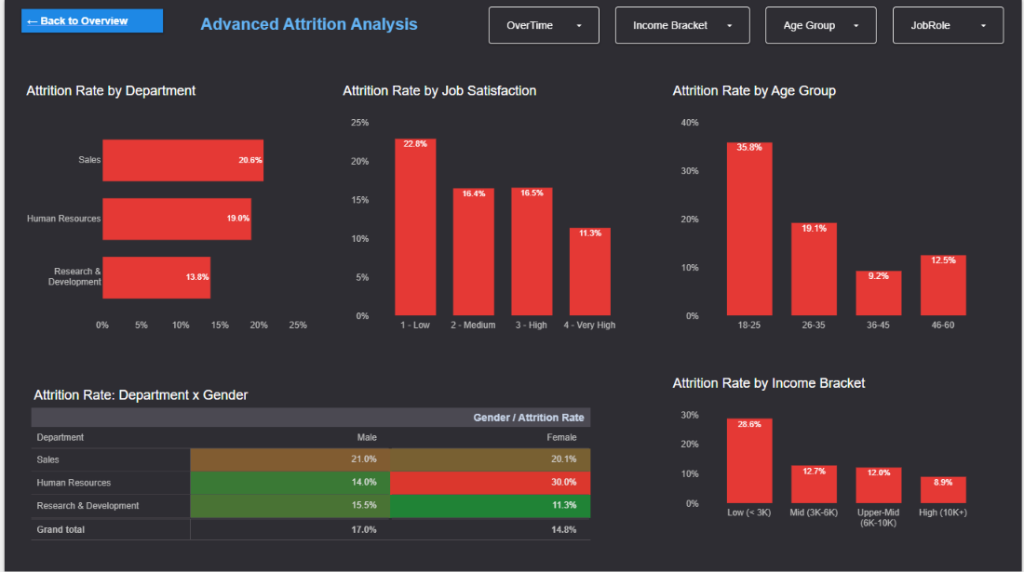

Appendix B: Calculated Fields
Field | Logic | Type | Used for
Attrition Flag | 1 if Attrition = Yes, otherwise 0 | Number | Input to Attrition Rate
Attrition Rate | Leavers divided by employees (sum of Attrition Flag over the employee count) | Percent | All rate charts and the pivot table
Age Group | Age <= 25: 18-25; <= 35: 26-35; <= 45: 36-45; otherwise 46-60 | Text | Age chart and filter
Income Bracket | MonthlyIncome < 3000: Low; < 6000: Mid; < 10000: Upper-Mid; otherwise High | Text | Income chart and filter
Satisfaction Level | JobSatisfaction 1 to 4 mapped to 1 - Low, 2 - Medium, 3 - High, 4 - Very High | Text | Satisfaction chart

