Superstore Sales and Profitability Analysis
Tableau dashboard project documentation
Project overview
This project turns the Tableau Sample Superstore Excel data into two interactive dashboards for exploring sales performance, profitability, and product returns. It is designed to help business users quickly see what is performing well, where profit is being lost, and how results change across products, categories, customer segments, managers, and time.

Project goal
Analyze sales, profitability, and returns to help business leaders identify top-performing categories, customer segments, products, and regional managers; track monthly performance; and spot loss-making sub-categories and return patterns. Build interactive Tableau dashboards that let users explore these measures using filters.

Dataset
Tableau Sample Superstore, supplied as an Excel workbook (.xlsx). The workbook includes sales, profit, order, product, customer segment, geographic, date, and returns information used in the dashboards. The displayed all-filter view reports 5,111 orders.
Tableau’s official Sample Data page — look for Superstore Sales.

At a glance
Sales Performance | Profitability & Returns
Sales: $2.33M | Profit: $292.30K
Orders: 5,111 | Profit margin: 12.56%
Average order value: $455.20 | Return rate: 5.79% | Returned orders: 296

Business questions
- How much sales activity does the business generate, and what is the average order value?
- Which categories, customer segments, products, and regional managers contribute most to sales?
- How do sales and profit change over time?
- Which sub-categories generate profit or losses, and where are returns concentrated?

Dashboard one Sales Performance
This dashboard provides a sales overview with filters for category, year, month, regional manager, and region. KPI cards summarize total sales, total orders, and average order value. Charts compare sales by segment and category, show manager performance, rank the top products, and track monthly sales.
https://public.tableau.com/views/Sales_Performance_dashboard_17922158434040/SalesPerformance?:language=en-US&:sid=&:redirect=auth&:display_count=n&:origin=viz_share_link
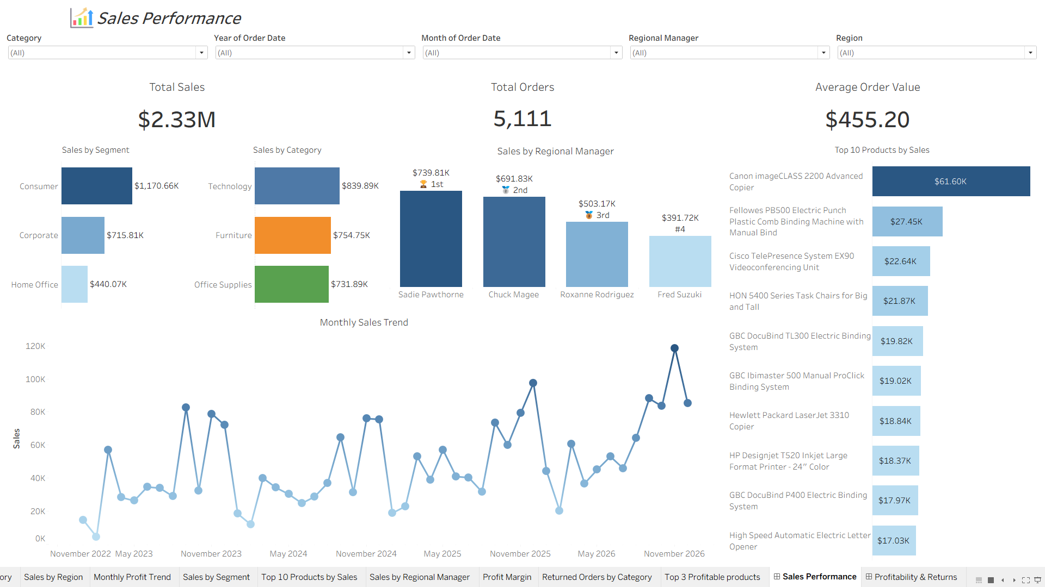

What the dashboard shows
- Consumer is the largest customer segment, with about $1.17M in sales.
- Technology is the top sales category, at about $839.89K.
- Sadie Pawthorne leads the regional managers shown, at about $739.81K.
- The leading product is Canon imageCLASS 2200 Advanced Copier, at about $61.60K.
- The monthly trend supports exploration of peaks and dips over time; filters allow users to inspect selected periods and groups.

Questions users can answer
Which segment or category leads sales? Which products make the top ten? Which regional manager has the highest sales? How does monthly sales performance change when I filter by date, category, region, or manager?

Dashboard two Profitability and Returns
This dashboard focuses on profit health and returns. Filters include category, sub-category, month, year, and quarter. KPI cards show total profit, profit margin, return rate, and returned orders. The charts compare returned orders by category, show monthly profit, rank profitable products, and display profit by sub-category with losses distinguished from gains.
https://public.tableau.com/views/Profit_Performance_dashboard/ProfitabilityReturns?:language=en-US&:sid=&:redirect=auth&:display_count=n&:origin=viz_share_link

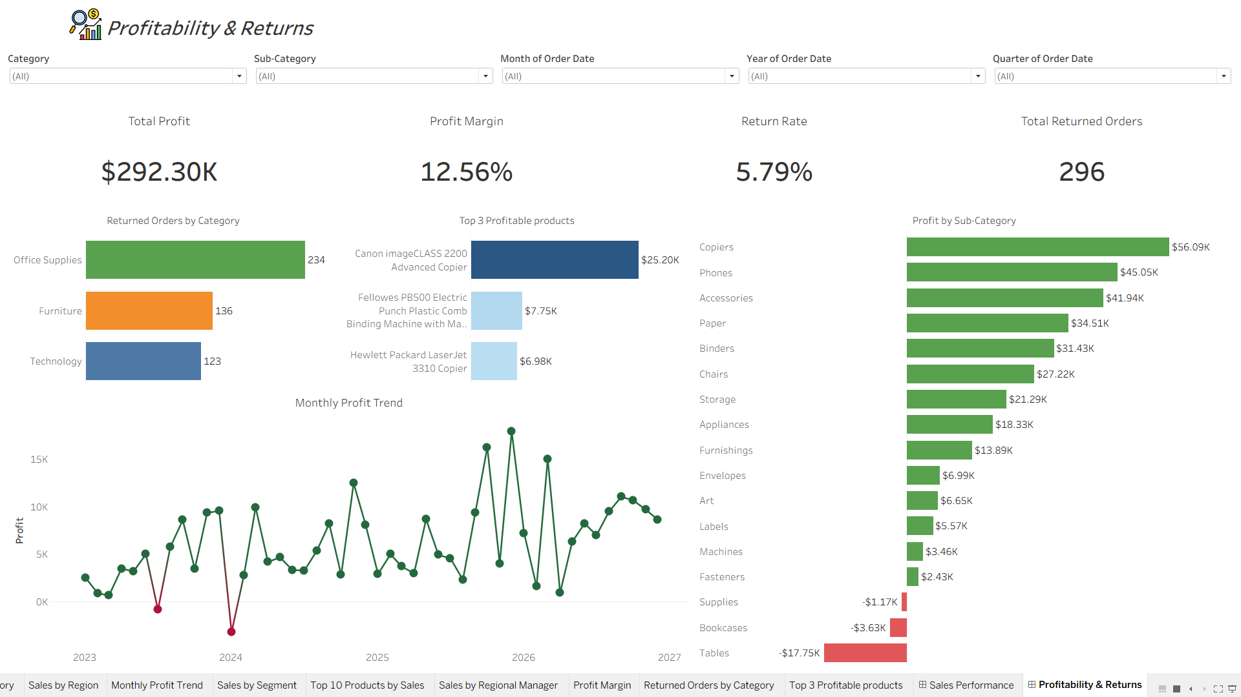

What the dashboard shows
- Total profit is $292.30K and overall profit margin is 12.56% in the all-filter view.
- The return rate is 5.79%, representing 296 returned orders.
- Office Supplies has the highest returned-order count among categories shown (234).
- Copiers is the most profitable sub-category at about $56.09K.
- Tables has the largest sub-category loss at about $17.75K; Bookcases and Supplies also show losses.
- The Top 3 Profitable Products chart identifies the highest-profit products in the current view.

Questions users can answer
Which sub-categories create the most profit or the largest losses? How does monthly profit vary? Which categories have the most returned orders? How do profit and returns change when filtering by date or product group?

Measures and interpretation
Measure | Dashboard interpretation
Total Sales | Sum of Sales; shown as currency and abbreviated in millions on the KPI.
Total Orders | Order count shown by the dashboard: 5,111 in the all-filter view.
Average Order Value | Sales divided by the displayed order count; $455.20 in the all-filter view.
Total Profit | Sum of Profit; $292.30K in the all-filter view.
Profit Margin | Profit divided by Sales; 12.56% in the all-filter view.
Return Rate | Returned orders divided by total orders; 296 / 5,111 = 5.79% in the all-filter view.
Returned Orders | Distinct count of order IDs marked as returned, as shown in the category chart.

Skills demonstrated
- Connected and explored a spreadsheet dataset in Tableau.
- Designed two purpose-driven dashboards with KPI summaries and supporting visual analysis.
- Used filters to support interactive exploration by date, category, geography, manager, and sub-category.
- Selected and formatted bar and line charts, labels, sorting, color, and currency/number formats.
- Presented positive and negative profit clearly and identified loss-making sub-categories.Project details to complete before publishing.

