MERIDIAN TECHNOLOGIES · INVESTOR DAY · MARCH 11, 2026
CONFIDENTIAL — FOR INTERNAL USE PRIOR TO PUBLIC DISCLOSURE

Investor Day Positioning Memo: Declaring Meridian's Strategic Identity
EXECUTIVE SUMMARY
Meridian enters Investor Day at an inflection point. After eleven years as a project management platform, the company has the assets — enterprise governance infrastructure, the Helio agent framework, FedRAMP/HIPAA compliance, and deep regulated-industry relationships — to stake a credible claim to a position no competitor currently occupies: the enterprise-grade agentic work platform for regulated industries. This memo recommends that Meridian declare itself exactly that on March 11, set three-year financial targets consistent with that identity, and make three specific commitments to investors that create accountability for the transition. The alternative — remaining a 'PM platform with AI features' — cedes the agentic narrative to Atlassian and Asana, strands Meridian in a pricing position mid-market customers are already rejecting, and gives the Helio team insufficient reason to stay.

THE POSITION
Meridian is the agentic work platform built for regulated enterprises.
Projects are how we started. Agents are how work gets done in the next decade. Meridian combines the only enterprise-grade agent governance infrastructure in the category — audit trails, role-based agent permissions, model selection, data residency — with the project management depth that makes agents actionable in the most complex, compliance-sensitive organizations in the world. We do not compete with the model labs. We are the platform on which regulated enterprises run them safely.

WHY THIS POSITION, WHY NOW
- Customer demand is ahead of our positioning. Enterprise customers are already asking for it. In 18 of 22 enterprise advisory board sessions (Dec 2025–Feb 2026), customers' top AI request was governance: audit trails, role-based agent permissions, model selection, and data residency. Not better PM features — agent governance. We have this infrastructure. No direct competitor does.
- The competitive white space is real and specific. Asana and Monday have raced to bundle AI into standard tiers, compressing margins and crowding the 'agentic bundled' quadrant. Smartsheet is decelerating in 'conservative PM.' Atlassian owns 'agentic premium' for dev/IT teams but has a thin story outside engineering organizations. The regulated-industry agentic platform position — financial services, pharma, life sciences, federal — is unoccupied.
- We are already building this. The Helio acquisition gave us a working agent orchestration framework that would have taken 15 months to build internally. The 2026 roadmap — agent governance suite (Q1), agent builder (Q2), workflow marketplace (Q3), pricing model refresh (Q3) — is already the Option B roadmap. We are not pivoting to this position; we are naming what we are building.
- We can afford it. With $506M in liquidity, $67.5M in 2025 FCF, and $250M identified M&A capacity, Meridian can fund the engineering hiring (25 applied AI engineers, 8 agent PMs), the two additional AI-native acquisitions in early diligence, and the mid-market pricing adjustment — without taking on debt or compromising the buyback.

COMPETITIVE LANDSCAPE
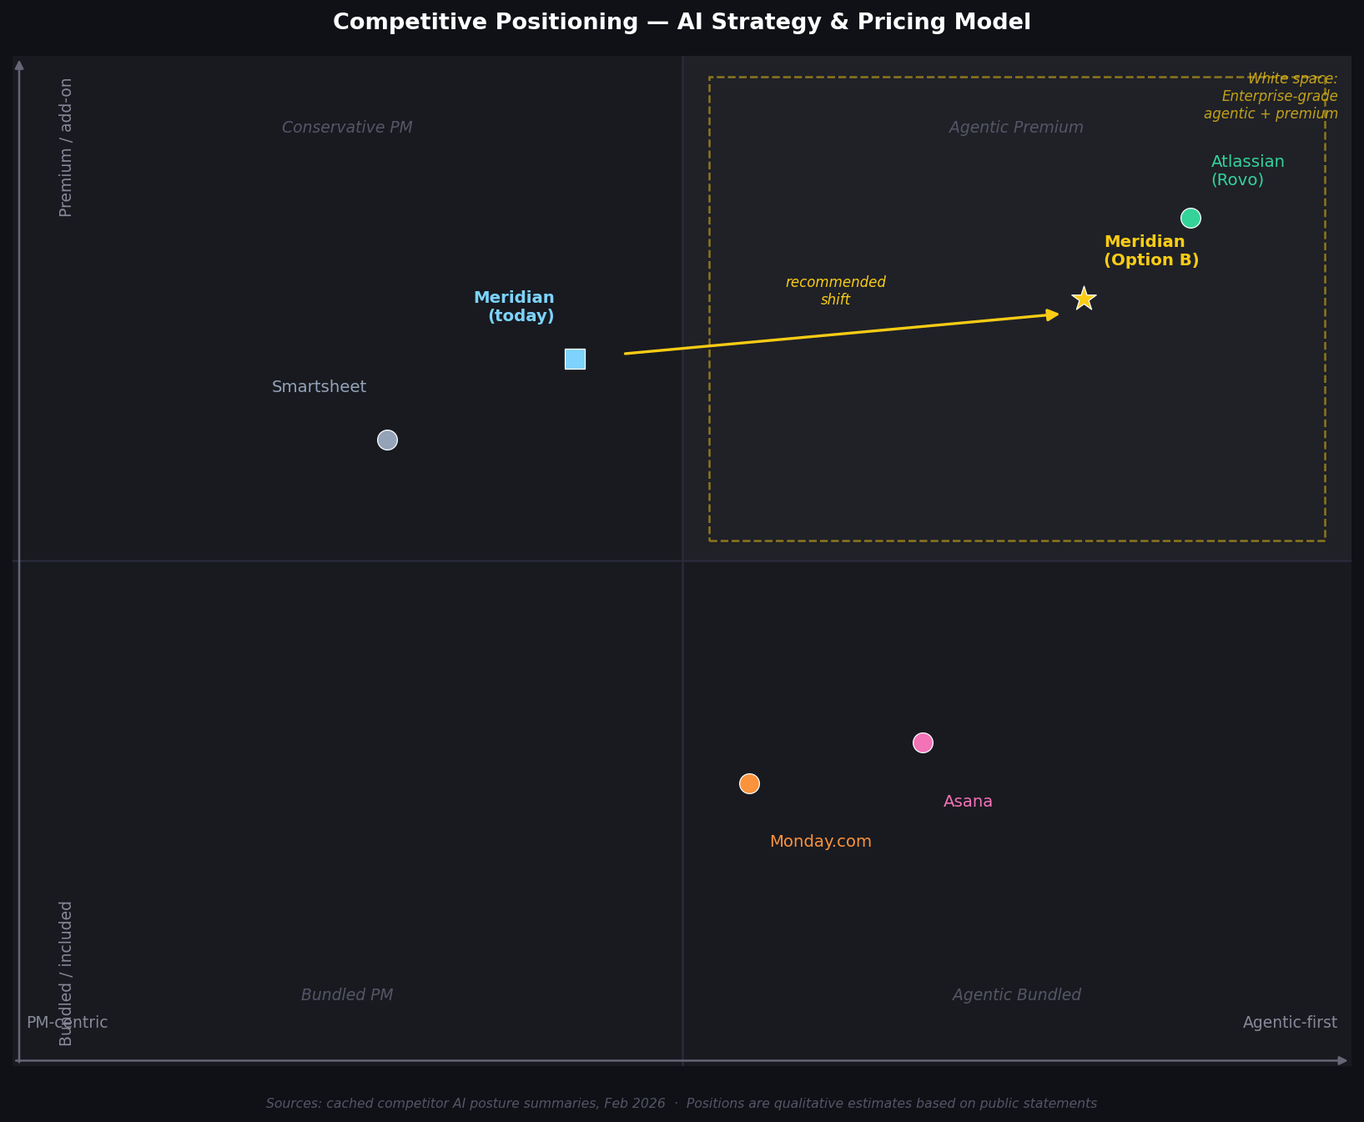
Figure 1: Competitive positioning — X: PM-centric → Agentic-first; Y: Bundled pricing → Premium/add-on. Source: public competitor statements, Feb 2026.
Competitor | AI Posture | Pricing Model | Meridian's Edge
Asana | "Agent OS" — AI bundled in Advanced+ | Bundled; no consumption | Governance depth Asana lacks; regulated-industry compliance Asana cannot match
Monday.com | "Work OS" — agents bundled in Pro+ | Bundled; no consumption | Enterprise governance, vertical depth; Monday has no FedRAMP, limited HIPAA
Smartsheet | "Trust-first AI" — AI Compliance Pack add-on | Bundled base; premium compliance add-on | Agentic ambition; Smartsheet explicitly rejects agentic narrative
Atlassian (Rovo) | "Agentic enterprise" — Rovo agent builder | Per-seat + consumption | Regulated non-dev verticals; Atlassian strong in engineering orgs only

THREE RISKS WE ARE MANAGING EXPLICITLY
- Revenue air gap during transition. Enterprise agentic adoption may be slower than category narrative suggests, creating an air gap between today's $3.5M Copilot ARR and the consumption revenue needed to justify the positioning. Mitigation: 2026 guidance does not assume agentic consumption as a dominant contributor; the PM motion funds the transition. We will provide a specific Copilot attach-rate target (>40% enterprise renewals) as the leading indicator investors should watch.
- Platform bypass by hyperscalers or model labs. Microsoft, Anthropic, or OpenAI enterprise agreements may make the agentic platform decision above Meridian's sales level, bypassing the buying motion entirely. Mitigation: model-neutral positioning and BYO-model support are non-negotiable product commitments; we do not tie Meridian's value to any single lab.
- Helio retention risk undermines the roadmap. The Helio team — 28 engineers whose work is the technical foundation of Option B — faces a compensation cliff in 2026. If they leave, the agent builder roadmap is exposed by 15 months. Mitigation: senior engineering comp refresh in Q1 2026; Helio retention packages extended; agent builder roadmap accelerated to reduce single-team dependency.

THREE COMMITMENTS TO INVESTORS
- Transparency on AI metrics, starting Q1 2026. We will report Copilot attach rate on enterprise renewals and in-product agentic action usage every quarter beginning Q1 2026. These are the leading indicators of whether the agentic platform is earning its positioning — and we will not hide behind aggregate ARR if they are moving in the wrong direction.
- Pricing model aligned to positioning by H2 2026. We will announce revised mid-market Copilot pricing — moving from a standalone $40/seat add-on to a mid-market bundle — by Q2 2026. We will simultaneously introduce consumption pricing for enterprise agent actions in H2 2026. The pricing model will match the platform identity.
- Three-year financial targets with a floor and a ceiling. We will return to a three-year plan with specific financial targets: $700M–$900M revenue by 2028 (range reflects agentic ramp variance), operating margin of 16–20%, and enterprise ARR above $350M. The wide range is honest. The floor assumes the PM motion holds; the ceiling assumes agentic consumption ramps on plan. We will update the range annually.

Prepared by: Office of the CEO · February 2026 · Confidential · Source data: meridian_internal_brief.md, meridian_ai_strategy_options.md, meridian_recent_customer_feedback.md, meridian_financials_summary.csv, competitors_cached/ (Feb 2026 snapshots)

