Gallery of examples for FLATcad program

Many everyday things are made of flat material: boxes, buildings, furniture, and more esoteric things such as origami folded models. In general, flat material can be cut (or trimmed), folded, assembled, and layered. With these four operations one can make a remarkable range of things. The goal of FLATcad is to support a user in designing things that can be made using these four operations. FLATcad will have a three-dimensional representation of the work-in-progress. The user sees this model on the screen. The user can operate on the model using any of the four operations. Each operation has parameters. For example, to fold a flat sheet the user must specify the line and direction of the fold. To assemble two pieces, the user must specify where the two pieces are to mate and in what particular geometry; and also the form of connection (finger joint, mortise-and-tenon joint, and so on). To cut or trim, the user must specify a cutting path.

FLATcad will maintain a representation of the model, its parts, and the sequence of operations that has led to the current model state. It will also maintain the constraints on the geometry that the operations have established. If the user cuts and assembles two parts with a notched-joint, for example, the system will remember the constraints on the local geometry (the notches in the two pieces are in a certain fixed configuration) and this will establish a place for each piece in the model. The constraints on the components will ensure that the model behaves the way physical material will behave when the model is finally manufactured.

We can think of FLATcad as establishing a “form language” for making things from two-dimensional materials. The software supports expressions in this language, simulates the manufacturing process by displaying the results graphically in three-dimensions on the screen, and assists with producing the files that will eventually be used to produce the physical model.

FLATcad will be able to support ordinary operations; however we do not intend to model some of the more challenging origami-like folding operations that require bending the material during the fold.

This document includes various examples that can be constructed in our FLATcad program with flat materials. The purpose of this document is to study what physical models can be fabricated from our program. It also describes scenarios of our FLATcad program using the fundamental operations: trimming, folding, layering, and assembling. We categorize these examples into three groups: (1) main operations (trimming, folding, layering and assembling) (2) kinetic/static models (3) flat sheet/flat sheets + extra materials
- Main Operations – Trimming, Folding, Layering and Assembling

  - Trimming
Name & Techniques | Example | Description
Snowflake Pattern |  | An example snowflake machine:  http://snowflakes.lookandfeel.com/  This website support to make snowflake pattern by simulating folding and cutting. It also saves your patter as EPS file which can be downloaded.  Also our Pop-up/Fold-out program supports a simple snowflake pattern making.

  - Folding

 | Example | Description
Pop up/Fold-out Card  * Techniques  - Platform  - Slits (single/double/multi)  - Tab  - Erasing  - Fold-out | 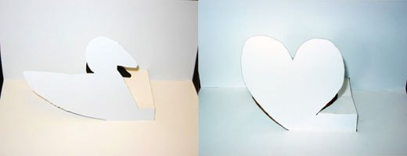 | Several Examples:  (1) Sue Hendrix's Popup Workshop  Popup workshop is a program to help you design simple pop-up cards, and print a pattern on your printer to cut and fold.  (2) 3D Card Maker  This program allows you to create pop-up cards by moving a square cursor across the card. You can design your pop-up card in 3D world directly.  (3) Ann Eisenberg's HypoerGami & JavaGami  HyperGami and JavaGami are programs to design a paper craft. You select a polyhedron from the build-in libraries. This program allows you to transform the polyhedron by adding other shapes, stretching and shrinking, truncating and slicing. The program then unfolds the transformed shape and displays the unfolded pattern. You can decorate your unfolded pattern before you print and fold it.  The pop-up cards in left pictures are created in our Pop-up/Fold-out Program.
Paper Package  * Techniques  - Die-cut  - Interlocking (insertion)  - Folding  - Design parts to be glued | 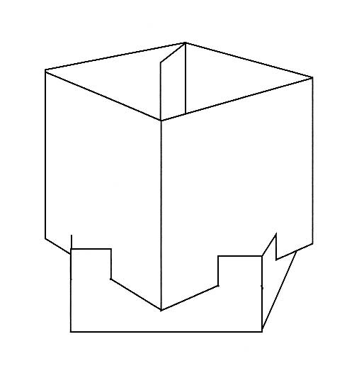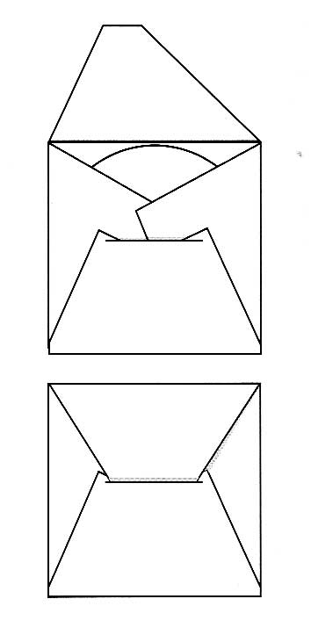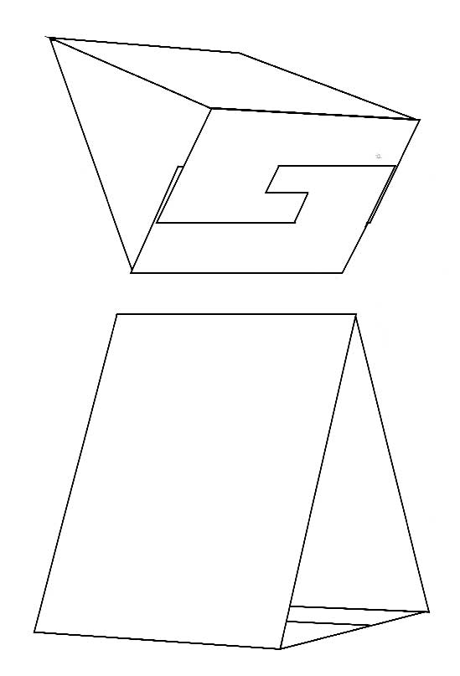 | We can create various packages by folding and cutting papers. If permanence is desired, papers can be glued.  A reference pattern book:  Folding Patterns for Display & Publicity

  - Layering

 | Example | Description
Chair & Fan  *Techniques  - Repetition  - Overlapping | 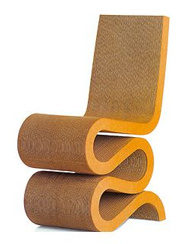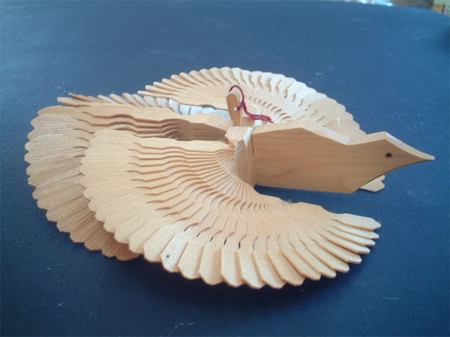 | For this chair (left), a layering operation is used to hold many layers together by hidden screws. This technique provides enough strength. For example, the Frank Gehry chair is tested to hold thousands of pounds.  For this fan (right), a layering operation is used differently. Around the body of dove, thin shapes overlap one another to represent wings.

  - Assembling
 | Example | Description
*Techniques  - Mortise-Tenon joints  - Finger joints  - Slot joints  - Butterfly joints | 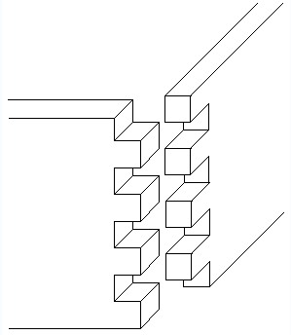  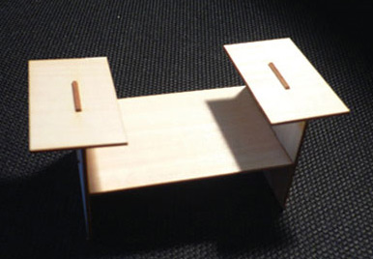 | Our Furniture Factory and Designosaur supports three kinds of jointing techniques : Mortise-Tenon joints, Finger joints, and Slot joints

- Kinetic / Static Models

  - Kinetic Models

 | Example | Description
Cabaret Mechanical Theater /  Japanese Karakuri  * It requires mechanical joints | 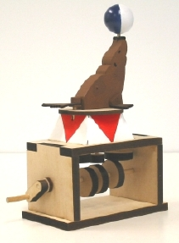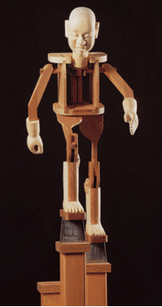 | Like analogue clockwork mechanism, this Cabaret Mechanical Theater and Japanese Karakuri make movements using mechanical joints. Old examples are 17-8c European automata and Japanese Karakuri  Example Problem:  Glenn Blavvelt’s Machineshop in Craft Technologies Group, Univ. of Colorado
Mobiles  - Hanging mobile  - Wall mobile  - Standing mobile | 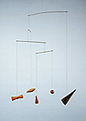 | Most types of mobiles are kinetic models.

  - Static Models
 | Example | Description
Craft Kits  * It requires mechanical joints | 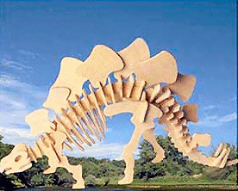  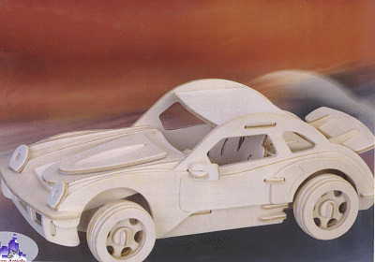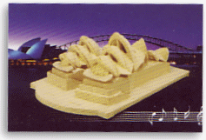 | Like off-the-shelf wood models, our FLATcad can generate furniture, animals including dinosaurs, and cars. It brings form to a three-dimensional creature by putting together planar parts. These parts join orthogonally using a paired jointing to make a three-dimensional structure.
Stabile (Mobiles) | 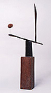 | It is one kind of mobile, but it is static unlike other types of mobiles.

- Only Flat Materials / Flat Materials + Extra Materials

  - Only Flat Materials
 | Example | Description
Craft Kits

Paper Package/ Pop-up, Fold-out Card , Snowflake | 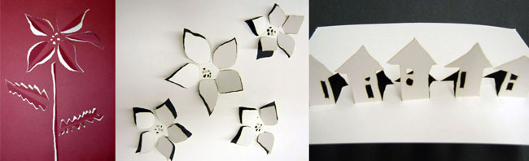  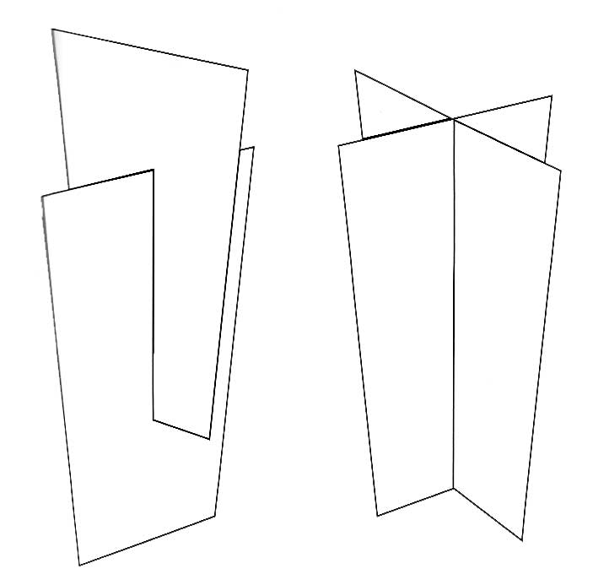

  - Flat Materials + Extra Materials
 | Example | Description
Mobiles | 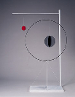 | It requires stings, wires and extra materials besides flat material to create mobile.

