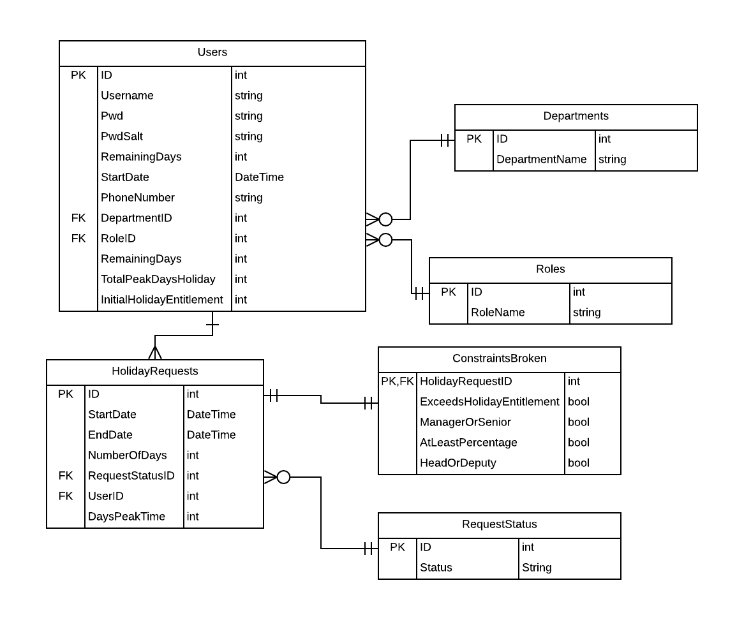

Figure 1 Final database UML Diagram

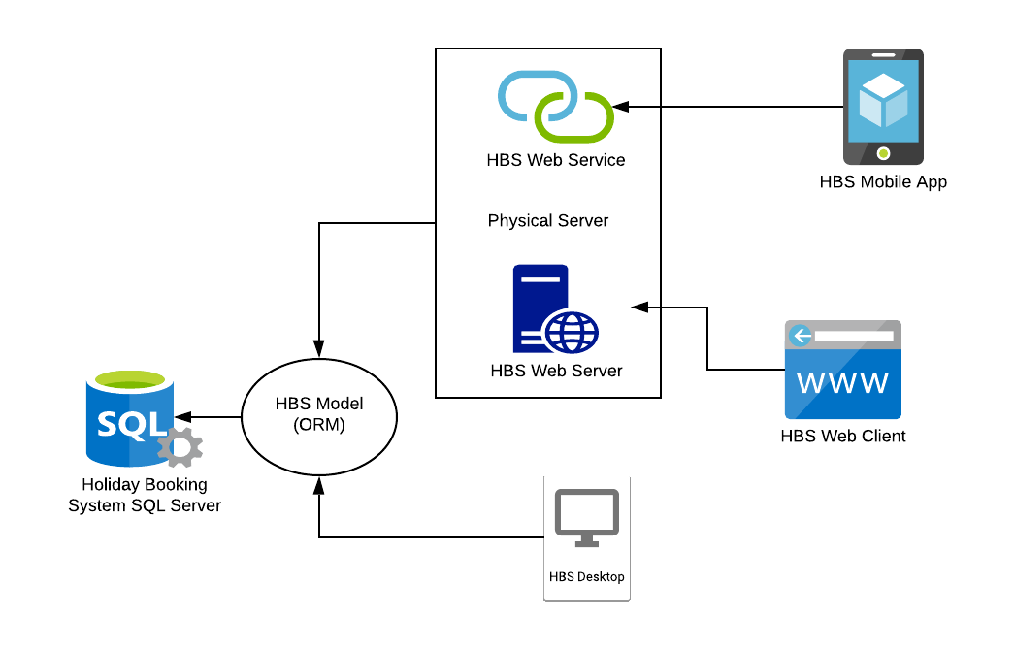

Figure 2 System Architecture Diagram