


PenguinSqueak™
Piezoelectric Ultrasound
Transducer Driver

Designed for use with the SQ-09 Transducer
(Sensor Technology Ltd.)

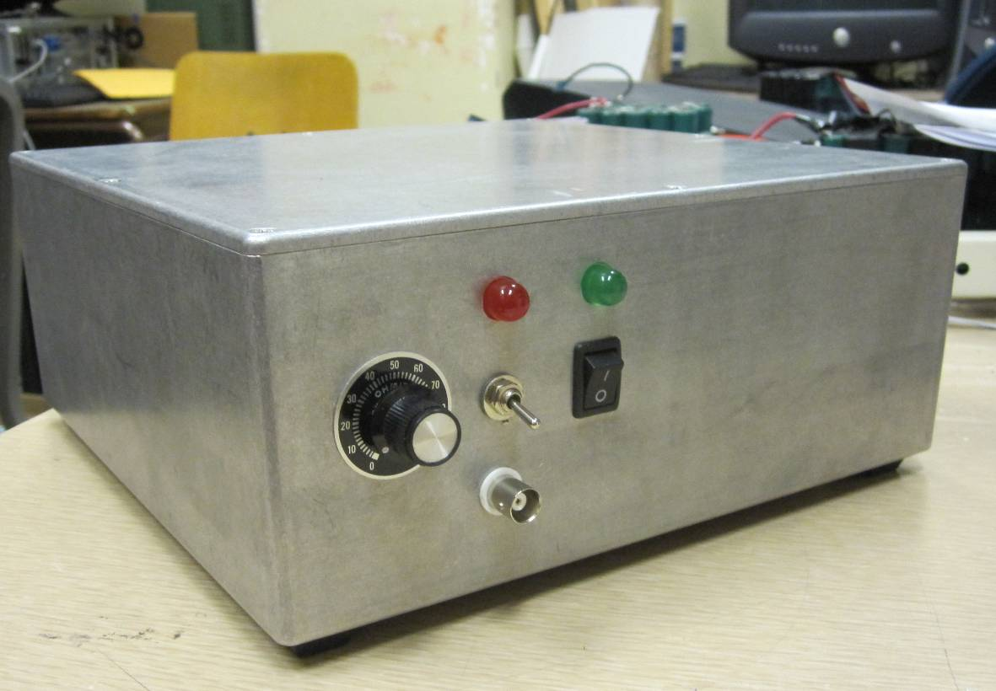

Alex Piggott

August 23, 2012
1. Overview

The PenguinSqueak™ Piezoelectric Ultrasound Transducer Driver is designed to provide a sine-wave excitation to the SQ-09 ultrasound transducer, manufactured by Sensor Technology Ltd.

The output frequency is fully adjustable using a knob, and the output can be toggled on and off using either the manual switch, or the electronic trigger. The output amplitude is set internally using a potentiometer, and should not be routinely adjusted.

The transducer driver consists of an analog sine-wave generator IC (NTE864), an op-amp signal conditioning stage, a discrete-transistor power amplifier, and an output transformer. The op-amp stage provides buffering, amplification, and the ability to switch the output on and off using either a debounced switched or an external trigger input. The discrete-transistor power amplifier provides both voltage and current amplification, and the 1:6 ratio output transformer boosts the output voltage. The output transformer uses a ferrite core for efficient high-frequency operation, and was specifically designed to minimize losses in the 10-30kHz regime.

1.1 Basic Parameters

Parameter | Value
Supply Voltage | 120VAC
Output Voltage | 60 – 80 V_{RMS}
Output Frequency | 12 – 33 kHz
External Trigger: ON voltage | 4.0 – 5.0 V
External Trigger: OFF voltage | 0.0 – 1.0 V
External Trigger Input Impedance | ≥ 5 kΩ
External Trigger Response Time | 1 – 3 milliseconds
Recommended transducer | SQ-09 (Sensor Technology Ltd).
Minimum load impedance | 200 ohms

2. Using the Transducer Driver

2.1 Front Panel
Power
Indicator
Output
Indicator
Power
Switch
Output
Switch
Trigger
Input

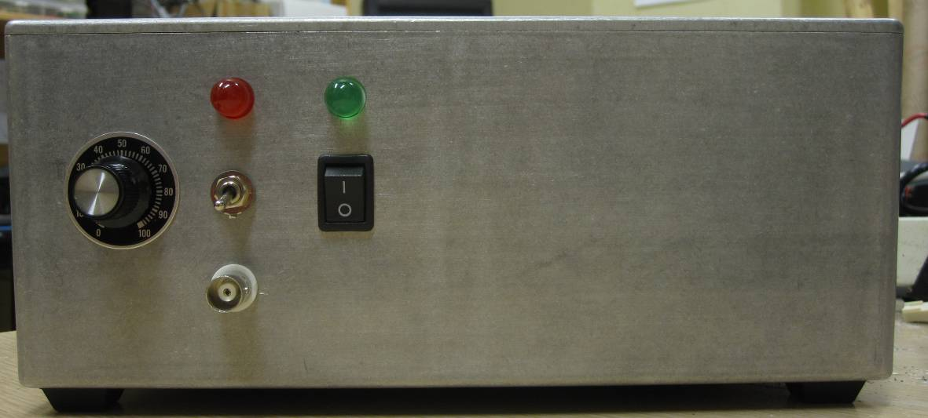
Frequency
Knob

2.2 Back Panel
Sine-wave Output to Transducer
120VAC Input
Cooling
Fan

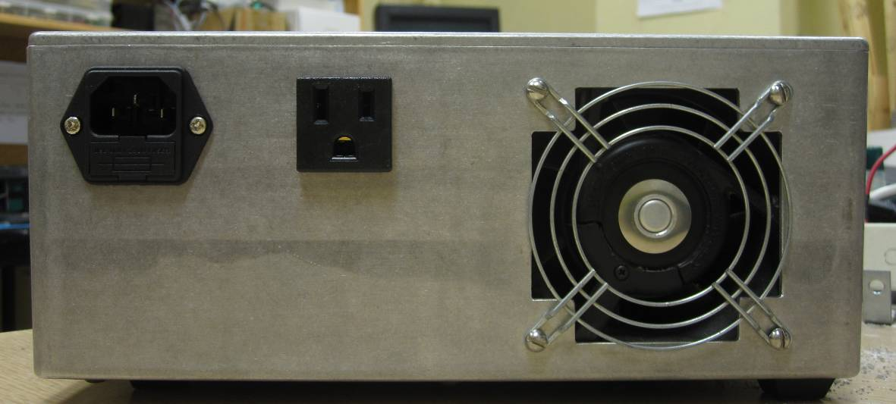
2.3 Detailed Descriptions of Interface

2.3.1 Controls
- Power Switch: turns power to the unit on/off

- Output Switch: turns sine-wave output to transducer on/off

- BNC Trigger Input: turns sine-wave output to transducer on/off electronically
- 5V = output on, 0V or open circuit = output off
- Response time is ~2-5 milliseconds
- Input is isolated by optoisolator

- Frequency Knob: adjusts the output frequency

Setting | Frequency (KHz)
0 | 12.0
10 | 13.5
20 | 15.9
30 | 18.0
40 | 20.2
50 | 22.5
60 | 25.0
70 | 27.3
80 | 29.6
90 | 31.7
100 | 32.6

2.3.2 Indicators
- Power Indicator (Green LED): indicates whether power is on / off

- Output Indicator (Red LED): indicates whether sine-wave output is on / off

2.3.3 Input/Output Connectors
- 120VAC Input: line input to transducer driver
- Standard 120VAC connector

- Sine-wave Output to Transducer: drives piezoelectric transducer
- 12 – 33 kHz, 60-80 V_{RMS} sine output
- Minimum load impedance: 200Ω

2.4 How to Use the PenguinSqueak™ Transducer Driver
- Plug the 120VAC power cable, and the SQ-09 transducer, into the back of the transducer driver.
- Turn on the transducer driver using the power switch. The green LED should turn on, and the rear fan should start spinning.
- Select the output frequency using the frequency adjustment knob.
- Turn the output on using either the output switch, or the external trigger input (the BNC connector on the front panel). The red LED should turn on. If the frequency is <18kHz, the sound produced by the transducer should be audible.

3. Internal Layout

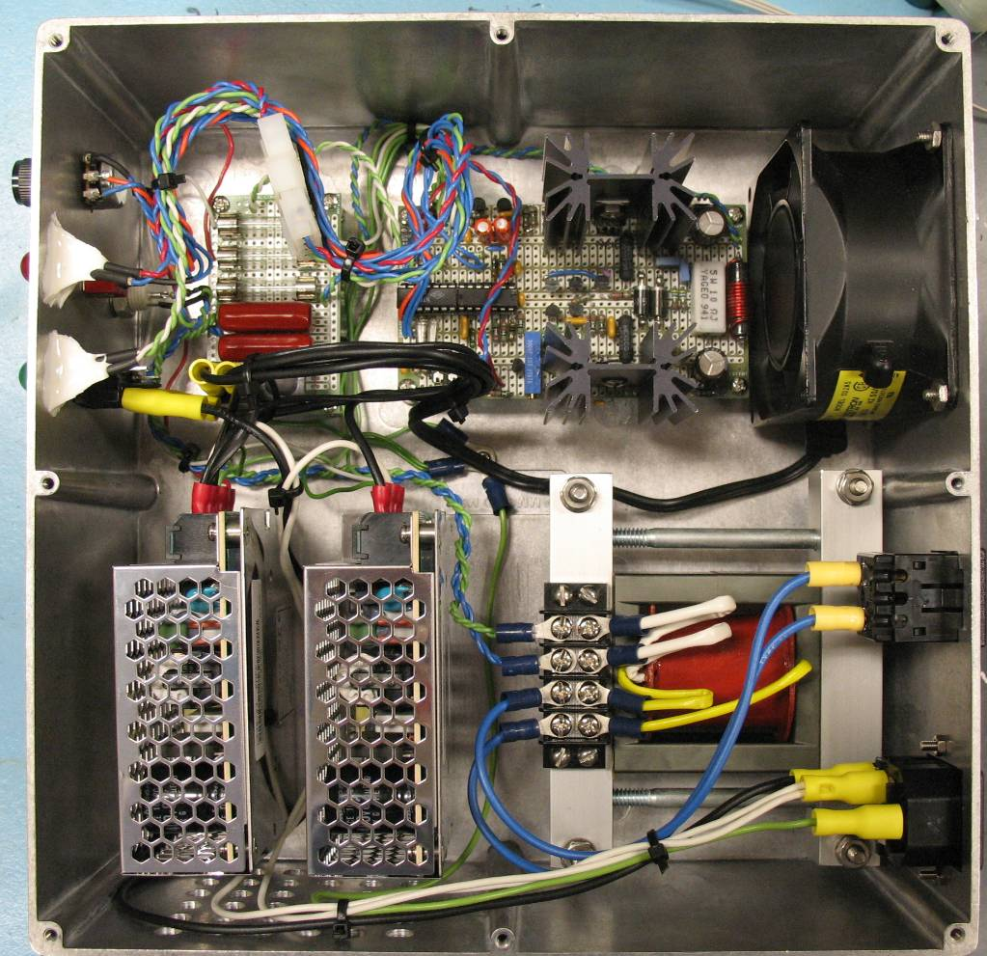
Power Supplies
24VDC
Output Transformer
1:6 turn ratio
120VAC In
5A fuse

Piezoelectric Transducer Output
Fan
Main Circuit Board
Sine generation, signal conditioning, power amplifier

Power Board
Fuses, relay,
coupling capacitors
Front Panel
LEDs, switches, trigger input
Enclosure Ground Screw
4. Circuit Design

4.1 List of Major Parts
All major components used in the ultrasound transducer driver are listed below. Passive components, such as capacitors, inductors, and resistors, have been omitted from the list.

Part Number | Description | Quantity
Sine Generation and Signal Conditioning
NTE864 | Sine wave generator IC | 1
TL074CN | Quad op-amp (JFET inputs, bipolar internals) | 1
2N7000 | N-MOSFET, signal | 2
LT815 | Optoisolator | 1
Green LED, large | Power on/off indicator | 1
Red LED, large | Output on/off indicator | 1
Power Amplifier
MPSA42 | NPN transistor, signal | 3
MPSA56 | PNP transistor, signal | 2
TIP121 | NPN Darlington, power | 1
TIP115 | PNP Darlington, power | 1
IN5402 | Diode | 2
Green LED, small | Used to bias NPN transistor | 1
Miscellaneous
TDK Lambda LS35-24 | 24VDC Switching Power Supply, 1.5A | 2
Panasonic ALE14B24 | Relay, SPST 16A, 24V coil | 1
M205, 5A fuse | 5×20mm fuse (in power entry module) | 1
3AG, 1A fuse | ¼ ×1 ¼ inch fuse | 3
Bulgin PF0001/63 | Power entry module | 1
TE-Connectivity 208697-2 | 3-prong output connector | 1

The NPN and PNP transistors used were simply those available at the time, and are not necessarily ideal. As a result, the signal NPN and PNP transistors, and the power Darlington NPN and PNP transistors, are not complementary transistors.

If this circuit is ever rebuilt, I strongly recommend that the following transistors be used instead, which have been designed to be used as complementary pairs:

MPSA06 (NPN transistor, signal)
MPSA56 (PNP transistor, signal)
TIP121 (NPN Darlington, power)
TIP126 (PNP Darlington, power)

4.2 Circuit Schematics
The circuit diagrams for the ultrasound transducer driver appear on the following pages.
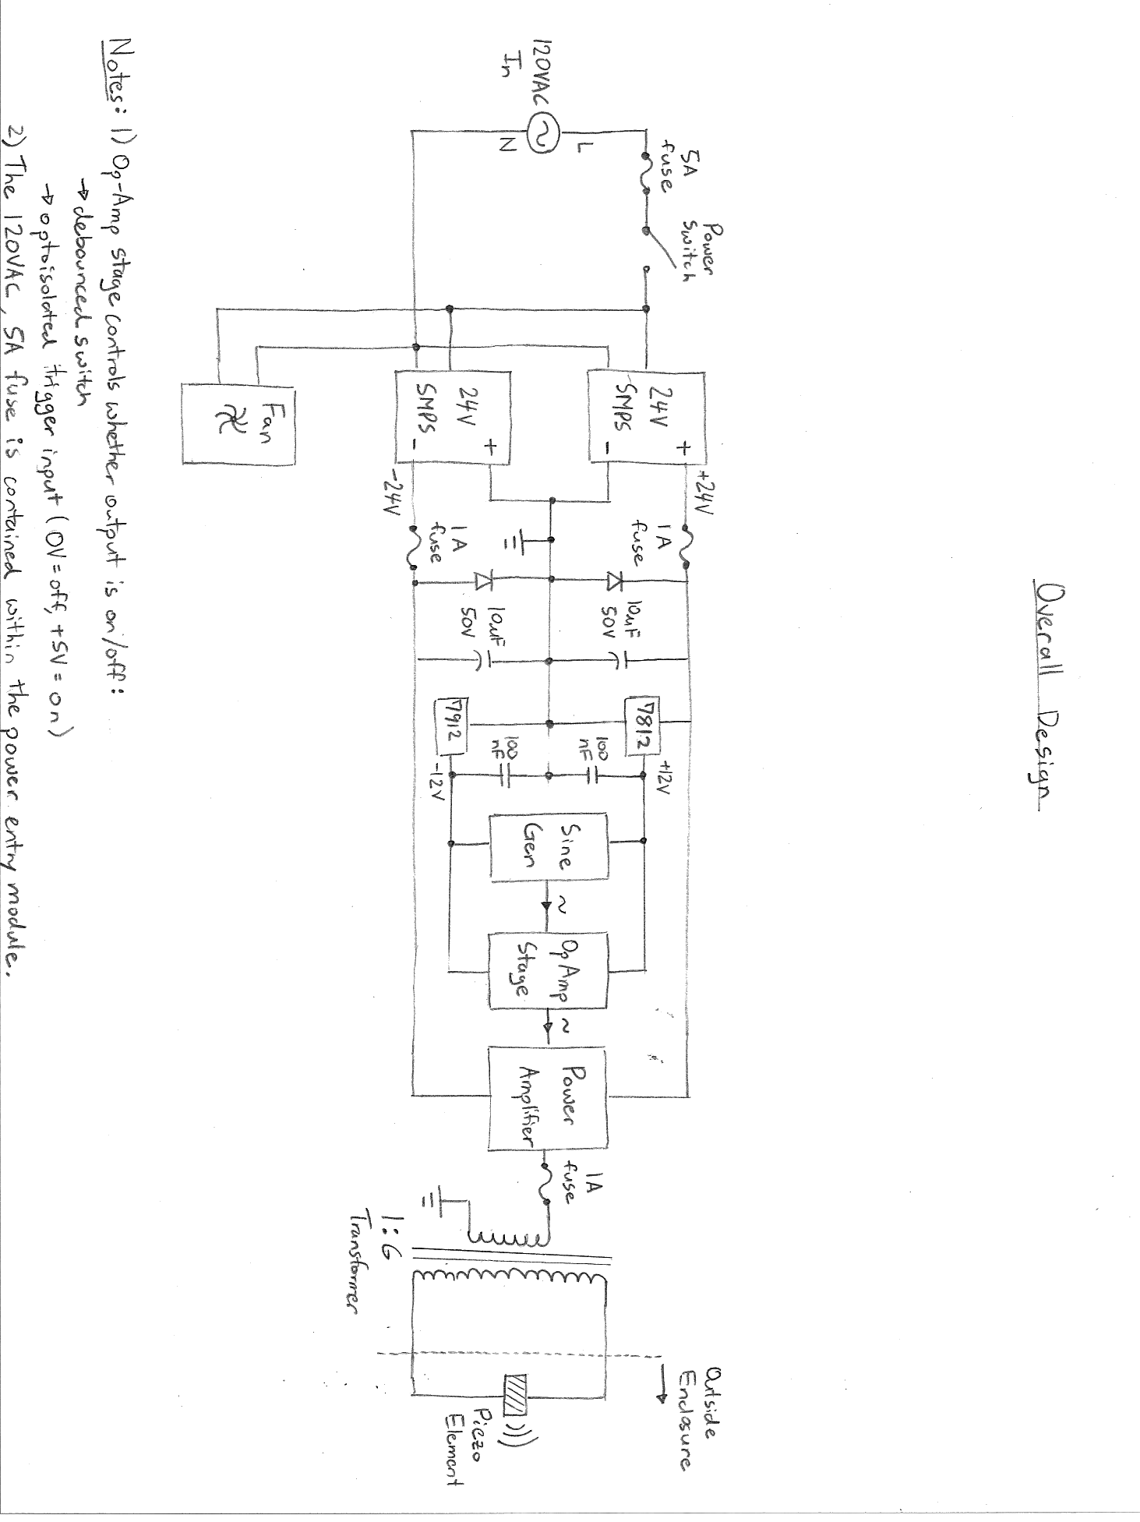

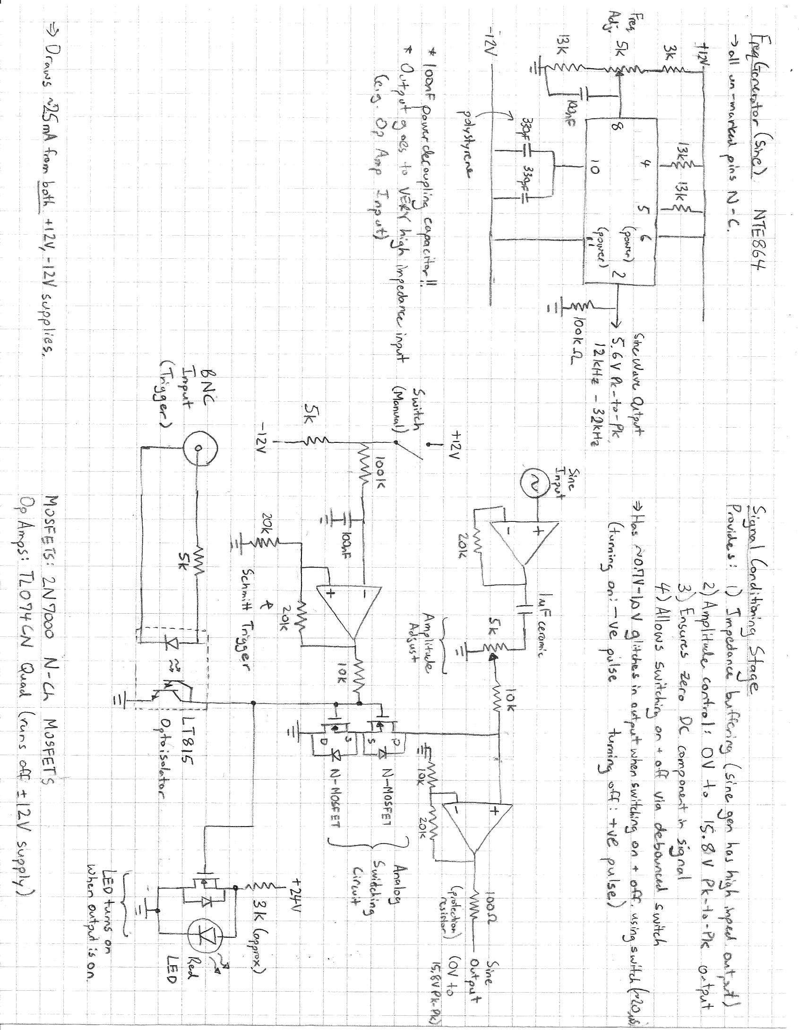
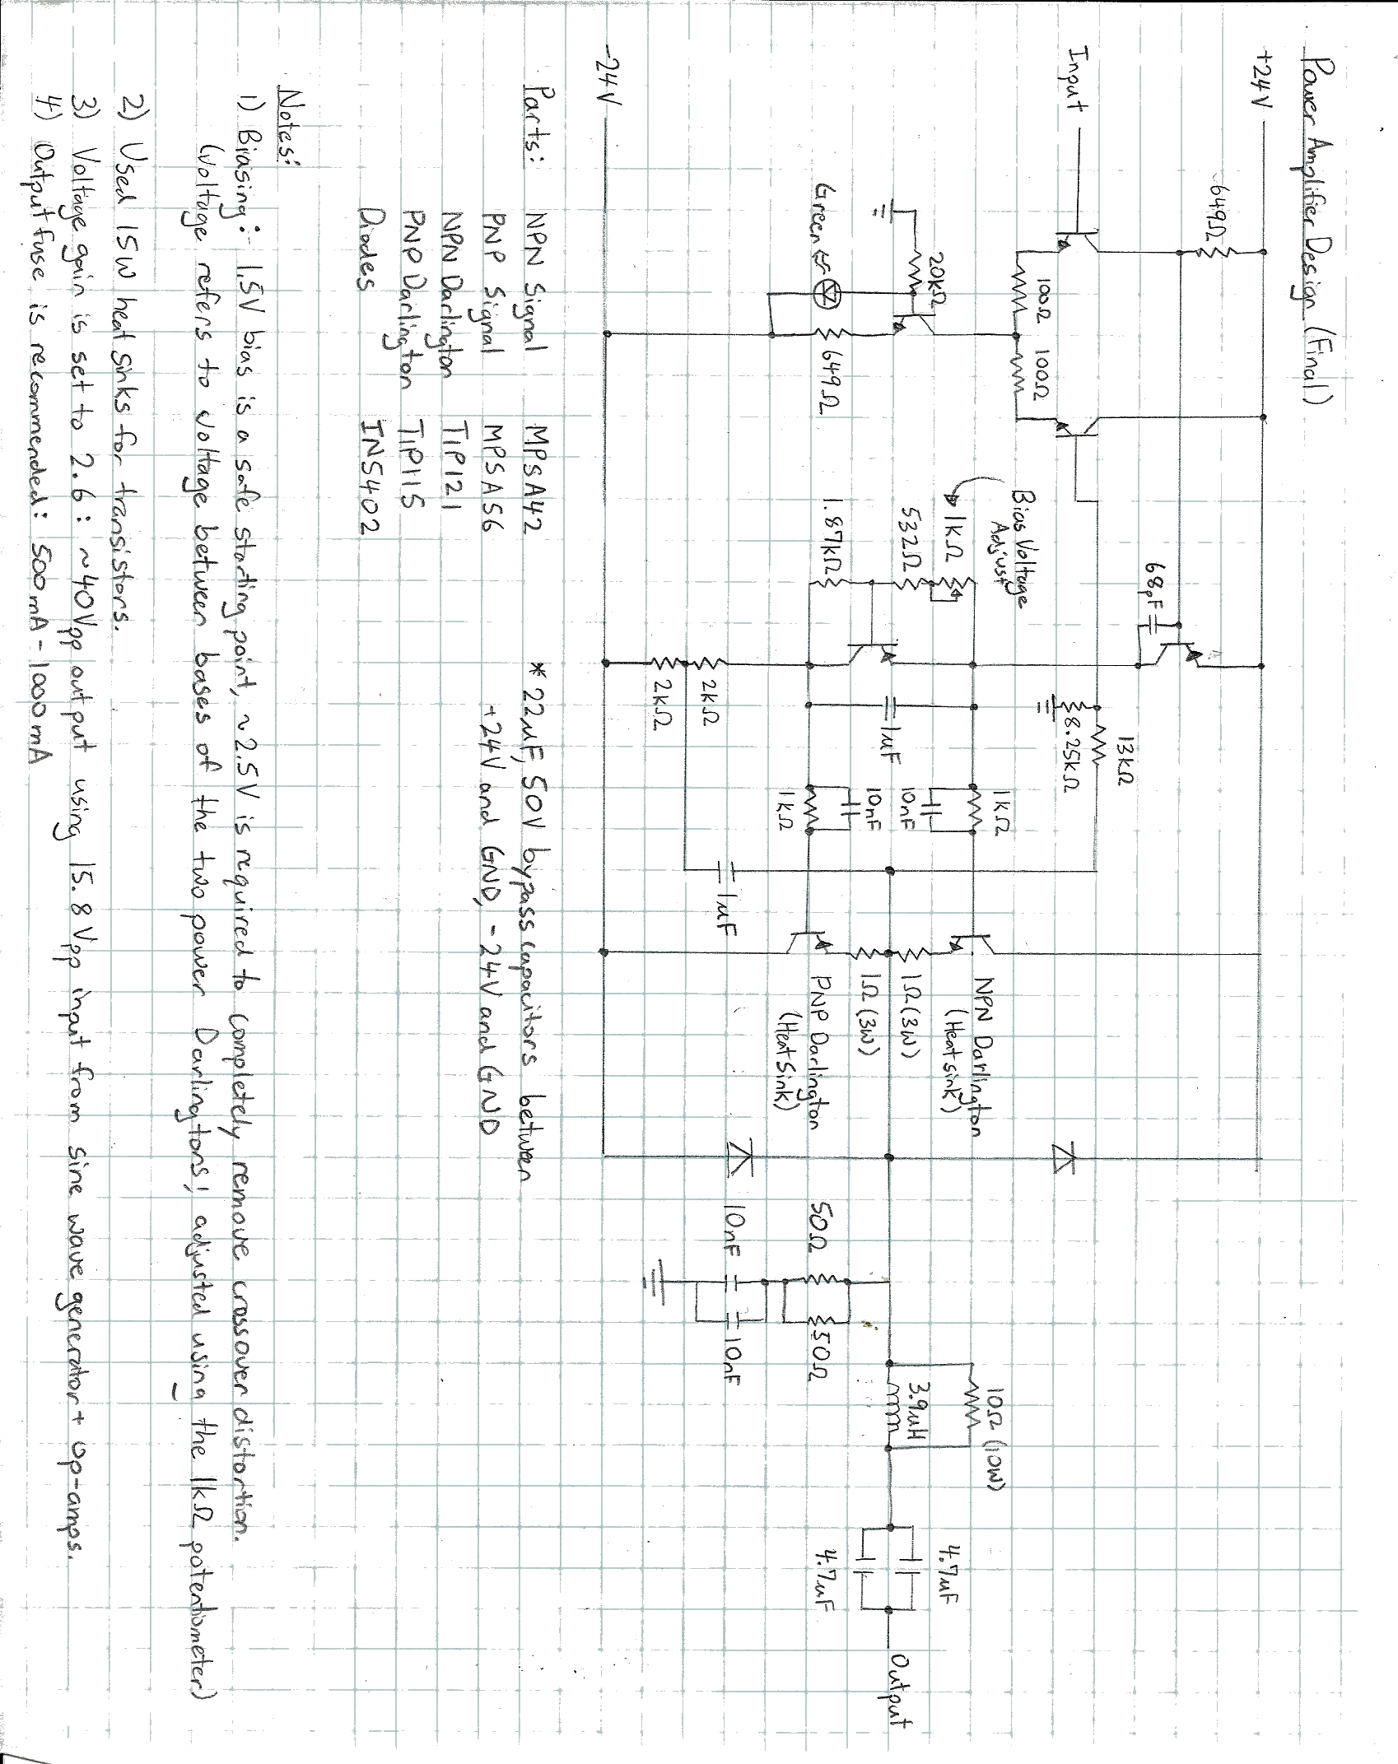
5. Troubleshooting

If the transducer driver fails to produce an output, the following suggestions may be helpful in troubleshooting the problem:

- Check if any of the fuses have blown:
  - One 5A fuse in the power entry module (120VAC)
  - Two 1A fuses after the 24V power supplies
  - One 1A fuse between the power amplifier and output transformer
- Some of the major mechanical components or connections may be faulty:
  - Check all connections
  - Confirm that the relay is functioning (the relay gates the power to the second 24V power supply, ensuring the +24V supply rail powers on before the -24V supply rail)
  - Confirm that the two switches on the front panel are functioning.
- The output transistors may have been damaged:
  - The two output Darlington transistors are attached to heat sinks
    - One NPN Darlington (TIP121)
    - One PNP Darlington (TIP115)
  - To replace the output transistors:
    - Remove the main circuit board from the enclosure.
    - Unscrew the transistor from the heat sink.
    - Desolder the transistor, and remove excess solder.
    - Screw a new transistor onto the heat sink, using a metal nut and bolt, and thermally conductive paste.
    - Solder the new transistor.
    - Return the circuit board to the enclosure.
- The input trigger optoisolator (LTV815) may have been damaged.
  - Replace the optoisolator in the IC socket.

WARNINGS:
- The heat sinks are ELECTRICALLY CONNECTED to the output power transistor tabs to improve heat-sinking.
- High voltages are present inside the transducer driver. Before opening the case, unplug the 120VAC power cord from the transducer driver, and wait for 15 seconds.
- The enclosure MUST be SAFELY GROUNDED before turning on the transducer driver. Ensure that all three (3) ground wires are solidly attached to the enclosure ground screw (see Section 3. Internal Layout).

