Power Management Board
Alexander Piggott
August 26, 2012

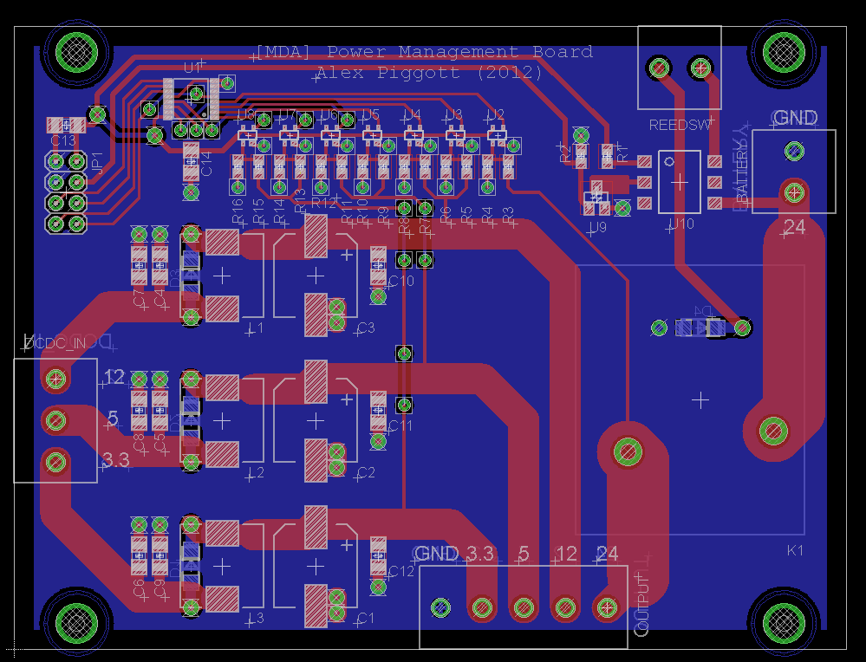

1. Overall Design
The power management board is designed to perform the following functions:
- FPGA Power Control: battery power is supplied to the submarine electronics only if explicitly commanded by the FPGA.
- External Kill Switch: battery power is immediately cut if the external kill switch is triggered.
- Power Supply Monitoring: a set of analog comparators alerts the FPGA to overvoltage / undervoltage conditions on each supply rail.
- Supply Voltage Filtering: the DC-DC power supply outputs are low-pass filtered using passive LC filters to reduce noise.

The overall circuit topology is given in figure 1.

2. FPGA Power Control and External Kill Switch
The 24V battery power passes through a relay on the power management board before being distributed to the rest of the submarine. The relay is normally open, and is closed only if both conditions are satisfied:
- The FPGA sends an active high output on the power enable line. If the FPGA output is floating, the relay coil will not be energized.
- The magnetic reed switch, which is used as the external kill switch, is closed.

3. Power Supply Monitoring
An array of 7 analog comparators monitors all four supply rails (+24V, +12V, +5V, +3.3V) for undervoltage and overvoltage conditions. Since the 24V rail is battery powered, and the likelihood of an overvoltage is vanishingly low, the 24V rail only has undervoltage monitoring. The outputs of the comparators are multiplexed using an 8:1 multiplexer and sent to the FPGA.

4. Power Supply Filtering
A simple LC filter provides low-pass filtering for each power supply. The cutoff frequency is set to 50kHz, which is lower than the switching frequency of the DC-DC power supplies currently used in the submarine. A freewheeling diode across each inductor limits voltage spikes in the event of sudden changes in current.

Power Management Board

+12V DC-DC
+5V DC-DC
+3.3V DC-DC
24V
Battery
Pack
+24V Bus Bar
+12V Bus Bar
+5V Bus Bar
+3.3V Bus Bar
GND Bus Bar
Reed Switch
Bus to FPGA
Figure 1: Power distribution topology for the submarine.

