Scanario-1 : Creating 2 users and give access to 2 users. After that remove access to one of the user

* Create playbook user.yaml
* Ansible-playbook user.yaml
* Creating pavan and sunil users to group dev
* To add a block of lines we use blockinline module. Single line lininfile
* 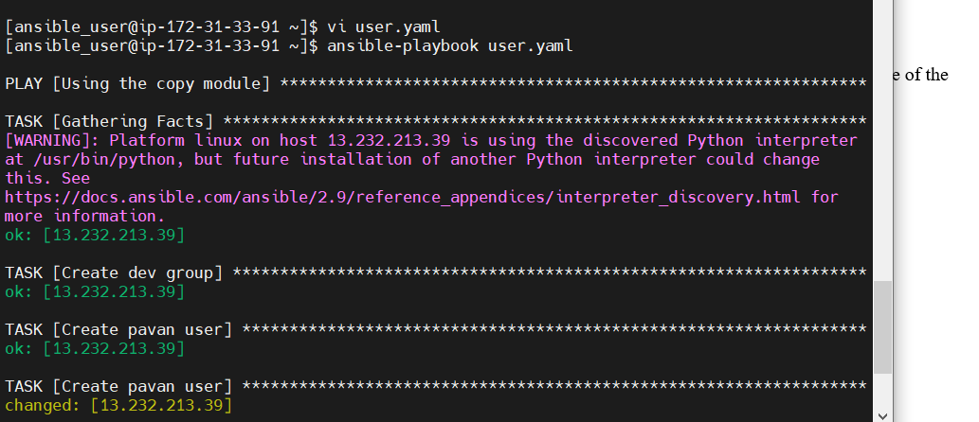
* To give access to the servers add the users in sudoers group :

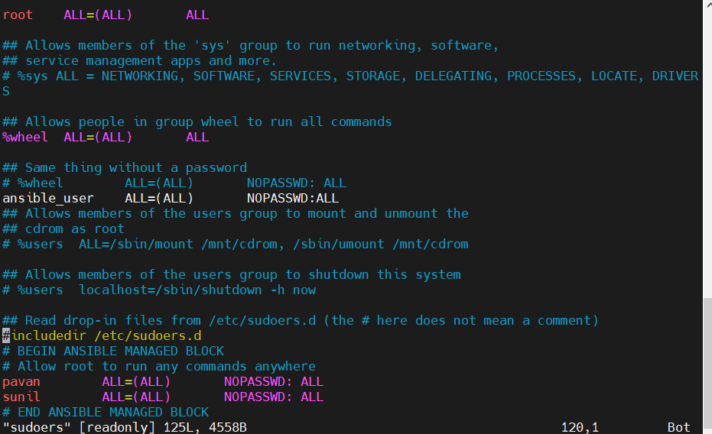

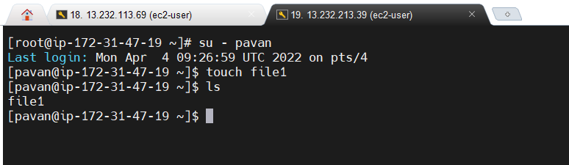

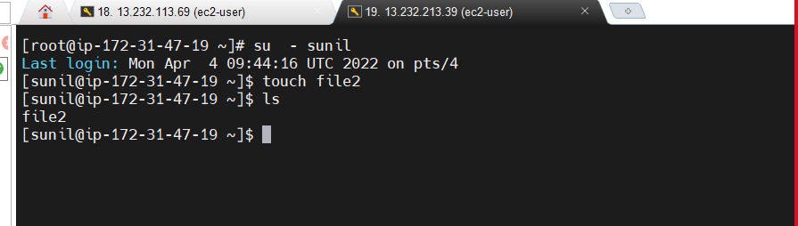

* To remove the user we give state = absent, remove: yes, force: yes

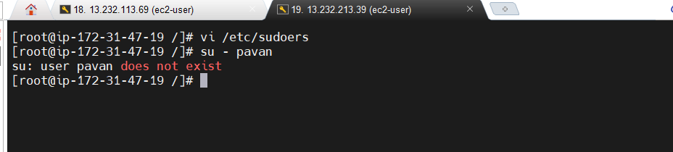

Check and install httpd service:

* Check in node --- systemctl status httpd

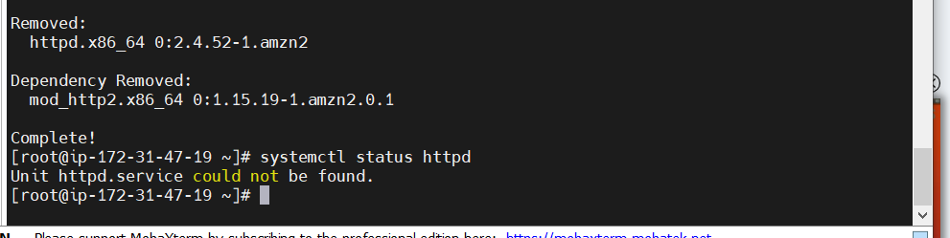

* Create a playbook to check and install if not installed
* ansible-playbook httpd.yaml

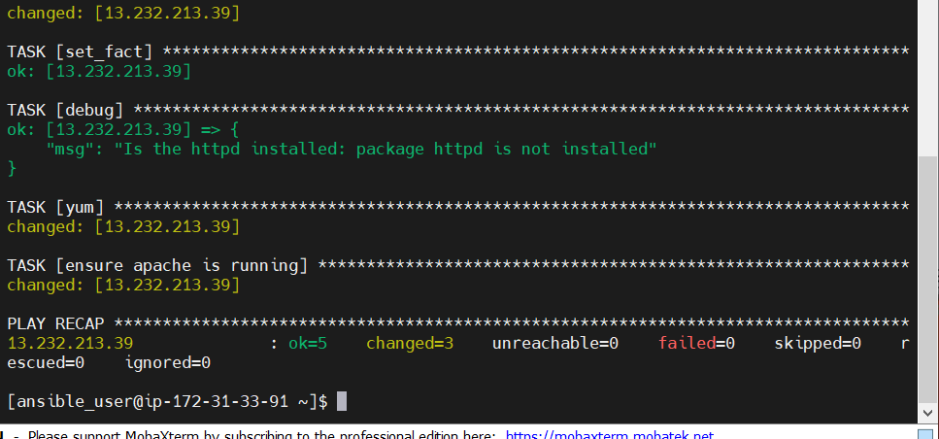

* check in node ----- systemctl status httpd

