**Simple Storage Service**

Amazon S3 is an object-based service that provides industry-leading scalability data availability, security, and performance.

Amazon S3 allows you to store and retrieve any amount of data from anywhere on the internet at any time.

Amazon S3 buckets is an public object storage service. Similar to files folders, It store objects that contain data and descriptive metadata.

A single S3 object can be a size of range **5TB.**

* The files which are stored in S3 can be from 0 Bytes to 5 TB.
* It has unlimited storage means that you can store the data as much you want.
* Files are stored in Bucket. A bucket is like a folder available in S3 that stores the files.
* S3 is a universal namespace, i.e., the names must be unique globally. Bucket contains a DNS address. Therefore, the bucket must contain a unique name to generate a unique DNS address.

If you create a bucket, URL look like:

AWS S3

* If you upload a file to S3 bucket, then you will receive an HTTP 200 code means that the uploading of a file is successful.

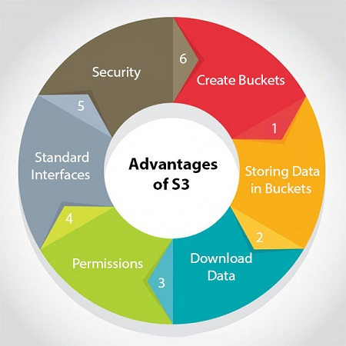

**Advantages of S3**

* **Create Buckets:** Firstly, we create a bucket and provide a name to the bucket. Buckets are the containers in S3 that stores the data. Buckets must have a unique name to generate a unique DNS address.
* **Storing data in buckets:** Bucket can be used to store an infinite amount of data. You can upload the files as much you want into an Amazon S3 bucket, i.e., there is no maximum limit to store the files. Each object can contain upto 5 TB of data. Each object can be stored and retrieved by using a unique developer assigned-key.
* **Download data:** You can also download your data from a bucket and can also give permission to others to download the same data. You can download the data at any time whenever you want.
* **Permissions:** You can also grant or deny access to others who want to download or upload the data from your Amazon S3 bucket. Authentication mechanism keeps the data secure from unauthorized access.
* **Standard interfaces:** S3 is used with the standard interfaces REST and SOAP interfaces which are designed in such a way that they can work with any development toolkit.
* **Security:** Amazon S3 offers security features by protecting unauthorized users from accessing your data.

### **S3 is a simple key-value store**

**S3 is object-based. Objects consist of the following:**

* **Key:** It is simply the name of the object. For example, hello.txt, spreadsheet.xlsx, etc. You can use the key to retrieve the object.
* **Value:** It is simply the data which is made up of a sequence of bytes. It is actually a data inside the file.
* **Version ID:** Version ID uniquely identifies the object. It is a string generated by S3 when you add an object to the S3 bucket.
* **Metadata:** It is the data about data that you are storing. A set of a name-value pair with which you can store the information regarding an object. Metadata can be assigned to the objects in Amazon S3 bucket.
* **Sub resources:** Sub Source mechanism is used to store object-specific information.
* **Access control information:** You can put the permissions individually on your files.

# **AWS Storage Classes**

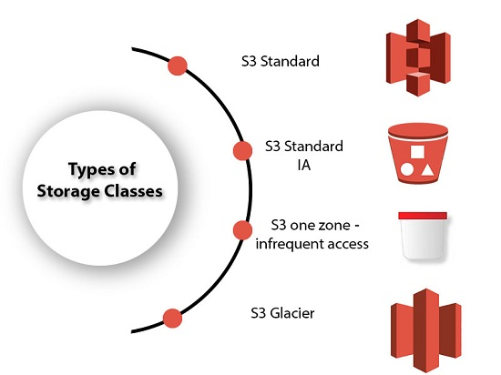

* S3 storage classes are used to assist the concurrent loss of data in one or two facilities.
* S3 storage classes maintain the integrity of the data using checksums.
* S3 provides lifecycle management for the automatic migration of objects for cost savings.

**S3 contains four types of storage classes:**

* S3 Standard
* S3 Standard IA
* S3 one zone-infrequent access
* S3 Glacier

### S3 Standard

* Standard storage class stores the data redundantly across multiple devices in multiple facilities.
* It is designed to sustain the loss of 2 facilities concurrently.
* Standard is a default storage class if none of the storage class is specified during upload.
* It provides low latency and high throughput performance.
* It is designed for 99.99% availability and 99.999999999% durability

### S3 Standard IA

* IA stands for infrequently accessed.
* Standard IA storage class is used when data is accessed less frequently but requires rapid access when needed.
* It has a lower fee than S3, but you will be charged for a retrieval fee.
* It is designed to sustain the loss of 2 facilities concurrently.
* It is mainly used for larger objects greater than 128 KB kept for at least 30 days.
* It provides low latency and high throughput performance.
* It is designed for 99.99% availability and 99.999999999% durability

## S3 one zone-infrequent access

* S3 one zone-infrequent access storage class is used when data is accessed less frequently but requires rapid access when needed.
* It stores the data in a single availability zone while other storage classes store the data in a minimum of three availability zones. Due to this reason, its cost is 20% less than Standard IA storage class.
* It is an optimal choice for the less frequently accessed data but does not require the availability of Standard or Standard IA storage class.
* It is a good choice for storing backup data.
* It is cost-effective storage which is replicated from other AWS regions using S3 Cross Region replication.
* It has the same durability, high performance, and low latency, with a low storage price and low retrieval fee.
* It is designed for 99.5% availability and 99.999999999% durability of objects in a single availability zone.
* It provides lifecycle management for the automatic migration of objects to other S3 storage classes.
* The data can be lost at the time of the destruction of an availability zone as it stores the data in a single availability zone.

### S3 Glacier

* S3 Glacier storage class is the cheapest storage class, but it can be used for archive only.
* You can store any amount of data at a lower cost than other storage classes.
* S3 Glacier provides three types of models:
  + **Expedited:** In this model, data is stored for a few minutes, and it has a very high fee.
  + **Standard:** The retrieval time of the standard model is 3 to 5 hours.
  + **Bulk:** The retrieval time of the bulk model is 5 to 12 hours.
* You can upload the objects directly to the S3 Glacier.
* It is designed for 99.999999999% durability of objects across multiple availability zones.

# Lifecycle Management

**Lifecycle Management** is used so that objects are stored cost-effectively throughout their lifecycle. A **lifecycle configuration** is a set of rules that define the actions applied by S3 to a group of objects.

**The lifecycle defines two types of actions:**

* **Transition actions:** When you define the transition to another storage class. For example, you choose to transit the objects to Standard IA storage class 30 days after you have created them or archive the objects to the Glacier storage class 60 days after you have created them.
* **Expiration actions:** You need to define when objects expire, the Amazon S3 deletes the expired object on your behalf.

**S3 Versioning**

Versioning is **a means of keeping the multiple forms of an object in the same S3 bucket**. Versioning can be used to retrieve, preserve and restore every version of an object in S3 bucket. For example, bucket consists of two objects with the same key but with different version ID's such as photo.

**Now,** Create a S3 Bucket for that goto All Service and See there is Storage click on that,

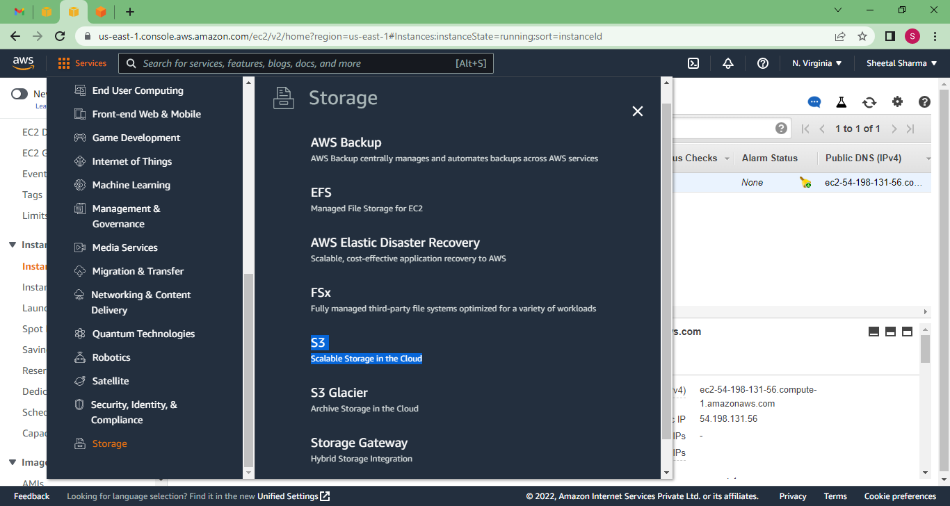

Click on S3 **Create Bucket**

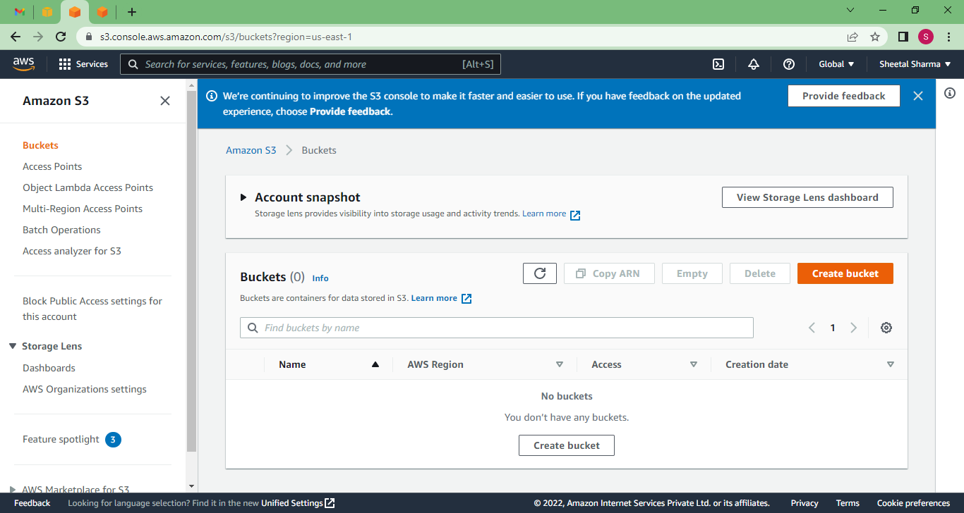

Here gives a unique bucket name, select Region, choose Object Ownership, Encryption and then create.



Bucket name must not be in Capital letter,

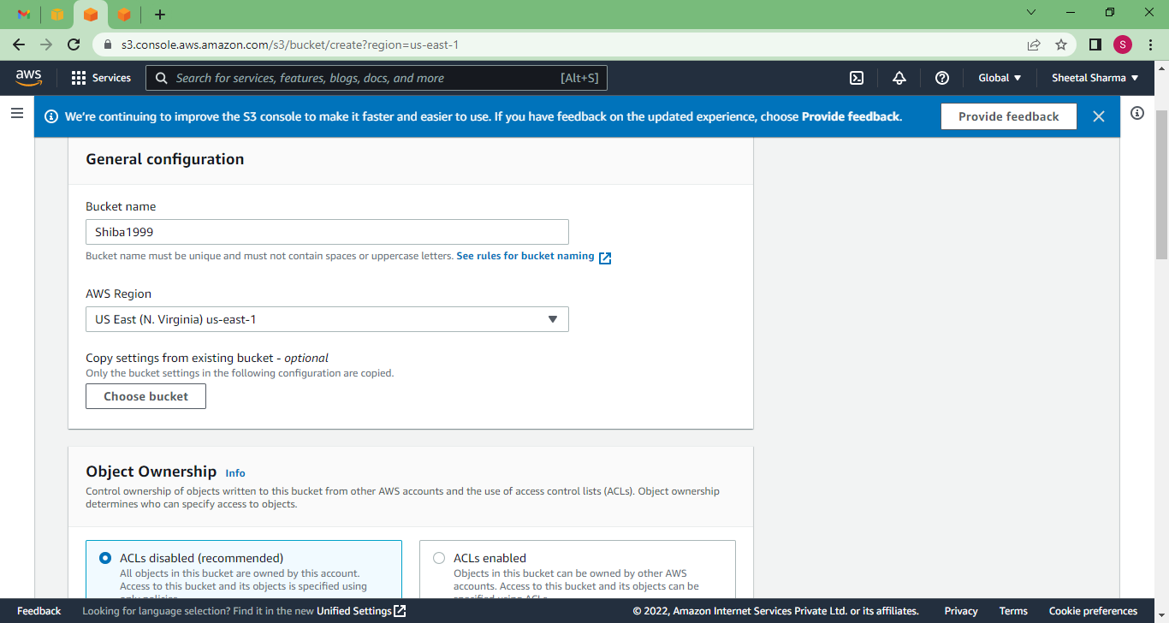

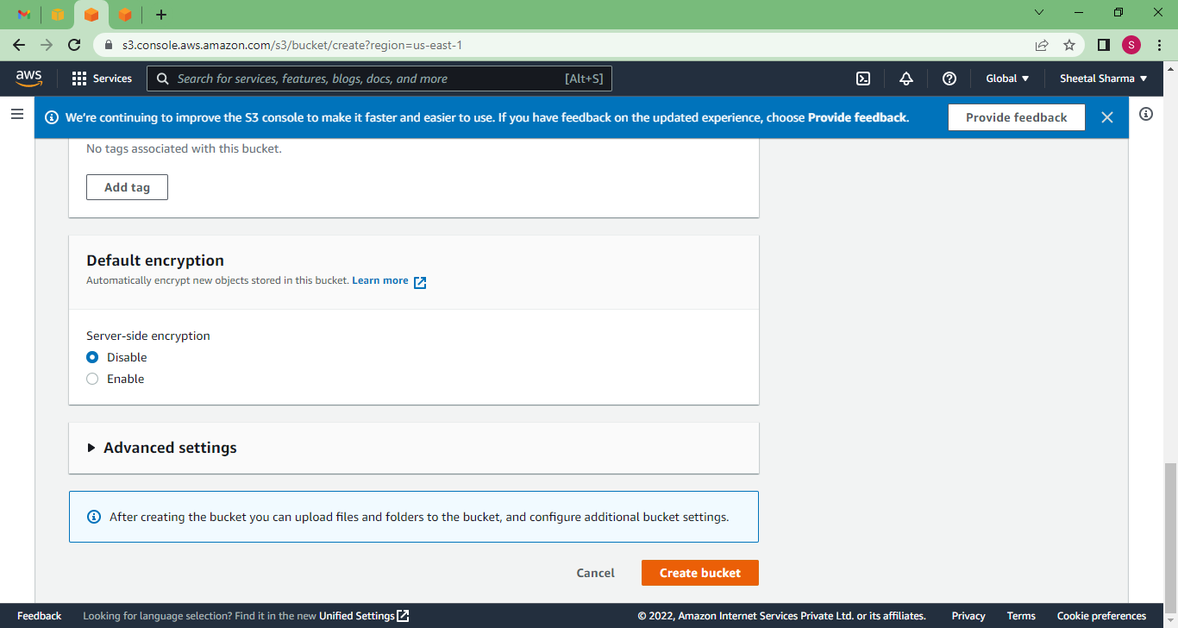

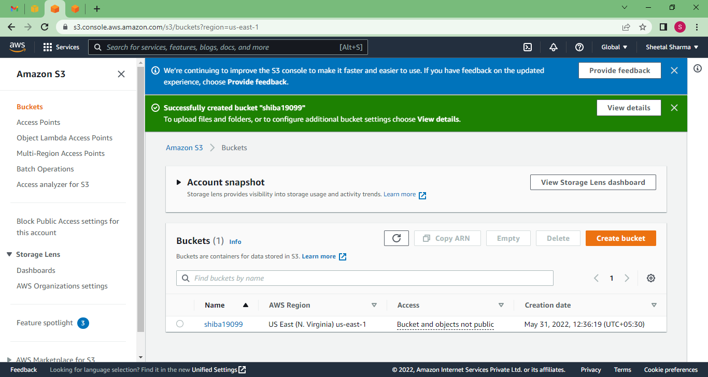

Now insert data manually,

Goto **Upload --> Add files or Folder --> Select object from your Device**

You can see here I uploaded my resume here as an object. Which is in pdf format.

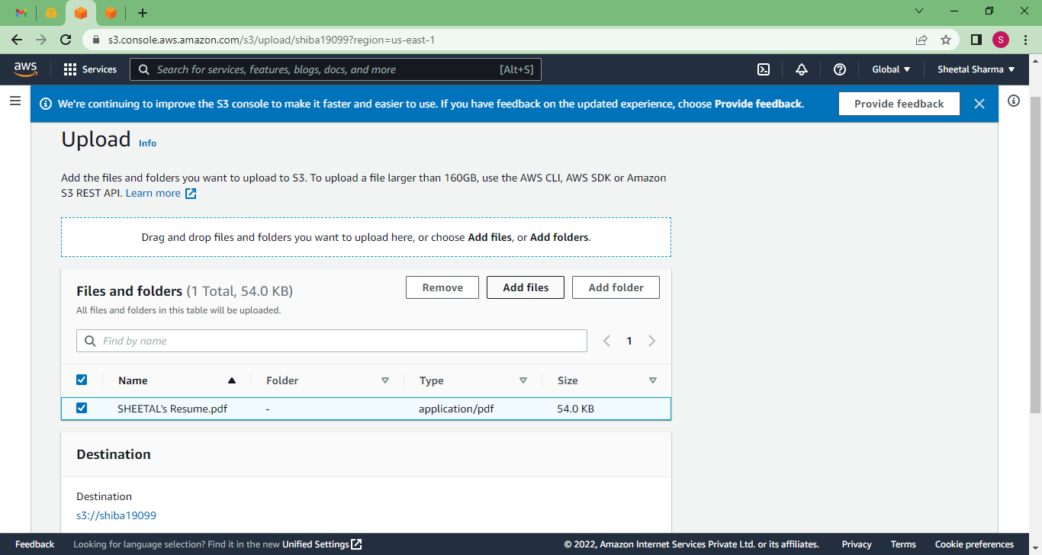

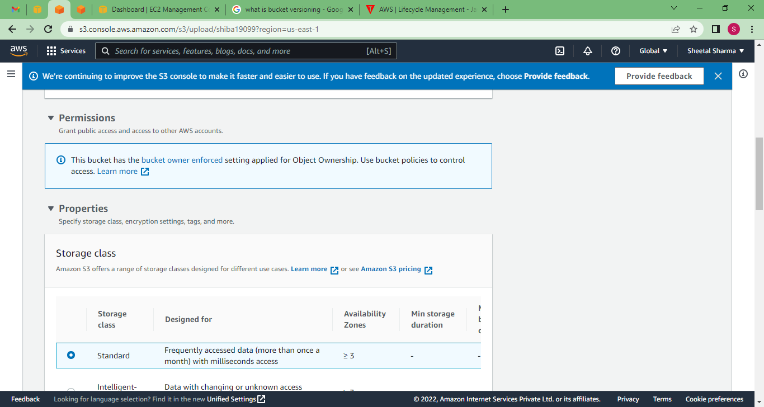

Here is some storage class if you want to change then you can change but by default it will be standard.

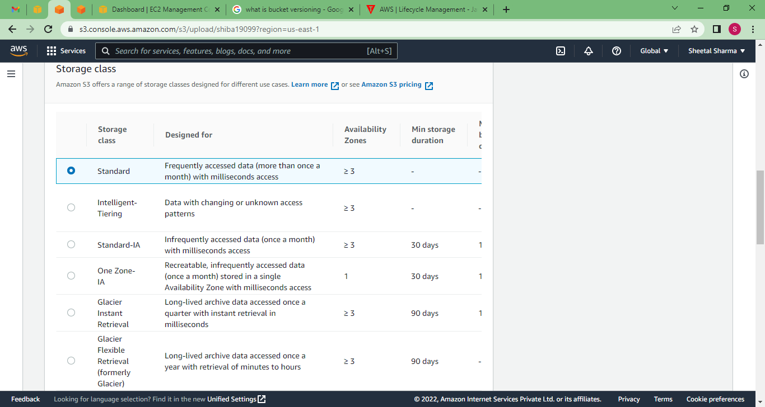

If you want to give any tag then you can... then Upload.

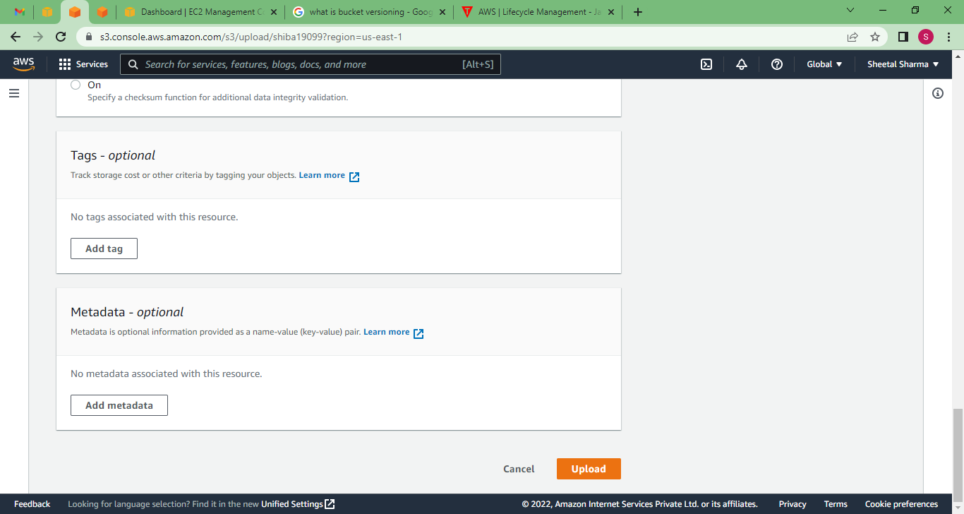

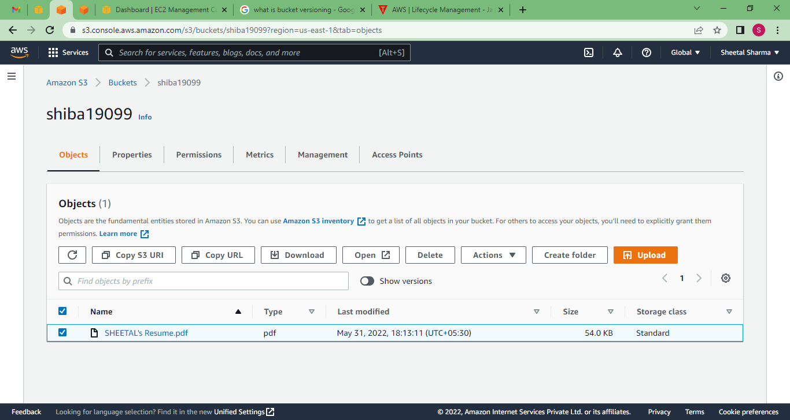

Here My object is uploaded, now see that object by url.

For that click on object name, here you can see that object url copy that and paste into your new tab browser.

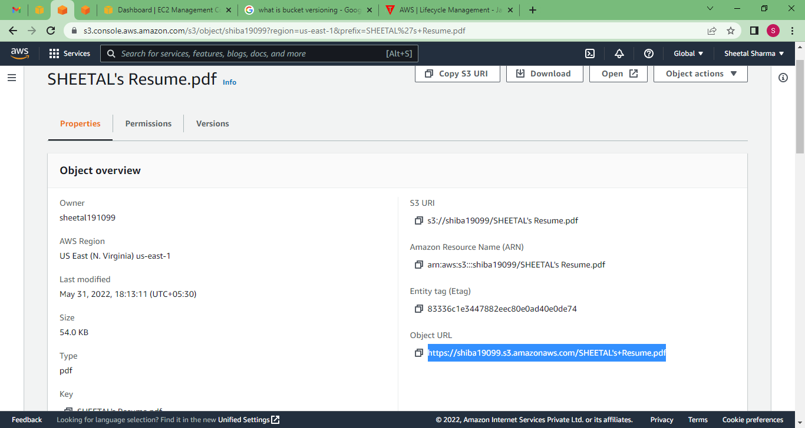

Here we get some error because object not have any public access, So give access to object.

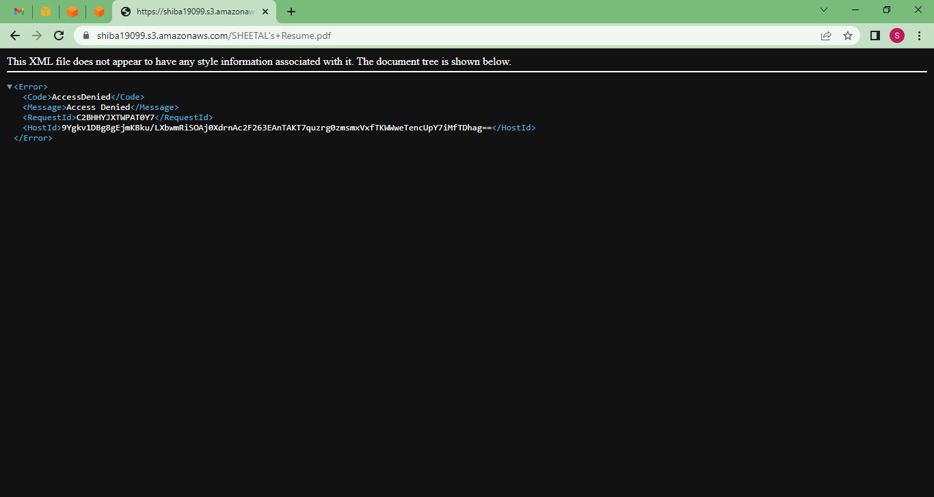

Now goto Permissions, and make ACL enable,

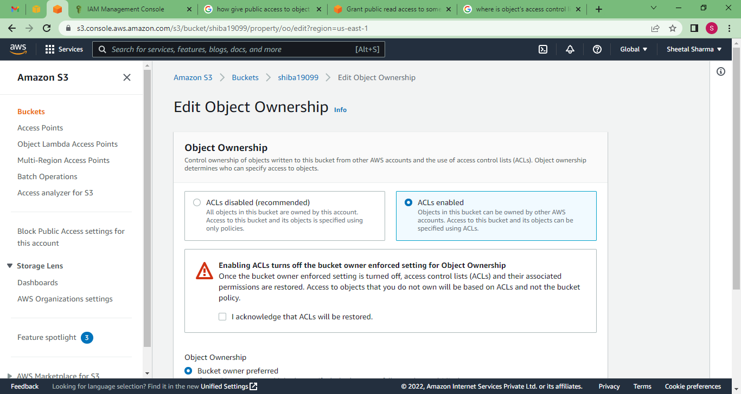

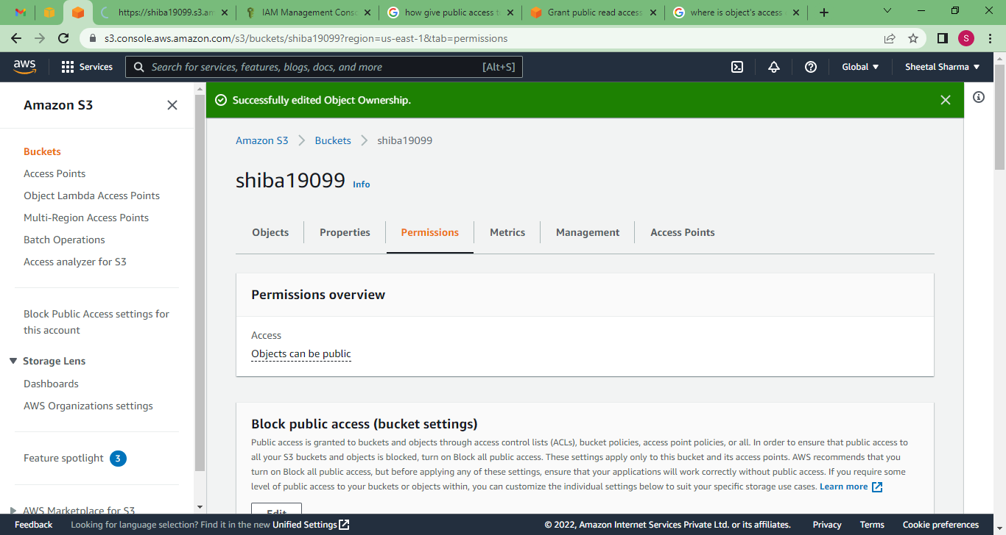

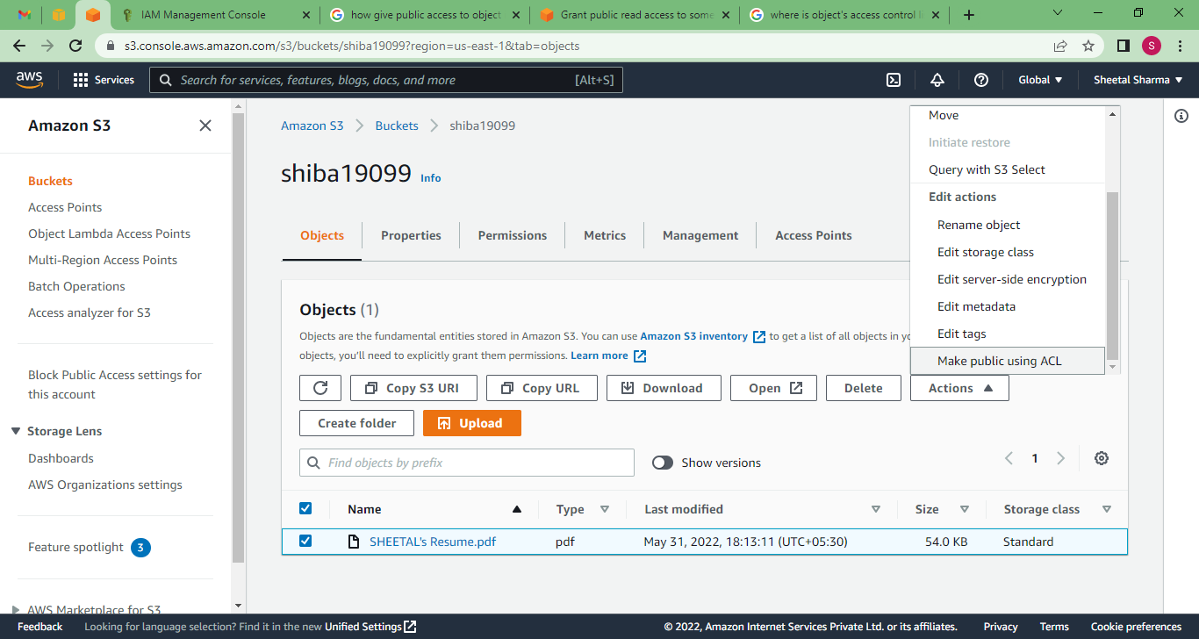

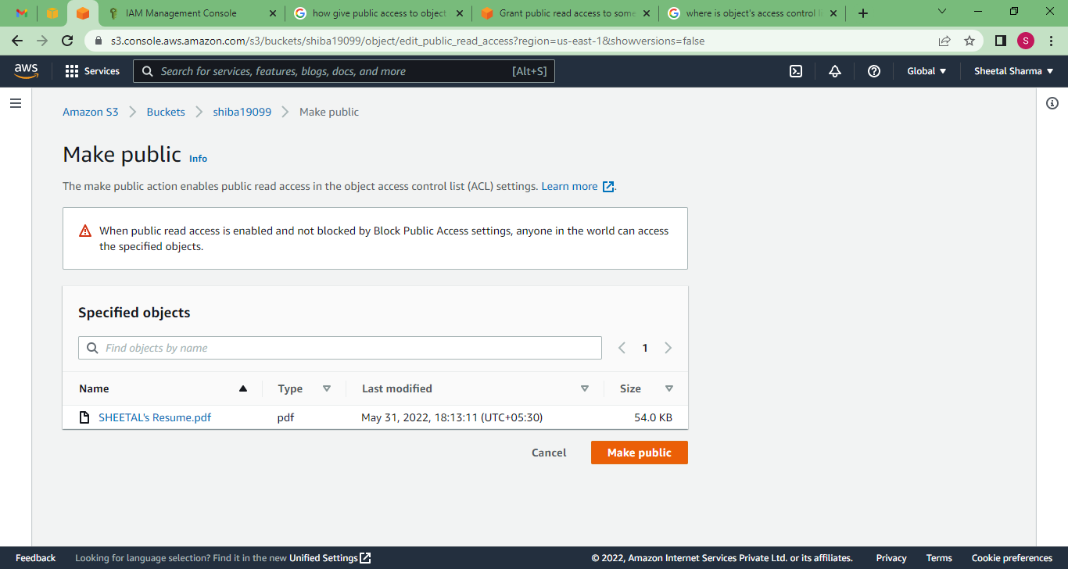

Now try again with run your object URL, and here I can see my pdf which is insert by me as an object.

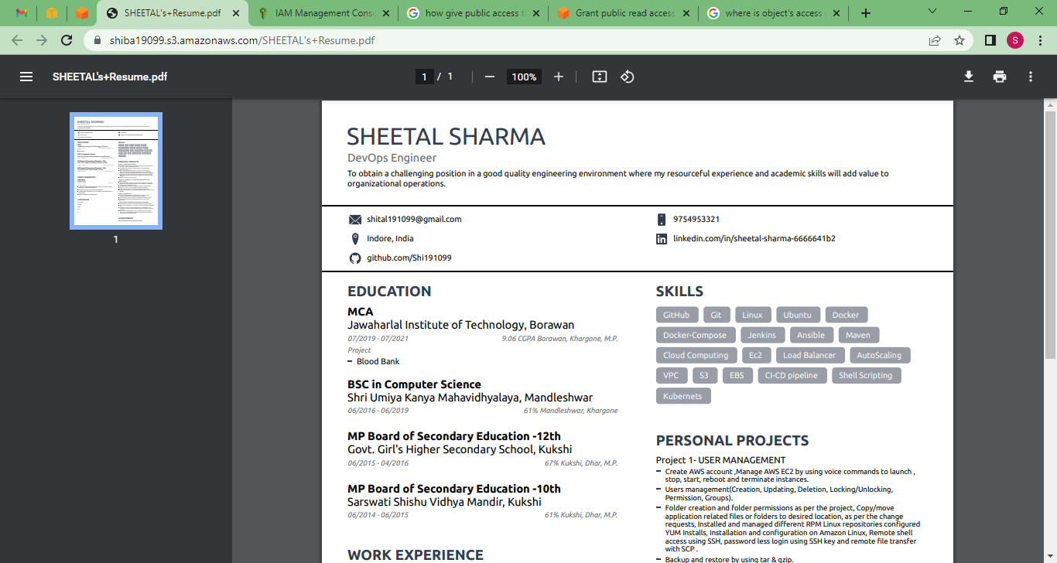

Now try with CLI,

For that Launch an Instance and connect that with Terminal and create Security credentials,

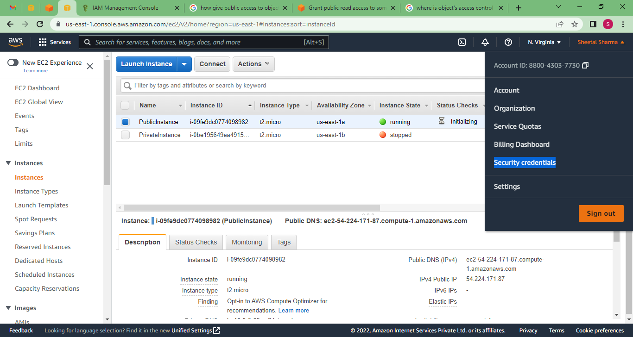

**Security Credentials --> Access Keys --> Create new Access Key**

+-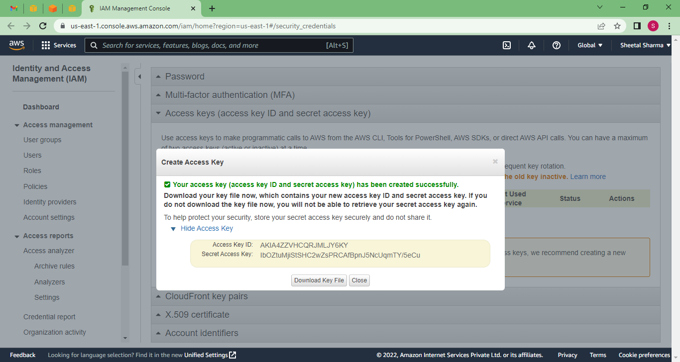

Copy this access key directly or download key file.

* **aws configure**
* **Paste Access key 1st**
* **Paste Secret Access key**
* **Enter correct Region**

If you getting this error **Could not connect to the endpoint URL: "https://s3.us-east-1a.amazonaws.com/"**

then open ~**/.aws/config** this file and check region name and fix it as **us-east-1**

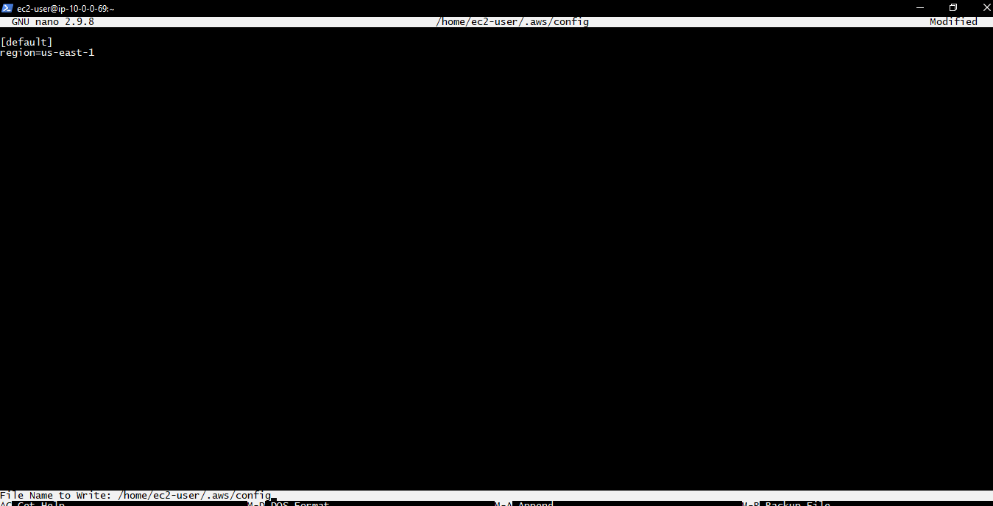

Then Run

* **aws s3 ls**

With this cmd we can see how much bucket is in S3.

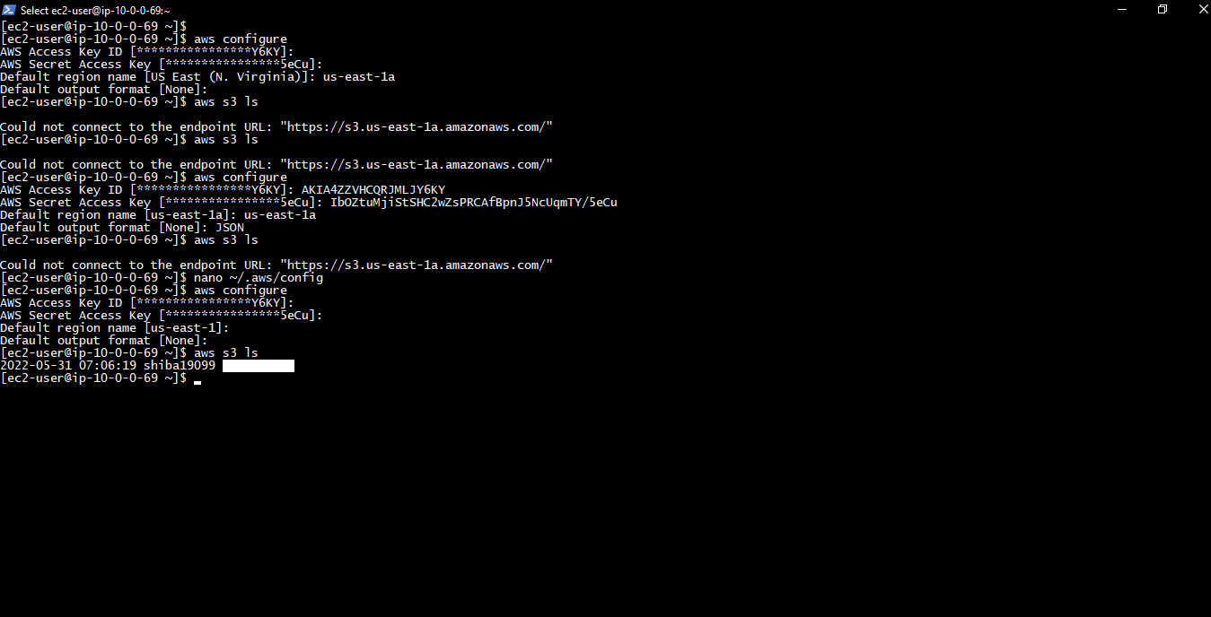

**Now create a bucket from AWS ec2 terminal, Run**

* **aws s3 mb s3://bucketname {mb bucket name (with this we can make bucket )}**
* **aws s3 rb s3://bucketname {rb bucket name (with this we can remove bucket )}**
* **aws s3 mv . s3://bucketname {mv bucket name (with this we can move data from ec2 to S3 bucket )}**
* **aws s3 mv s3://bucketname . {mv bucket name (with this we can move data from S3 to Ec2 )}**
* **aws s3** **sync . s3://bucketname {sync bucket name (with this we can copy data from ec2 to S3 bucket )}**
* **aws s3 sync s3://bucketname . {sync bucket name (with this we can copy data from S3 to Ec2 )}**
* **aws s3 mv s3://bucketname . {mv bucket name (with this we can move data from S3 to Ec2 )}**
* **aws s3 rm s3://bucketname --recursive {rm bucket name (with this we can remove content from S3** **bucket )}**

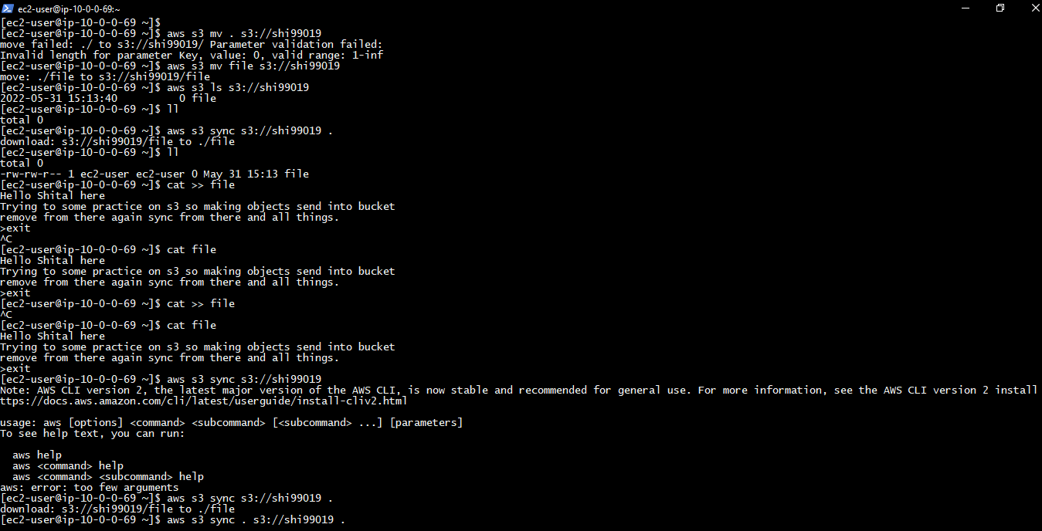

Now move this file to S3 bucket,

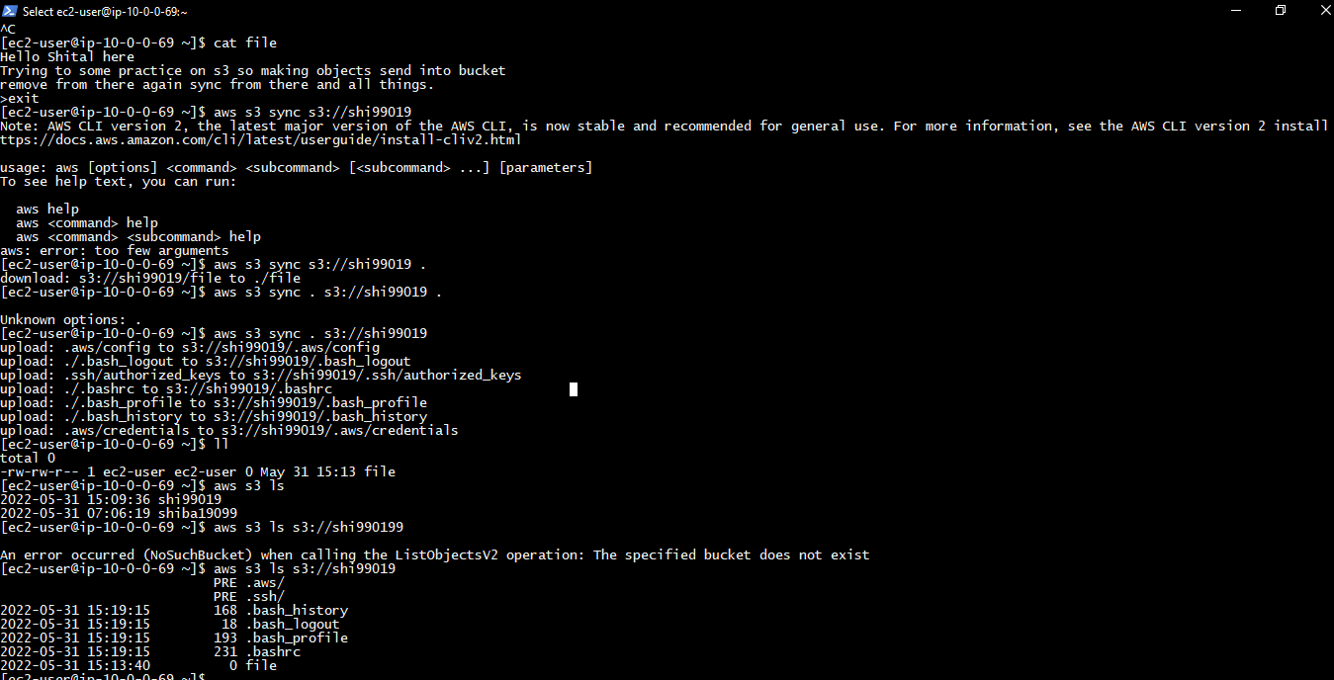

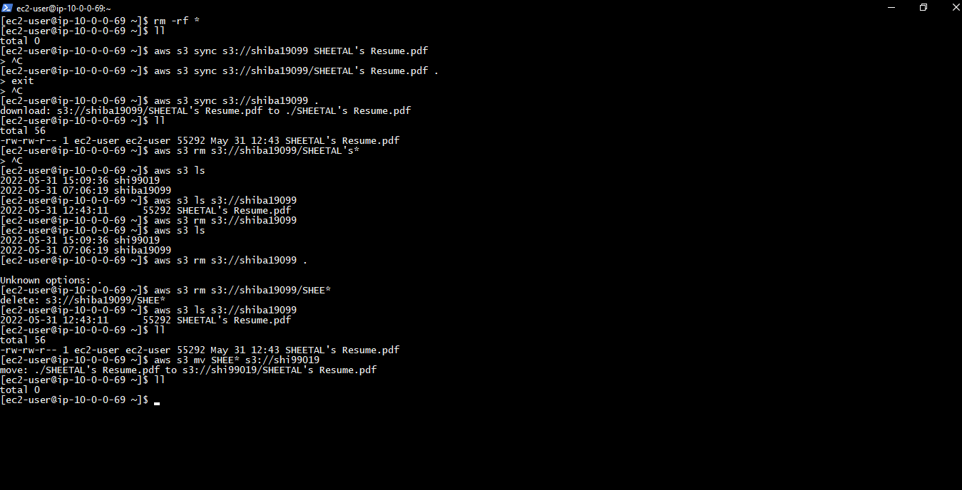

**Now check in to S3 bucket this all thing actually happening or not,**

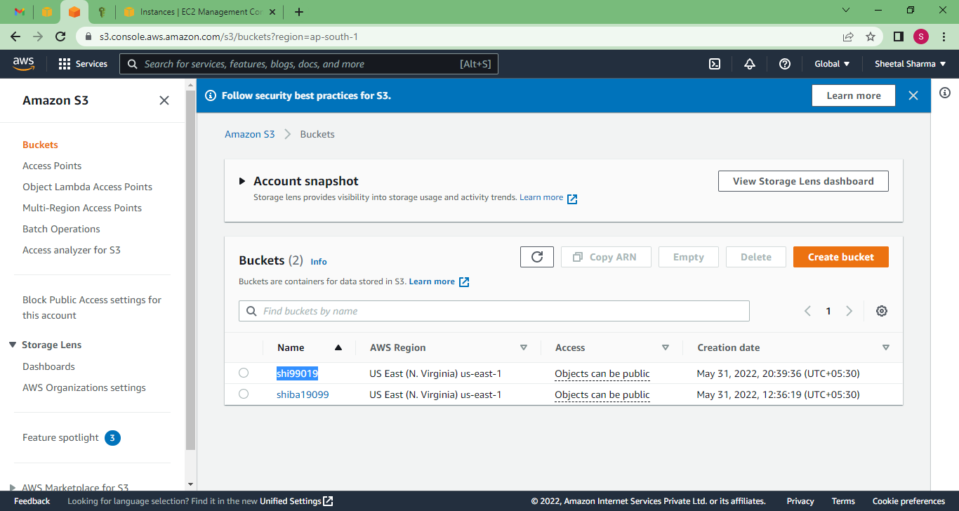

Here is that Bucket which we created in CLI, Now checks for object so click on bucket,

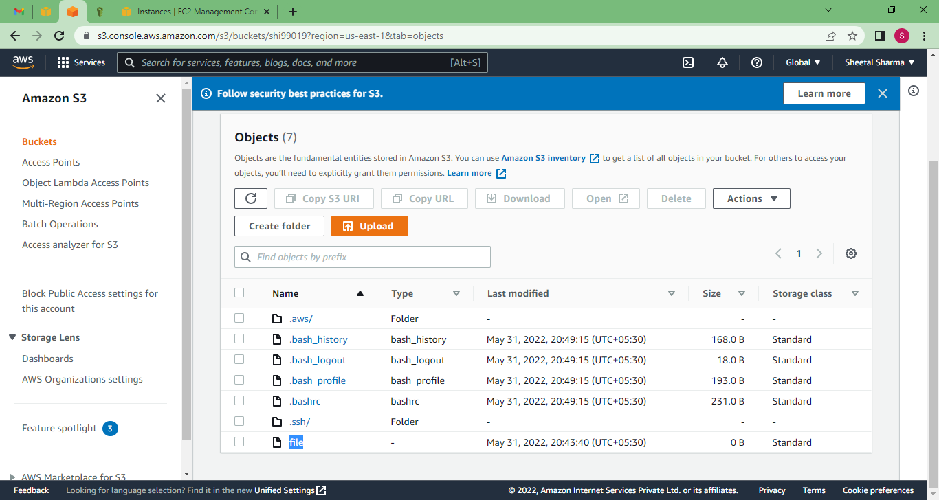

Try to open that object and see content of object,

As of now that object doesnot have any permission for public access for that goto objects then permission.

**Objects --> Permission --> ACL enable**

**Click on Object --> Action --> make public**

Ya now I am able to see my Object content.

**Now try to delete bucket by CLI,**

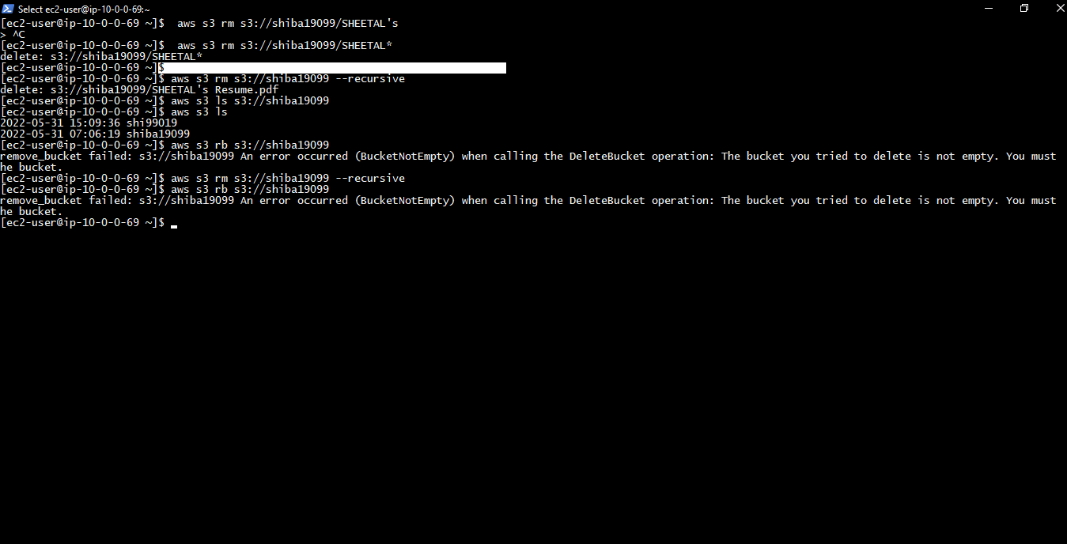I have to do empty bucket 1st,

