**Alpine Image**

**A minimal Docker image based on Alpine Linux with a complete package index**

Those are the names of the OS in the container in which Node will be running.

Alpine is for Alpine Linux, Jessie and Stretch are versions of Debian.

**Create an Image for tomcat**

|  |
| --- |
| **FROM tomcat:8.0-alpine**    **ADD webapp.war /usr/local/tomcat/webapps/**    **EXPOSE 8080** |

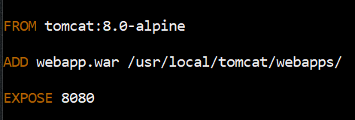

* **docker pull shikashi/tomcat-image**

**Create an Image for Angular app**

|  |
| --- |
| **FROM node:alpine**  **WORKDIR /app**  **COPY . .**  **RUN npm install**  **RUN npm run build --prod**  **#****stage 2**  **FROM nginx:alpine**  **COPY /dist/angular-app /usr/share/nginx/html** |

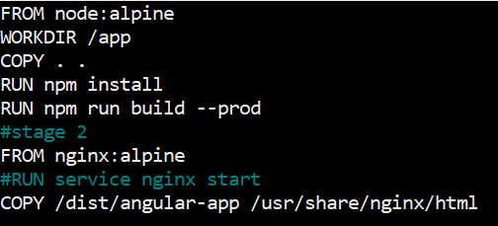

* **docker pull shikashi/angular-img**

**Create an Image for Java-App**

**Docker file**

|  |
| --- |
| **FROM tomcat:8.0-alpine**    **COPY /webapp/target/*.war /usr/local/tomcat/webapps/web.war**    **EXPOSE 8091** |

**Jenkins file**

|  |
| --- |
| **pipeline {**  **agent any**  **tools {**  **maven 'M2'**  **}**  **stages {**  **stage ('Build') {**  **steps {**  **git 'https://github.com/Shi191099/** **Dockerize-Java-app.git** **'**  **sh 'mvn clean package'**  **}**    **}**  **stage ('deploy') {**  **steps {**  **deploy adapters: [**  **tomcat9**  **(**  **credentialsId: '5d352b89-ab10-4b92-922a-f2ef77e7f5dd',**  **path: '',**  **url: 'http://13.127.77.90:8090/'**  **)**  **],**  **contextPath: 'web',**  **war****: '**/*.war'**  **}**  **}**  **stage ('build Docker img') {**  **steps {**  **sh 'docker build -t shikashi/web-****war .'**  **}**  **}**  **stage ('push Docker img') {**  **steps {**  **withCredentials([string(credentialsId: 'docker-s3cret', variable: 'docker')]) {**  **sh 'docker login -u shikashi -p ${docker}'**  **}**    **sh 'docker push shikashi/web-war'**  **}**  **}**  **stage ('Run Container on Dev Server') {**  **steps {**  **sshagent(['pem']) {**  **sh 'ssh -o StrictHostKeyChecking=no ec2-user@172.31.47.18'**  **sh 'docker run -d -P shikashi/web-war'**  **}**  **}**  **}**  **}**  **}**  **https://youtu.be/gdbA3vR2eDs** |