**CICD using aws code pipeline with elastic beanstalk**

Elastic beanstalk:

- create elastic beanstalk and create application as deployapp

- mention platform here I am taking java

- sample application – create

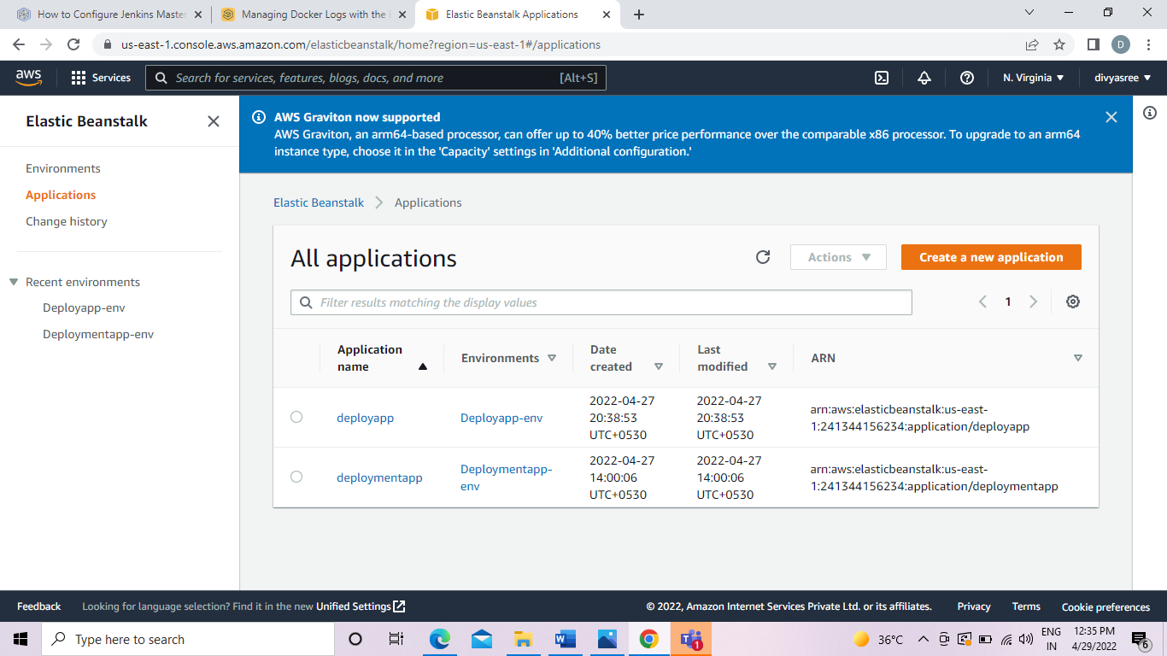

Code pipeline:

- Create a pipeline divpipeline- default – next

- add source stage

- connect to github

- mention repo name – divyasreedevops/order-service

- master branch – github webhook (for changes)

- add build stage

- build provider – aws codebuild

- create project – name – div

- operating system – amazon linux2

- runtime – standard – image (3.0)

- add deploy stage

- add deploy stage – aws elastic beanstalk – deploy app -

- deployapp-env – next – create pipeline

Deployment – elasticbeanstalk - url /orders