A2i update Overview

1. Add Nav menu on navbar in all html page
2. Venobox used on expand menu side image in all html page
3. 3 pictures are added on footer in all html page
4. Digital centre Slider Customized in all digital centre page
5. Added User Accebility in all html page

A2i update Details

1. Add Nav menu on navbar in all html page

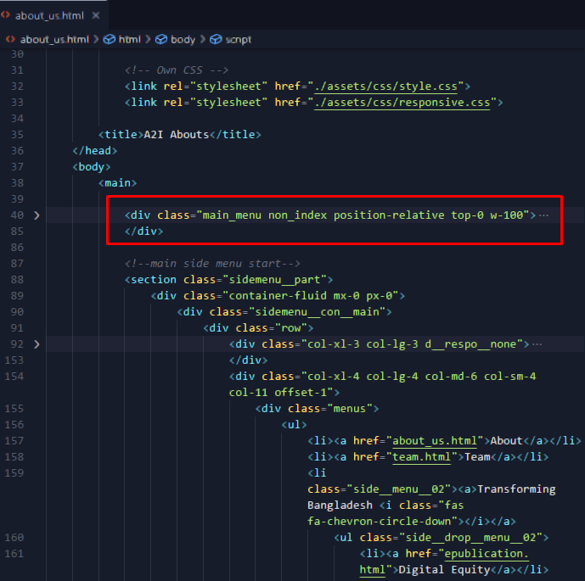

1. Venobox used on expand menu side image in all html page

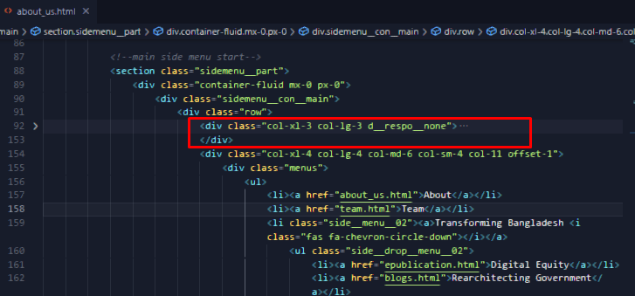

For Responsive,

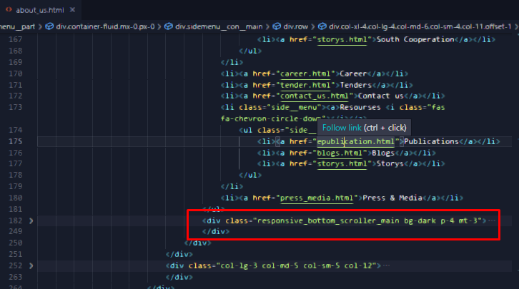

And for video venobox,

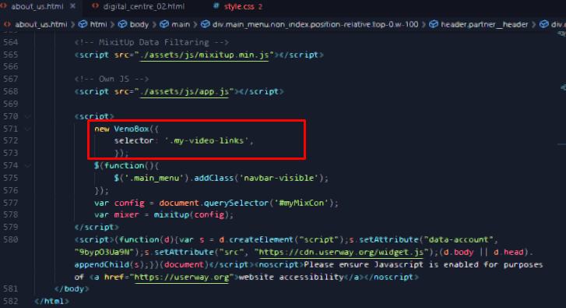

Using it in All Page...

1. 3 pictures are added on footer in all html page.

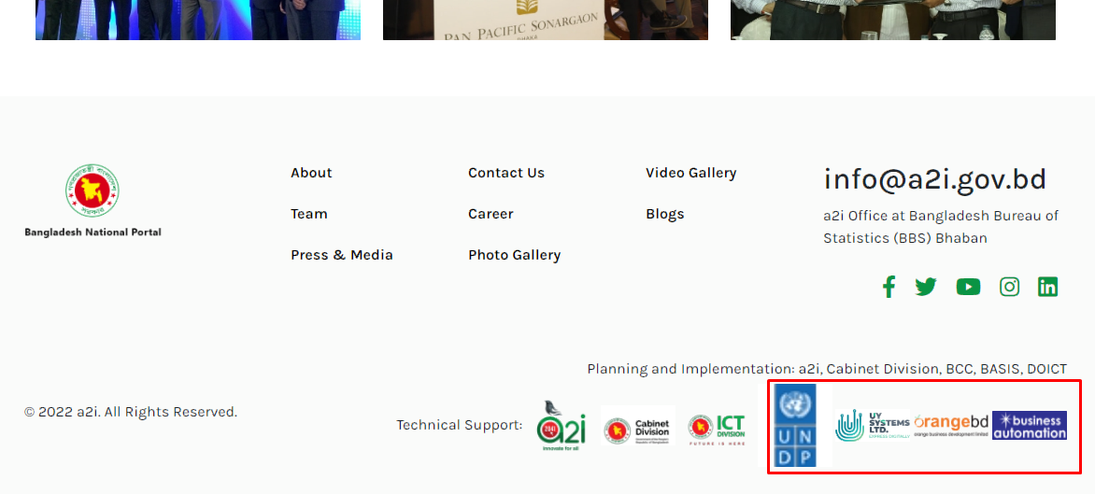

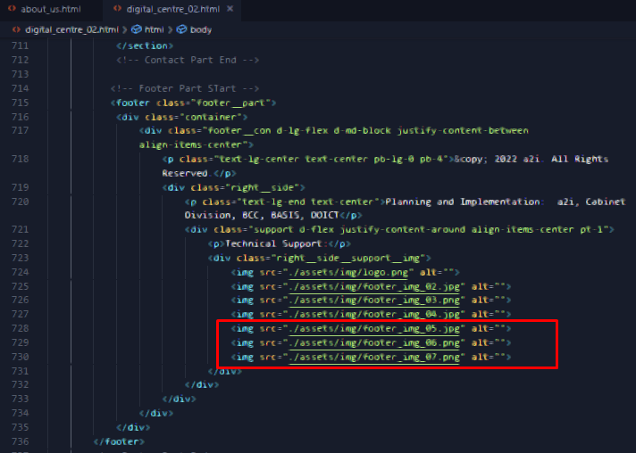

In All Page used.

1. Digital centre Slider Customized in all digital centre page

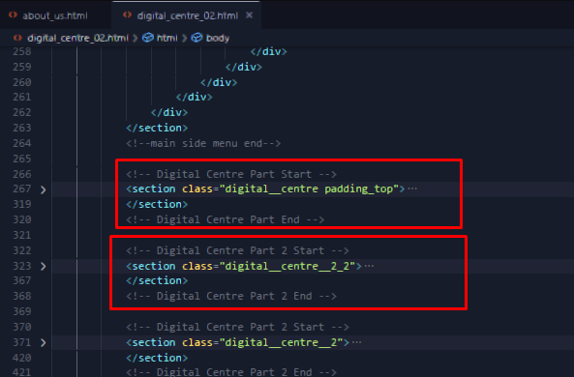

Using it on all digital centre page

1. Added User Accebility in all html page.

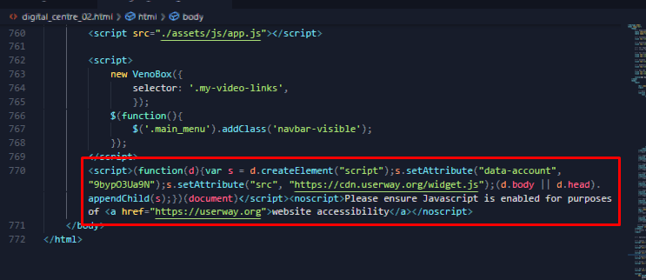

Using it in all html page

Note: Use Updated style.css and app.js .

No new page or file added in this modification.