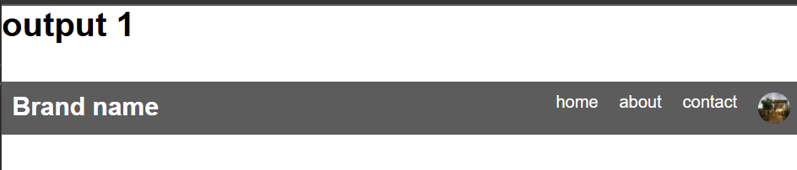

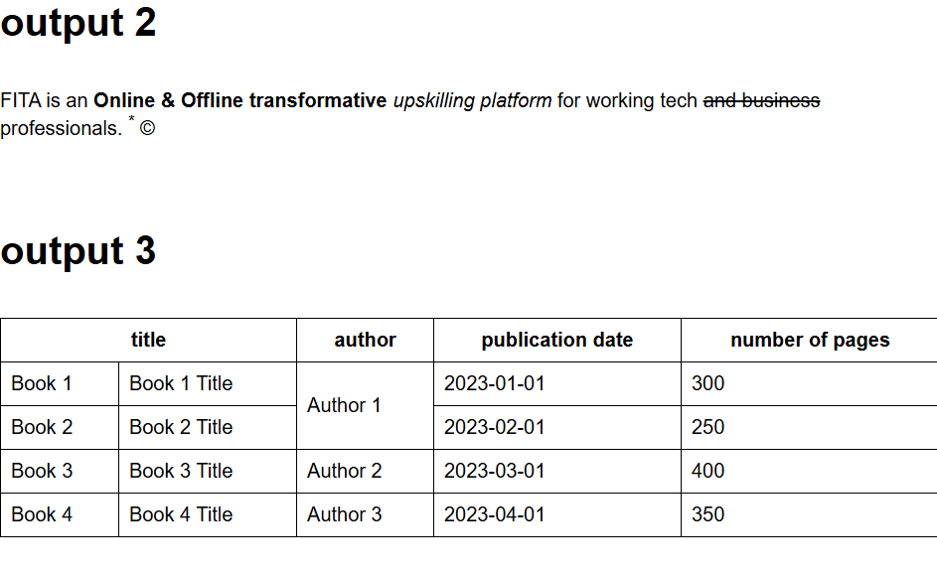

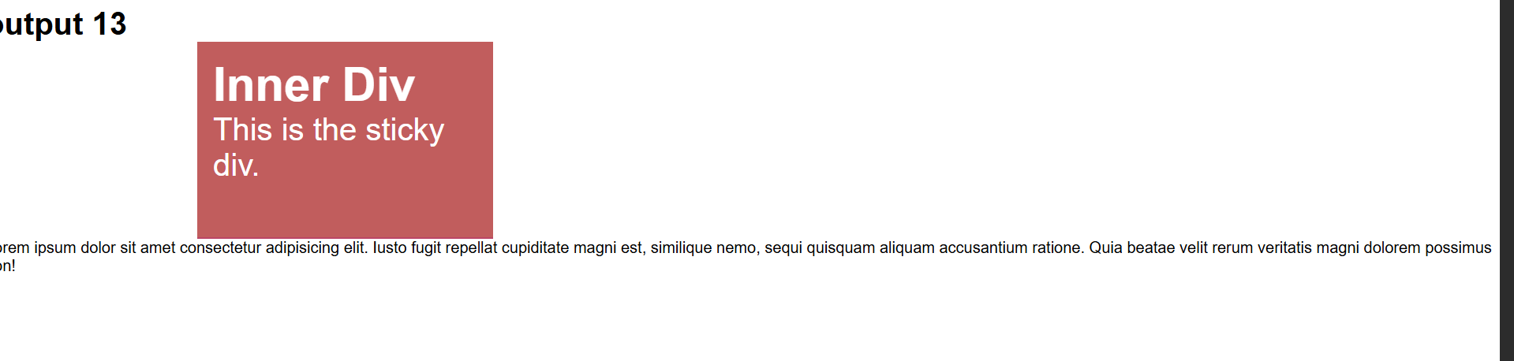

11OUTPUT



