**IOT(INTERNET OF THINKS)**

**Project Title**: Noise Pollution Monitoring

**PHASE 3:** “SIMULATION”

**1.1Simulation**

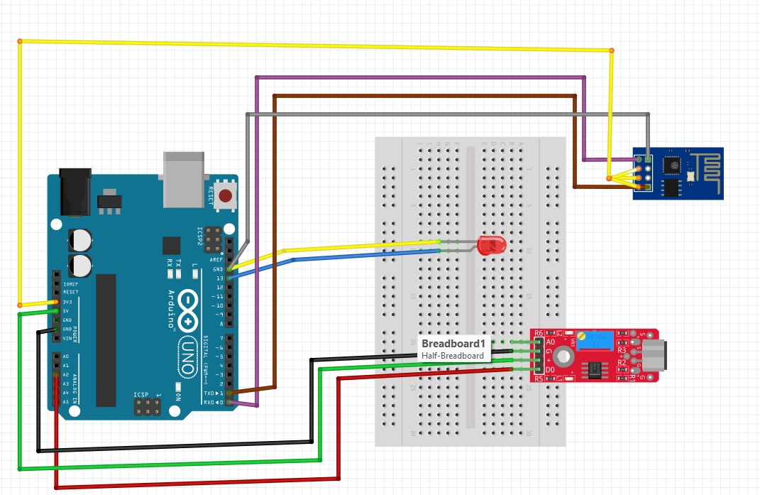

**Diagram 1.1**

In the above diagram we have connecte the Ardiuno uno Rev3 with the sound sensor EY-037,LED light to blink when noise outrages the threshold and ESP8266 serial wifi module.

**1.2 Description**

In this phase we have built the simulation of our project in fritzing.The coding parts for working and storage has been Hardcoded into points :

i)Ardiuno Hardware Code (language:C)

ii)Server and Storage Code (language:C)

iii)Frontend Code (language:HTML & CSS)

**1.3 Code and Scripts**

**1.3.1 Aurdino code**

#include <Adafruit_Sensor.h>

#include <Adafruit_ADXL345_U.h>

#define ANALOG_PIN A2

#define LED_PIN 13

#define SOUND_THRESHOLD 500

Adafruit_ADXL345_Unified soundSensor = Adafruit_ADXL345_Unified(12345);

void setup() {

Serial.begin(9600);

pinMode(LED_PIN, OUTPUT);

soundSensor.begin();

soundSensor.setRange(ADXL345_RANGE_16_G);

}

void loop() {

sensors_event_t event;

soundSensor.getEvent(&event);

int soundValue = analogRead(ANALOG_PIN);

float soundDB = 20 * log10(soundValue);

Serial.print("Sound Level (dB): ");

Serial.println(soundDB);

if (soundDB > SOUND_THRESHOLD) {

digitalWrite(LED_PIN, HIGH);

} else {

digitalWrite(LED_PIN, LOW);

}

delay(1000); }

**1.3.2 Server POST Code**

#include <SPI.h>

#include <Ethernet.h>

#include <MySQL_Connection.h>

byte mac_addr[] = { 0xDE, 0xAD, 0xBE, 0xEF, 0xFE, 0xED }; // Change this to your Ethernet shield's MAC address

IPAddress server_ip(192, 168, 1, 100); // Change this to your MySQL server's IP address

char user[] = "your_username";

char password[] = "your_password";

char db[] = "your_database_name";

EthernetClient client;

MySQL_Connection conn((Client *)&client);

const int soundSensorPin = A0; // Analog pin connected to the sound sensor

void setup() {

Serial.begin(9600);

Ethernet.begin(mac_addr);

if (conn.connect(server_ip, 3306, user, password, db)) {

Serial.println("Connected to MySQL server");

} else {

Serial.println("Connection failed");

}

}

void loop() {

int soundValue = analogRead(soundSensorPin);

storeDataInMySQL(soundValue);

delay(1000); // Adjust the delay as needed

}

void storeDataInMySQL(int value) {

char INSERT_SQL[] = "INSERT INTO sound_data (value) VALUES (?)";

MySQL_Stmt stmt = conn.prepareStatement(INSERT_SQL);

stmt.set(1, value);

if (stmt.execute()) {

Serial.println("Data stored in MySQL");

} else {

Serial.println("Data storage in MySQL failed");

}

stmt.close();

}

**1.3.3 Frontend Scripts**

We are currently working on further development and enhancements of the frontend scripts.We apologies for any inconvenience this may cause.The HTML and CSS components of the website will be uploaded in the next phase of the project.

**1.4 Further Updates**

In the next Phase of this project we will be:

i)Setting Physical Hardware.

ii)Designing the frontend website.

iii)Setting up the server as per the provided code.

iv)Connecting the hardware and software together.

**1.5 Outcome**

In Phase 3,we have successfully achieved our simulation goals and ignite our initial steps as outlined in the Phase 3 description.The coding ascepts are progressing well and will continue to be optimized, except for the Aurdino C codes which are already optimized.The development of the frontend is scheduled for the upcoming phases.