**IOT(INTERNET OF THINKS)**

**Project Title**: Noise Pollution Monitoring

**PHASE 4:** “PROJECT UPDATES”

**1.1 SYPNOSIS :**

Till now, in our project that IOT Noise Detection we have submitted the outlay of the project in Phase-1. Then we have intended our innovation model, material/platform used, and knowing the hardware requirements in Phase-2. Atlast the simulation model, server side codes, and the arduino hardware code have been submitted in the Phase-3.

**2.1 IN THIS PHASE :**

Now we have moved a step forward and pointed out our materials to construct our hardware part that is the arduino part. Further the code is feeded to the arduino and serial output is got from the sound sensor KY-037. The hardware setup image is posted down :

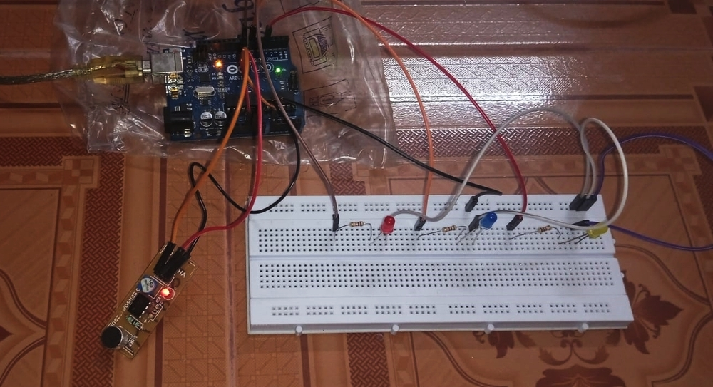

2.1 SOUND SENSOR BLINK

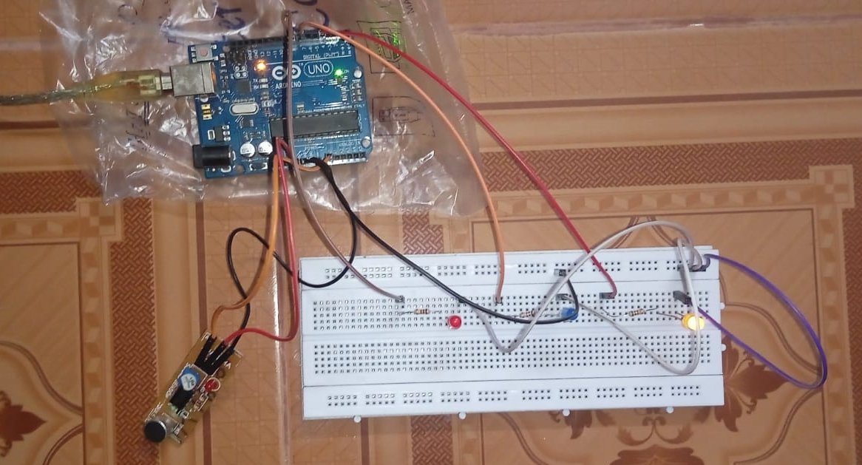

2.2 LOW INDICATING LED BLINK

**3.1 AURDINO EXPLAINATION :**

* In the above model I have connected the 3pin sound sensor with the arduino using male to female jumper wires.
* Here the 5v VCC is the red wire, Ground wire is denoted by black wire and the orange wire is for the analog output (which will be either turn 0v (HIGH) when there is sound and 5v (LOW) when no noise) that can be manipulated to any type of outputs (like dB).
* The yellow LED indicates good level of sound/noise (as per humans hearing capacity) i.e. 0-55dB and blue is for moderate noise 55-105dB and red is for high noise >120dB.

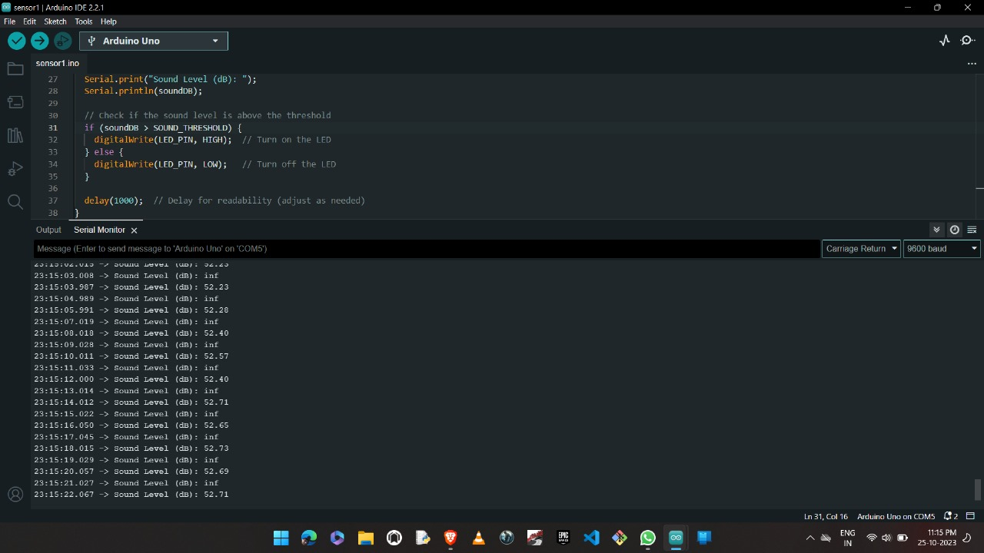

3.1 AURDINO IDE READING

**4.1 FRONTEND SIDE :**

* The frontend part is still in under development. apologies for further delay, but it will be completely finished before the Phase-5 beginning.
* The outlay of the frontend will be, the website will contain an noise meter (we call it as Noise`O`meter) that will show the range of the noise produced using the sound sensors output.
* The Noise`O`meter will have a range from 0 to 140 dB.

**5.1 BACKEND SIDE :**

* The code for the server and the database have been ready but there are some troubleshoots in the data receiving from the arduino uno. Because of we can't able to afford ESP32 or ESP8266 wifi module for this time as our expenses already have exited our limit.
* We can't able to use http or other wifi related protocols to present the data from the server (Backend) to the website (Frontend).
* We will turn to seek other alternatives for this problem and will be presented to you in the github in Phase-5.

**6.1 FURTHER IN THIS PROJECT :**

* In further, as I will keep my word to present the frontend with the server attached to the Noise`O'meter to show the live data.
* We will be seeing for further tweeks to our project, to make this project a better innovative model.

**7.1 CONCLUSION :**

In summary,our IOT Noise Detection project has advanced steadily through its phases,culminating in afunctional Arduino hardware setup for sound detection.We are currently working on the frontend, which will showcase a Noise’O’meter on awebsite.Although backend data reception has presented challenges, we are actively exploring alternative solutions.Our commitement remains unwavering, and we aim to provide live data on the Noise’O’meter as promised.This project represents an innovative and valuable contribution to noise monitoring technology.