**IOT(INTERNET OF THINKS)**

**Project Title**: Noise Pollution Monitoring

**PHASE 5:** “THE ENDGAME”

**1.1 SYPNOSIS :**

Till now, in our project that IOT Noise Detection we have submitted the outlay of the project in Phase-1. Then we have intended our innovation model, material/platform used, and knowing the hardware requirements in Phase-2. In the simulation model, server side codes, and the arduino hardware code have been submitted in the Phase-3.Atlast in Phase-4 we have provided the actual Hardware connections and working of our Noise Monitor, and also programmed our Arduino UNO.

**2.1 IN THIS PHASE :**

**2.1.1 FRONTEND SIDE :**

The website is made up and tinkered at its own way as we all discussed to add and remove some elements.At the end we get a really simple and sleak website for our Noise Pollution Monitoring Device and it’s the one we call it as Noise’Ometer.It has been given to your view down:

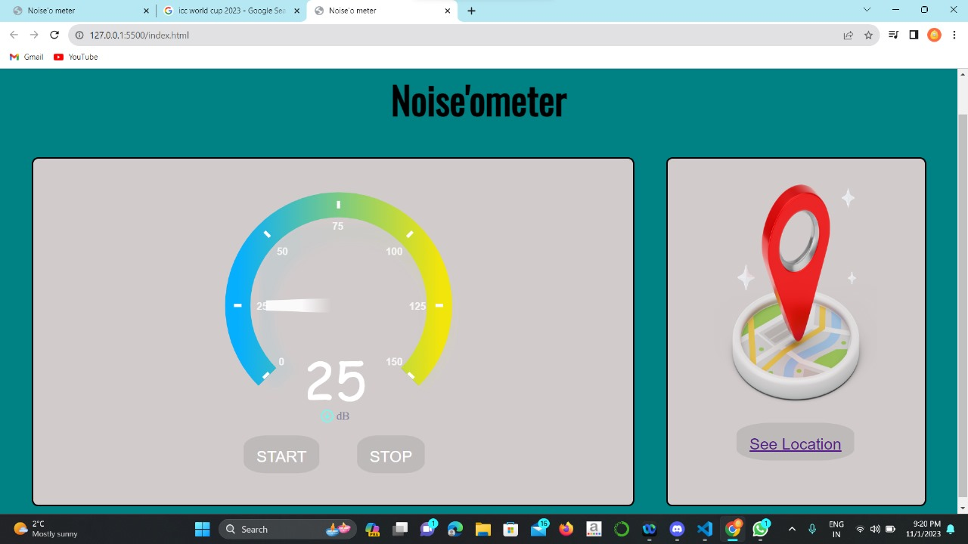

2.1 Noise’Ometer Webpage

As we said, the frontend side is completed .We are very happy to present you as we have mentione in our last phase.

**2.2.1 BACKEND SIDE :**

For the backend of our project, we have selected Vercel as our tool to receive the live data/reading sent from our Noise Monitoring Device(Arduino UNO), the code for sending data is provided below:

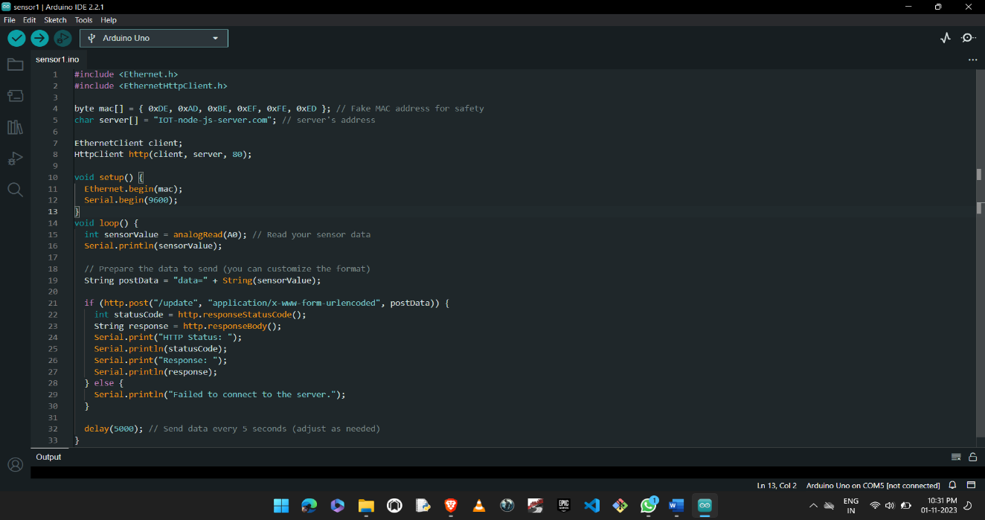

2.2.1 Data Send code

For receving end we have used node.js with sql, the node.js code helps in displaying the readed value into Noise’Ometer. And the node.js code is given below:

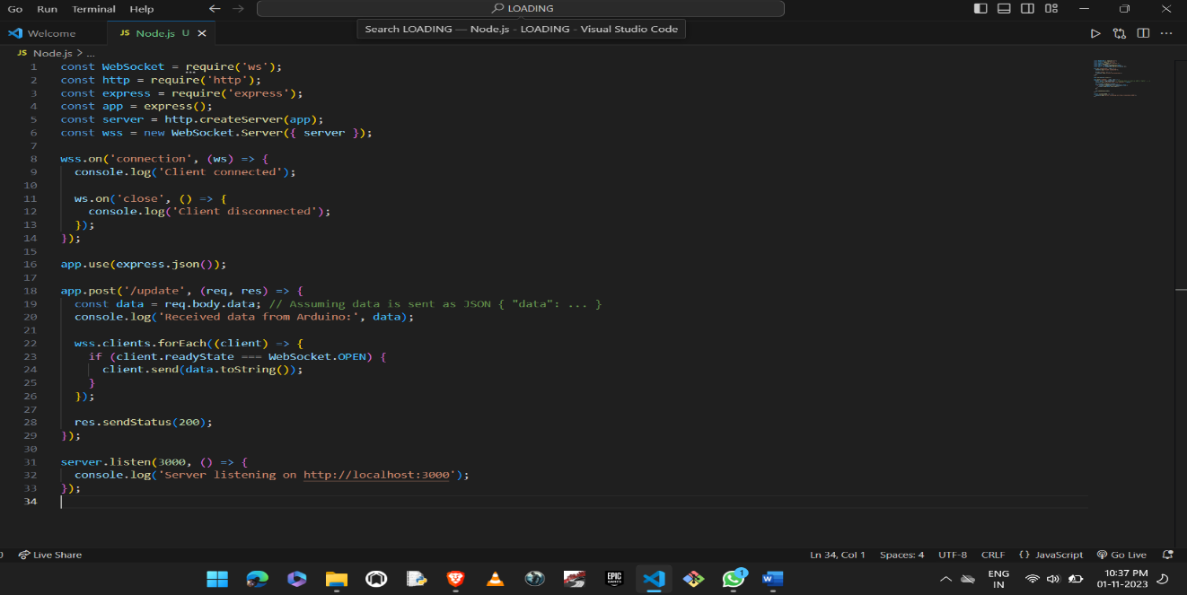

2.2.2 Node.js code

**3.1 OVERALL PROJECT :**

1. Arduino UNO setup of Hardware:

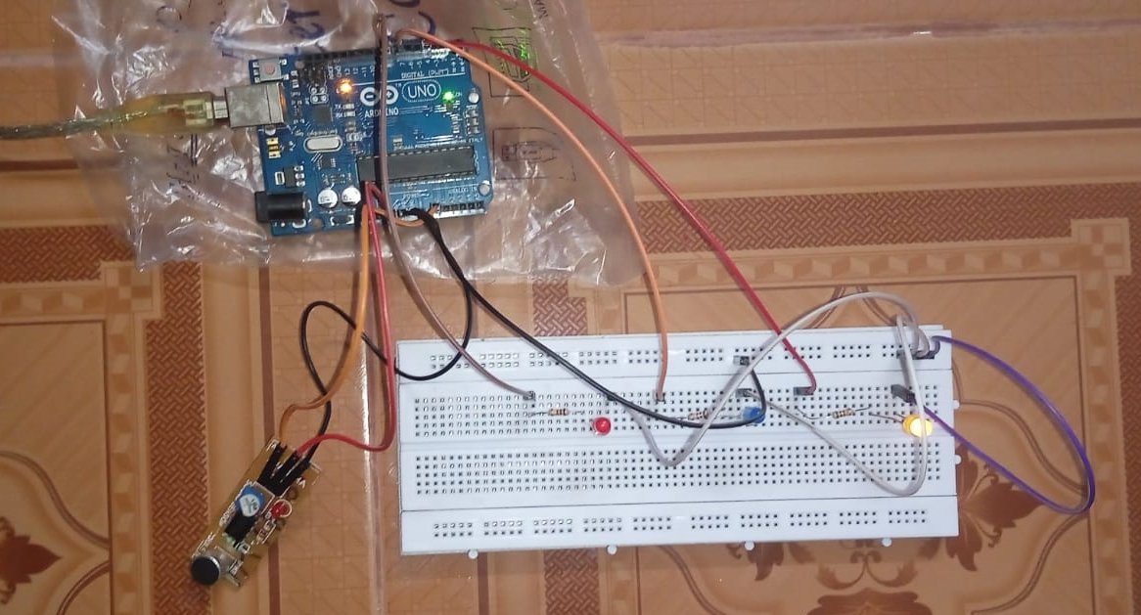

3.1 Arduino setup

1. Arduino code for noise reading:

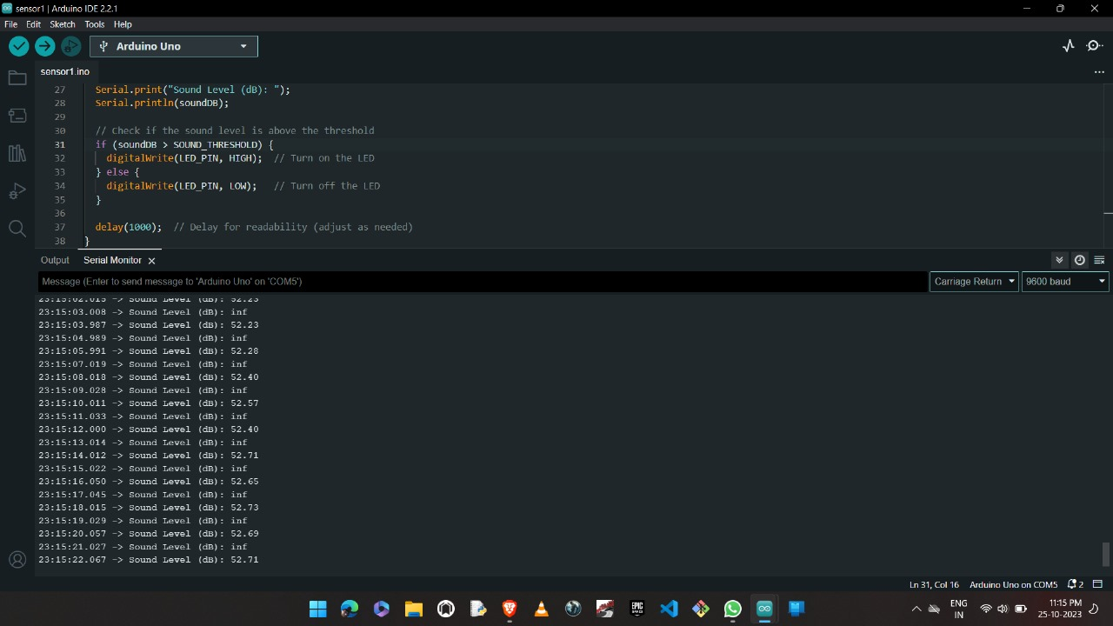

3.2 AURDINO IDE READING

1. Data/Readding sender code in C language using Arduino IDE, packages as HTTP, wired Wifi :



* 1. Data Send code

1. Data/Readings receving through Node.js code and Postgres in Vercel website with the help of Github:



3.4 Node.js code

5.In the you and we as well get to see our Noise’Ometer showing the real-time readings in a meter ranges from 0(low) to 150(High):



3.5 Noise’Ometer Webpage

**4.1 CONCLUSION :**

In summary,our IOT Noise Detection project has steadily gone through many phases,culminating in afunctional Arduino hardware setup for sound detection, website as a displayer, Postgres,Vercel , and GitHub as our Backend servers.We are at the end of the project and we have learned a lot in it.We the team made this project are happy to say we have well finished our assigned work on time in each and every phase.We are happy to submit it to your views and hands.Please consider our soulful gratitude our project and we hope you will like and rate(Grade) our project a good.

**THANKING YOU.**