AIOPS TRAINING | DAY 2
Hands-on Task: Login Is Slow
27 October 2026 | AIOps Team, Presidio
The task
Users say the login page is very slow. Logins still work, but take over a second. Your job: build a small AI helper that finds out why and suggests a fix, but only fixes it after a human says yes.
(The answer it should find: the database connection pool is full, so logins wait in a queue.)
For the AI model, use whatever you have access to: a local model with Ollama, or Amazon Bedrock.
What the dashboard shows
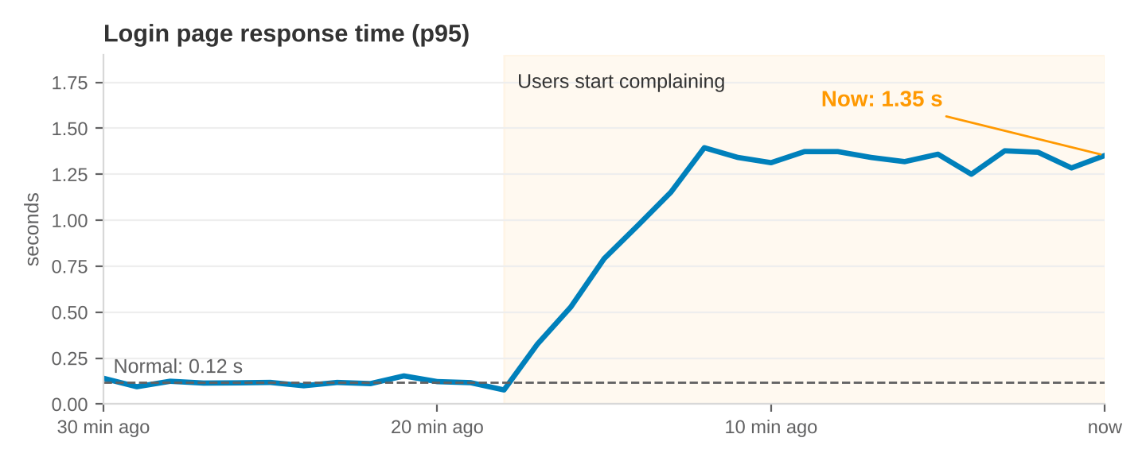
The rule your helper must follow
