# **GIT COMMANDS**

Contents

1- Local GIT PULL/PUSH 2

1- Create a folder 2

2- Go inside folder and right click on and select “Git Bash here”. 2

3- Now follow these commands below 2

4- Now add java file/files to your folder. (The folder named after you) 2

5- Follow these commands. 3

2- How to switch between different branches. 4

1- Initialize the empty repo. 4

2- Pull form the remote git repo. 4

3- Link the local and remote branch 4

4- Fetch all branches 4

5- Once fetched successfully checkout the particular branch you want to work. 4

6- Check the status. 5

7- Do git add/commit/push 5

3- Removing a folder/directory from GIT 5

# Local GIT PULL/PUSH

## Create a folder

(Any location will be fine; I have created under C:\Users\<username>\git\studentPractice)

## Go inside folder and right click on and select “Git Bash here”.

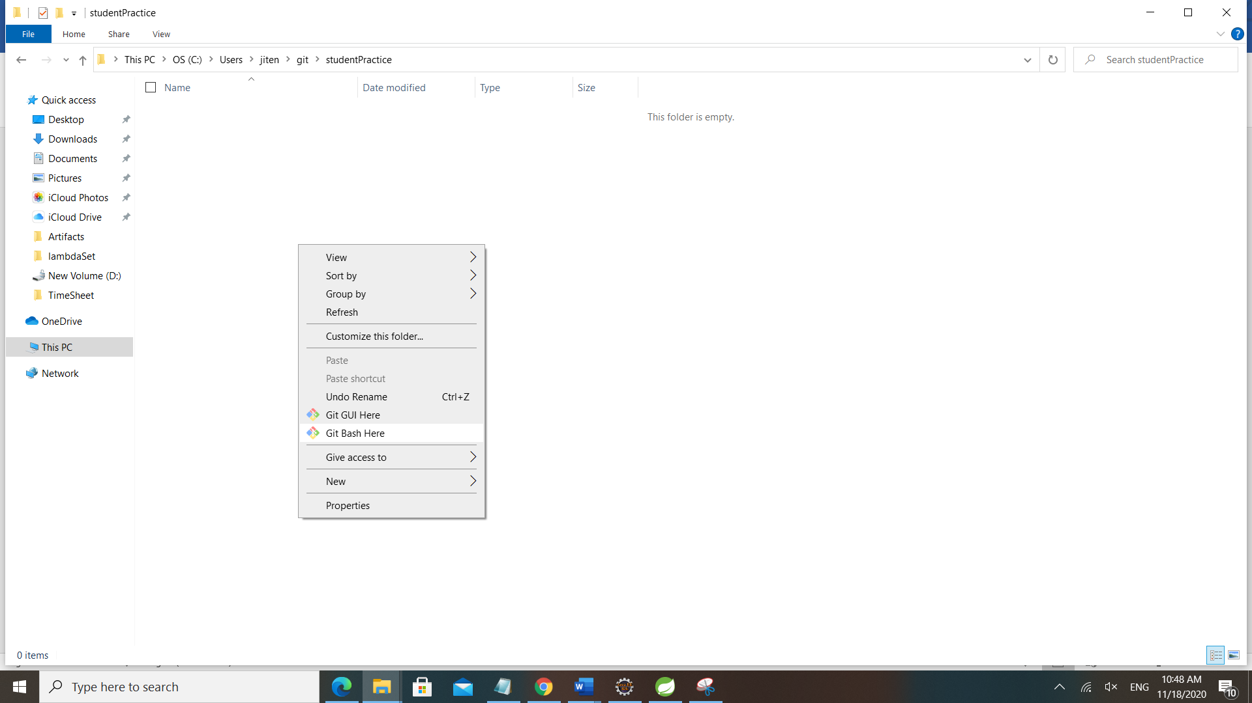

## Now follow these commands below

Note :- In command 2 and 3, use your own credentials in “user.name” and “user.email”.

After these 4 steps you should able to see all the folder structure downloaded from git.

jiten@DESKTOP-R9E8DO3 MINGW64 ~/git/studentPractice (master)

$ git init

Initialized empty Git repository in C:/Users/jiten/git/studentPractice/.git/

jiten@DESKTOP-R9E8DO3 MINGW64 ~/git/studentPractice (master)

$ git config --global user.name "jstudentGit"

jiten@DESKTOP-R9E8DO3 MINGW64 ~/git/studentPractice (master)

$ git config --global user.email "jitendrakumarsamal1@gmail.com"

jiten@DESKTOP-R9E8DO3 MINGW64 ~/git/studentPractice (master)

$ git pull https://github.com/projectcarv/PracticeSet.git

remote: Enumerating objects: 134, done.

remote: Counting objects: 100% (134/134), done.

remote: Compressing objects: 100% (82/82), done.

remote: Total 259 (delta 40), reused 68 (delta 14), pack-reused 125

Receiving objects: 100% (259/259), 47.05 KiB | 1.04 MiB/s, done.

Resolving deltas: 100% (61/61), done.

From https://github.com/projectcarv/PracticeSet

* branch HEAD -> FETCH_HEAD

jiten@DESKTOP-R9E8DO3 MINGW64 ~/git/studentPractice (master)

## Now add java file/files to your folder. (The folder named after you)

## Follow these commands.

jiten@DESKTOP-R9E8DO3 MINGW64 ~/git/studentPractice (master)

$ git checkout master

Already on 'master'

jiten@DESKTOP-R9E8DO3 MINGW64 ~/git/studentPractice (master)

$ git status

On branch master

Untracked files:

(use "git add <file>..." to include in what will be committed)

src/com/projectcarv/praciceSet/project2021/Dharmendra/MultiplicationTable.java

nothing added to commit but untracked files present (use "git add" to track)

jiten@DESKTOP-R9E8DO3 MINGW64 ~/git/studentPractice (master)

$ git add src/com/projectcarv/praciceSet/project2021/Dharmendra/MultiplicationTable.java

jiten@DESKTOP-R9E8DO3 MINGW64 ~/git/studentPractice (master)

$ git status

On branch master

Changes to be committed:

(use "git restore --staged <file>..." to unstage)

new file: src/com/projectcarv/praciceSet/project2021/Dharmendra/MultiplicationTable.java

jiten@DESKTOP-R9E8DO3 MINGW64 ~/git/studentPractice (master)

$ git commit -m "multiplication table added to by Jitendra"

[master d5498eb] multiplication table added to by Jitendra

1 file changed, 12 insertions(+)

create mode 100644 src/com/projectcarv/praciceSet/project2021/Dharmendra/MultiplicationTable.java

jiten@DESKTOP-R9E8DO3 MINGW64 ~/git/studentPractice (master)

$ git status

On branch master

nothing to commit, working tree clean

jiten@DESKTOP-R9E8DO3 MINGW64 ~/git/studentPractice (master)

$ git remote add origin https://github.com/projectcarv/PracticeSet.git

jiten@DESKTOP-R9E8DO3 MINGW64 ~/git/studentPractice (master)

$ git push --set-upstream origin master

Enumerating objects: 16, done.

Counting objects: 100% (16/16), done.

Delta compression using up to 8 threads

Compressing objects: 100% (6/6), done.

Writing objects: 100% (9/9), 883 bytes | 441.00 KiB/s, done.

Total 9 (delta 3), reused 0 (delta 0), pack-reused 0

remote: Resolving deltas: 100% (3/3), completed with 3 local objects.

To https://github.com/projectcarv/PracticeSet.git

5a3b6a7..d5498eb master -> master

Branch 'master' set up to track remote branch 'master' from 'origin'.

1. **If you will get any error in any of these steps, you will now check in the browser you will get all the updates**

<https://github.com/projectcarv/PracticeSet/tree/master/src/com/projectcarv/praciceSet/project2021>

# 2- How to switch between different branches.

## Initialize the empty repo.

jiten@DESKTOP-R9E8DO3 MINGW64 /d/Projects/Project-2021/remoteProj

$ git init

Initialized empty Git repository in D:/Projects/Project-2021/remoteProj/.git/

Note- No need to do global config user.name and user.email if you are not the very first user

## Pull form the remote git repo.

jiten@DESKTOP-R9E8DO3 MINGW64 /d/Projects/Project-2021/remoteProj (master)

$ git pull https://github.com/projectcarv/PracticeSet.git

remote: Enumerating objects: 57, done.

remote: Counting objects: 100% (57/57), done.

remote: Compressing objects: 100% (25/25), done.

remote: Total 352 (delta 17), reused 47 (delta 12), pack-reused 295

Receiving objects: 100% (352/352), 2.16 MiB | 889.00 KiB/s, done.

Resolving deltas: 100% (103/103), done.

From https://github.com/projectcarv/PracticeSet

* branch HEAD -> FETCH_HEAD

## Link the local and remote branch

jiten@DESKTOP-R9E8DO3 MINGW64 /d/Projects/Project-2021/remoteProj (master)

$ git remote add origin https://github.com/projectcarv/PracticeSet.git

## Fetch all branches

Note- fetch all command will fetch all the codes from all remote branches.Look carefully the below red highlights it shows local “caldev” branch is in sync with remote “origin/caldev” branch.The same is for master and testbranch.

jiten@DESKTOP-R9E8DO3 MINGW64 /d/Projects/Project-2021/remoteProj (master)

$ git fetch --all

Fetching origin

remote: Enumerating objects: 31, done.

remote: Counting objects: 100% (31/31), done.

remote: Compressing objects: 100% (12/12), done.

remote: Total 25 (delta 8), reused 22 (delta 5), pack-reused 0

Unpacking objects: 100% (25/25), 207.32 KiB | 499.00 KiB/s, done.

From https://github.com/projectcarv/PracticeSet

* [new branch] caldev -> origin/caldev

* [new branch] master -> origin/master

* [new branch] testbranch -> origin/testbranch

## Once fetched successfully checkout the particular branch you want to work.

jiten@DESKTOP-R9E8DO3 MINGW64 /d/Projects/Project-2021/remoteProj (master)

$ git checkout caldev

Switched to a new branch 'caldev'

Branch 'caldev' set up to track remote branch 'caldev' from 'origin'.

## Check the status.

jiten@DESKTOP-R9E8DO3 MINGW64 /d/Projects/Project-2021/remoteProj (caldev)

$ git status

On branch caldev

Your branch is up to date with 'origin/caldev'.

nothing to commit, working tree clean

## Do git add/commit/push

jiten@DESKTOP-R9E8DO3 MINGW64 /d/Projects/Project-2021/remoteProj (caldev)

$ git status

On branch caldev

Your branch is up to date with 'origin/caldev'.

Untracked files:

(use "git add <file>..." to include in what will be committed)

src/com/projectcarv/artifacts/

nothing added to commit but untracked files present (use "git add" to track)

jiten@DESKTOP-R9E8DO3 MINGW64 /d/Projects/Project-2021/remoteProj (caldev)

$ git add src/com/projectcarv/artifacts/

jiten@DESKTOP-R9E8DO3 MINGW64 /d/Projects/Project-2021/remoteProj (caldev)

$ git commit -m "folder added artifacts"

[caldev cf9bd57] folder added artifacts

1 file changed, 0 insertions(+), 0 deletions(-)

create mode 100644 src/com/projectcarv/artifacts/gitCommandDetails.docx

jiten@DESKTOP-R9E8DO3 MINGW64 /d/Projects/Project-2021/remoteProj (caldev)

$ git push

Enumerating objects: 11, done.

Counting objects: 100% (11/11), done.

Delta compression using up to 8 threads

Compressing objects: 100% (5/5), done.

Writing objects: 100% (7/7), 144.53 KiB | 14.45 MiB/s, done.

Total 7 (delta 2), reused 0 (delta 0), pack-reused 0

remote: Resolving deltas: 100% (2/2), completed with 2 local objects.

To https://github.com/projectcarv/PracticeSet.git

4625a7e..cf9bd57 caldev -> caldev

jiten@DESKTOP-R9E8DO3 MINGW64 /d/Projects/Project-2021/remoteProj (caldev)

# 3- Removing a folder/directory from GIT

jiten@DESKTOP-R9E8DO3 MINGW64 /d/Projects/Project-2021/remoteProj (caldev)

$ git rm -r src/com/projectcarv/artifacts

rm 'src/com/projectcarv/artifacts/Git first pull and push from Local.docx'

rm 'src/com/projectcarv/artifacts/readMe.txt'

jiten@DESKTOP-R9E8DO3 MINGW64 /d/Projects/Project-2021/remoteProj (caldev)

$ git commit -m "deleted the artifact folder"

[caldev 4625a7e] deleted the artifact folder

2 files changed, 3 deletions(-)

delete mode 100644 src/com/projectcarv/artifacts/Git first pull and push from Local.docx

delete mode 100644 src/com/projectcarv/artifacts/readMe.txt

jiten@DESKTOP-R9E8DO3 MINGW64 /d/Projects/Project-2021/remoteProj (caldev)

$ git push

Enumerating objects: 9, done.

Counting objects: 100% (9/9), done.

Delta compression using up to 8 threads

Compressing objects: 100% (3/3), done.

Writing objects: 100% (5/5), 382 bytes | 382.00 KiB/s, done.

Total 5 (delta 2), reused 0 (delta 0), pack-reused 0

remote: Resolving deltas: 100% (2/2), completed with 2 local objects.

To https://github.com/projectcarv/PracticeSet.git

6b2b1c5..4625a7e caldev -> caldev